**Guidance 13**

**Indigent Psychiatric Medication Program, known as the Indigent Drug Program (IDP)**

**Contract Reference:** *Sections A-1.1, A2-8, and C-1.3.2*

**Authority:**  *Section 394.676, F.S.*

**Frequency:** *Ongoing*

**Due Date:** *Not Applicable*

1. **Purpose**

The purpose of this guidance document is to:

* 1. Establish IDP administration procedures;
  2. Provide written guidelines to the Managing Entities (ME) and IDP Providers; and
  3. Establish Florida State Hospital’s (IDP/FSH Warehouse) medication order guidelines and processes for receiving, storing, and shipping IDP medications.

1. **Definitions**
   1. **IDP Dispensing Unit:** A pharmacy holding a current permit from the Florida Board of Pharmacy that dispenses medication for the IDP.
   2. **IDP/FSH Warehouse:** A physical space located on the campus of Florida State Hospital (FSH) at Chattahoochee, Florida. This space is reserved for receiving, storing, and shipping IDP medications.
   3. **Inventory:** A listing of medications available through the IDP/FSH Warehouse that can be ordered by agencies that participate in the IDP. An inventory is also known as a formulary.
   4. **Patient Assistance Program (PAP):** Any program offered through private agencies or pharmaceutical manufacturers designed to provide medication at low or no cost to uninsured individuals.
   5. **Psychiatric or Psychotropic Medication:** Any drug prescribed with the primary intent to stabilize or improve mood, mental status, behavioral symptomatology, or mental illness. The medications include but are not limited to the following major categories:
      1. Antipsychotics;
      2. Antidepressants;
      3. Anxiolytics;
      4. Mood stabilizers; and
      5. Cerebral or psychomotor stimulants.
      6. Other medications commonly used may include, but are not limited to, beta blockers, anticonvulsants, cognition enhancers, and opiate blockers.
   6. **Side Effect and Adverse Drug Reaction:** Any effect other than the primary intended effect resulting from medication treatment. Side effects may be negative, neutral, or positive for the patient. An adverse drug reaction is an undesired or unexpected side effect, allergy, or toxicity that occurs with the administration of medication. Adverse drug reactions can range from mild side effects to very severe reactions, including death. Onset may be sudden, or it may take days to develop undesired or toxic reactions to medications.

1. **P****rogram Administration** 
   1. **Managing Entities**

If Managing Entities receive funding under the IDP, they will:

* + 1. Approve organizations requesting to become IDP providers. To be eligible, organizations must be under contract with the regional ME.
    2. Each July, provide a list of approved IDP providers to the Department’s Office of Substance Abuse and Mental Health (SAMH). SAMH will then determine the provider line of credit.
    3. Report bulk purchases into SAMHIS. Using the EVNT (non-client specific file upload) contractors should submit a service using the IDP OCA (MH076) with the Incidental Expense covered service (28) and the actual dollar amount for the units.
    4. Ensure that agreements between IDP providers and participating pharmacies are current and executed.
    5. Ensure that IDP providers use IDP funds for individuals who meet the criteria.
  1. **IDP Providers**
     1. IDP providers will:
        1. Assess and enroll individuals in the IDP who meet the clinical and financial criteria established in ch. 394, F.S.
           1. To meet the clinical criteria individuals:

Must be a member of at least one of the Department’s priority populations; and

Must not reside in a state mental health treatment facility or an inpatient community unit.

* + - * 1. To meet the financial eligibility criteria individuals:

Must have a net family income that is at or below 150 percent of the Federal Poverty Income Guidelines, as published annually in the Federal Register;

Must lack third-party insurance or other psychotropic medications funding sources; and

Must not participate in a program where other funding sources pay for psychotropic medications. If individuals have third party insurance for psychotropic medications but were temporarily denied benefits for these medications, they may receive IDP medications until such time as eligibility is reestablished.

* + - 1. Provide information to individuals regarding adverse effects, side effects, possible allergic reactions, co-occurring disorders, and instructions on what to do in case of an emergency;
      2. Submit updated information to the IDP/FSH Warehouse and to the ME with the first medication order, and ensure that the following information is updated as needed:
         1. The providers’ IDP contact information including name, e-mail, and phone number;
         2. The authorized person’s name who approves the Supply Requisition (See Appendix 1); and
         3. A copy of the pharmacy license(s). Keep a copy of the license and the permit issued in accordance with the requirements specified in s. 499.012(1)(d), F.S.
      3. Use the Supply Requisition (See Appendix 2) obtained via email from the IDP/FSH Warehouse to place orders, and select medications from the Mental Health Treatment Facilities Inventory found in the Department’s CFOP 155-1, Appendix G:
         1. Submit orders only as needed;
         2. Order no more than 12 different medications in each requisition; If ordering more than 12 different medications in one order, use an additional Supply Requisition;
         3. Fax or e-mail the completed, signed, and approved Supply Requisition directly to the IDP/FSH Warehouse; and
         4. Pay line of credit surpluses to IDP/FSH Warehouse before the Warehouse processes new orders.
      4. Submit the last order and payment before May 15 of the fiscal year;
      5. Review all orders for accuracy;
         1. Review the medication with the Issue Document (See Appendix 3) to ensure accuracy;
         2. If discrepancies are found, call the IDP/FSH Warehouse within 24 hours or email the Issue Document with corrections; and
         3. Retain a copy of the Issue Document.
      6. Ensure that IDP prescriptions meet the following conditions:
         1. There cannot be more than two refills, and one prescription cannot cover more than a 90-day supply;
         2. Must be listed on the IDP Inventory; and
         3. Must be filled at an IDP pharmacy.
      7. Actively participate in Patient Assistance Programs (PAP) that provide psychiatric medications without cost;
      8. Provide training in: recognizing, reporting, and documenting adverse effects, side effects, possible allergic reactions, and co-occurring disorders to staff working with individuals under the IDP.
      9. Review updated video presentations for medication guidelines or read the adult medication guidelines available through the Florida Mental Health Institute (FMHI) of the University of South Florida’s Medicaid Drug Therapy Management Program for Behavioral Health, found at <http://flmedicaidbh.fmhi.usf.edu/>.
      10. Review and validate the IDP/FSH Warehouse monthly statements.
      11. Address emergency situations, including but not limited to:
          1. Order additional psychiatric medications from either the IDP/FSH Warehouse or a pharmacy of their choice (for urgent needs); and
          2. Pay dispensing fees to IDP Dispensing Unit for individuals who cannot afford them.
      12. Implement medication receiving, storage, and administrative procedures that meet the current State approved prescribing instructions pursuant to s. 465.035, F.S.; and
      13. Contact via telephone or e-mail the IDP/FSH Warehouse to cancel backorders or portions of backorders; provide the Supply Requisition number.
    1. IDP Providers may:
       1. Return outdated medications:
          1. For inventory management purposes include a packaging slip that contains an itemized medication list; and
          2. Clearly mark the package as **outdated.**
       2. Return overstocked medications:
          1. Complete the Supply Requisition. Under the remarks section of the requisition state that overstocked medications are returned for credit and explain the reason for returning the medications;
          2. Mail medications in package(s) clearly marked as **overstocked**; and
          3. Only return unopened medications.
       3. Submit a check to the IDP/FSH Warehouse accounting office to prepay orders to extend the line of credit. The remaining line of credit cannot be carried over into the next fiscal year.
  1. **The IDP/FSH Warehouse**

The IDP/FSH Warehouse will:

* + 1. Process Supply Requisitions.
    2. Mail back the packages to the providers that return their medication with an incorrect or incomplete Supply Requisition.
    3. Provide monthly statements to the MEs no later than the 10th of the month following the end of the quarter. The statements will list each provider’s approved line of credit and balance. If providers submit orders after the lines of credit have reached a zero balance, the IDP/FSH Warehouse accounting office will:
       1. Calculate the actual cost of the order; and
       2. Notify the provider of the cost.
    4. Release providers’ line of credit as follows:
       1. Deduct administrative costs from providers’ remaining line of credit to process orders;
       2. Bill the difference to providers during the first three quarters of the fiscal year if the cumulative order(s) amount exceeds the quarterly release;
       3. Hold future order shipments if payment is missing; and
       4. Call or email providers if orders exceed its line of credit during the fourth quarter.
    5. Accept any returned medications with a minimum of a nine-month shelf-life left prior to their expiration dates upon receipt at the IDP/FSH Warehouse;
    6. Reject partially used medications, regardless of the expiration date;
    7. E-mail providers the monthly Financial Report that shows their account credit amount;
    8. Generate the Issue Document (See Appendices 3 and 4) to include actual costs billed for the medications;
    9. Attach an Issue Document form to any backorders;
    10. Submit copies of the Issue Documents to the pharmacies that receive the medication orders;
    11. Not give credit to providers for returning outdated medications; and
    12. Not accept orders or payments submitted after May 15 of the fiscal year.
  1. **Office of Substance Abuse and Mental Health**

The SAMH will determine the IDP provider line of credit based on available resources and actual utilization including:

* + 1. Previous fiscal year’s annual line of credit;
    2. Monthly expenditures;
    3. End of year balance; and
    4. Funds from other funding sources expended on IDP medications.

1. **Contact Information**

For questions regarding IDP/FSH Warehouse contact:

Genea F. Dukes

Florida State Hospital

Indigent Psychiatric Medication Program (IDP)

Pharmacy Building 1235

Chattahoochee Florida 32324

E-Mail: Genea.Dukes@myflfamilies.com@myflfamilies.com

Work No. (850) 663-7274

Intercom: 1107

Fax No. (850) 663-7291

**Appendix 1**

SIGNATURE AUTHORIZATION FORM

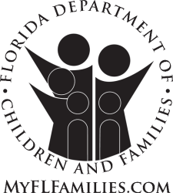

**Rick Scott**

*Governor*

**Mike Carroll**

*Secretary*

**Bob Quam**

*Chief Hospital Administrator*



Signature Authorization

Indigent Drug Program

Florida State Hospital

The following persons are authorized to submit drug orders to the Indigent Drug Program warehouse.

|  |  |  |  |
| --- | --- | --- | --- |
| **Name** | **Facility** | **Signature** | **Date** |
|  |  |  |  |
|  |  |  |  |
|  |  |  |  |
|  |  |  |  |

SIGNATURE OF APPROVAL: _____________________

TITLE: _____________________

DATE _____________________

(Needs to be approved by supervisor of highest-level employee listed above)

Florida State Hospital

100 North Main Street/POB 1000 🞄 Chattahoochee, Florida 32324-1000

Mission: Work in partnership with local communities to protect the vulnerable, promote strong and economically self-sufficient families, and advance personal and family recovery and resiliency

**If you require Americans with Disabilities Act accommodations to participate in an event at Florida State Hospital, please notify Human Resources at (850) 663-7585 at least seven (7) days prior to the event. Deaf or hard of hearing individuals may call 1-800-955-8771.



1. F ACCREDITED GOVERNOR’S STERLING AWARD RECIPIENT

**Appendix 2**

SUPPLY REQUISITION



**Appendix 3**

ISSUE DOCUMENT TO CONFIRM EXAMPLE

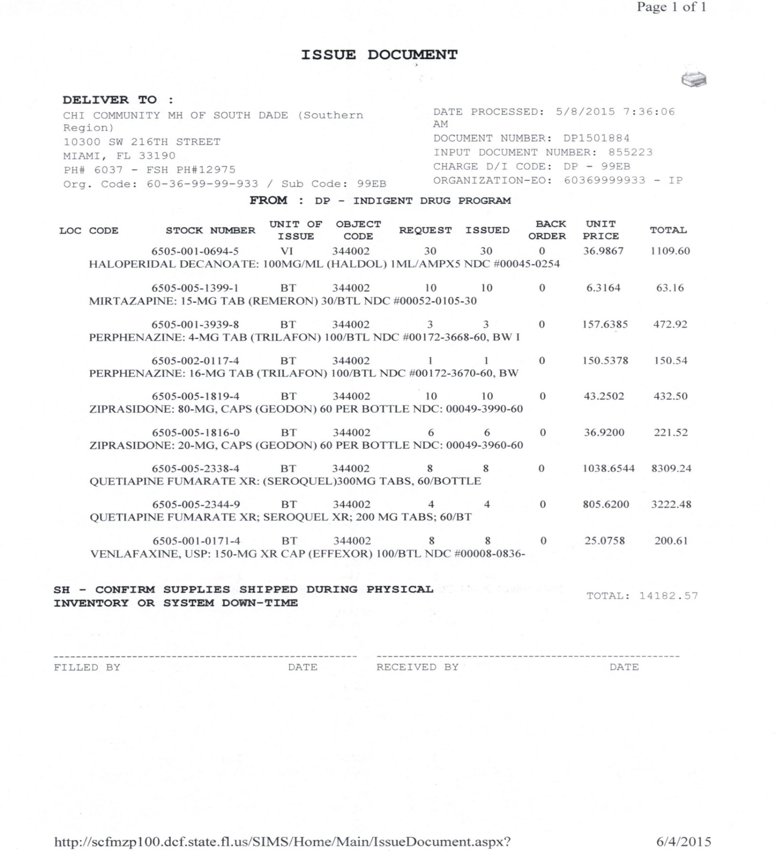

**Appendix 4**

ISSUE DOCUMENT TO REVERSE EXAMPLE

