Primary Prevention Guidelines

  - Primary Prevention Services
    - The Provider shall implement Primary Prevention Services in accordance with the Contract and Guidance 4 – Primary Prevention Guidelines.
    - The Provider shall maintain a half-time prevention designee to facilitate programming and coordinate primary prevention activities.
The provider shall have an employee that is designated half of their time to facilitate the tasks listed under C-1.2. Primary Prevention Services in contract. However, if the previous designee is no longer with the provider, the provider may appoint an interim designee or disperse tasks among other staff. In this instance, one staff person must be appointed designee to maintain the implementation plan and monitor task completion. This designated staff person must be funded in part by this contract.
Documentation:
How to document this in the Template 9- Primary Prevention Report:
This shall be documented in the Template 9-Primary Prevention Report under the section titled Outputs (Contracted Service Task) as Employed or Vacant.
There is no back up documentation required for this task.
    - Staff providing prevention services shall attend primary prevention orientation or other equivalent training as approved by the Department within 90 days of employment.
The primary prevention training is intended to orient new staff in the theory, provision, and skills necessary to plan, implement, and facilitate comprehensive prevention programming. This training can be a prevention training facilitated by the Department’s Technical Assistance and Training provider. The provider may also attend prevention training elsewhere; however, it must meet the previous listed intention and be approved by the Department.
This training should include an overview of primary prevention theory, risk and protective factors associated with intimate partner violence perpetration, social ecological model, current promising practices in primary prevention, and other essential skills to plan and implement primary prevention strategies and activities.
It is not necessary to have a longstanding employee to attend this training. This is only intended for newly hired prevention staff to attend this training within 90 days of their employment.
We have provided below link for the Departments Technical Assistance and Training provider for Domestic Violence Services:
- Florida Domestic Violence Collaborative
Documentation:
How to document this in the Template 9- Primary Prevention Report:
This shall be documented in the Template 9-Primary Prevention Report under the section titled Outputs (Contracted Service Task) as N/A or Completed. If completed, it should only be marked as completed in the month the task was completed. All other months should be N/A.
If the task is completed, the required documentation is a certificate of completion from the training this is due with that month’s reporting submitted to the contract manager.
    - Primary Prevention Implementation Plan
      - The Provider shall submit Template 4 – Prevention Implementation Plan which shall include prevention partners and Community Action Teams.
      - The Provider shall refer to prior year’s plans and completed deliverables to develop a meaningful plan that continues to prioritize prevention efforts critical in the efforts to end violence.
      - The Prevention Implementation Plan shall address risk/protective factors, root causes of domestic and dating violence, and activities that prioritize Community Action, Youth Engagement and Leadership, and Social Change efforts to end violence. Providers may also use findings from annual local fatality review or the annual statewide review to inform their prevention strategies and plan. A template with examples is available upon request.
Guidance regarding C-1.2.4. Primary Prevention Plan can be found in Template 4- Prevention Implementation Plan. Providers do not have to use the provided template but should provide a clear view of their plans for the year in the chosen format. Providers when submitting their plan should label their plans according to naming conventions as stated in contract i.e., Prevention Implementation Plan (Template 4). However, these plans should address the criteria and requirements in C-1.2.4.1, C-1.2.4.2, C-1.2.4.3. Fatality review data is not required for the plan. It is best practice to use data to inform prevention strategies and activities. Reviewing local and state fatality review data, while it is interventive, can give providers starting points to work backwards to finding the common risk and protective factors to prevent the violence specifically in their service provision area. For more information on the risk and protective factors associate with domestic violence please see VetoViolence | Resources for violence prevention (cdc.gov).
Documentation:
How to document this in the Template 9- Primary Prevention Report:
This shall be documented in the Template 9-Primary Prevention Report under the section titled Outputs (Contracted Service Task) as N/A or Completed. If completed, it should only be marked as completed in the month the task was completed. All other months should be N/A.
If the task is completed, the required documentation is the Template 4-Prevention Implementation Plan or if utilizing another plan format, please ensure that it is labeled as Template 4- Prevention Implementation Plan.
    - Community Action Team Meetings
Provider’s prevention staff shall attend Community Action Team meetings that include discussions, planning activities, or engagement of activities directly related to the community’s primary prevention programming. Community Action Teams may consist of all youth members, all adult members, or a combination of both. Community Action Teams may be a stand-alone team or a subcommittee of an existing Domestic Violence (DV)/Sexual Violence (SV) task force. If submitting as part of a larger task force, prevention activities must be listed on the agenda. If there are only intervention topics or activities, this will not count toward meeting the requirements. For documentation to be approved, the meeting or activity shall not be comprised solely of center staff. These meetings shall be ongoing and not one-off meetings. For example, if a provider were to attend three or four separate types of meetings in their area where prevention is on the agenda and submitted a different meeting per quarter, this would not be allowable. The purpose of this task is to establish one sustainable and consistent team that will drive and engage in prevention-related activities.
Documentation:
How to document this in the Template 9- Primary Prevention Report:
This shall be documented in the Template 9-Primary Prevention Report under the section titled Outputs (Contracted Service Task) as N/A or Completed. If completed, it should only be marked as completed in the month the task was completed. All other months should be N/A.
If the task is completed, the required documentation is a sign-in sheet and an agenda that includes all elements listed in C-2.10.5 of the contract.
    - Learning Calls
The Provider shall participate in quarterly learning calls. These calls will be coordinated by the Department or Department’s designated training and technical assistance provider.
These calls do not need to be called learning calls. In the past these have been called “Prevention Quarterly Call”, “Prevention Monthly Call”, and “Initiative - Primary Prevention Call.”
We have provided below link for the Departments Technical Assistance and Training provider for Domestic Violence Services:
- Florida Domestic Violence Collaborative
Documentation:
How to document this in the Template 9- Primary Prevention Report:
This shall be documented in the Template 9-Primary Prevention Report under the section titled Outputs (Contracted Service Task) as N/A or Completed. If completed, it should only be marked as completed in the month the task was completed. All other months should be N/A.
If the task is completed, the required documentation is a certificate of attendance or completion from the technical assistance and training provider. If a certificate is unattainable, an attestation signed by the staff’s supervisor shall suffice as back up documentation.
    - Prevention Survey
Provider’s prevention staff shall complete an online survey distributed during each fiscal year. These surveys are used to assess increases in capacity to provide primary prevention services. Links to the online survey will be sent out through the Contract Manager to the contact person included in Section 1.3.3. This individual shall ensure that the survey link is distributed to the Provider’s prevention staff. The survey shall be completed within 30 calendar days of distribution.
Documentation:
How to document this in the Template 9- Primary Prevention Report:
This shall be documented in the Template 9-Primary Prevention Report under the section titled Outputs (Contracted Service Task) as N/A or Completed. If completed, it should only be marked as completed in the month the task was completed. All other months should be N/A.
There is no back up documentation required for this task as the Department will log which provider has completed this task.
    - Primary Prevention Programming Series
      - The Provider shall offer prevention programming series with youth, parents, and/or other community members, consisting of at least six sessions with the same cohort.
      - The prevention programming series shall be focused on but not be limited to social-emotional learning programs for youth; safe, equitable, and respectful relationships; bystander empowerment; parenting skills and family enrichment programs; or men and boys’ programs. The Department must approve all other programming focuses.
      - Curriculum for the programming must be approved in writing by the Department. Changes to a previously approved curriculum shall be submitted for re-approval.
      - The Provider shall maintain a sign-in sheet that shows attendance for the series; No identifying information shall be required.
      - The Provider shall prepare group process notes upon completion for each session in the series.
This programming series can be completed with any demographic; however, the programming must address the reduction of risk factors associated with domestic violence and increase protective factors.

For the risk and protective factors associated with domestic violence see VetoViolence | Resources for violence prevention (cdc.gov).

Any curriculum or programming to be facilitated must be submitted to the providers contract manager and approved by the Department.

Sign-in sheets and process notes can be of the provider’s design. Additionally, as per contract for performance measure E-1.2.1 the primary prevention programming shall need either a satisfaction survey, retrospective survey, post-test, or other documented means developed by the provider. These evaluation tools may be anything the provider uses to measure the increase of positive change in attitudes and beliefs at the completion of programming. If the provider should need assistance in developing these tools, the Department encourages the provider to utilize the technical assistance and training provider for domestic violence services.

We have provided below link for the Departments TA and Training provider for Domestic Violence Services:
- Florida Domestic Violence Collaborative
Documentation:
How to document this in the Template 9- Primary Prevention Report:
This shall be documented in the Template 9-Primary Prevention Report under the section titled Outputs (Contracted Service Task) as N/A or Completed. If completed, it should only be marked as completed in the month the task was completed. All other months should be N/A.
Additionally, this task is to be documented in the Performance Measure of the Template 9- Primary Prevention Report:
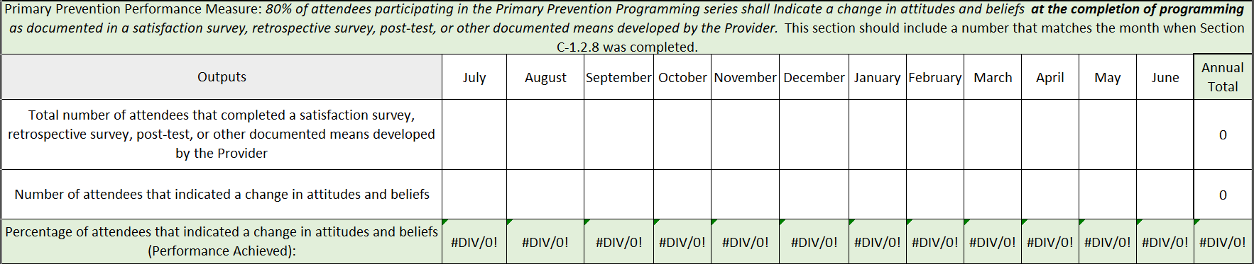
Once the task is marked completed in the Outputs (Contracted Service Task) in C-1.2.8, there must be a number in the same month. The number comes from the evaluation tools developed by the provider. The report will not be accepted if one section is marked complete or has a number and the other section is N/A or 0’s. These are the only two sections of the report if one is complete the other must have an entry. These are also to be marked complete at a series completion.
If the task is completed, the required documentation is a sign-in sheet that shows attendance for the series (no identifying information shall be required) and group process notes upon completion for each session in the series.
    - Community Prevention Training
The Provider may offer training or coordinate training for staff of community agency(ies) on primary prevention and how it relates to their work. The community agency(ies) can be a member of the Community Action Team or can be part of a larger training on domestic violence intervention, but prevention must be a substantial component. This can include, education and higher education, healthcare settings, service agencies, law enforcement, community businesses, and others. This is not an exhaustive list and if a provider has any questions, please reach out to the contract manager. This training must be approved by the Department prior to facilitation. This training and all associated materials must be submitted to the providers contract manager for review and approval no more than 30 days prior to facilitation.
Documentation:
How to document this in the Template 9- Primary Prevention Report:
This shall be documented in the Template 9-Primary Prevention Report under the section titled Outputs (Contracted Service Task) as N/A or Completed. If completed, it should only be marked as completed in the month the task was completed. All other months should be N/A.
If the task is completed, the required documentation is a sign-in sheet and an agenda that includes all elements listed in C-2.10.5 of the contract.
    - County Organization Meeting
The Provider shall coordinate and participate in at least one meeting each fiscal year with another entity that adds value to the work of the Provider at a county level. The purpose of this meeting must include, the Provider’s prevention strategy, incorporating prevention into the other agency’s work, and prevention or partnership opportunities.
Documentation:
How to document this in the Template 9- Primary Prevention Report:
This shall be documented in the Template 9-Primary Prevention Report under the section titled Outputs (Contracted Service Task) as N/A or Completed. If completed, it should only be marked as completed in the month the task was completed. All other months should be N/A.
If the task is completed, the required documentation is a sign-in sheet and an agenda that includes all elements listed in C-2.10.5 of the contract.
  - Primary Prevention Services
    - A minimum of 80% of attendees participating in the Primary Prevention Programming series shall Indicate a change in attitudes and beliefs at the completion of programming as documented in a satisfaction survey, retrospective survey, post-test, or other documented means developed by the Provider.
This performance measure is based on the C-1.2.8 task in Standard Contract Part 2 under Exhibit C. the primary prevention programming shall need either a satisfaction survey, retrospective survey, post-test, or other documented means developed by the provider. These evaluation tools may be anything the provider uses to measure the increase of positive change in attitudes and beliefs at the completion of programming. If the provider should need assistance in developing these tools, the Department encourages the provider to utilize the technical assistance and training provider for domestic violence services. We have provided below link for the Departments TA and Training provider for Domestic Violence Services:
- Florida Domestic Violence Collaborative
Documentation:
How to document this in the Template 9- Primary Prevention Report:
This shall be documented in the Template 9-Primary Prevention Report under the section titled Outputs (Contracted Service Task) as N/A or Completed. If completed, it should only be marked as completed in the month the task was completed. All other months should be N/A.
Additionally, this task is to be documented in the Performance Measure of the Template 9- Primary Prevention Report:
Once the task is marked completed in the Outputs (Contracted Service Task) in C-1.2.8, there must be a number in the same month. The number comes from the evaluation tools developed by the provider. The report will not be accepted if one section is marked complete or has a number and the other section is N/A or 0’s. These are the only two sections of the report if one is complete the other must have an entry. These are also to be marked complete at a series completion.
If the task is completed, the required documentation is a sign-in sheet that shows attendance for the series (no identifying information shall be required) and group process notes upon completion for each session in the series.
Reporting Schedule: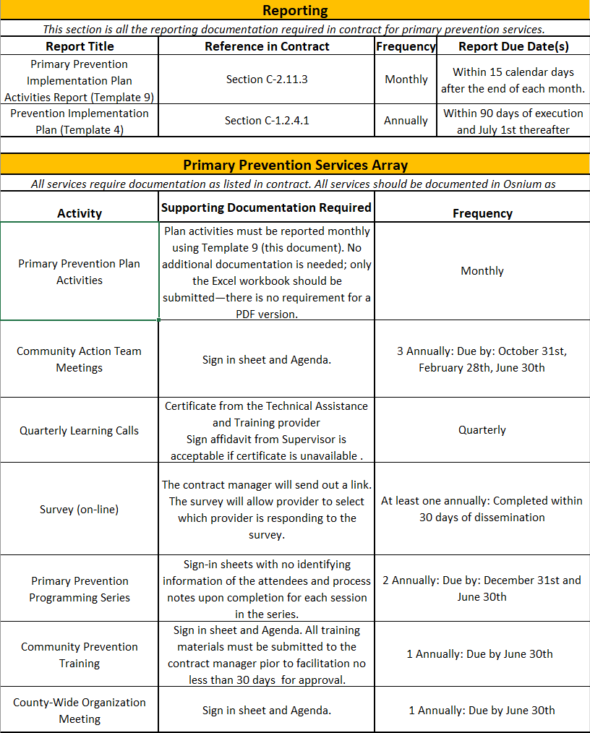

Template 9-Primary Prevention Report Guidance:
In the Activities Section of the report, all activities reported to be completed in Template 4- Prevention Implementation Plan should be reported in this section. Template 4- Prevention Implementation Plan, as submitted, has separate sections and guidance on what activities would be reportable in the respective sections. Below is guidance and some examples of what activities are reportable in each section.
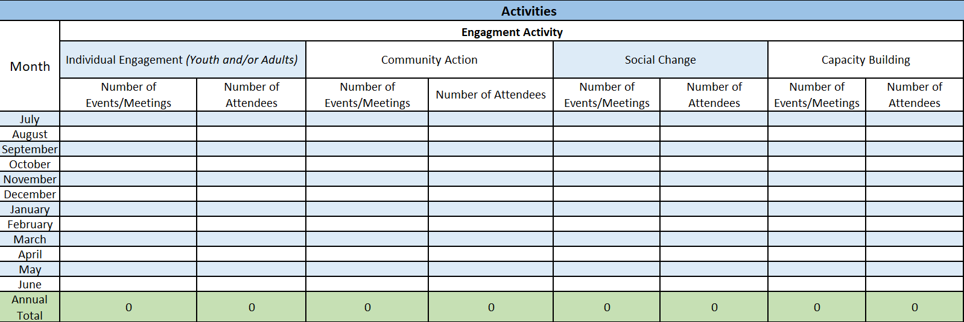
For Individual Engagement, this may include:
- Facilitating educational programs and workshops to understand the dynamics of intimate partner violence (IPV).
- Recognizing early warning signs and learning about healthy relationship practices.
- Developing and practicing skills such as effective communication, conflict resolution, and emotional regulation to foster healthy relationships.
- Teaching and modeling these skills to young people and children.
- Providing financial education and access.
- Involving young people in prevention efforts through education, leadership opportunities, and peer mentoring programs.
- Educating and building care givers and caring adults’ capacity to have conversations around relationships and engaging in protective factors.

This is not an exhaustive list of all activities that can be included under this section. Any activity that aligns with working at the individual level of the socioecological model, as listed in Template 4-Prevention Implementation Plan, can be documented here. Furthermore, all sessions of the Primary Prevention Programming for Task C-1.2.8 should also be documented in this section. For example: If you provide 4 sessions of a 6-session series in the month being reported, the number of activities is 4 and the total attendance is the number of people in each session added together for a total.
Community Action involves coordinated efforts by community members, organizations, and stakeholders to prevent intimate partner violence (IPV). This includes:
- Forming alliances with local organizations, schools, healthcare providers, and law enforcement to create a unified approach to IPV prevention.
- Distributing resources such as educational materials, support services, and helplines to ensure community members have access to necessary information and assistance.
- Conducting workshops, seminars, and training sessions to educate the community on healthy relationships, conflict resolution, and bystander intervention.
- Organizing events such as forums to engage the community in discussions and actions against IPV.

This is not an exhaustive list of all activities that can be included under this section. Any activity that aligns with working at the relational and community levels of the socioecological model, as listed in Template 4-Prevention Implementation Plan, can be documented here. Furthermore, Task C-1.2.5 and Task C-1.2.10 should also be documented in this section. For example, Community Action Team Meetings and attendees can be counted in this section.
Social change activities refer to collective efforts aimed at transforming societal norms, attitudes, and behaviors to prevent intimate partner violence (IPV) before it occurs. These activities include:
- Public Awareness Campaigns: Initiating and participating in campaigns to educate the public about IPV, its signs, and prevention strategies. The number of campaigns or individual posts can be counted as an event and the reach can be counted as attendees.
- Advocacy and Policy Change: Working to influence policies and legislation that support IPV prevention and protect survivors. Any meetings had with individuals or work towards this can be counted towards
- Community Education: Providing educational programs and workshops to promote healthy relationships and challenge harmful norms and behaviors.
- Media Engagement: Utilizing media platforms to spread awareness and promote positive messages about IPV prevention.
- Support for Survivors: Creating and promoting resources and support systems for IPV survivors to ensure their safety and well-being.

This is not an exhaustive list of all activities that can be included under this section. Any activity that aligns with working at the societal level of the socioecological model, as listed in Template 4-Prevention Implementation Plan, can be documented here. For Example: training for faith leaders, business owners, and/or neighborhood leaders on recognizing and responding to domestic violence and promoting collaborative relationships and respect.
Capacity building activities refer to efforts aimed at enhancing the skills, resources, and abilities of individuals, organizations, and communities to effectively prevent intimate partner violence (IPV). These activities include:
- Providing training programs and workshops to increase knowledge and skills related to IPV prevention, including recognizing signs of IPV, understanding its dynamics, and learning intervention strategies.
- Creating and distributing educational materials, toolkits, and guidelines to support IPV prevention efforts.
- Assisting organizations in developing policies, procedures, and infrastructure to better address IPV prevention and support survivors.
- Identifying and nurturing leaders within the community who can advocate for IPV prevention and drive change.
- Facilitating connections and partnerships among organizations, stakeholders, and community members to share resources, knowledge, and best practices.
- Offering expert support and consultation to organizations and individuals working on IPV prevention initiatives.
- Conducting evaluations and assessments to measure the effectiveness of IPV prevention programs and identify areas for improvement.

This is not an exhaustive list of all activities that can be included under this section. Any activity that aligns with building capacity, whether internally or within the community, to participate in and accomplish intimate partner violence prevention, as outlined in Template 4-Prevention Implementation Plan, can be documented here. For Example: A training series to strengthen the ability of local organizations, leaders, and service providers to prevent intimate partner violence (IPV) and support survivors. Additionally, creating a toolkit that has educational materials, referral guides, and policy templates to support implementation in their settings.

