CORE Media Directory

Module | Activity / Unit | Media
Orientation |  | Secretary’s Welcome and Message  Available via The Center’s secure site:    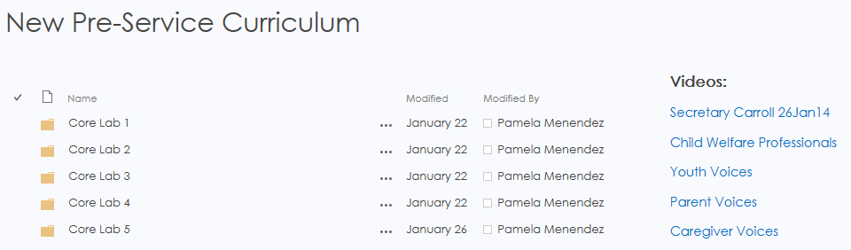
Orphan Train
http://www.youtube.com/watch?v=cWTTcNBfaRw

Module 2 | Slide 3.1.5 | Science of Early Childhood Development  http://developingchild.harvard.edu/index.php/resources/multimedia/videos/inbrief_series/inbrief_science_of_ecd/
Impact of Neglect on Child Development
http://developingchild.harvard.edu/resources/multimedia/videos/inbrief_series/inbrief_neglect/

Module 5 | Unit 5.3 | The following are video options to use during training.  https://www.youtube.com/watch?v=R3tpOXNNMTc  Rethinking Mental Illness  https://www.youtube.com/watch?v=V0V0WX55t_I  The Other Side  https://www.youtube.com/watch?v=54sDdNa9vek  Mental Illness: What You See/What You Don’t  https://www.youtube.com/watch?v=bOPgdNRjS1g  Jordana Steinberg: Living with Mental Illness
 | Unit 5.4 | Hard Times Generation, 60 Minutes  https://www.youtube.com/watch?v=ZZj3hr0OZzw
Module 6 | Slide 6.2.6 | Safe Sleeping  https://www.youtube.com/watch?v=0zoQ7n3omqQ
This is a shorter (3:21), local Florida video. Six years ago, Sherkendra's daughter died while they were co-sleeping in an adult bed. Her baby was just 6 weeks old. Sherkendra's story is powerful.

https://www.youtube.com/watch?v=Jv_ecuxcSmo&feature=youtu.be
 | Unit 6.6 | OxyContin Express  https://www.youtube.com/watch?v=wGZEvXNqzkM
 | Unit 6.7 | Here are a list of YouTube videos that you can use during the unit.  http://www.youtube.com/watch?v=A-luJWp2_SI  (PSA showing violence)  http://www.youtube.com/watch?v=G_ht2vAYPoc  (911 call by a child during a domestic violence incident)  http://www.youtube.com/watch?v=WL3rfk2iFww  (PSA showing woman with injuries)
 | Unit 6.7 | Recording of a 911 call - a phone call to police with a 6-year-old girl named Lisa calling with panic in her voice about her mommy and the baby getting hurt.  http://www.youtube.com/watch?v=G_ht2vAYPoc

Core Lab 1 | Act. 2 | Listening to Youth and Listening to Parents  Available via The Center’s secure site:
 | Act. 3 | Observing the Interview - Worker A & B  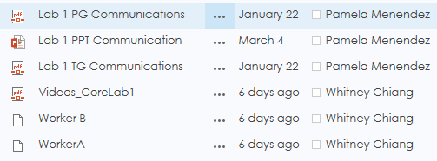
 | Act. 4 | “Empathy”  https://www.youtube.com/watch?v=1Evwgu369Jw
 | Act. 6 | Etiquette for Using Interpreters by NJ Legal Services  http://www.youtube.com/watch?v=pVm27HLLiiQ
 | Act. 8 | Active Listening Skills by Tom Peters  https://www.youtube.com/watch?v=IwB7NAvKPeo
Core Lab 2 | Act. 7 (slide 2.3.6) | Building Rapport – Worker A & B  (Audio only, no video. Need to change module.)  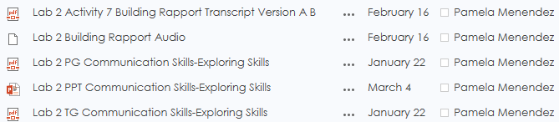
Core Lab 3 | Act. 1 | Observation of Summarization with Foster Parent  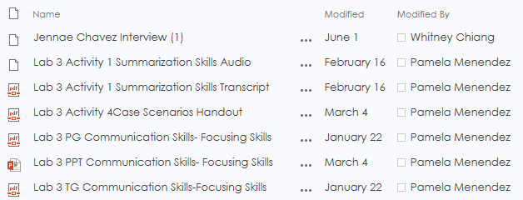
 | Act. 2 | Interview – Jennae Chavez  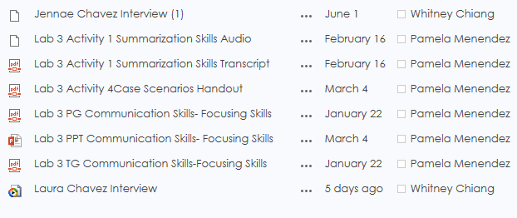
 | Act. 3 | Interview – Laura Chavez
Core Lab 4 | Act. 1 | Ten Step Investigative Interview – Part 1  https://www.youtube.com/watch?v=7my1T4Ghf7A
 | Act. 2 | Ten Step Investigative Interview – Part 2  www.youtube.com/watch?v=7my1T4Ghf7A
 | Act. 4 | Ten Step Investigative Interview – Part 3  https://www.youtube.com/watch?v=7my1T4Ghf7A
Core Lab 5 | Act. 1 | Neen Video  https://vimeo.com/15851924
 | Act. 4 | Interview Planning and Closing  Located on The Center’s secure trainers site:  