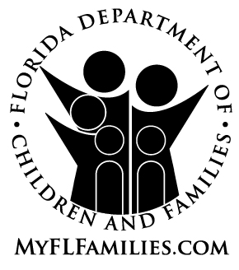 | State of Florida  Department of Children and Families | Ron DeSantis  Governor  Shevaun Harris  Secretary

Date:

To: Florida Public State University, Public Florida College System Institution, or
Public Postsecondary Career and Technical Program

From: , Department of Children and Families
or Community Based Care Lead Agency

Title:

Subject: Tuition and Fee Exemption for Students Receiving or Formerly Receiving Services from the Department of Children and Families

Please accept this letter certifying that (name), whose date of birth is __________________, meets one of the following criteria necessary to obtain exemption from paying tuition and fees at a Florida public state university, public Florida College System institution or public postsecondary career and technical program, pursuant to the “Florida K-20 Education Code,” Section 1009.25(1)(c)-(d), Florida Statutes (check one):

He or she is or was at the time he or she reached age 18 in the custody of the Department of Children and Families;
He or she was adopted from the Department of Children and Families after May 5, 1997;
He or she is or was at the time of reaching age 18 in the custody of a relative under s. 39.5085, F.S.;
He or she is or was at the time of reaching age 18 in the custody of a non-relative under s. 39.5085, F.S.;
He or she is or was at the time of reaching age 18 in the custody of a guardian under s. 39.6225, F.S.; or,
He or she was placed in a guardianship by the court after spending at least 6 months in the custody of the department after reaching 16 years of age.

The tuition and fee exemption CANNOT be used at an out-of-state educational institution or in-state private university, private community college or private postsecondary career and technical program. Please contact the financial aid office at the school to determine whether alternative tuition and fee exemptions or scholarships are available through the school.

Effective July 1, 2010¹, this exemption remains valid until the young person reaches the age 28, which will occur on .
(MM/DD/YYYY)

Please contact , Florida Department of Children and Families or Community Based Care Lead Agency at to verify information contained in this form or for additional information.

___________________________________________ _________________
Signature of Community-Based Care Lead Agency Representative Date Signed

¹ Please note: If you are receiving this form when leaving the custody of DCF but are not ready to use the exemption at this time, you will need to read Section 1009.25(1)(c), F.S., to ensure that the statute still provides the tuition and fee exemption for former foster youth in the category in which you qualify. Florida laws may change from year to year.

