Title IV-E Eligibility

Workshop

Session B Guide

October 2019

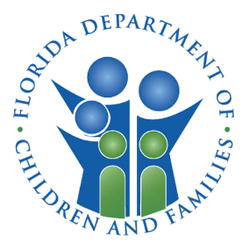
Contents
Session B Objectives 5
Initial Title IV-E Eligibility Determination 6
Removal Types and Removal Episodes 6
Removal Types 6
Removal Episode 6
Removal Home 7
Date AFDC Applies 7
Assistance Group vs. Standard Filing Unit 9
Assistance Group (AG) 9
Standard Filing Unit (SFU) 9
Assistance Group Diagrams 10
Basic Tab 13
FSFN - Removal from Home Information and Removal Home Address 14
FSFN – AFDC Information 15
Initial Determination 20
Initial Determination Tab 20
Eligibility Information 21
Question 1 to Question 4 22
Question 6A to Question 6B 24
Question 7 to Question 8 28
Question 7 – Income 29
Question 8 – Assets 36
Placements in the Current Removal Episode 38
Question 9 and AFDC Criteria 38
Ongoing IV-E Eligibility (Redetermination) 40
Annual Judicial Finding 41
Changes to Child’s Circumstances 41
FSFN Documentation 42
Redetermination Logic Changes 43
Extended Foster Care (EFC) 44
EFC Eligibility Overview 44
EFC Program Entry 45
EFC Program Funding 45
Title IV-E EFC Eligibility Determination 46
FSFN – Title IV-E EFC Eligibility Questions 49
Title IV-E EFC Ongoing Eligibility 51
IV-E EFC Discharge 52
FSFN Documentation 52
Maintenance Adoption Subsidy (MAS) and Extended MAS (EMAS) 55
Title IV-E MAS 55
Applicable Child 57
Non-Applicable Child 57
MAS Termination Reasons 57
Adoption Eligibility Record Creation 57
FSFN - Adoption Eligibility 58
Adoption Eligibility Page Changes 60
Private Adoption Changes 62
MAS Termination Reasons 63
Adoption Subsidy Agreement 64
Adoption Subsidy Agreement Page 64
Adoption Subsidy Agreement Page Changes 65
EMAS Special Populations 67
EMAS Termination Reasons 68
Medicaid Summary 69
Reports 71

Session B Objectives
After this session, you will be able to:
- Determine Title IV-E Foster Care and Extended Foster Care eligibility based on the given data for different scenarios.
- Explain the process to document private adoption and associated eligibility determination.
- Identify Title IV-E Maintenance Adoption Agreement and Extended Maintenance Adoption Subsidy changes in FSFN.
- Validate Medicaid for each case.
- Utilize the Eligibility Exception and Title IV-E Determination Due reports.
- Apply IV-E foster care FSFN changes.
- Apply data entry for different scenarios.

Initial Title IV-E Eligibility Determination
All children removed and placed in out of home care, regardless of placement setting, must have a Title IV-E Eligibility Determination approved in FSFN within 30 calendar days of entry into out of home care.
FSFN will auto-generate a Title IV-E Eligibility Determination upon the:
- Approval of an Out of Home Placement or
- Creation of a Private Adoption Page.

Removal Types and Removal Episodes

Removal Types
The child's removal may be considered a physical or constructive removal pursuant to a court order or a voluntary placement agreement.
- Physical Removal occurs when the child is taken from the removal home or the person subject to the contrary to welfare finding leaves the home at the time of the court order.
- Constructive Removal occurs when the child is living with a person other than the subject of the contrary to welfare finding at the time the court order (or voluntary placement agreement) authorizes the removal of the child.
- The child may or may not remain in the same home at the time of the action.
- The child must have lived with the subject of the contrary to welfare finding within six calendar months of the initiation of court proceedings (or execution of the voluntary placement agreement).

Removal Episode
Removal Episode refers to the period of time that begins with the child’s removal (physically, judicially, or voluntarily) and includes one or more subsequent placements in out of home care settings. A removal episode ends when a child is:
- Reunified with his or her parent(s); this does not include a child who is returned for a trial home visit; or,
- Legally adopted (finalized); or,
- Permanently placed in the home of a relative or non-relative and the Department and court involvement ceases, (i.e., permanent guardianship); or,
- Emancipated; or,
- Legally married with no annulment of the marriage; or,
- Aged out of care between the ages of 18 and 21, if child was in the legal custody of the Department at age 18 and opted out of Extended Foster Care (EFC).

Removal Home
The removal home is the home of the subject of the contrary to welfare finding (or who executed a voluntary placement agreement) and is used in evaluating the AFDC requirements as part of the Title IV-E eligibility determination. A removal may be from a variety of situations and still qualify for Title IV-E, including, for example:
- A hospital, following either birth, an illness, or injury
- A homeless shelter
- A car or other vehicle
- A tent or other temporary shelter

Date AFDC Applies
For court-ordered removals, FSFN requires the user populate the Date AFDC Applies to the auto-generated Title IV-E Eligibility Determination upon saving the page for the first time. Prior to working through an initial determination:
- Click the Legal Select hyperlink on the Initial Determination tab to launch the Legal Select Pop-up page.
- Select the Legal Action or Legal Document that represents when court proceedings were initiated and return to the Title IV-E Eligibility Determination page.
- The date court proceedings were initiated is the date the petition/motion is filed with the court. If a petition was not filed or filed after the removal order, then the date used is the effective date of the order.
- FSFN will provide a link to the selected legal action/legal document and pre-fill the Date AFDC Applies with the Order/Completed Date.
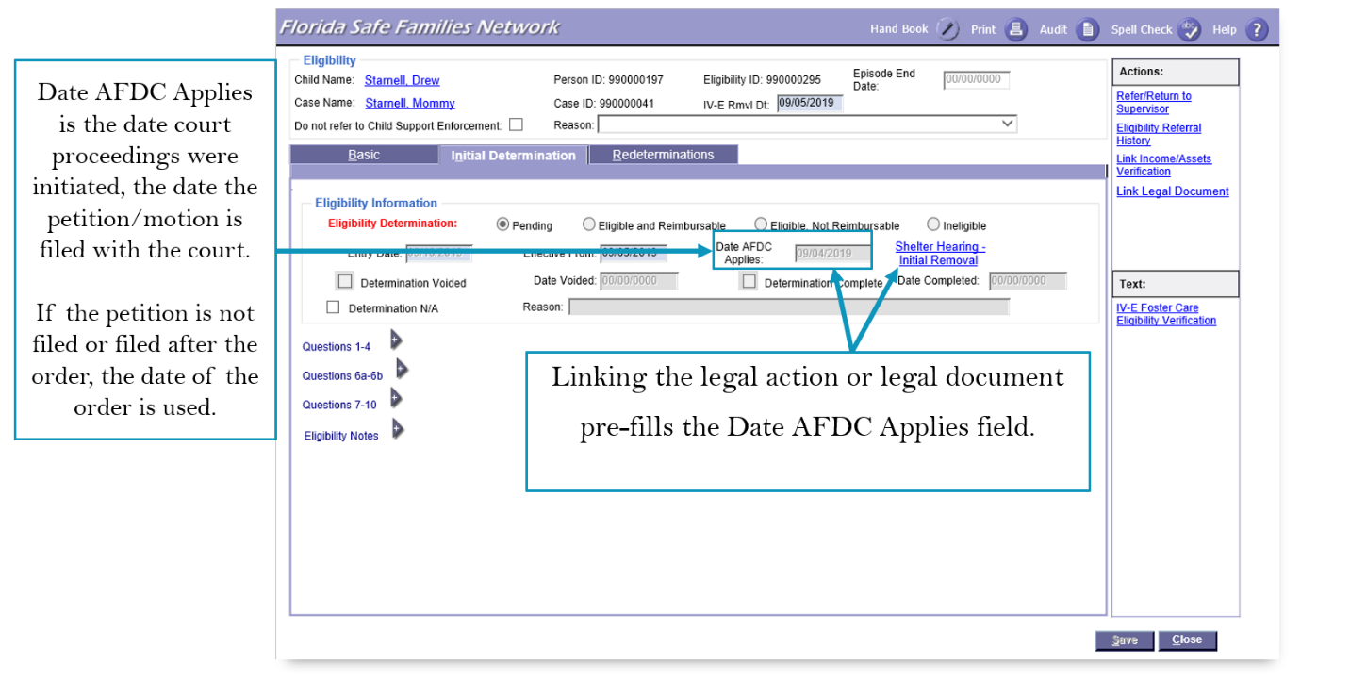
- Save the Title IV-E Eligibility Determination page to continue working through the determination.

Assistance Group vs. Standard Filing Unit
Revenue maximization staff use the facts of the removal home to enter data in FSFN, which will determine if the child would have been eligible to receive AFDC under rules in effect on July 16, 1996. The child must meet both the AFDC technical and financial requirements based on the Assistance Group (AG) and Standard Filing Unit (SFU).

Assistance Group (AG)
The Assistance Group (AG) includes individuals of parent or sibling relation to the child in which eligibility is being determined who resided in the removal home. Assistance Group members can be:
- Child
- Siblings (as long as they meet AFDC requirements)
- Parents
- Parent of a half-sibling and any other children of this parent (when mutual AFDC child lives in home)
- Stepparents (when mutual AFDC child lives in home)

Standard Filing Unit (SFU)
The Standard Filing Unit (SFU) is all individuals from the Assistance Group whose income and/or assets and needs are considered in the determination of eligibility. The SFU establishes the family size in which the CNS is applied and is comprised of the persons in the Assistance Group (AG) unless excluded by on the of the following:
- Siblings who do not meet AFDC requirements
- SSI recipient
- Adoption Subsidy recipient (child)
- Alien – Non-Qualified Non-Citizen
- Alien – Qualified Non-Citizen who entered the Country within the past 5 years and not from Haiti or Cuba

Assistance Group Diagrams
A series of scenarios and diagrams to help determine a child’s Assistance Group are shown below:

Basic Tab
The Basic tab consists of:
- Demographic Information – lists the Child's demographic information from the Person Management record.
- Removal from Home Information – lists the type of removal along with the Name and Relationship of the individual(s) from whom the child was removed.
- Removal Home Address – pre-fills with the Primary Caregiver’s Primary Residence address that was in effect at the time of removal.
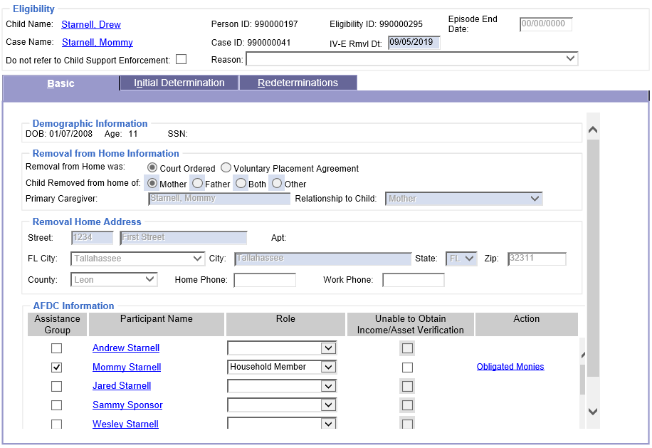
- AFDC Information – allows the user to identify the Assistance Group, access the Asset and Employment page, establish roles, document Care Expenses and Obligated Monies, and indicate if Income/Asset Verification is unable to be obtained. This section drives the inputs into the income and asset calculations.

FSFN - Removal from Home Information and Removal Home Address
- Removal from Home was – indicates whether the removal was Court Ordered or through a Voluntary Placement Agreement.
- System derived as the Manner of Removal from the child’s current Out of Home Placement page.
- FSFN will indicate Court Ordered if the Manner of Removal is Temporary Physical Custody or the Title IV-E Eligibility was created as part of the Private Adoption process.
- Child Removed from home of – Generally system derived based on the Primary and Secondary Caregivers documented on the child's current Out of Home Placement page and corresponding relationships from the Maintain Case page. FSFN selects one of the following based on the relationship values:
- Mother if relationship is Mother, Mother – Adoptive, Mother – Birth, or Mother – Step.
- Father if relationship is Father, Father – Adoptive, Father – Birth, Father – Step, Father – Legal, or Father – Prospective.
- Both if the Primary Caregiver is Mother and the Secondary Caregiver is Father, or vice versa.
- Other for any other relationship value.
- If the Title IV-E Eligibility page is created as part of the Private Adoption process, the field defaults to Mother.
- Primary Caregiver – System derived from the Primary Caregiver documented on the child's current Out of Home Placement page.
- Relationship to Child – If Mother or Father, system derived based on the Primary and Secondary Caregivers documented on the child's current Out of Home Placement page and corresponding relationships from the Maintain Case page. FSFN selects one of the following based on the relationship values:
- Mother if relationship is Mother, Mother – Adoptive, Mother – Birth, or Mother – Step.
- Father if relationship is Father, Father – Adoptive, Father – Birth, Father – Step, Father – Legal, or Father – Prospective.
- If the Primary Caregiver is not Mother or Father, the user is required to select the appropriate relationship from the drop down.

FSFN – AFDC Information

Assistance Group
- There is a check box to allow case participants to be included in the Assistance Group/ Standard Filing Unit Information on the Initial Determination tab.
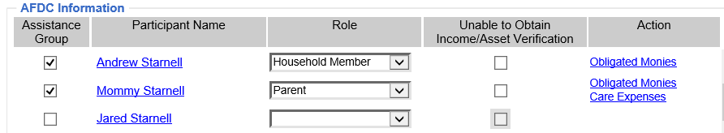

Roles
- This functionality allows the user to identify the Role of each case participant. Selecting a Role is required once the participant is included in the Assistance Group.
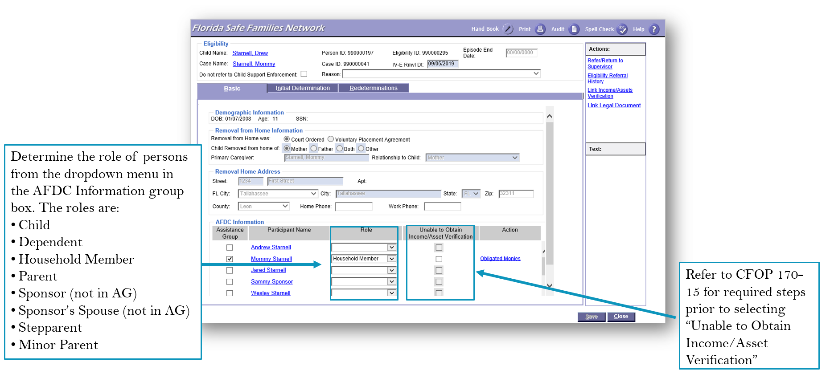
The available Roles values are:
Role | Display Logic | Additional Rules
Child | Defaults for the child for whom eligibility is being determined.
Dependent | Available for all case participants.
Household Member | Available for all case participants. | Only used for Grandparents, Parent of Mutual Sibling(s)
Parent | Available if the participant is identified as Mother or Father on the Relationship tab of the Case. | Maximum of 2 participants can be identified as Parent.
Sponsor | Available  only for a Case Participant not selected in the Assistance Group when another Case Participant has a Role of:  - Parent,  - Minor Parent, or  - Stepparent  and this parent is defined as an Alien.  An Alien is a Non-Qualified, Non-Citizen, or Qualified Non-Citizen if Entry Date on Person Management is less than 5 years prior to the AFDC Month.  Sponsor will only be available if the time frame is less than 3 years from the Entry Date. | Maximum of 1 participant can be identified as Sponsor.
Sponsor’s Spouse | Only available if another participant has Sponsor selected and the check box is not selected.
Stepparent | Available if the participant is identified as Stepmother or Stepfather on the Relationship tab of the Case. | Maximum of 2 participants can be identified as Step-Parent.
Minor Parent | Available if the participant is identified as Mother or Father (on the Relationship tab of the Case) and is under the age of 18 as of the AFDC Month/Day/Year.

Unable to Obtain Income/Asset Verification
Allows documentation of the inability to verify income/assets for one or more Assistance Group members. Selecting the check box sets the AFDC question on the Initial Tab to No and the child will be Ineligible.
- Prior to utilizing the Unable to Obtain Income/Asset Verification functionality staff must document the following methods, at a minimum, have been tried:
- Seek self-declaration from the income/asset holder.
- Review of FLORIDA system.
- Review of SunTax system.
- Review of Family Functionality Assessment (FFA).
- Review of Investigative TANF.
- Review of court indigency form.
- Review of FSFN Narratives from contacts with income/asset holder.

Obligated Monies
Obligated Monies is only used for Applied Income logic. A pop-up page allows for documentation of any monetary obligations those in the Role of Parent, Stepparent, Sponsor or Sponsor's Spouse or have relative to non-assistance group members.
NOTE: Don’t duplicate dependents between Adults/Parents.

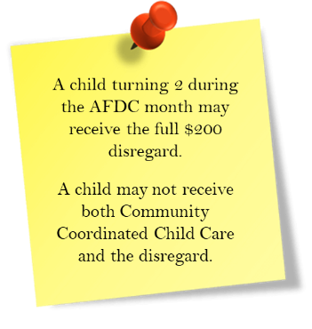
Care Expenses
Care Expenses Disregard is a deduction up to $200 per child under the age of two or up to $175 per child age 2 or older. To qualify,
- Care must be necessary for the parent to maintain employment.
- The child in need of care must be under age 13, or physically or mentally incapable of caring for himself, or be under court supervision and in the assistance group.
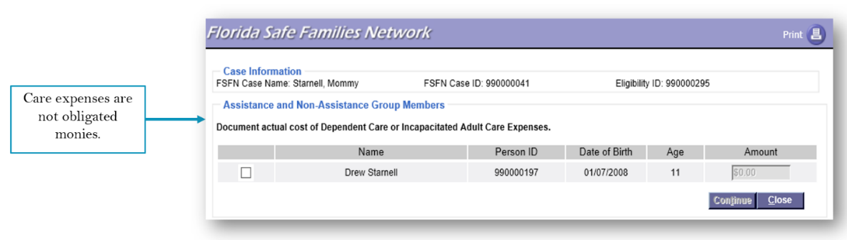
The cost each employed full-time parent incurs per child up to applicable limits. The cost must be necessary for the parent to maintain employment (more detail in Care Expenses Disregards). A pop-up page allows for documentation of care expenses for those in the Role of Parent, Minor Parent, or Stepparent.

Verify Assets and Income
Assets and Employment documentation is an integral part of the Title IV-E Eligibility Determination process.
- The information captured on the Assets and Employment page is used to calculate the child’s eligibility for IV-E Foster Care, Young Adult Program Eligibility, TANF, Adoption TANF, and Medicaid.
- The information is also provided to Child in Care workers via the FLORIDA Interface to assist in determining Medicaid Eligibility.

- The Link Income/Assets Verification hyperlink launches the Income and Assets Select Pop-up page when clicked. Once the Initial Determination is complete, the hyperlink becomes the View Linked Income/Assets Verification, which will launch the pop-up page in view only mode.
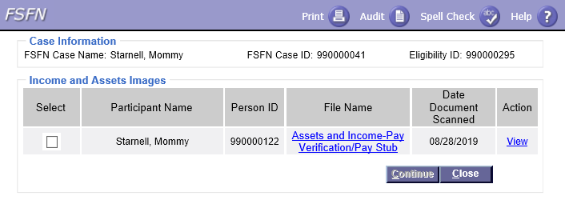
- Documents must be uploaded and linked.
Select to link to the document
Click the hyperlink to view the document

Initial Determination

Initial Determination Tab
The Initial Determination Tab dynamically changes to display the applicable questions when the Manner of Removal is Court Ordered or Temporary Custody versus Voluntary. The page defaults based on the current information in FSFN and refreshes each time the page is launched, or when returning from a pop-up page, while the Initial Determination is Pending.
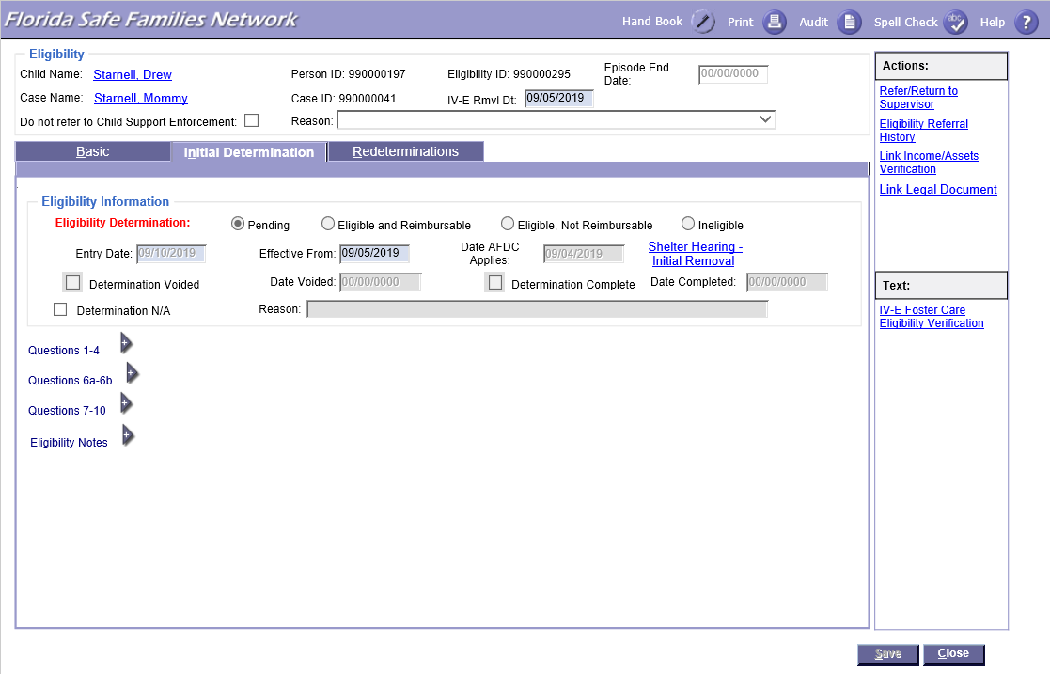

Eligibility Information
The Eligibility Information group box displays the following:
- The child’s Eligibility Determination as
- Eligible and Reimbursable
- Eligible, Not Reimbursable
- Ineligible
- Pending
- A check box that shows if the determination has been completed.
- A check box that shows if the determination has been voided and a system derived date when the Initial Determination is voided.
- Four date fields:
- Effective From Date – The beginning date for the eligibility status. The date is system-defaulted from the placement begin date of the first licensed placement. If the child is placed in one calendar month and the contrary to welfare judicial finding obtained the next month, the Effective From date is the date is the date the contrary to welfare language is received.
- Entry Date – The system date when the eligibility information is initially entered. The date is system defaulted from the first time the Save button is selected.
- Date AFDC Applies – Pre-fills with the Order/Completed Date of the Legal Action or Legal Document linked from the Legal Select pop-up page while the Initial Determination is Pending.
- Date Completed – The system date when the initial determination is completed (approved). The date is system defaulted from the date Complete Determination is selected.

Question 1 to Question 4
Question 1: System derived from a comparison of the Date AFDC Applies to the child’s date of birth.

Question 2B: System derived from the child’s citizenship status from the Person Management page.

Question 3A

- User selected based on the content of the removal order or transcript.
- If yes, a Select Legal Document hyperlink appears to identify and link the order. The order must be linked to submit the eligibility determination for approval.

Question 3B: User selected based on the content of the removal order or transcript.

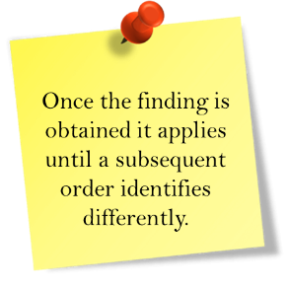
Question 3C: User selected based on the content of the removal order or transcript.

Question 4: Question 4 has new logic and system validation related to the requirement that reasonable efforts to prevent removal must be obtained within 60 days of the removal date.
- A radio button is added to Question 4 to indicate it has been less than 60 days since the child’s removal.
- The responses to this question are only available if the answer to Question 3B is No.
- A Yes response to Question 4 displays a required date field. In addition, a Select Legal Document hyperlink will be displayed as the order containing the required language must be linked.
- Cannot approve/complete when Less than 60 Days is selected.

Question 6A to Question 6B
Questions 6A and 6B test whether the child’s removal home is that of a specified relative and whether deprivation exists.

Specified Relative
The child must have been living with and removed from the home (removal home) of a Specified Relative. The definition includes any relative by blood (including half-blood), marriage, or adoption within the fifth degree of kinship to the child even if the marriage was terminated by death or divorce.
- Specified Relative is determined by the subject of the contrary to welfare judicial finding.
- Removal Home is the home of the specified relative who is the subject of the contrary to welfare judicial finding.
- The legal father supersedes the birth father.

Specified Degree of Relationship
The following relatives meet the specified degree of relationship for a specified relative:
- First degree: Parent (adoptive, legal, or biological) or stepparent. NOTE: The parent of a stepparent is not a specified relative
- Second degree: Sibling and grandparent, or stepsibling
- Third degree: Great-grandparent, aunt, uncle, niece, or nephew
- Fourth degree: Great-great grandparent, great-aunt, great-uncle, or first cousin
- Fifth degree: Great-great-great-grandparent, great-great aunt, great-great uncle, or first cousin once removed

Non-judicial Determination
If there is no legal determination of paternity, a nonjudicial determination of paternal relationship must be made on the natural, biological father or his relatives using one of the methods listed below:
- The child’s birth certificate.
- Written or oral statement verifying paternal relationship from individuals who have person knowledge of the blood relationship. This method requires two collateral statements.
- Other verification documentation that verifies alleged relationship such as, but not limited to, hospital records, school records, religious records, tax returns.
- If a legal determination of paternity was in effect at the time in which AFDC applies, and the legal determination contradicts a nonjudicial determination, the initial foster care Title IV-E Eligibility Determination must be voided and reconstructed.

Question 6A: The question has been changed to add a Date Field for the date the child last lived with the specified relative.
- If the removal is a constructive removal and the child is living with a person other than the person subject to the contrary to welfare finding, the child must have lived with the subject of the contrary to welfare finding within six calendar months of the initiation of court proceedings (or execution of a voluntary placement agreement).
- If the date entered is not the same month as the AFDC Month, or within the 6 months prior to the AFDC month, a FSFN validation message will display prompting the user for a valid date.

Date Last Lived with Parent/Specified Relative
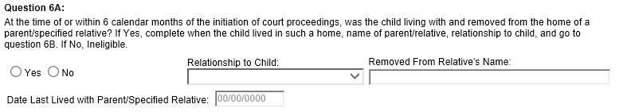

Deprivation
- Parental unemployment or underemployment: Unemployment/underemployment deprivation only applies to a two-parent household. To qualify, the following criteria must be met:
- One parent must be determined as the principal wage earner (PE) by establishing who earned the greater amount of income in the 24-month period prior to the AFDC month.
- The PE must then meet one of the following two criteria:
- Sufficient work history – has worked six or more quarters within the last 13 quarters (minimum of $50 earned each quarter). A quarter of work refers to a period of three consecutive calendar months ending on March 31, June 30, September 30, and December 31.
- Unemployment Compensation – PE has received unemployment compensation benefits within one year prior to the AFDC month.
If the above criteria are met, the PE may meet one of the following:
- Unemployment = not working for at least 30 days prior to AFDC month.
- Underemployment = working less than 100 hours in the AFDC month or has a temporary one-month increase over 100 hours but worked less than 100 hours during the prior two months and expected to work less than 100 hours in the following month.
- Parental incapacity (of one or both parents): To meet the criteria, the incapacity must be severe enough to substantially reduce or entirely eliminate the parent’s ability to support or care for the child. A parent who has an incapacitating condition must either:
- Be unable to work; or
- Be unable to engage on a full-time basis in his or her usual occupation including caring for his/her children or any comparable alternate occupation available in the community; or
- Be unable to engage full-time in an occupation, but accepts substantially reduced wages due to the debilitating nature or effects of the condition; or
- Be handicapped or disabled his or her entire life.
Documentation of incapacity includes:
- Verification of the receipt of Social Security benefits
- Agency determination based on medical evidence concerning the incapacitating condition and a written statement from physician concerning the individual’s ability work or care for the child(ren) and indicating that the incapacity is expected to last at least 30 days.

Question 6B: If two parents are selected on the Basic Tab, FSFN determines whether the Underemployment or Unemployment criteria are met and if so, selects Yes and the corresponding Deprivation Type.
- Users should not select Underemployment/Unemployment But should allow FSFN to generate this Deprivation Type.
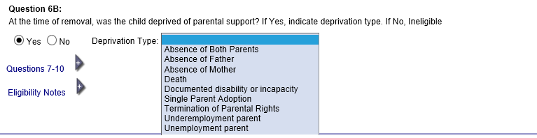

Question 7 to Question 8
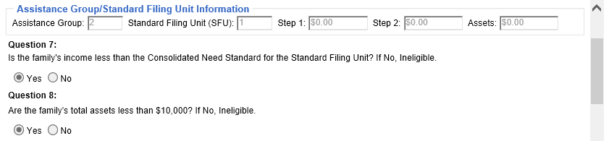
Questions 7 and 8 test the income and assets of the Standard Filing Unit (SFU) to determine whether the AFDC financial requirements are met.

FSFN Assistance Group/Standard Filing Unit Information
The Assistance Group Standard Filing Unit Information displays just above Questions 7-8 on the Initial Determination page and is used to answer Question 7 and Question 8.
This information is system derived and pre-populated from FSFN background processing as shown below.
- Assistance Group – System derived based on the participants selected as part of the Assistance Group on the Basic tab.
- Standard Filing Unit (SFU) -- System derived from FSFN’s stored SFU calculation procedure and based on participants in the Assistance Group.
- Step 1 – System derived. This is the resulting amount that is compared to 185% of CNS for the Gross Income Limitation calculation.
- Step 2 – System derived. This is the resulting amount that is compared to 100% of CNS for the Determination of Need calculation.
- Assets – System derived from the Assets and Employment page. The amount will determine the answer to Question 8. The calculated total is compared against the CNS guidelines for determining the Standard Filing Unit.
CNS guidelines along with Step 1 and Step 2 income calculations are described in more detail in the Income and Assets sections that follow.

Question 7 – Income

Income Limit
This requirement is a two-step process comparing the income of the SFU to the Consolidated Need Standard (CNS). CNS is the amount recognized by the Federal Poverty Income Guidelines. The table below shows the monthly CNS for various SFU sizes:
SFU Size | 1 | 2 | 3 | 4 | 5 | 6 | 7 | 8 | 9 | 10
100% Income Limit | $645 | $864 | $1082 | $1300 | $1519 | $1737 | $1955 | $2174 | $2392 | $2610
185% Income Limit | $1194 | $1598 | $2002 | $2405 | $2809 | $3213 | $3617 | $4021 | $4425 | $4829
100% - add $219 for each SFU size over 10 185% - add $404 for each SFU over 10

Income that is received in a frequency other than monthly is converted to a monthly amount.
The monthly conversions utilized are:
- Annually = Gross Income divided by 12.
- Every 6 Months = Gross Income divided by 6.
- Quarterly = Gross Income divided by 3.
- Twice Monthly = Gross Income multiplied by 2.
- Biweekly = Gross Income multiplied by 2.15.
- Weekly = Gross Income multiplied by 4.3.
- Hourly = (Gross Income X Hours per Week X 30.416) divided by 7.
Calculations for income that begins or ends in the month AFDC Applies is treated based on actual income received. Income started or ended in the AFDC month must be entered as monthly, twice monthly, or weekly. Refer to the AFDC Income Calculations Flowchart for detailed information.

Included and Excluded Income
- Included Earned Income includes, but is not limited to:
- Wages, salaries, gratuities/tips, commission, bonus.
- Payments from the sale of blood or plasma.
- Net profit from self-employment, including babysitting, farming, lawn care, selling newspapers.
- Rental income if participant actively manages property.
- Excluded Earned Income
- For a child, income derived from a training program.
- Income of an SSI or Adoption Subsidy recipient; lump sum SSI payment in the month of receipt and the month following receipt.
- Included Unearned Income includes, but is not limited to:
- Retirement, disability payments, unemployment/worker’s compensation, proceeds from insurance policy, severance pay, training allowance for an adult.
- Annuities, IRA, Keogh Plan, pensions, dividends, royalties, interest, revocable trust funds.
- Prizes, awards, gifts, inheritances.
- Alimony and child support payments.
- Social Security benefits (except SSI), Railroad retirement, Veterans benefits.
- Rental income if managed by another person.
- Excluded Unearned Income
- Income of an SSI or Adoption Subsidy recipient; lump sum SSI payment in the month of receipt and the month following receipt.
- Trust funds not available on demand
- Cash gifts up to $30 per member received per calendar quarter
- Assistance from government agencies: Governmental rent/housing subsidy, Non-Relative Caregiver Program funds, Relative Caregiver Program funds, value of food stamps, stipends, allowance
- Vendor payments
- Specialty payments made by law, including Agent Orange Settlement Fund, Radiation Exposure Compensation Act, certain Native American payments, children of Vietnam veterans born with congenital defect spina bifida or certain disabilities per Public Law 106-419, Alaska Native Claims Settlement Act or Maine Indian Claims Settlement Fund.

Earned Income – First Payment in AFDC Month:
The following graphic applies to the calculation for income first received during the AFDC Applies month. Please refer to page 8 of the AFDC Income and Assets Calculations Flowchart for details.
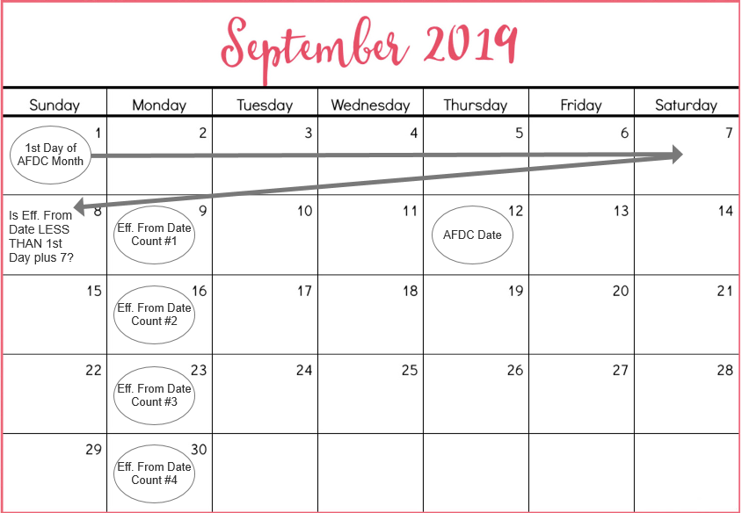

Earned Income – Last Payment in AFDC
The following graphic applies to the calculation for income last received during the AFDC Applies month. Please refer to page 8 of the AFDC Income and Assets Calculations Flowchart for details.
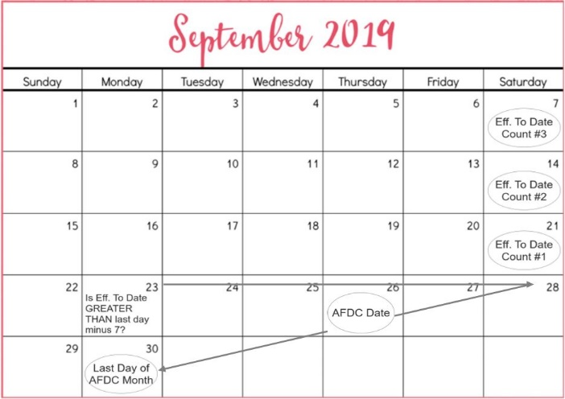

Step1 of the Income Test – Gross Income Limitation
- Determine if the SFU’s gross countable income is less than or equal to 185% of the CNS, after applying appropriate exclusions and disregards.
- If the SFU’s adjusted gross income is more than 185% of the CNS, the child would not have been eligible for AFDC and is not eligible for Title IV-E.
- If the SFU’s adjusted gross income does not exceed 185% of the CNS, proceed to Step 2 of the Income Test.
Income Disregards for Step 1 (185% of CNS) are shown below:
- Student Earned Income Disregard: The total earned income of a child who is a full-time student. A full-time student is defined as a child who is in a current grade level of Kindergarten through twelfth, Special Education, or Non-grade or enrolled in college or vocational/technical for a minimum of 9 credit hours.
- Dependent Child Training Program Disregard: The total earned income of a child who is a participant in a training program such as Job Corps.
- Child Support Disregard: A deduction up to $50 of the total amount of child support payments received for all children in the SFU.

Step 2 of the Income Test – Determination of Need
- Compare the SFU’s countable income, after applying further appropriate disregards, to 100% of the CNS.
- If the SFU’s income exceeds 100% of the CNS, the child would not have been eligible for AFDC and is not eligible for Title IV-E.
- If the SFU’s adjusted gross income does not exceed 100%, the child would meet AFDC financial criteria.
Income Disregards for Step 2 (100% of CNS) are shown below:
- Student Earned Income Disregard: The total earned income of a child who is a full-time student. A full-time student is defined as a child who is in a current grade level of Kindergarten through twelfth, Special Education, or Non-grade or enrolled in college or vocational/technical for a minimum of 9 credit hours.
- Dependent Child Training Program Disregard: The total earned income of a child who is a participant in a training program such as Job Corps.
- Child Support Disregard: A deduction up to $50 of the total amount of child support payments received by children in the SFU.
- Student and Employee Earned Income Disregard: The total earned income of a child who is a part-time student who is not full-time employee. To qualify, the child must be enrolled a minimum of 4.5 credit hours but less than 9 and be employed less than 30 hours per week. NOTE: FSFN will only take whole numbers and will round up. Therefore 4.5 credit hours should be entered as 5 credit hours).
- Employment Disregard (Unless income was reduced without good cause): A deduction up to $90 from the earned income. This disregard does not apply when earned income has been reduced without good cause.
- Care Expenses Disregard: A deduction up to $200 per child under the age of two (or turns two in the AFDC Month) or up to $175 per child age 2 or older.
- To qualify, care must be necessary for the parent to maintain employment. Additionally, the child in need of care must be under age 13, or physically or mentally incapable of caring for himself, or be under court supervision and in the assistance group. Verification of the need for care must be obtained only when questionable. The cost of care incurred must be paid to an individual not in the assistance group.
Income Disregards for Applied Income for Stepparent, Alien Parent, and Grandparent (with Minor Parent):
- Employment Disregard (unless income was reduced without good cause): A deduction up to $90 from the earned income. This disregard does not apply when earned income has been reduced without good cause.
- CNS Disregard: A deduction equaling the CNS for a family of the same size as the participant and other individual living in the same home but not included in the assistance group.
- Obligated Monies Disregard: A deduction equaling the monthly amount of money paid to, or on behalf of, an individual not in the assistance group that the participant could claim as a dependent for personal tax purposes and the monthly amount of payments made for child support or alimony with respect to individual not in the assistance group.
Income Disregards for Sponsor and Sponsor Spouse:
- Employment Disregard (Unless income was reduced without good cause): A deduction up to $90 from the earned income. This disregard does not apply when earned income has been reduced without good cause.
- 20% Disregard: A deduction, up to $175, equaling the total monthly unearned and earned income of the sponsor and sponsor's spouse reduced by 20 percent of the total of any amounts received by them in the month as wages or salary or as net earnings from self-employment.
- CNS Disregard: A deduction equaling the CNS for a family of the same size as the participant and other individual living in the same home but not included in the assistance group.
- Obligated Monies Disregard: A deduction equaling the monthly amount of money paid to, or on behalf of, an individual not in the assistance group that the participant could claim as a dependent for personal tax purposes and the monthly amount of payments made for child support or alimony with respect to individual not in the assistance group.

Question 8 – Assets

Asset Limit
An asset is an item of ownership that is convertible into cash. Count the asset only if it is available and accessible for conversion into cash. The child nor the family may have an accumulation of more than $10,000 in countable and accessible assets. If the countable asset value exceeds $10,000, the child does not meet AFDC criteria.
- Assets must be considered available to the SFU member such that the participant has the legal ability to access the asset even if a penalty applies.
- Assets are determined based on the equity value or amount depending on the asset type. Equity value is determined by the estimated value of the asset minus any indebtedness.
- The equity value or amount of the asset is as of the Date AFDC Applies.

Included and Excluded Assets
- Included Asset includes, but is not limited to:
- Vehicles: aircraft, *automobile, camper, *marine vessel, *motor home, *motorcycle, travel trailer, *truck (* are qualifying vehicles for Asset Disregards)
- Bonds, cash, certificate of deposit, funds in checking/savings/convenience bank account, inheritance, lump sum SSI payment once past the month of receipt and the month following receipt
- IRA, Keogh plan, life insurance (cash value), mutual fund shares, promissory notes (loans), savings bonds, stocks, trust account
- Funeral agreement
- Business inventory, real estate, real property

- Excluded Asset includes, but is not limited to:
- Primary Homestead of SFU
- Inherited real property which have not be probated
- Personal possessions
- Crops and livestock for home use
- Real property or real estate when a “good faith effort to sell” for up to 9 months
- Burial plots/spaces (one per SFU member)
- Asset Disregards
- $1500 of equity value for one *qualifying vehicle per assistance group
- $1500 of equity value for one funeral agreement per SFU member
- $1500 of total asset value from Sponsor/Sponsor Spouse (if applicable)
- Asset Disregards – Applied Income
- $1500 of equity value for one qualifying vehicle per AG
- $1500 of equity value for one funeral agreement per SFU member
- $1500 of total asset value from Sponsor/Sponsor Spouse (if applicable)
- $1500 Sponsor and Sponsor Spouse disregard
- Qualifying Vehicles for Disregard
- Automobile
- Motorcycle
- Truck
- Motor Homes
- Marine Vessels

Placements in the Current Removal Episode
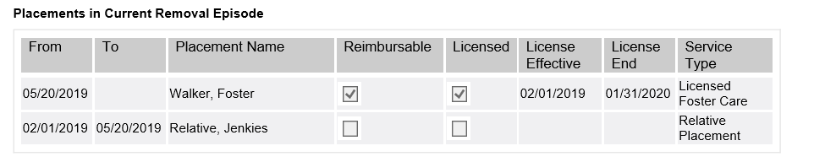
This table lists all placements for the child in the current removal episode based on the Title IV-E Effective From date while the Title IV-E is Pending. The child is not reimbursable for any periods in which placement was in an unlicensed or a secured facility.
- There is a check box to indicate if the placement is reimbursable. The check box is system derived based on the Provider having an active license for the specific Service Type as of the Effective Date.
- Provider license status is pre-filled based on information from the Provider License page.

Question 9 and AFDC Criteria
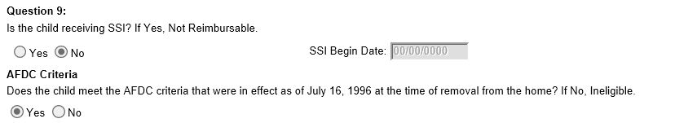
This section of eligibility determination looks at whether the child is receiving SSI and meets the AFDC criteria. Answers to these questions will impact the child’s Title IV reimbursability and eligibility.

- Is the child receiving SSI? – If the Assets and Employment page documents the child having Supplemental Security Income (SSI) as of the Initial Determination Date, this question defaults to Yes.

- Does the child meet the AFDC criteria that were in effect as of July 16, 1996 at the time of removal from the home? – System derived as Yes if all the following questions are Yes: Question 1 Question 2B, Question 6A, Question 6B, Question 7 and Question 8. Otherwise, system derived as No.
- Additionally, AFDC Criteria is not met, and the answer will be No if the Removal Address is outside the State of Florida.

Ongoing IV-E Eligibility (Redetermination)
A redetermination of Title IV-E eligibility must be completed, at least annually in FSFN, to document ongoing Title IV-E eligibility requirements and when there are changes in the child’s circumstances that may affect Title IV-E eligibility.
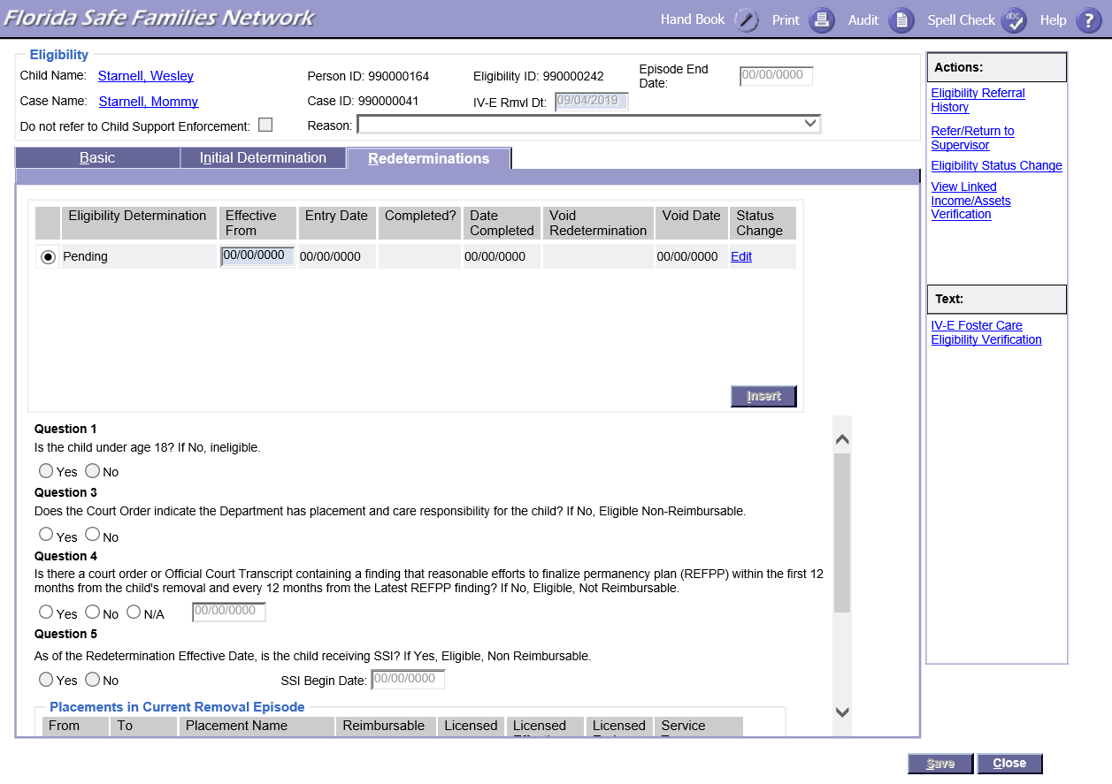

Annual Judicial Finding
For a Title IV-E eligible child to maintain a reimbursable status, a judicial finding of Reasonable Efforts to Finalize the Child’s Permanency Plan (REFPP) must be made within 12 months of the date the child is considered to have entered foster care and within every subsequent 12-month period while the child remains in out of home care.
- The date the child is considered to have entered foster care is the earlier of either:
  - The date of a judicial finding to the effect that the child has been subjected to child abuse or neglect; or,
  - Sixty (60) calendar days after the date the child is physically or constructively removed from the home through a court order or voluntary placement agreement.
- A judicial finding must be made that the Department/CBC made (or is making) reasonable efforts to finalize the permanency plan for the child based on the permanency plan that is in effect.
  - Judicial findings must be made on a case-by-case basis per the individual circumstances of the child.
  - The use of nunc pro tunc orders are not allowable for Title IV-E documentation to support the judicial finding.
- Failure to obtain this initial judicial finding of reasonable efforts to finalize the child’s permanency plan makes the child temporarily non- reimbursable for Title IV-E foster care. The child becomes non-reimbursable beginning the first day of the month after the month the finding is due and remains non-reimbursable until the first day of the month in which the finding is made.

Changes to Child’s Circumstances
When a change occurs, certain factors of the child’s eligibility must be assessed to determine if the child continues to be Title IV-E reimbursable. The following changes require the manual completion of a Title IV-E eligibility redetermination in FSFN:
- License for current placement expires and is not extended or re-licensed in the following month.
- SSI benefits begin or terminate.
- Change in placement and care responsibility.
NOTE: Placement change automation starts after initial determination approval. Any placement changes entered before the initial determination require completion of manual redeterminations.

FSFN Documentation
The Redeterminations tab displays the history of all Title IV-E Eligibility Redeterminations for the child’s removal episode. The following events must be documented on the Redetermination tab of the Title IV-E eligibility determination module in FSFN:
- Reasonable Efforts to Finalize Permanency Plan (REFPP):
- A Redetermination must be completed to document the REFPP judicial finding 12-month requirement. The court order containing the finding must be linked to the Redetermination in FSFN. The effective date of the Redetermination should reflect the first day of the month in which the judicial finding was made.
- If the REFPP judicial finding is not obtained within the 12-month timeframe, based on the month of the last REFPP judicial finding, a Redetermination is completed to reflect the child as Title IV-E Eligible, Not Reimbursable effective on the first day of the 13th month. The Redetermination shall be completed by the 13th month.
- Redetermination as Title IV-E Eligible, Not Reimbursable will be autogenerated as of the 14th month after the date of the judicial finding that reasonable efforts were made to prevent removal (or the most recent redetermination Question 4 date) if no redetermination has been completed.
- A Redetermination shall be completed with an effective date on the first day of the month in which the REFPP judicial finding is made to regain Reimbursable status and is contingent on other reimbursability elements being met.
- NOTE: Use N/A when completing a Redetermination for any Redetermination reason other than for REFPP.

- Change in SSI:
- If a change in the Supplemental Security Income (SSI) benefit occurs, such as approval or termination of benefit, the FSFN Assets and Employment module must be updated and a Redetermination completed in FSFN to accurately document the change in Title IV-E reimbursability. Effective Date equals the date the first payment was received.

Redetermination Logic Changes
Changes to the Redeterminations page are shown below:
- Submit Void/Void Redetermination and Void Date – A two-step process for voiding Redeterminations. Voiding a Redetermination voids all Eligibility Redeterminations created after the Effective From Date. The system populates a Void Date once a Redetermination is successfully voided. When the Placement is made in error, only the row generated from the placement change will void.
- Insert Button – Inserts a pending Redetermination row.
- Question 4 – Is there a court order or official court transcript containing a finding of reasonable efforts to finalize the permanency plan (REFPP) within the first 12 months from the child's removal, and every 12 months from the latest REFPP finding?
- If Yes, the Date field is enabled and required.
- If No, the child is Eligible, Not Reimbursable.
- N/A is used when 12 months has not elapsed.

Extended Foster Care (EFC)

EFC Eligibility Overview
The Extended Foster Care program is intended to serve young adults as defined in Florida Statutes. For a young adult to participate in EFC, the young adult must be
- In the legal custody of the Department on the date of their 18th birthday, has not achieved permanency and has not reached the age of 21.
- Best Interest Judicial Findings
- In a qualifying activity on an ongoing basis. Qualifying activities are shown below:
- Completing secondary education or a program leading to an equivalent credential.;
- Enrolled in an institution that provides postsecondary or vocational education.
- Participating in a program or activity designed to promote or eliminate barriers to employment.
- Employed for at least 80 hours per month.
- Unable to participate in programs or activities listed above full time due to a physical, intellectual, emotional, or psychiatric condition that limits participation.
- Must be supported by documentation in the young adult’s case file or school or medical records of a physical, intellectual, or psychiatric condition that impairs the young adult’s ability to perform one or more life activities.
- Residing in a supervised living arrangement approved by the Department or CBC. A supervised living arraignment may include a foster home, group home, college dormitory, shared housing, apartment, or another housing arrangement if the arrangement is approved by the CBC and is acceptable to the young adult. Participating in case management and judicial proceedings.

EFC Program Entry
According to Florida Statutes, a child living in licensed care on his or her 18th birthday is automatically opted into the EFC program and remains under the jurisdiction of the court and in the care of the department. If a young adult opts out of the EFC program or is involuntarily terminated, he or she may apply for readmission prior to turning age 21. For re-entry, the young adult and a Department representative must execute an Extended Foster Care Voluntary Placement Agreement (EFC VPA).

EFC Program Funding
The preferred funding source is Title IV-E; therefore, a Title IV-E eligibility determination must be completed for all young adults entering the program. If a young adult is determined not to meet Title IV-E requirements, the young adult’s participation in EFC will be state funded. There are two paths to determine Title IV-E eligibility for EFC; the path is determined by the entry method of the young adult into the program.
- A young adult who exercises the option to remain in foster care, immediately upon turning 18, retains their Title IV-E eligibility status which was made at the time the young adult entered foster care as a child.
- If a child was determined Title IV-E Ineligible for the latest removal episode prior to turning 18, the young adult’s EFC eligibility will remain Title IV-E Ineligible. A subsequent Title IV-E Eligibility Determination shall not be completed.
- A young adult’s entry into foster care as a child must have met the requirements outlined in CFOP 170-15, Chapter 4 regarding Title IV-E eligibility.
- If the young adults’ placement prior to age 18 was Non Reimbursable, a manual Redetermination row must be added to make them Reimbursable with supervised Independent Living Arrangement (ILA).
- A young adult who applies to re-enter EFC, after a voluntary opt-out or involuntary termination, must have a Title IV-E EFC Eligibility determination completed based on the circumstances at the time of the removal/re-entry into care as a young adult pursuant to the EFC VPA.

Title IV-E EFC Eligibility Determination
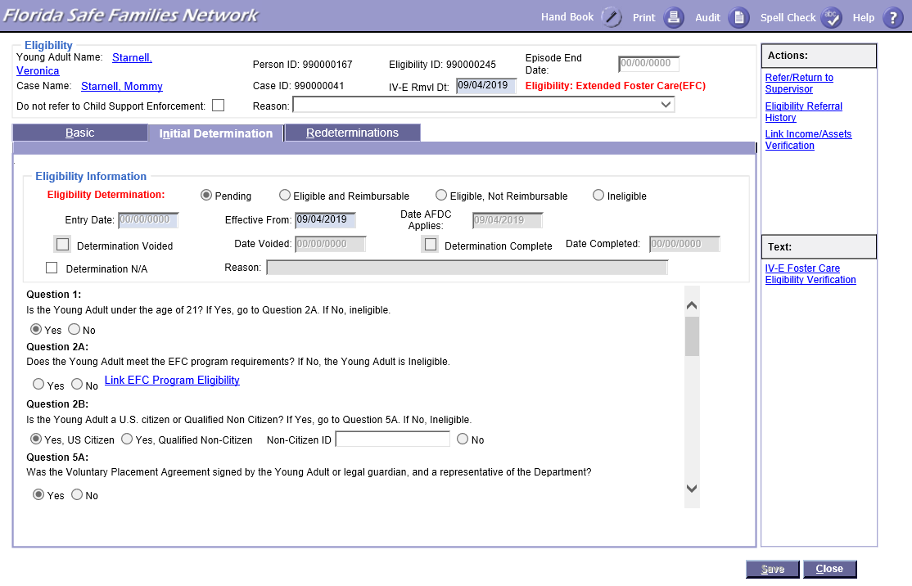
- Upon execution of an EFC Voluntary Placement Agreement for a young adult’s re-entry into EFC, a Title IV-E EFC Eligibility Determination must be completed in FSFN within 30 calendar days.
- Title IV-E EFC eligibility consists of federal Title IV-E and AFDC technical and financial, criteria.
- The AFDC determination is made without regard to the parent(s)/legal guardian(s) or others in the assistance unit in the home from which the young adult was removed as a younger child, and without regard to the young adult’s spouse.
- To claim Title IV-E funding, the young adult must be determined Title IV-E Eligible, Reimbursable.
- Title IV-E EFC VPA Requirements
- Placement and Care Responsibility – The young adult must be in foster care under the placement and care responsibility of the Department. The young adult is Title IV-E, Not Reimbursable for any month in which the Department does not have placement and care responsibility.
- The EFC VPA authorizes the Department to have placement and care responsibility for the young adult in the EFC program.
- Best Interest Judicial Finding – Requires a judicial determination within 180 days of a young adult’s EFC VPA entry into foster care that such placement is in the best interest of the young adult for continued eligibility for Title IV-E funding. If the finding is not made within 180 days, the young adult is Title IV-E ineligible as of the 181st day and for the remainder of the foster care episode.
- Supervised Independent Living Setting – A young adult must reside in a supervised living arrangement that is approved through a Supervised Living Arrangement Assessment. The young adult is Title IV-E, Not Reimbursable if not living in an approved supervised living setting.
- AFDC Technical Requirements – A young adult is Title IV-E ineligible for the entire foster care episode if any of the AFDC requirements are not met:
- Age – A young adult who is at least 18 years old and younger than 21 years old.
- Citizenship or Qualified Non-Citizen Status – A young adult must be a citizen or a Qualified non-citizen.
- Living with/Removed from Home of a Specific Relative – A young adult is considered to be his or her own specified relative, thus meeting the requirement.
- Deprivation – A young adult is deemed to be deprived as long as the young adult is not residing with his or her natural/legal or adoptive parent(s).
- Standard Filing Unit (SFU) – For Title IV-E EFC Eligibility, the SFU consists of the young adult only. The SFU size correlates to the CNS amount that is used in the income limit tests
- If the young adult receives Supplemental Security Income (SSI), he or she is excluded from the SFU and all income and resources are excluded from the income and asset limit calculations.

- AFDC Financial Requirements – A young adult is Title IV-E ineligible for the entire foster care episode if any of the AFDC requirements are not met.
SFU Size | 1
185% of Consolidated Need Standard | $1194
100% of Consolidated Need Standard | $645

- Income Limit. This requirement is a two-step process based on the income of the young adult. This determination is calculated by FSFN based on the entries made in the FSFN Assets and Employment module.
- Step 1 of the Income Test – Gross Income Limitation. Determine if the SFU’s gross countable income is less than 185% of the consolidated need standard (CNS), after applying appropriate disregards. If it does not, proceed to Step 2.
- Step 2 of the Income Test – Determination of Need. Determine if the SFU’s countable income is less than 100% of the CNS, after applying appropriate If it does not, the young adult is Title IV-E eligible.
- Asset Limit – The young adult must not have combined assets/resources in excess of $10,000, after applying appropriate disregards.

FSFN – Title IV-E EFC Eligibility Questions
Because Title IV-E Determination for a young adult differs slightly from Title IV-E Determination for a child, the questions in FSFN are different as well.
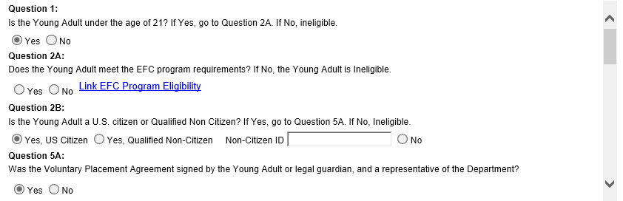

Question 5B
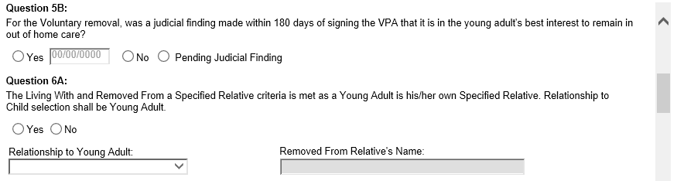

User selected based on the judicial finding. If Yes, a Select Legal Document hyperlink appears to identify and link the order, and the Date field is enabled and required.
If “Pending Judicial Finding” is selected, the Date and Legal Document are not required, and the Eligibility Determination can be completed. Select Pending Judicial Finding unless 180 days has passed. Once 180 days is passed, select No.

Question 6B
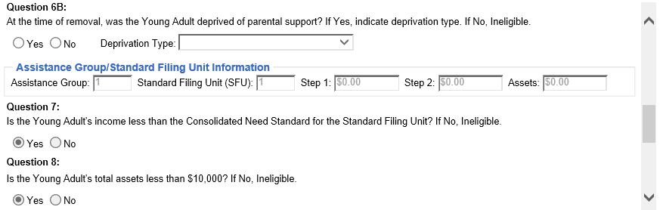

Question 7 to Question 9 test the income and assets of the Standard Filing Unit (SFU) to determine whether the AFDC financial requirements are met.
This section of eligibility determination also looks at the young adult’s placements and reimbursability, including whether the child is receiving SSI.

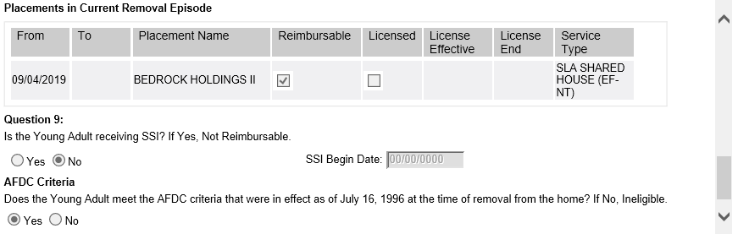
The table above lists all placements for the young adult in the current removal episode based on the Title IV-E Effective From date.
- Is the young adult receiving SSI? – If the Assets and Employment page documents the young adult having Supplemental Security Income (SSI) as of the Initial Determination Date, this question defaults to Yes.
- Does the child meet the AFDC criteria that were in effect as of July 16, 1996 at the time of removal from the home? – System derived as Yes if all of the following questions are Yes: Question 1 Question 2B, Question 6A, Question 6B, Question 7 and Question 8. Otherwise, system derived as No.

Title IV-E EFC Ongoing Eligibility
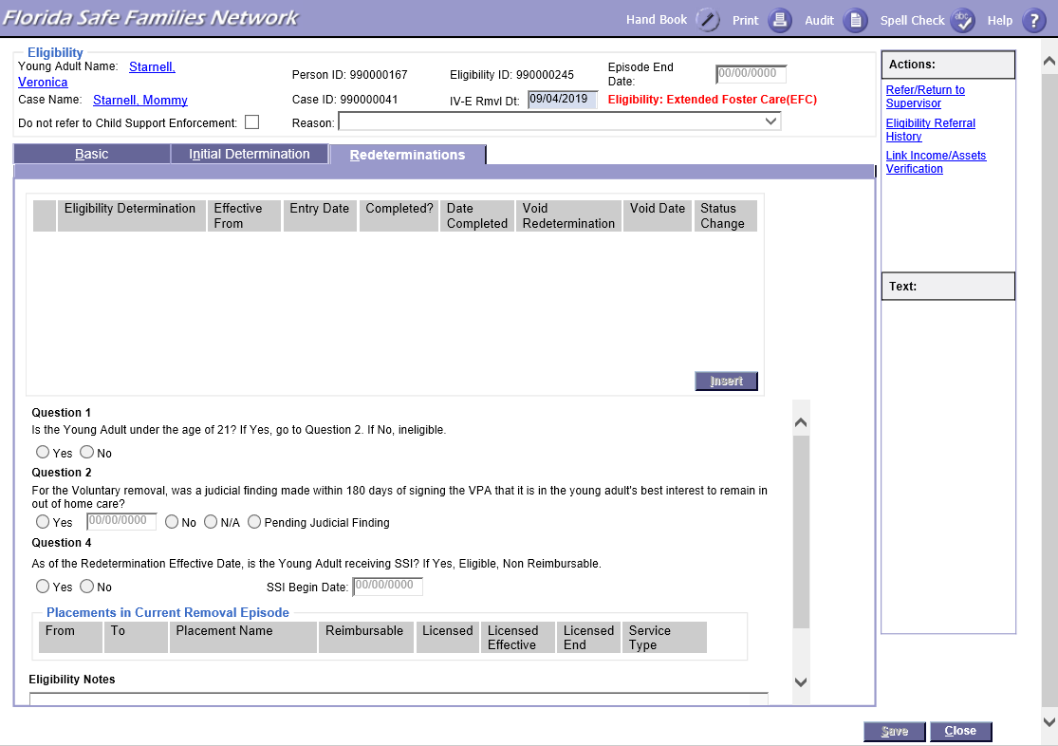
- Reasonable Efforts to Finalize Permanency Plan – For court-ordered entry into foster care, to continue reimbursable status of Title IV-E eligibility, there must be a judicial finding that reasonable efforts were made to finalize the permanency plan (REFPP) every 12 months. The judicial finding shall be based on the permanency plan that is in effect. For young adults, this may include activities outlined in the young adult’s transition and/or case plan that are intended to prepare the young adult for independence.
- For a young adult who remained in foster care continuously upon turning 18 years old, the 12-month timeframe is based upon the last finding prior to the young adult turning 18 years old. Subsequent REFPP judicial findings must be made no later than 12 months from the preceding finding as long as the young adult remains in extended foster care.
- Failure to obtain the initial and subsequent judicial findings, as prescribed above, results in the foster care maintenance payment being non-reimbursable for federal financial participation. Title IV-E reimbursement may resume for the month in which the REFPP finding is made.
- Placement and Care Responsibility – For young adults who remain in foster care continuously via a court order, the court order shall provide the Department with placement and care responsibility. The young adult is Title IV-E, Not Reimbursable for any month in which the Department does not have placement and care responsibility.

IV-E EFC Discharge
A young adult’s eligibility continues until one of the following occurs:
- Young adult turns 21 years old.
- Young adult voluntarily opts out.
- Young adult is involuntarily terminated.

FSFN Documentation
- Initial Title IV-E EFC Eligibility Determination for Re-Entry:
- An initial Title IV-E EFC eligibility determination shall be completed in FSFN within 30 calendar days of the young adult re-entering the EFC program. The appropriate modules of FSFN must be completed for the young adult.
- The Title IV-E EFC Eligibility Determination module for a voluntary removal is automatically generated upon the approval of an out of home placement with a service category type of Independent Living. The following data must be entered in FSFN for the young adult before working on the Title IV-E EFC Eligibility Determination:
- Person Management must document citizenship status, date of birth, and age;
- Assets and Employment module must document all income (earned and unearned) and assets/resources for the AFDC eligibility month (at a minimum) for which FSFN provides as an option and included in the eligibility calculation. Supporting documentation must be linked and uploaded to FSFN.
- Education Record, if applicable.
- Upload, as a Legal Document, the court order containing Best Interest finding, if determination has been made.
- The “Do not refer to Child Support Enforcement” checkbox must be marked and the Reason value of “Not Applicable – Young Adult” selected.
- Ongoing Title IV-E Eligibility Determination for Voluntary Removal:
- For a young adult who is determined Title IV-E eligible, ongoing eligibility requirements must be documented in FSFN within 30 calendar days of the event.
- Best Interest. If a judicial finding that it is in the young adult’s best interest to remain in foster care has not been made by the time the Initial Title IV-E EFC Eligibility Determination was completed, a Redetermination must be completed to document when the Best Interest finding was made or after the 180-day period has lapsed, whichever occurs first. If the Best Interest finding is not made, a young adult becomes Title IV-E Ineligible for the remainder of the removal episode on the 181st day from entry into care. Note: On the 181st day, FSFN will autogenerate a Redetermination row making the young adult Ineligible for the remainder of the removal episode (Applies to new functionality only).
- Change in SSI. If a change in the SSI benefit occurs, such as approval or termination of benefits, for a Title IV-E eligible young adult, the FSFN Assets and Employment module must be updated and a Redetermination completed in FSFN to accurately document the change in Title IV-E reimbursability.
- Ongoing Title IV-E Eligibility Determination for Court-Ordered Removal:
- For a young adult who was determined Title IV-E eligible as a child, ongoing eligibility requirements must be documented in FSFN within 30 calendar days of the event.
- A redetermination must be completed in FSFN when a young adult enters EFC/SLA and their prior placement was non-reimbursable in order to make them reimbursable.
- The following events must be documented on the Redetermination tab of the Title IV-E Eligibility Determination module in FSFN:
- Reasonable Efforts to Finalize Permanency Plan (REFPP).
- Change in SSI. If a change in the SSI benefit occurs, such as approval or termination of benefits, for a Title IV-E eligible young adult, the FSFN Assets and Employment module must be updated and a Redetermination completed in FSFN to accurately document the change in Title IV-E reimbursability.

Maintenance Adoption Subsidy (MAS) and Extended MAS (EMAS)
Title IV-E maintenance adoption subsidy is available to any special needs child who meets the eligibility requirements provided in section 473 of the Social Security Act (the Act). The Department/CBC will provide adoption assistance to every child it determines is eligible, unless the prospective adoptive parent(s) decline such assistance. Further, the Department/CBC is prohibited from imposing additional eligibility requirements not contained in federal law.
- The intent of Title IV-E maintenance adoption subsidy (MAS) is to promote the adoption of special needs children from the foster care system. The maintenance adoption assistance program financially assists adoptive parents in maintaining their same standard of living, especially foster parents and relatives who developed an emotional attachment with children placed in their homes.
- The Extended Maintenance Adoption Subsidy (EMAS) program is intended to utilize Title IV-E funds to provide adoption assistance for eligible young adults up to 21 years of age. To be eligible for the program, young adults are required to meet Title IV-E eligibility criteria along with state option requirements. EMAS authorizes the adoptive parent(s) to receive an adoption subsidy payment on behalf of the young adult and the young adult to receive Medicaid.

Title IV-E MAS
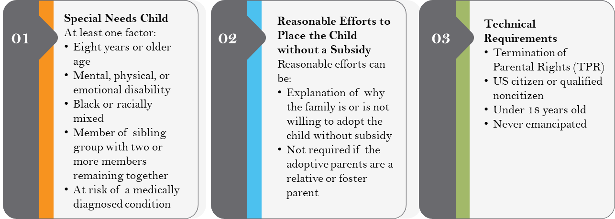
- Every adoptive family must be informed about the availability of adoption subsidy and its purpose. The adoption case manager must ask all potential adoptive parents if they will adopt without subsidy and document this discussion in FSFN and/or in the adoption home study.
  - Explanation is not required if the adoptive parents are a relative or foster parent.
- Maintenance adoption subsidy payments to the adopting parent(s) and Medicaid benefits for the child become available at the point that the Adoption Assistance Agreement is signed, and the child is placed in the adoptive home.
- Each child must meet the following three requirements for maintenance adoption subsidy:
- The child must have been permanently committed to the Department or a licensed child-placing agency. A child who is voluntarily relinquished to an attorney may be eligible if the child is determined to meet one of the primary factors for special needs and was determined eligible for SSI prior to finalization or received maintenance adoption subsidy in an initial adoption, they still meet one of the primary factors for special needs and this is a subsequent adoption.
- The child has one or more factors:
- Is 8 years of age or older.
- Is of black or racially mixed heritage (at least one parent is black).
- Is a member of a sibling group being placed together for adoption.
- Has a physical or mental health concern.
- Has a documented developmental delay.
- Is at risk of a medically diagnosed condition.
- Except for foster parent and relative caregiver adoptions, there must be documentation of a reasonable but unsuccessful effort to place the child without subsidy.

Applicable Child
An Applicable Child is a child who:
- Meets the applicable age for the federal fiscal year; or,
- Has been in foster care for at least 60 consecutive months; or,
- Is a sibling to an eligible Applicable Child if both have the same adoption placement.

Non-Applicable Child
A child who does not meet applicable child criteria is evaluated as a non-applicable child.

MAS Termination Reasons
- Adoptive parents are no longer legally responsible for the support of the child.
- Child turns 18.
- The child is no longer receiving any support from the adoptive parents.
- Adoptive parents or child passes away.

Adoption Eligibility Record Creation
- An Adoption Eligibility record is created:
- When an Adoption Assistance Agreement (from the Adoption Subsidy Information page) is created for a child that has an approved removal placement within the same case or for a child for whom a pending Private Adoption page exists at the time the Adoption Assistance Agreement is saved.
- Manually through the Financial Work page by selecting the Create Adoption Eligibility from the Eligibility dropdown for children that have a valid approved out of home placement within the same case or a child for whom a pending Private Adoption page exists.
- Upon creation of an Adoption Eligibility record through either method, a Title IV-E Foster Eligibility page will be created, if one does not exist for the removal episode.
  - Exception: Cases discharged to permanent guardianship that are reopened for adoption retain their last Title IV-E eligibility status. Once TPR occurs in such a case, an out-of-home placement is documented beginning on the TPR date (with the same provider from the discharged removal episode). FSFN will not generate a Title IV-E eligibility determination when an out-of-home placement provider is the same provider as the prior removal episode discharged as permanent guardianship or permanent placement. Instead, the Adoption Eligibility will utilize the prior Title IV-E eligibility determination.
- When the Post Adoption Services case is created using the Create New Case After Finalization functionality, the Adoption Assistance Agreement, Adoption Eligibility, and Adoption TANFs will be copied to the new case.

FSFN - Adoption Eligibility
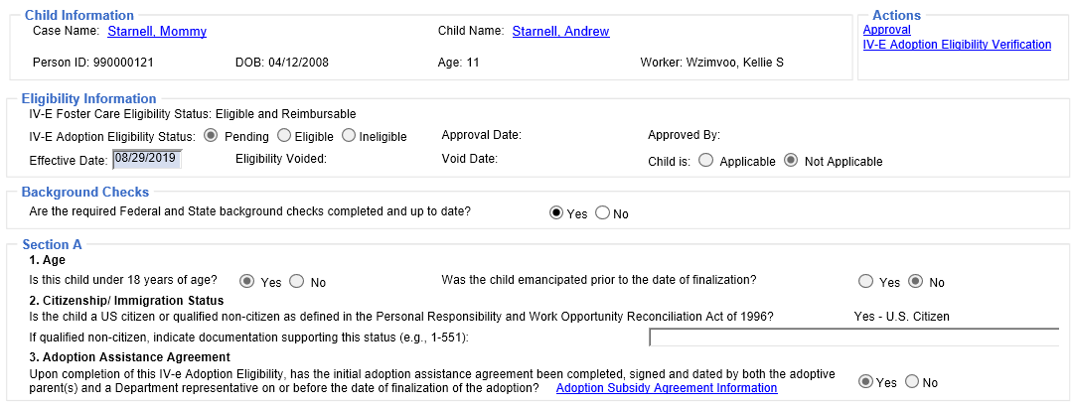
- Background Checks – Added required field for user to select Yes or No that the required Federal and State background checks are completed and up to date.
  - Note: If No, background check compliance needs to be addressed before moving forward.
- Special Needs Determination Non-Applicable Child – Added a series of questions on whether a non-applicable child meets all three special needs criteria.
- Separate Person Approval Requirement - Adoption Eligibility must have second level approval completed by a different user (i.e., a separate person approves the Adoption Eligibility).
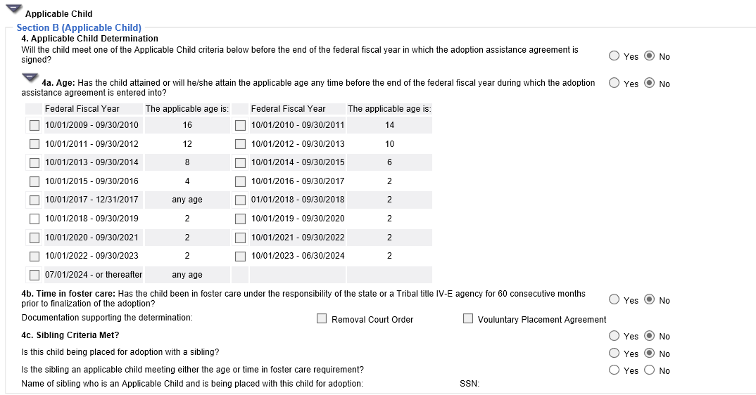
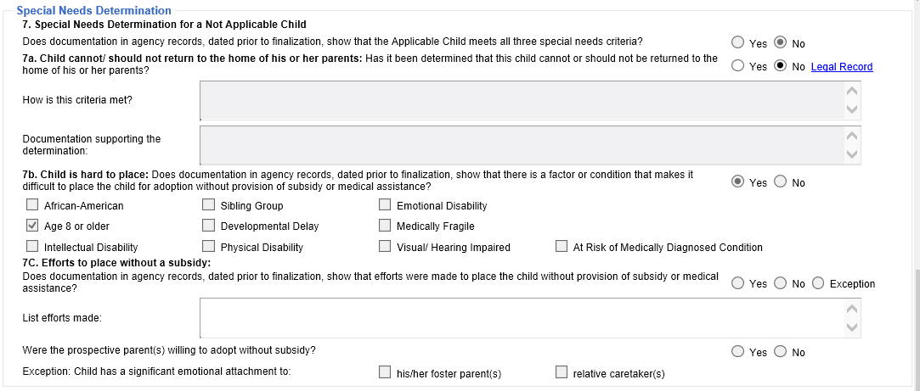
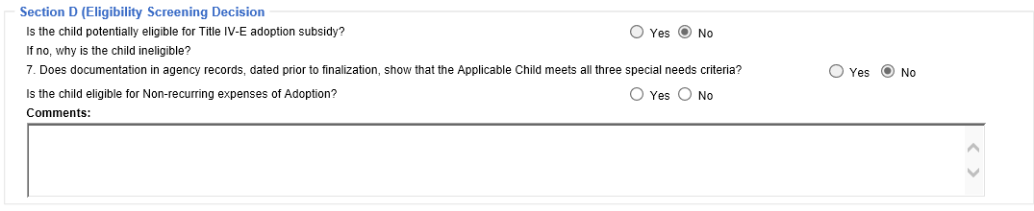

Adoption Eligibility Page Changes
The following screenshots identify important changes to the Adoption Eligibility page in FSFN.
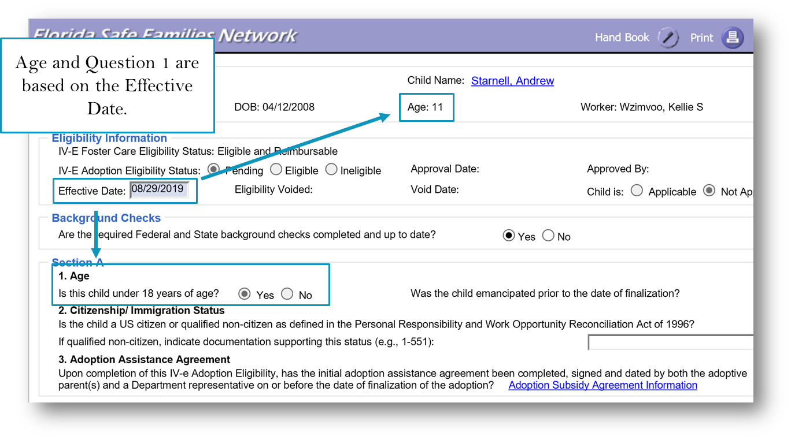
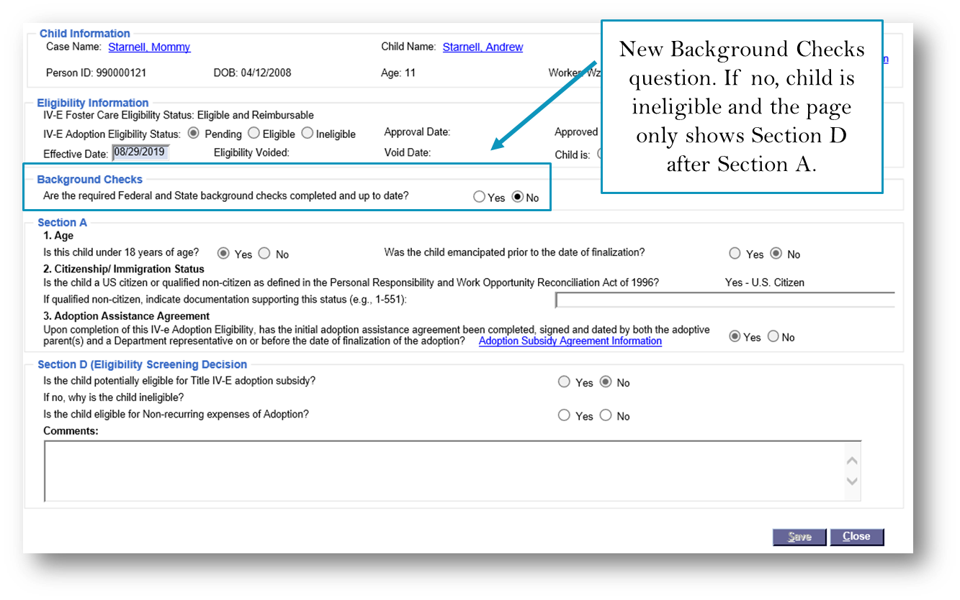
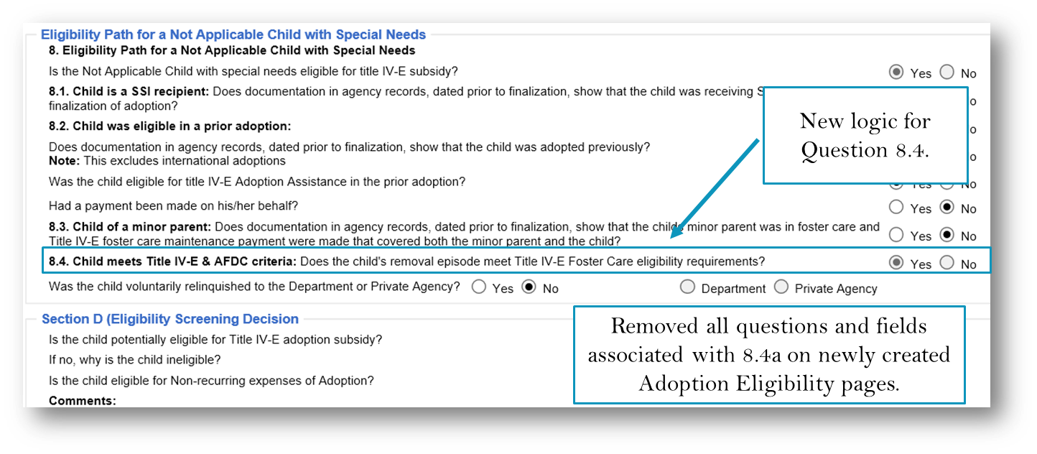
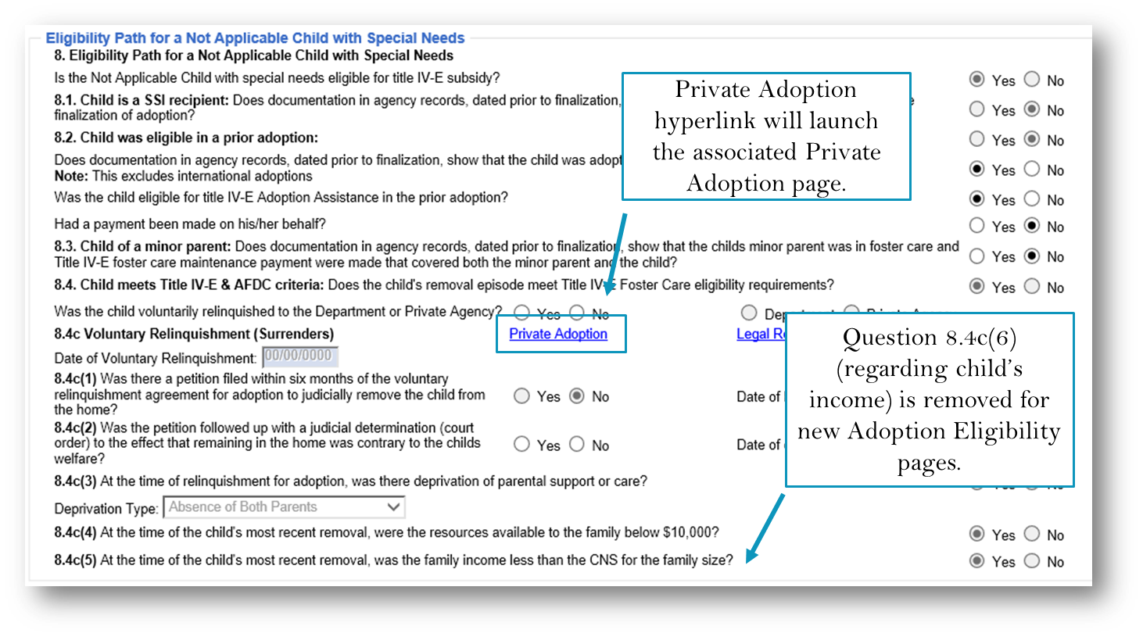

Question 8.4 is now system-derived as Yes if the IV-E Foster Care status for the current Removal Episode Eligible Reimbursable or Eligible Non-Reimbursable is. Question 8.4 will also system-derive as Yes if Question 8.4c (Private Adoption process) is Yes.

Private Adoption Changes
A new Security Resource has been added to allow those with the applicable security to de-select the Complete checkbox.
The following identifies important changes for Private Adoptions in FSFN:
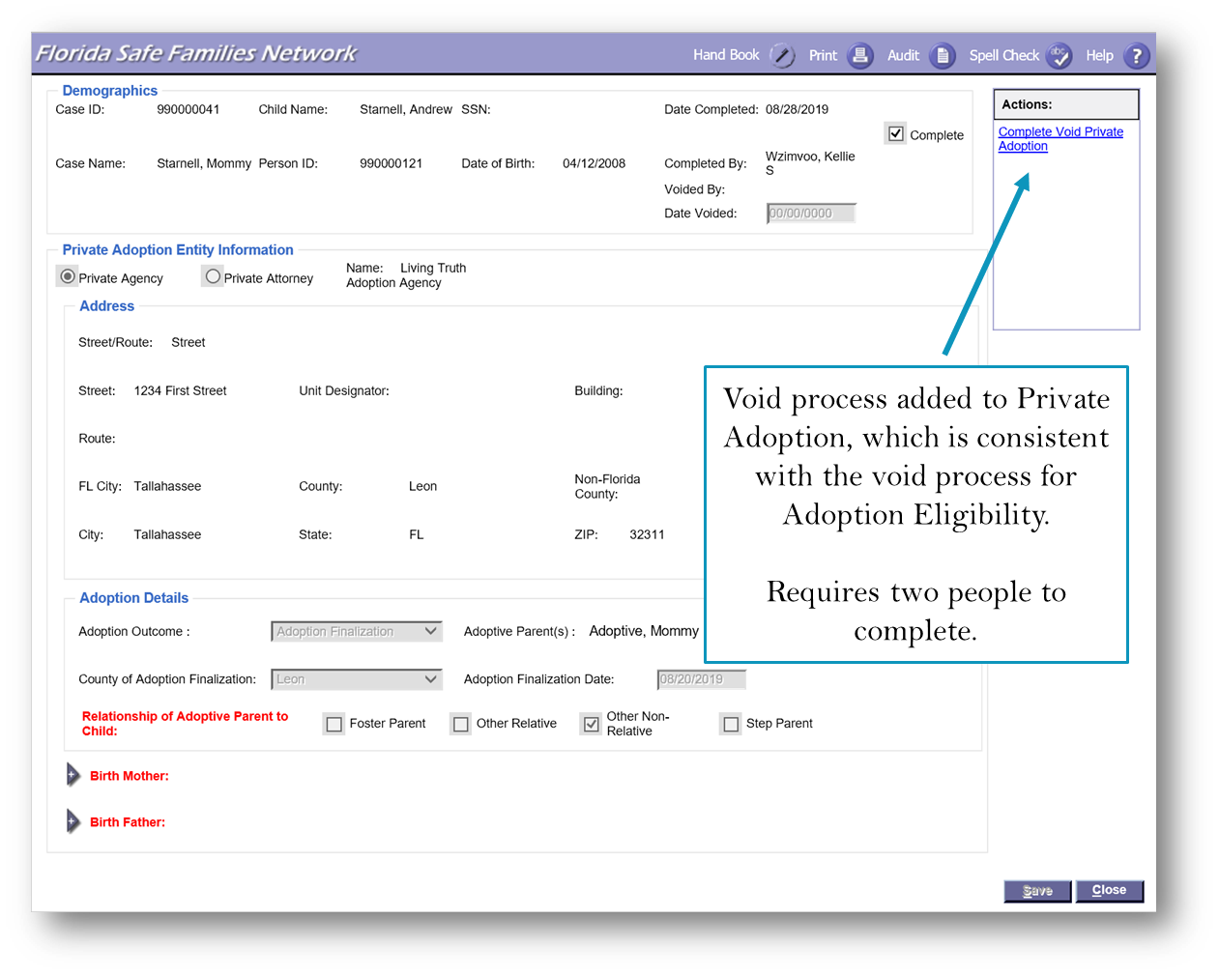
- At least one value must be selected for Relationship of Adoptive Parent to Child.
- The Mother or Father must have all three of the following:
  - Documented Termination of Parental Rights Date
  - At least one Race selected
  - At least one Ethnicity selected
- Create New Case after Finalization and the AFCARS logic have been modified to exclude those Private Adoption pages which meet the required logic but have been voided.
- A new Security Resource has been added to allow those with the applicable security to de-select the Complete checkbox.
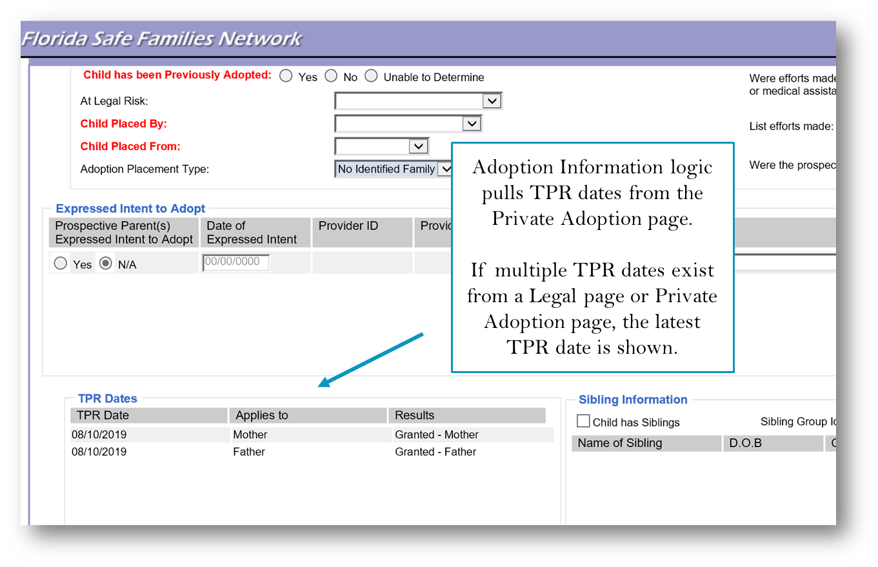

MAS Termination Reasons
A child’s eligibility continues until one of the following occurs:
- Adoptive parents are no longer legally responsible for the support of the child.
- Child turns 18.
- The child is no longer receiving any support from the adoptive parents.
- Adoptive parents or child passes away.

Adoption Subsidy Agreement
The Department/CBC must enter into an Adoption Assistance Agreement (AAA) with the prospective adoptive parent(s) and begin paying Title IV-E, TANF, or state funded adoption assistance on behalf of a Title IV-E, TANF, or state funded eligible child at the time of adoptive placement, but no later than prior to the finalization of the adoption.

Adoption Subsidy Agreement Page
- The Adoption Subsidy Agreement Information page handles the functionality to document the legal agreements dictating the terms of adoption benefits.
- The Adoption Assistance Agreement between the Department of Children and Families (DCF) and the Adoptive Parents template is launched from this page.
- An Adoption Subsidy Agreement Information page cannot be created unless an open, approved removal/placement exists for the participant or there is a pending Private Adoption page.
- When the Adoption Subsidy Agreement Information page is created, and the child does not have an Adoption Eligibility record, an Adoption Eligibility record is created.

Adoption Subsidy Agreement Page Changes
The following screenshot identifies important changes to the Adoption Eligibility page in FSFN.
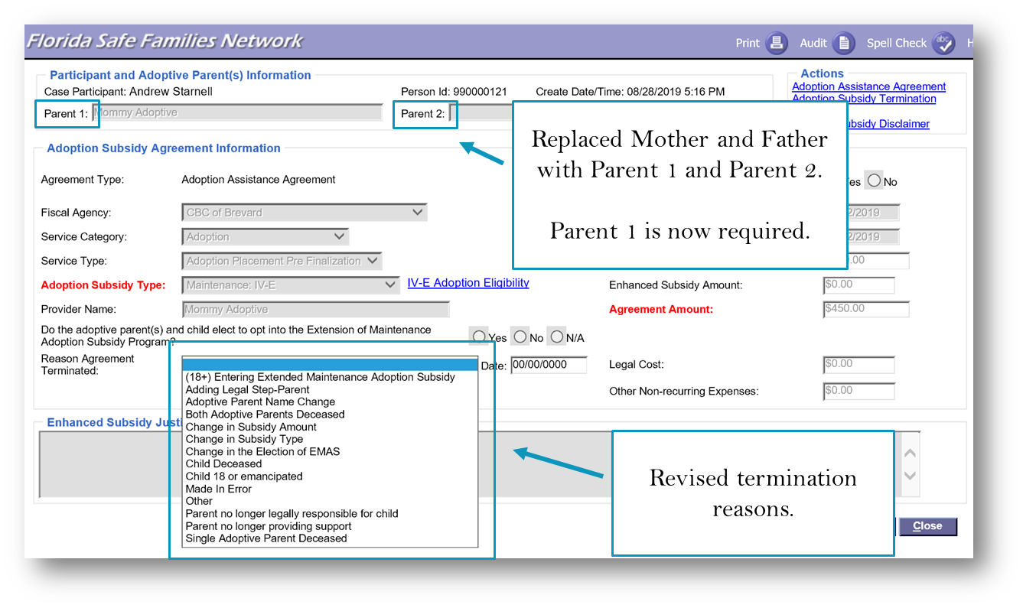
- The following termination reasons were added to the drop down:
- (18+) Entering Extended Maintenance Adoption Subsidy
- Adding Legal Step-Parent
- Adoptive Parent Name Change
- Change in Subsidy Amount (previously “Change in Subsidy”)
- Change in Subsidy Type
- Made in Error
- “(18+) Entering Extended Maintenance Adoption Subsidy” cannot be selected unless the Opt-in Question is “Yes”.
- For “Adding Legal Step-Parent”, “Adoptive Parent Name Change”, “Change in Subsidy Type”, and “Change in the Election of EMAS”, upon saving the page:
- FSFN autogenerates a new AAA.
- Does not require end of Service.
- The Adoption Eligibility remains effective.
- Upon saving with “Change in Subsidy Amount” selected:
- FSFN autogenerates a new AAA.
- FSFN requires Ending the Service.
- Upon saving with “Made in Error” selected:
- A new AAA will not be created.
- FSFN will void the Adoption Eligibility and associated Adoption TANF.

EMAS Special Populations
The Extended Maintenance Adoption Subsidy (EMAS) program is intended to utilize Title IV-E funds to provide adoption assistance for eligible young adults up to 21 years of age. A young adult is potentially eligible for the program if the adoptive parents signed the initial Adoption Assistance Agreement and opted-in to the program when the young adult was 16 or 17 years old.
Florida implemented the Extended Maintenance Adoption Subsidy program on January 1, 2019. Federal regulations allow all young adults currently eligible for EMAS the opportunity to opt-in to the program even if their Adoption Subsidy Agreement was completed before Florida’s implementation of the program. Therefore, youth and young adults who have an initial Adoption Assistance Agreement executed at the age of 16 or 17 prior to January 1, 2019 are potentially eligible for the Extended Maintenance Adoption Subsidy until they turn 21.
Prior to the implementation of EMAS functionality in FSFN, the Adoption Subsidy Agreement did not have the option to opt into EMAS. For young adults who are not yet 21 but whose initial Adoption Subsidy Agreement was executed prior to January 1, 2019 while they were 16 or 17, identify the applicable FSFN scenario below for steps to document eligibility and participation in EMAS:
- Child with an active AAA
- Terminate the AAA with “Change in the Election of EMAS”
- Complete the autogenerated AAA and opt-in to EMAS
- Terminate the AAA with “(18+) Entering Extended Maintenance Adoption Subsidy”
- Child with a closed case and terminated AAA
- Reopen the Post-adoption Case
- Create a new AAA and opt-in to EMAS
- Terminate the AAA with “(18+) Entering Extended Maintenance Adoption Subsidy”
- Child with a closed case and non-terminated AAA
- Reopen the Post-adoption Case
- Terminate the AAA with “Change in the Election of EMAS”
- Complete the autogenerated AAA and opt-in to EMAS
- Terminate the AAA with “(18+) Entering Extended Maintenance Adoption Subsidy”

EMAS Termination Reasons
A young adult’s eligibility continues until one of the following occurs:
- Adoptive parents are no longer legally responsible for the support of the child.
- Young Adult reaches 21 years of age.
- Young adult no longer participates in one of the qualifying activities.
- Adoptive parents or young adult passes away.

Medicaid Summary
- All children in Out of Home Care are eligible for Medicaid, regardless of placement, unless the child currently receives SSI Medicaid.
- Medicaid must be applied for within 2 business days of removal.
- For youth turning 18, refer to the Medicaid Coverage Map for Young Adults.
- A child whose guardian is participating in GAP is eligible for Medicaid services.
- Recipients of Adoption or Guardianship Assistance Benefits.
- All children who are determined eligible for adoption assistance or guardianship assistance are eligible for Medicaid.
- A child whose benefits are funded by Title IV-E is categorically eligible to receive Medicaid services in the state of residence without regard to family income.
- When a child relocates outside of Florida, the child welfare professional must assist the parent(s)/guardian(s) in obtaining Medicaid in the new state of residence. This involves following procedures established in support of ICAMA per s. 409.401, F.S.
- The Child Welfare professional must complete the appropriate documentation and process as instructed by the ICAMA unit.
- When a child relocates outside of Florida, the Child Welfare professional must assist the adoptive parent(s)/guardian(s) in obtaining Medicaid in the new state or residence.
- This involves following procedures established in support of ICAMA.
- The Child Welfare professional must complete the appropriate documentation and process as instructed by the ICAMA unit.
- Medicaid benefits will terminate upon the child turning 18 years old or upon termination of the Adoption Assistance Agreement or Guardianship Assistance Agreement, whichever occurs first.
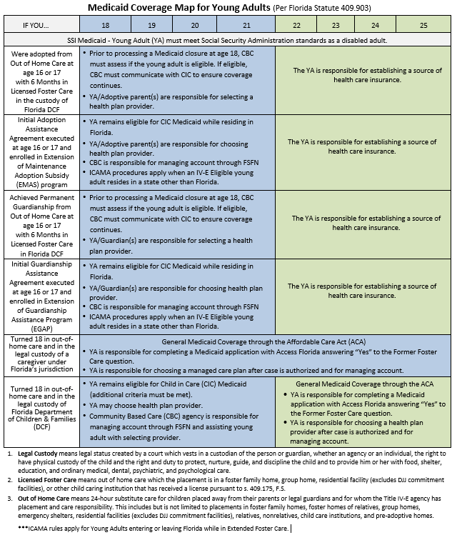

Reports
These reports are in the FSFN Reporting Environment within the Eligibility folder.
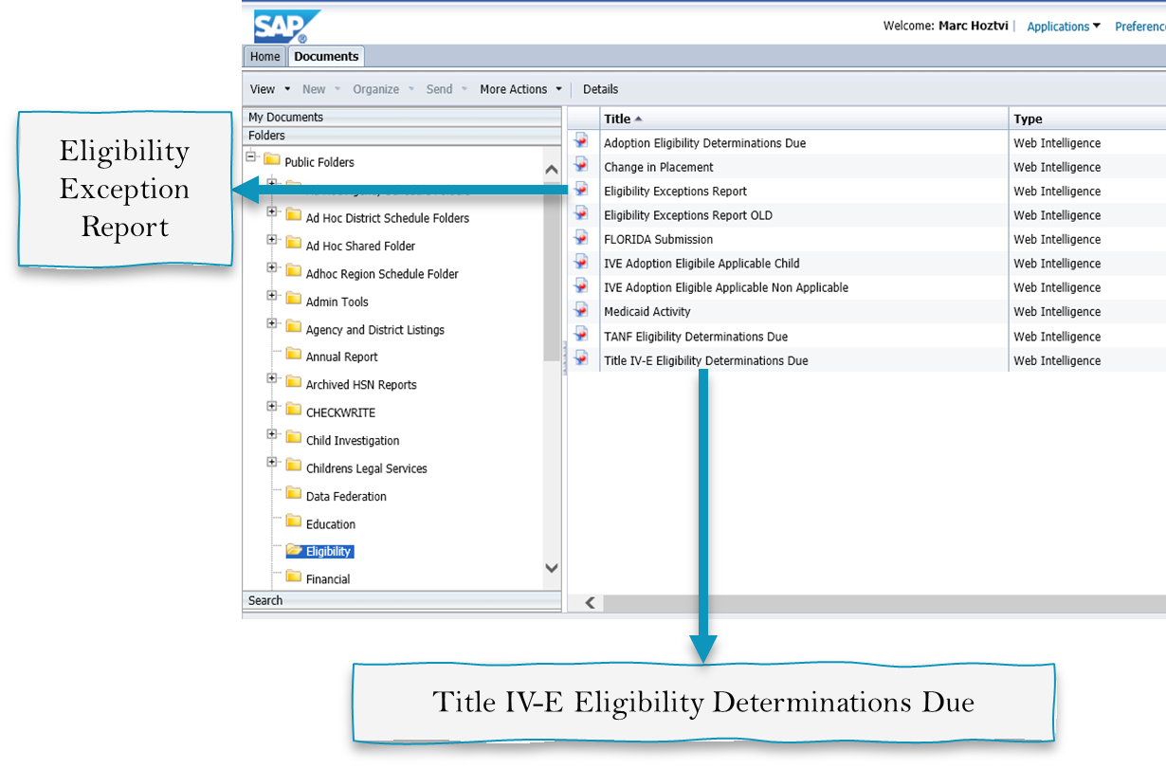
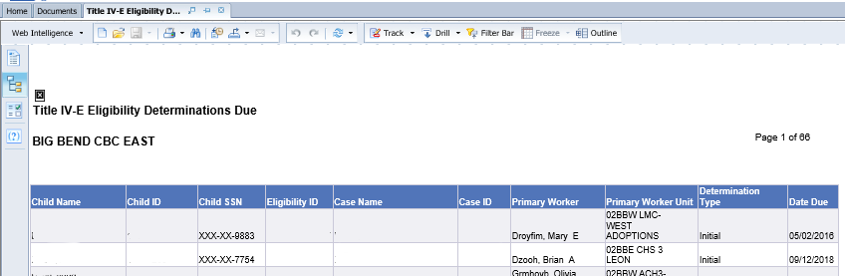
Title IV-E Eligibility Determinations Due Report

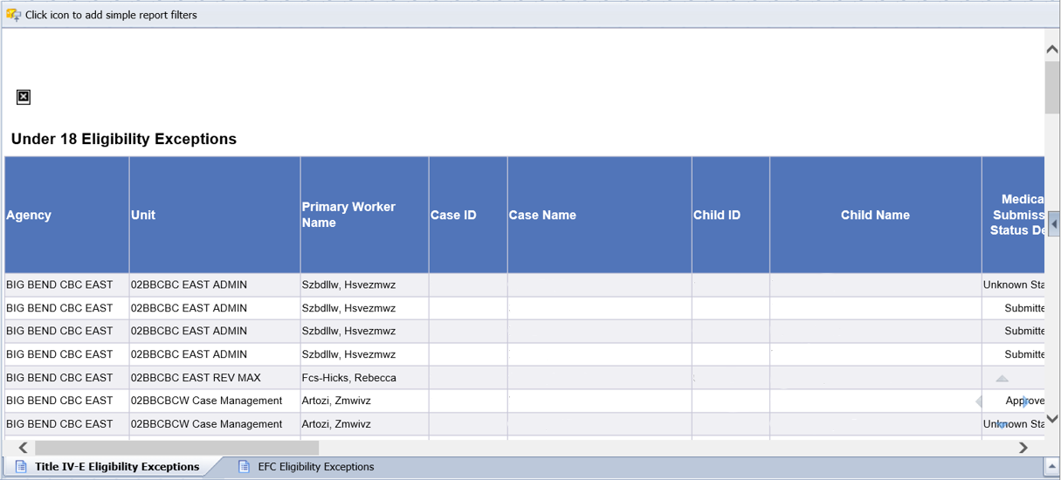
Under 18 Eligibility Exceptions Report

