Guardianship Assistance Program (GAP)

Session B
July 2019
Trainer’s Guide


Contents
How to Use This Guide 42
Layout of Information 42
Trainer Guide Icons 43
Course Summary 44
Session B Objectives 45
Guardianship Assistance Program (GAP) 46
GAP Application Form 47
Guardianship Assistance Program Negotiation 48
GAP Negotiation Rules 48
GAP vs. SSI and SSA 50
Enhanced Payments 51
Foster Care Board Rates 52
Local Process for Payments 53
Determination of GAP Payments 53
Guardianship Assistance Agreement 54
Successor Guardian 55
FSFN Guardianship Assistance Agreement 57
FSFN Guardianship Assistance Agreement Payment Entry 60
Discharge to Permanent Guardianship 63
Continued Program Eligibility 65
Annual Redetermination 66
Redetermination Process 67
Local Process for Holding Payments 68
Transferring to Successor Guardian 69
Redetermination 70
GAP Termination 73
FSFN GAP Termination Reasons 74
GAA Termination 75
FSFN GAA Termination Reasons 76
GAP Appeals 78
Conclusion of GAP 79
Extended Guardianship Assistance Program (EGAP) 80
Caregiver Benefits 80
Extended Guardianship Assistance Program (EGAP) Overview 81
Extended Guardianship Assistance Program (EGAP) Timeline Overview 82
Guardianship Assistance Agreement Established at the Age of 16 or 17 83
FSFN Extended Guardianship Assistance Agreement Election Question 84
Youth Transitioning to Young Adult (60-day Period) 85
EGAP Eligibility Requirements 85
Notification Prior to 18th Birthday 86
EGAP Qualifying Activities 87
Extension of Guardianship Assistance Agreement (EGAA) 88
Initiating EGAP 89
FSFN Extension of Guardianship Assistance Program 90
FSFN Extension of Guardianship Assistance Program 92
EGAP Education 96
Employment 98
Assets and Employment Program 99
Medical/Mental Health 100
Negotiating EGAP Payments 101
Finalizing the Agreement 102
EGAP Payments 104
EGAP Ongoing Program Eligibility 105
EGAP Redetermination Process 106
EGAP Termination 108
EGAP Termination Reasons 108
EGAP Termination for Appealable Reasons 109
FSFN EGAP Termination Reasons and Process 110
EGAP Readmission 112
FSFN Practice 114
Appendix 118

How to Use This Guide

Layout of Information
This guide is designed to assist the trainer in delivering this module through the use of color, layout, and graphics.
Shaded text indicates material that only the instructor sees. It contains your script, in black text, and background information, or directions in red text. This example shows your script.
Icons show the type of instructional strategy (i.e., presentation)

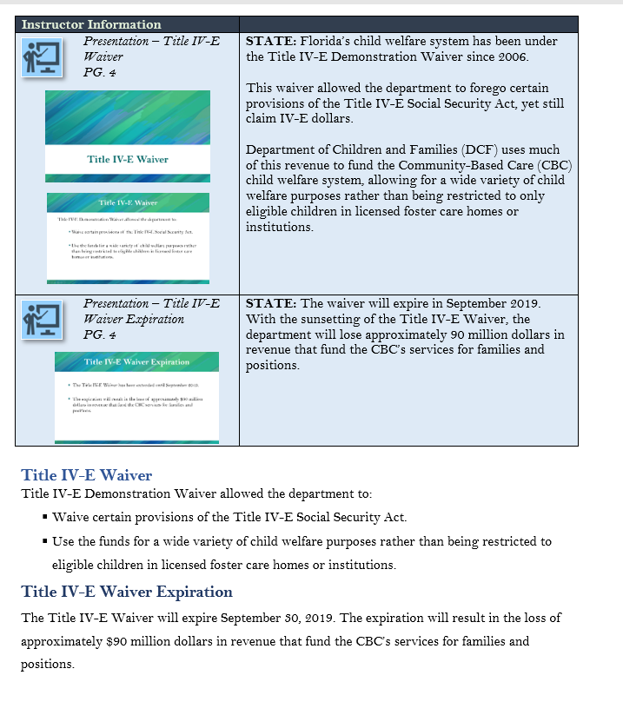
Participant Guide page number for your reference.

Copies of the PowerPoint™ slides that correspond to the Participant Guide pages.

Text and graphics on a white background is a replica of the Participant Guide page. You can refer to it to make your point and see exactly what the participants are seeing.

Trainer Guide Icons
 | Presentation

Course Summary
Course Goal: To enable trainees to apply the GAP and EGAP procedures for the eligible Permanent Guardianship cases.
Structure of Course
- Guardianship Assistance Program (GAP)
- GAP Continued Eligibility
- Extension of Guardianship Assistance Program (EGAP)
Length of Course: 6 hours
Materials and Supplies Required:
- Participants Guide
- PowerPoint Presentation
Equipment
- Computer
- LCD Projector
Instructional Methods
- Lecture
- Hands-on FSFN Practice

Session B Objectives
When you complete this session, you will be able to:
- Process the Guardianship Assistance Program Eligibility application.
- Negotiate the payment amount.
- Explain the Guardianship Assistance Agreement (GAA).
- Describe Successor Guardian.
- Describe the process for adding and changing the Successor Guardian processes.
- Describe the redetermination process.
- Identify the termination reasons.
- Describe the appeal process.
- Describe the readmission process.
- Document the processes in FSFN.
- Execute the Extension of Guardianship Assistance Program (EGAA).
- Identify qualifying activities.
- Describe the EGAP redetermination process.
- Describe the EGAP termination reasons.
- Describe the EGAP appeals.
- Describe the EGAP readmission process.
- Document the processes in FSFN.

Guardianship Assistance Program (GAP)
Instructor Information
Presentation – Session B Agenda  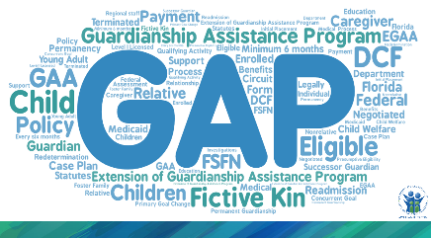  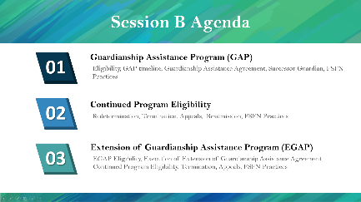 | STATE: Welcome to the train-the-trainer Guardianship Assistance Program (GAP) workshop Session B.  STATE: In this session, we will continue covering GAP processes, continued program eligibility requirements, and the Extension of Guardianship Assistance Program timeline and procedures.  Specifically, we will cover the following topics;  - Guardianship Assistance Program (GAP)  STATE: In this part, we will keep exploring the GAP stages.  - Continued Program Eligibility  STATE: Once a guardian is receiving GAP benefits, what should a guardian do to keep receiving the benefits? We will look at these processes.  - Extension of Guardianship Assistance Program  STATE: Last, we will look at the processes and procedures of the Extension of Guardianship Assistance Program. Also, we will explore the continued EGAP eligibility, termination reasons, and appeal process.
Instructor Information
Presentation – Session B Objectives  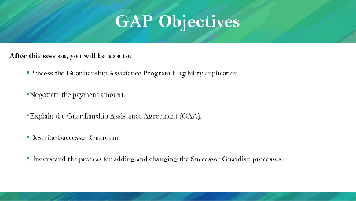  PG. 25 | STATE: Once you complete this session, you will be able to:  - Process the Guardianship Assistance Program Eligibility application.  - Negotiate the payment amount.  - Explain the Guardianship Assistance Agreement (GAA).  - Describe Successor Guardian.  - Describe the process for adding and changing the Successor Guardian processes.

GAP Application Form
Instructor Information
Presentation – GAP Application Process  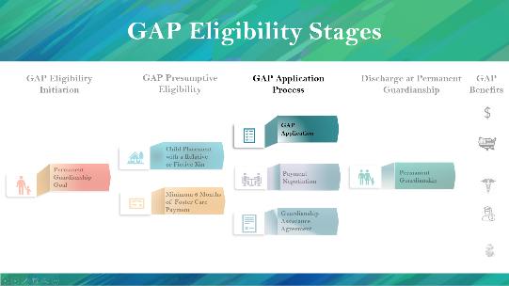  PG. 27  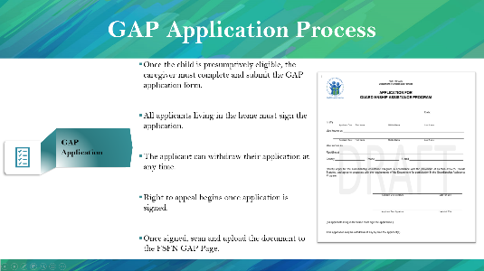 | STATE: Let’s look again at our GAP Eligibility Stages. As you can see, once the child is deemed presumptively eligible for GAP benefits, the relative or fictive kin must complete the GAP application to start the process.  NOTE: A copy of the form is in the appendix of the participant’s guide.  STATE: The form must be signed by all applicants living in the home. In this form, applicants refer to licensed caregivers. Anyone licensed in the same house must sign the application form.  Also, keep in mind that the applicants can withdraw their applications at any time if they change their minds. The caregiver’s right to appeal also begins once the form is signed.  STATE: Once the form is signed by all parties, scan and upload the document to the FSFN GAP Page.
GAP Application Process: GAP Application Form
- Once the child is presumptively eligible, the caregiver must complete and submit a GAP application form.
- All applicants living in the home must sign the application.
- The applicant can withdraw their application at any time.
- Right to Appeal begins once the application is signed.
- Once signed, scan and upload the document to the FSFN GAP Page.

Guardianship Assistance Program Negotiation

GAP Negotiation Rules
Instructor Information
Presentation – GAP – Negotiating Payments  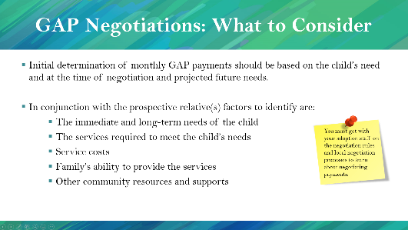  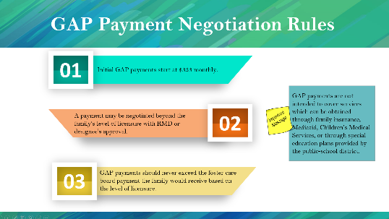  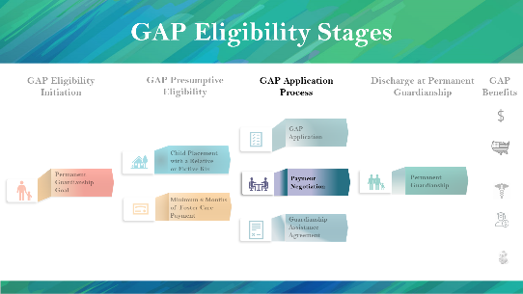  PG. 27 | STATE: Once the form is signed, the child welfare professional and caregiver should negotiate a payment amount based on the child’s needs.  STATE: Three general rules around negotiation apply to all cases.  - Initial GAP payments start at 333 dollars per child monthly.  - The payment may be negotiated beyond the family’s level of licensure with RMD or designee’s approval.  - The GAP payment should never exceed the foster care board level payment the family would receive based on the level of licensure.  STATE: Always remember these rules. They do not change.  So, what should you pay attention when negotiating with the relative or fictive kin?  Keep in mind the child’s need at the time of negotiation and projected future needs. Pay attention to:  - The immediate and long-term needs of the child  - The services required to meet the child’s needs  - Service costs  - Family’s ability to provide the services  - Other community resources and supports  STATE: Remember, each child is different, and each circumstance is different.  STATE: GAP Payments are not intended to cover services which can be obtained through family insurance, Medicaid, Children’s Medical Services, medical subsidy, or through special education plans provided by the public-school district.  STATE: You MUST get with your adoption staff for additional training on negotiation rules and local negotiation processes.
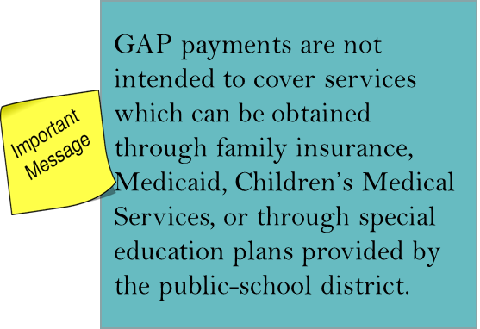
GAP Eligibility Initiation: Negotiating Payments
- Initial GAP payments start at $333 per child monthly.
- The payment may be negotiated beyond the family’s level of licensure with RMD or designee’s approval.
- GAP payments should never exceed the foster care board level payment the family would receive based on the level of licensure.
GAP Negotiations: What to Consider
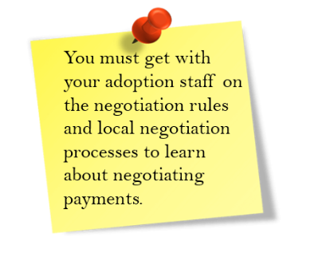
- The initial determination of monthly GAP payments should be based on the child’s need and at the time of negotiation and projected future needs.
- In conjunction with the prospective relative(s) factors to identify are:
    - The immediate and long-term needs of the child
    - The services required to meet the child’s needs
    - Service costs
    - Family’s ability to provide the services
    - Other community resources and supports

GAP vs. SSI and SSA
Instructor Information
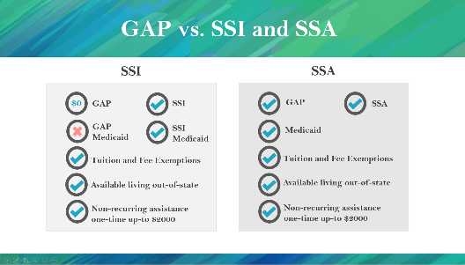  Presentation – GAP vs. SSI and SSA PG. 28 | STATE: During the negotiation, remember whether the child is receiving SSI or SSA may affect his or her GAP payment eligibility.  STATE: Because SSI and GAP are coming from the Title IV-E fund, a child receiving SSI is not eligible for GAP payments. However, the guardian must still sign a $0 agreement. In the case of the child no longer receiving SSI, the child will become eligible for GAP payments. In that case, the guardian must inform the CBC, and a new GAA must be executed with the new payment amount.  Under SSI, the child is also eligible for SSI Medicaid, which is a better option than GAP Medicaid. Therefore, the child will not be covered under GAP Medicaid. However, the child is eligible for other benefits, such as tuition and fee exemption, available to live out-of-state, and non-recurring assistance one-time up-to $2000.  STATE: If the guardian is receiving SSA, the child is still eligible for both GAP and SSA payments along with the other GAP benefits (i.e., Medicaid, tuition and fee exemption, available to live out-of-state, and non-recurring assistance one-time up-to $2000).
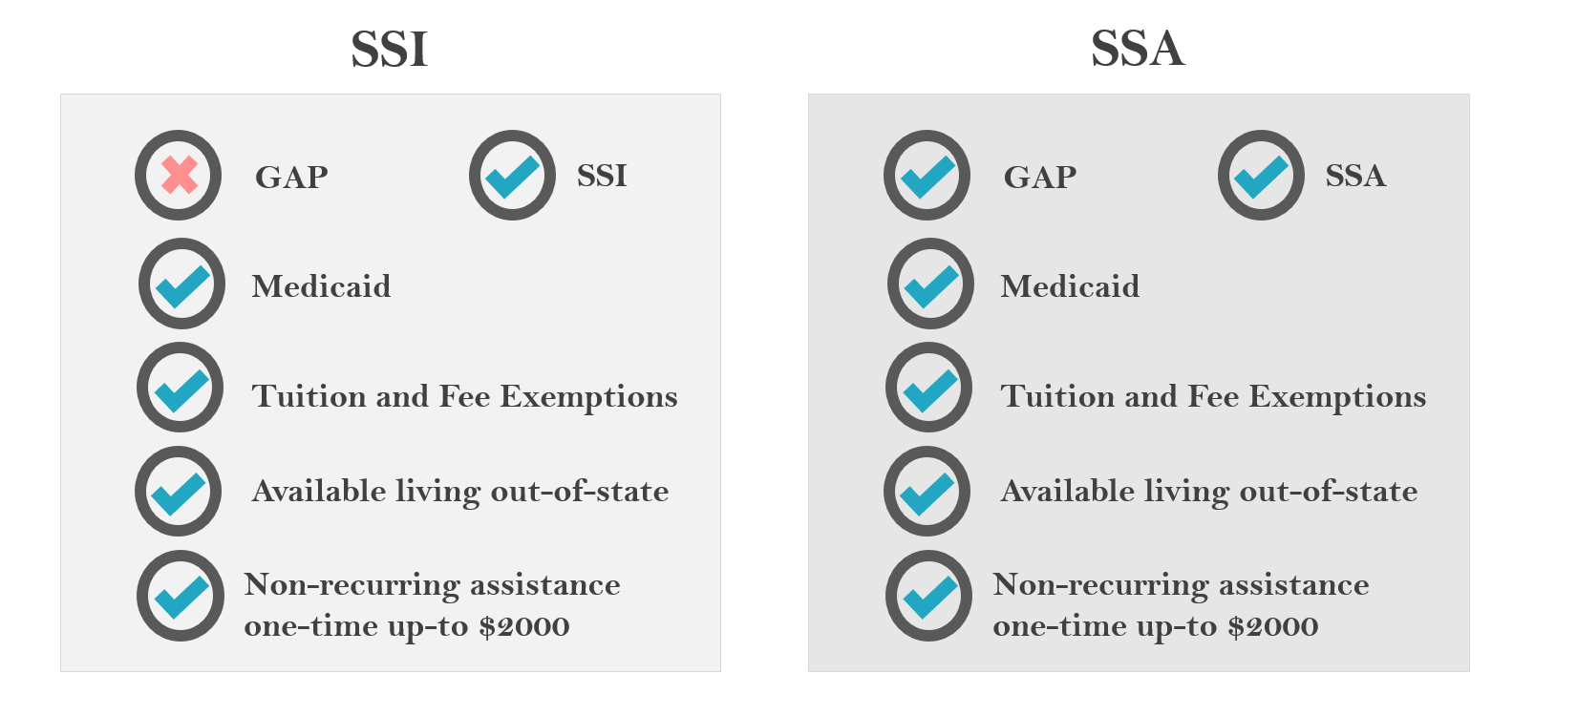
GAP vs. SSI and SSA

Enhanced Payments
Instructor Information
Presentation – Enhancement Payments  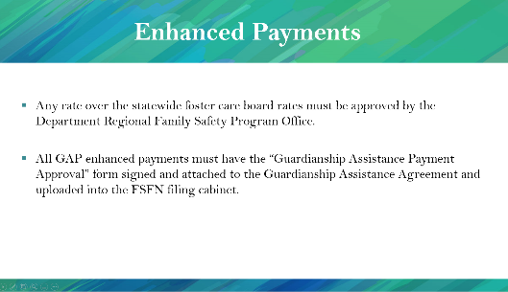  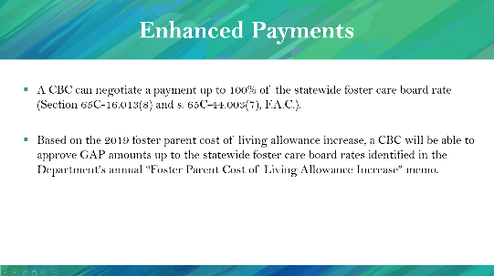  PG. 29 | STATE: A CBC can negotiate a payment up to 100% of the statewide foster care board rate (CFOP 170-10 Chapter 14, section 14-5i.)  Based on the 2019 foster parent cost of living allowance increase, a CBC will be able to approve GAP amounts up to the statewide foster care board rates for families licensed as Level II-V identified in the Department’s annual “Foster Parent Cost of Living Allowance Increase” memo.  Any rate over the statewide foster care board rates must be approved by the Department Regional Family Safety Program Office.  All GAP enhanced payments must have the “Guardianship Assistance Payment Approval” form signed and attached to the Guardianship Assistance Agreement and uploaded into the FSFN filing cabinet.
Enhanced Payments
- A CBC can negotiate a payment up to 100% of the statewide foster care board rate (CFOP 170-10 Chapter 14, section 14-5i)
- Based on the 2019 foster parent cost of living allowance increase, a CBC will be able to approve GAP amounts up to the statewide foster care board rates for families licensed as Level II-V identified in the Department’s annual “Foster Parent Cost of Living Allowance Increase” memo.
- Any rate over the statewide foster care board rates must be approved by the Department Regional Family Safety Program Office.
- All GAP enhanced payments must have the “Guardianship Assistance Payment Approval” form signed and attached to the Guardianship Assistance Agreement and uploaded into the FSFN filing cabinet.

Foster Care Board Rates
Instructor Information
Presentation – Foster Care Board Rates  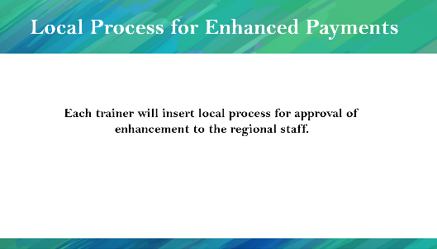  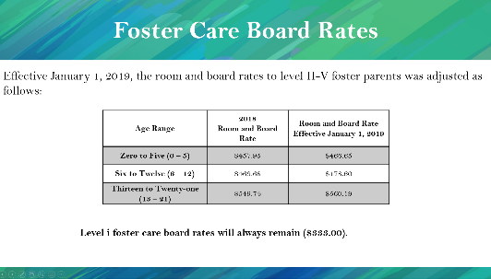  PG. 29 | STATE: Effective January 1, 2019, the room and board rates to level II-V foster parents was adjusted as follows:  READ the slide.  STATE: Level I Foster Care Board Rates will always remain $333.  NOTE: Insert your local process for approval of enhancement to the regional staff.
Foster Care Board Rates
Effective January 1 the room and board rates to level II-V foster parents was adjusted as follows:
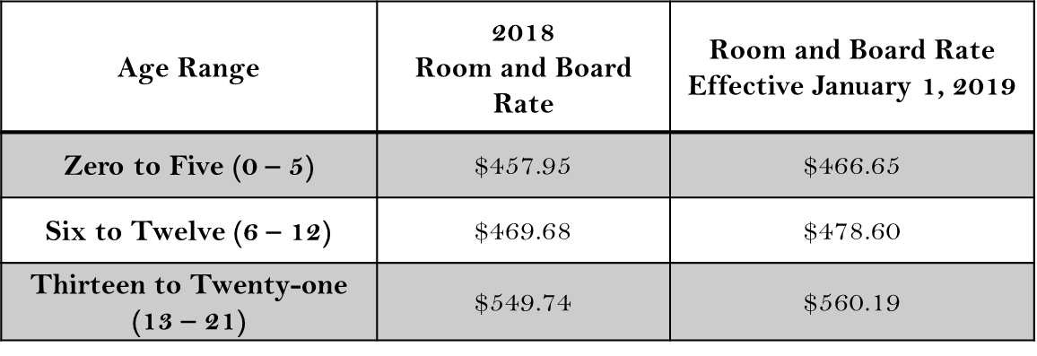

Level I Foster Care Board Rates will always remain $333.

Local Process for Payments
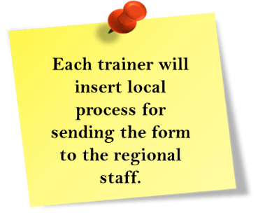

Determination of GAP Payments
Instructor Information
Presentation – Determination of GAP Payments  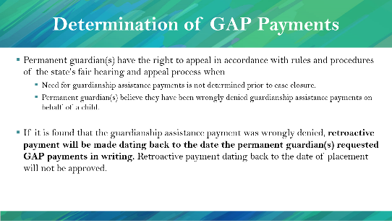  PG. 30 | STATE: If a guardian feels like she or he has been wrongly denied GAP payments or the need for GAP payments is not determined before case closure, the guardian has the right to appeal by the state’s fair hearing process.  STATE: If it is found that the guardianship assistance payment was wrongly denied, retroactive payments will be made dating back to the date the relative(s) requested GAP payments in writing. Retroactive payment dating back to the date of placement will not be approved.
Determination of GAP Payments
- Relatives(s) have the right to appeal by rules and procedures of the state’s fair hearing and appeal process when:
- The need for guardianship assistance payments is not determined before case closure.
- Relative(s) believe they have been wrongly denied guardianship assistance payments on behalf of a child.
- If it is found that the guardianship assistance payment was wrongly denied, retroactive payment will be made dating back to the date the relative(s) requested GAP payments in writing. Retroactive pay dating back to the date of placement will not be approved.

Guardianship Assistance Agreement
Instructor Information
Presentation – GAP Application Process: Guardianship Assistance Agreement  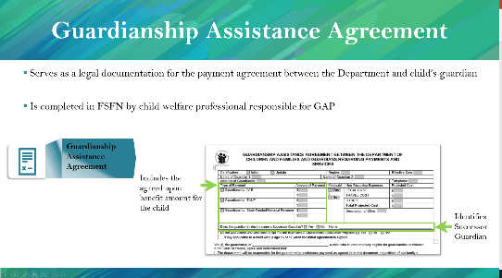  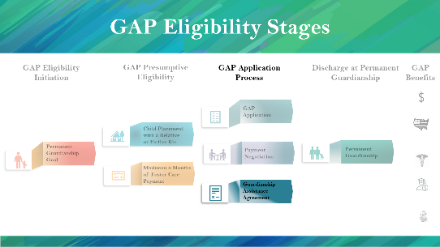  PG. 31 | STATE: The Guardianship Assistance Agreement (GAA) serves as a legal document between the Department and the child’s guardian.  The Guardianship Assistance Agreement (GAA) is crucial for GAP eligibility because if the relative or fictive kin does not sign the agreement; they will not be eligible for GAP benefits.  The child welfare professional responsible for GAP will complete the form in FSFN.  The form includes the agreed upon benefits for the child and identifies the Successor Guardian.  NOTE: A copy of the GAA is included in the appendix of the participant’s guide.
GAP Application Process: Guardianship Assistance Agreement
- Serves as a legal documentation for payment between the Department and the child’s relative.
- Is completed in FSFN by child welfare professional responsible for GAP.
- Includes the agreed upon benefits for the child.
- Identifies the Successor Guardian.

Successor Guardian
Instructor Information
Presentation – Successor Guardian  PG. 31  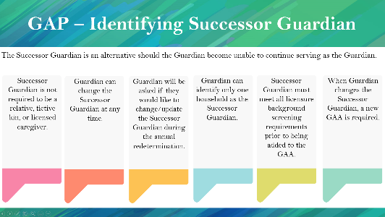 | STATE: The Successor Guardian is defined as the alternative guardian if the current guardian becomes unable to continue serving as the guardian.  - The Successor Guardian is not required to be a relative, fictive kin, or licensed caregiver.  - Guardian can change the Successor Guardian at any time.  - The guardian will be asked if they would like to change/update the Successor Guardian during the annual redetermination. The annual redetermination process will be discussed later in this session.  - The guardian can identify only one household as the Successor Guardian.  - The Successor Guardian must meet all background screening requirements prior to being added to the GAA.  - When the Guardian changes the Successor Guardian, a new GAA is required.  STATE: Document the background check for a Successor Guardian on the current caregiver’s Person Provider page. Add the Successor Guardian as a non-household member on the Members tab, and the Successor Guardian will be available on the Background Screening page (launched from the Actions panel).
Presentation – Background Screening for Successor Guardian  PG. 32  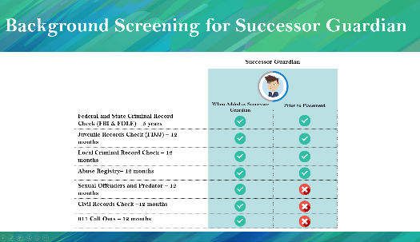 | STATE: The Successor Guardian goes through two background checks: the first occurs when added as the Successor Guardian and the second is Prior to Placement. When added as the Successor Guardian, the following background checks are conducted in accordance with Ch. 39 standards:  - Federal and State Criminal Record Check (FBI & FDLE)  - Juvenile Records Check (FDJJ)  - Local Criminal Record Check  - Abuse Registry  - Sexual Offenders and Predator  - Civil Records Check  - 911 Call Outs  If the child is placed with the Successor Guardian, the following background checks will be conducted in accordance with Ch. 39 standards:  - Federal and State Criminal Record Check (FBI & FDLE)  - Juvenile Records Check (FDJJ)  - Local Criminal Record Check  - Abuse Registry
Successor Guardian
- The Successor Guardian is an alternative should the Relative become unable to continue serving as the Relative.
- The Successor Guardian is not required to be a relative, fictive kin, or licensed caregiver.
- Relative can change the Successor Guardian at any time
- Guardian will be asked if they would like to change/update the Successor Guardian during the annual redetermination.
- Guardian can identify only one household as the Successor Guardian.
- Successor Guardian must meet all background screening requirements prior to being added to the GAA.
- When the guardian changes the Successor Guardian, a new GAA is required.
Background Screenings for Successor Guardian
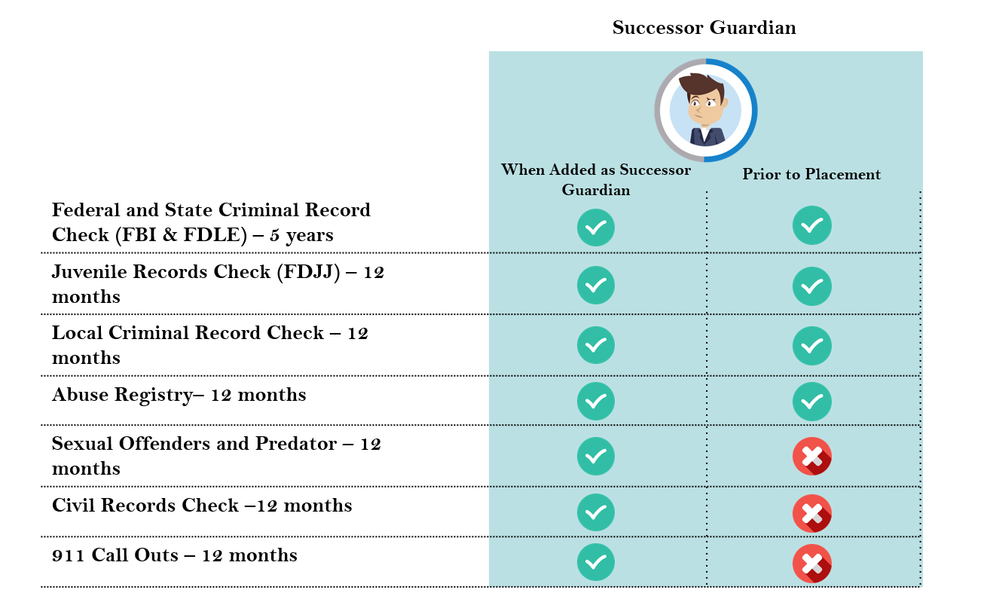

FSFN Guardianship Assistance Agreement
Instructor Information
Presentation – FSFN  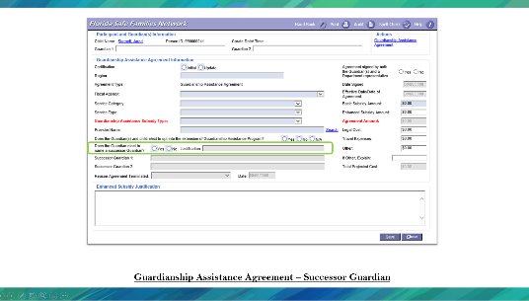  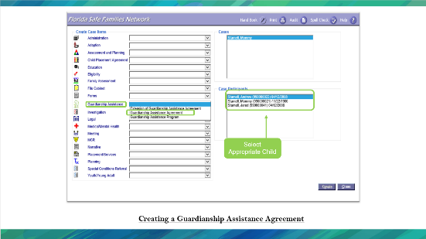  PG. 33 | STATE: There are two ways to create a Guardianship Assistance Agreement.  Via Case Work Button  From the FSFN Desktop select the Case Work Button. From Create Case Work, select the Case name then select the participant (child), which will receive the payments. On the left side of the page, under the Create Case Items, look for the label Guardianship assistance. In the drop-down, select Guardian Assistance Agreement. Double check all selections and select “create” at the bottom right side of the page.  Via Case Book  Collapse all Expandos on the left side of the FSFN Desktop. Open the Expando labeled Cases. Select the Case Book hyperlink next to the appropriate Case. On the right side of Case Book, select Guardianship Assistance Agreement under the Participant Actions. Choose participant (child), which will receive the payments. Double check all selections and select “create” at the bottom right side of the page.  Successor Guardian: When completing the Guardianship Assistance Agreement, if the Relative has selected a Successor Guardian, that information can be placed here.  HIGHLIGHT: Successor Guardian is a federal requirement. If the guardian chooses not to identify a Successor Guardian, the child welfare professional should document that reasonable efforts were made to identify a Successor Guardian.

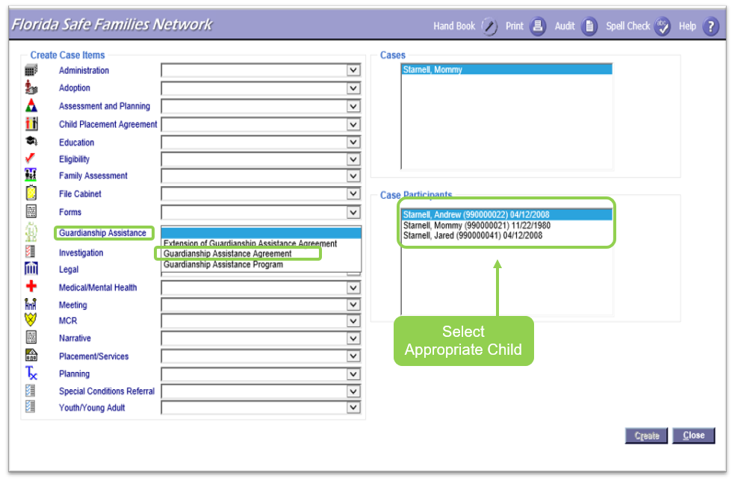
Creating a Guardianship Assistance Agreement
Via Case Work Button
From the FSFN Desktop, select the Case Work Button. From Create Case Work select the Case name then select the participant (child), which will receive the payments. On the left side of the page, under the Create Case Items, look for the label Guardianship assistance. In the drop-down, select Guardian Assistance Agreement. Double check all selections and select “create” at the bottom right side of the page.
Via Case Book
Collapse all Expandos on the left side of the FSFN Desktop. Open the Expando labeled Cases. Select the Case Book hyperlink next to the appropriate Case. On the right side of Case Book, select Guardianship Assistance Agreement under the Participant Actions. Select participant (child), which will receive the payments. Double check all selections and select “create” at the bottom right side of the page.

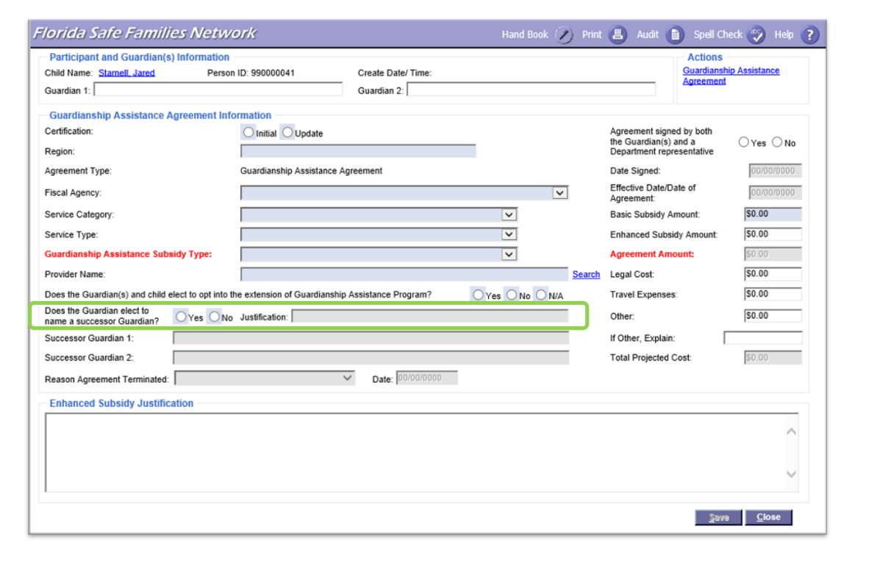
Guardianship Assistance Agreement – Successor Guardian
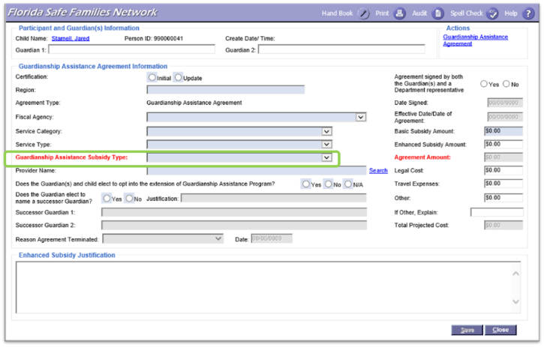
When completing the Guardianship Assistance Agreement, if the Relative has selected a Successor Guardian, that information can be placed here. If they have not selected a Successor Guardian, the Justification section must be filled out. In the Justification section, child welfare professional should document that reasonable efforts were made to identify a Successor Guardian. Background Checks must be completed when the Successor Guardian has been identified.

FSFN Guardianship Assistance Agreement Payment Entry
Instructor Information
Presentation –Guardianship Assistance Program (GAP)  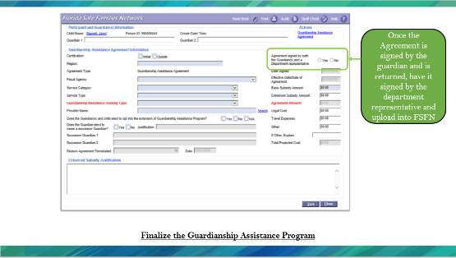  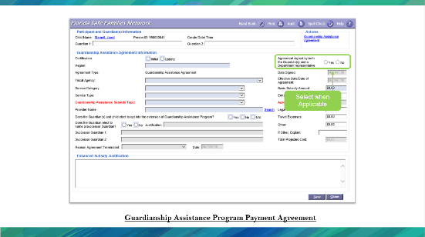  PG. 35  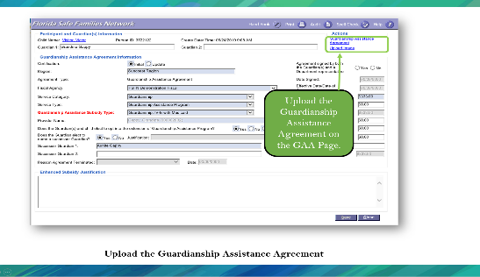  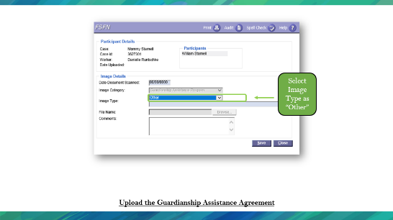 | STATE: Once the Guardianship Assistance Agreement has been signed, upload an image of the document to FSFN on the Guardianship Assistance Agreement Page.
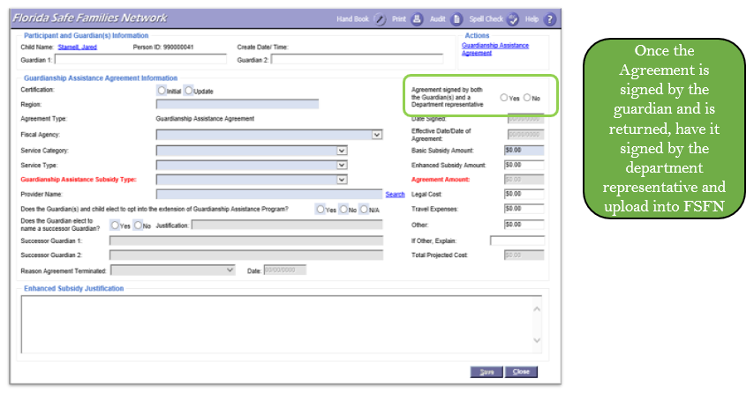
Finalize the Guardianship Assistant Agreement
Upload the Guardianship Assistance Program Agreement
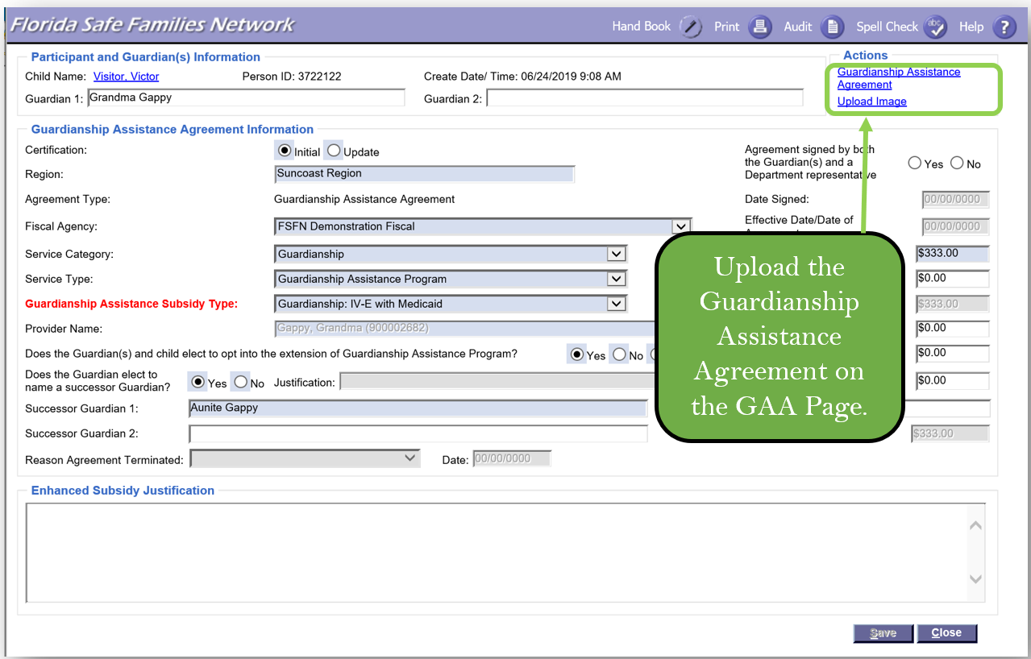
Once the Guardianship Assistance Agreement has been signed, upload an image of the document to FSFN on the Guardianship Assistance Agreement Page.

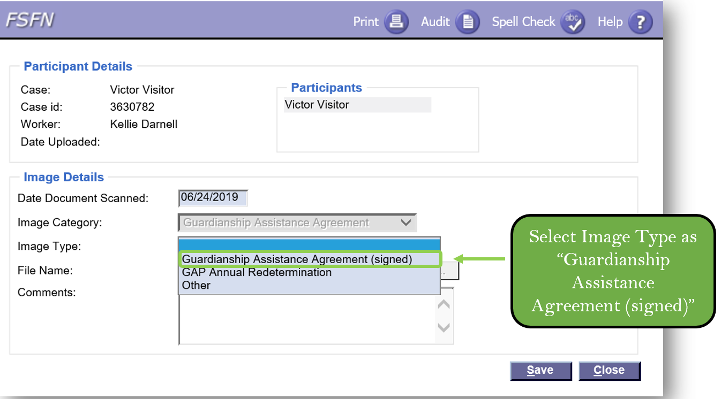

Discharge to Permanent Guardianship
Instructor Information
Presentation – GAP Application Process: Discharge to Permanent Guardianship  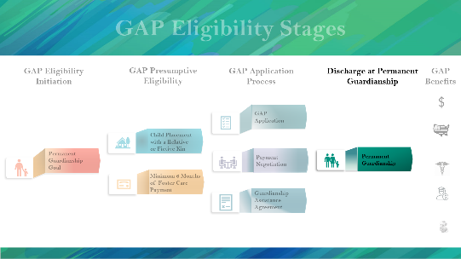  PG. 38  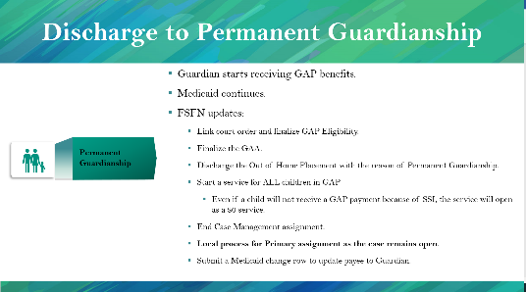  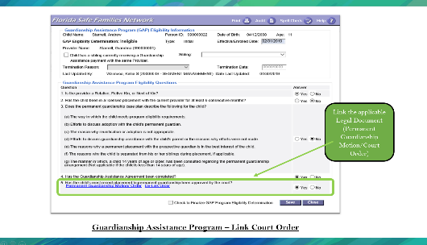 | STATE: Once the court discharges the child to permanent guardianship:  - Guardian starts receiving GAP benefits.  - Medicaid continues.  - FSFN updates:  - Link court order and finalize GAP Eligibility.  - Finalize the GAA.  - Discharge the Out of Home Placement with the reason of Permanent Guardianship.  - Start a service for ALL children in GAP  - Even if a child does not receive a GAP payment because of SSI, the service will open as a $0 service.  - End Case Management assignment.  - Local process for Primary assignment as the case remains open.  - Submit a Medicaid change row to update the payee to the Guardian.
GAP Application Process: Discharge to Permanent Guardianship
- Guardian starts receiving GAP benefits.
- Medicaid continues.
- FSFN updates:
  - Link court order and finalize GAP Eligibility.
  - Finalize the GAA.
  - Discharge the Out of Home Placement with reason of Permanent Guardianship.
  - Start a service for ALL children in GAP.
  - Even if a child does not receive a GAP payment because of SSI, the service will open as a $0 service.
  - End Case Management assignment.
  - Local process for Primary assignment as the case remains open.
  - Submit a Medicaid change row to update payee to Guardian.
Guardianship Assistance Program – Link Court Order
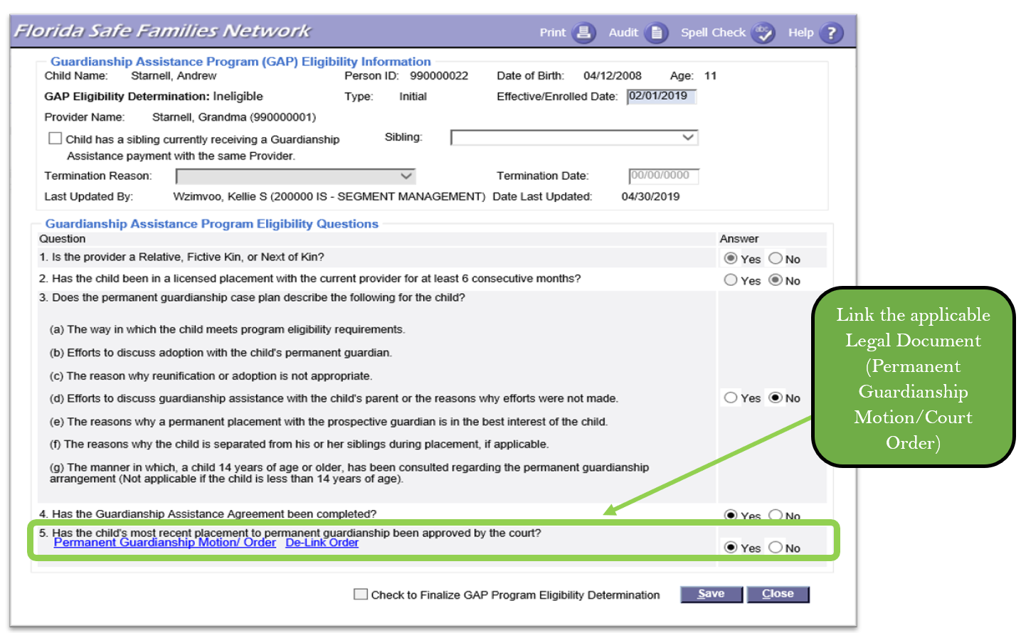

Continued Program Eligibility
Instructor Information
Presentation – Continued Program Eligibility  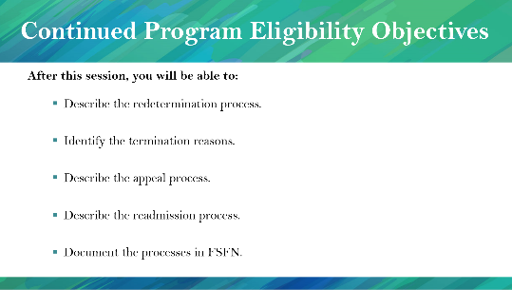  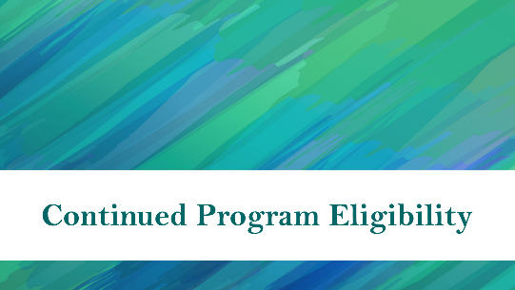  PG. 39 | STATE: Once the guardian receives the GAP benefits on behalf of the child, they need to go through the annual redetermination process to continue receiving the benefits.  In line with that, after this session, you will be able to  - Describe the redetermination process.  - Identify the termination reasons.  - Describe the appeal process.  - Describe the readmission process.  - Document the processes in FSFN.

Annual Redetermination
Instructor Information
Presentation – Annual Redetermination  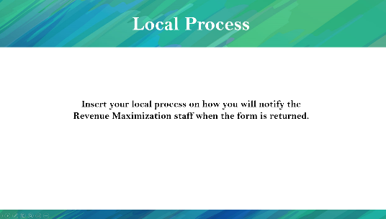  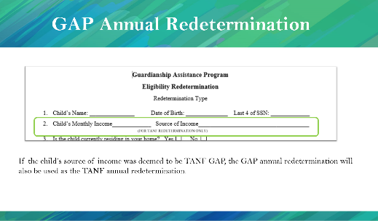  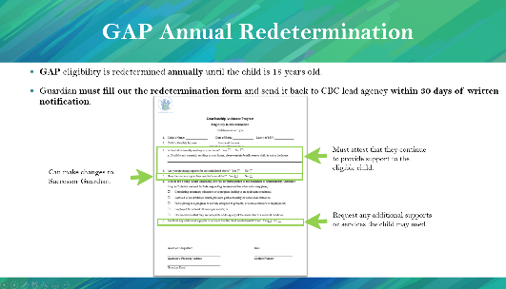  PG. 39 | STATE: GAP eligibility is redetermined annually until the child is 18 years old.  - Relative must fill out the redetermination form and send it back to CBC lead agency within 30 days of written notification.  - Relative must attest that they continue to provide support to the eligible child.  - Relative can make changes to Successor Guardian.  - Relative may request any additional supports and services the child may need.  STATE: If the child’s source of income was deemed to be TANF, the GAP annual redetermination would also serve as the TANF annual determination.  NOTE: A copy of the Annual Redetermination form is included in the appendix of the participant’s guide.  NOTE: Insert your local process on how you will notify the Revenue Maximization staff when the form is returned.
Annual Redetermination
- GAP eligibility is redetermined annually until the child is 18 years old.
- Relative must fill out the redetermination form and send it back to CBC lead agency within 30 days of written notification.
- Relative must attest they continue to provide support to the eligible child.
- Relative can make changes to Successor Guardian.
- Relative may request any additional supports and services the child may need.

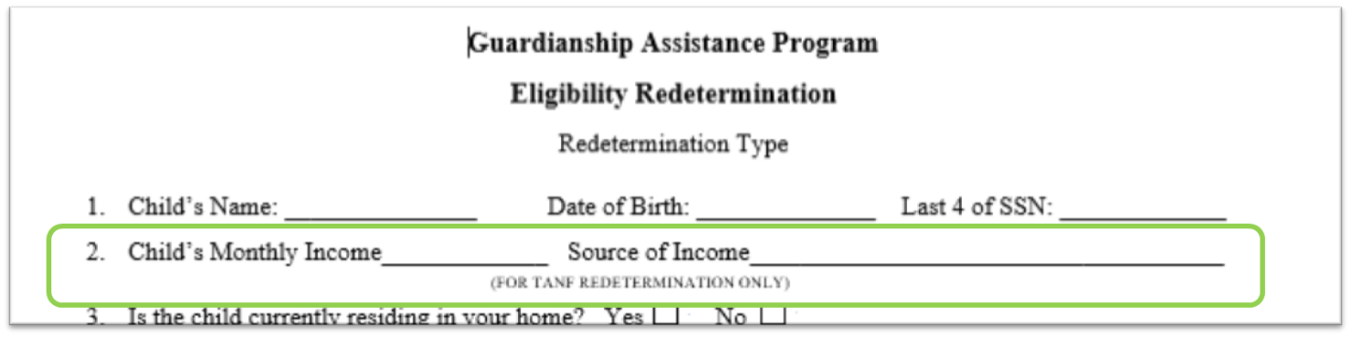
If the child’s source of income was deemed to be TANF GAP, the GAP annual redetermination would also be used as the TANF annual redetermination.

Redetermination Process
Instructor Information
Presentation – GAP Redetermination Process  PG. 40  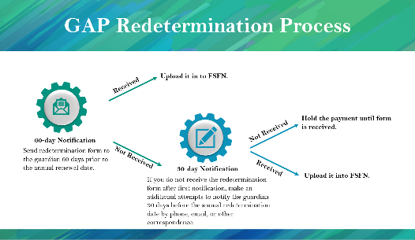 | STATE: Child welfare professional responsible for GAP will send the redetermination form to the guardian 60 days prior to the annual renewal date. If they do not receive the form 30 days before the annual renewal date, the form will be sent again. Try different methods to communicate with the guardian if needed, such as email or by phone, if you have that information. If you do not receive the form before the annual renewal date, hold the payments until the guardian responds.
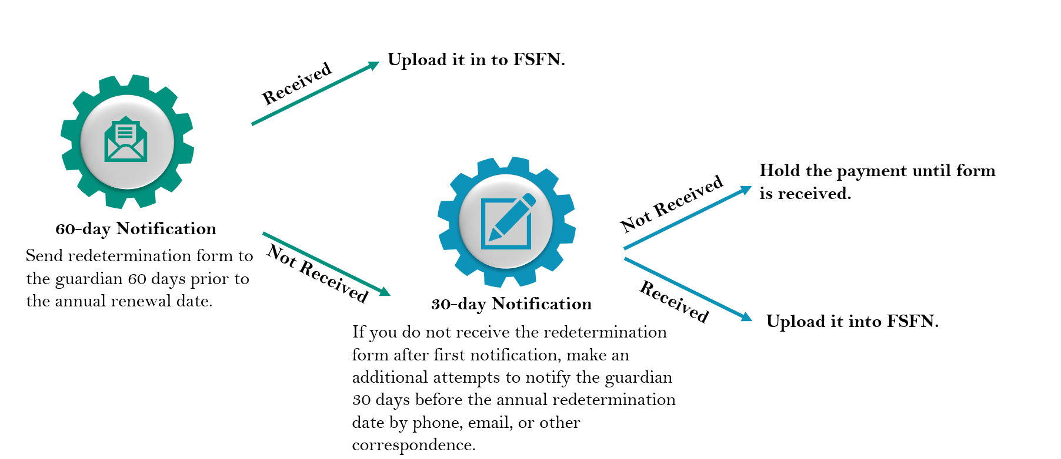
Redetermination Process

Local Process for Holding Payments
Instructor Information
Presentation – Local Process for Holding Payments  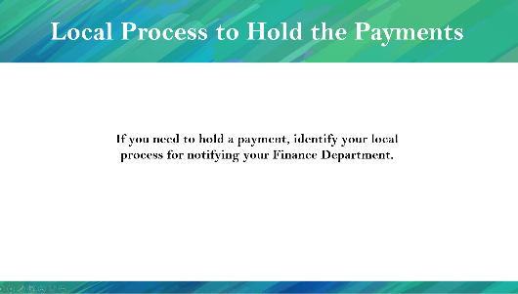 | NOTE: If your CBC decides to hold the payments, please identify your local process.

Transferring to Successor Guardian
Instructor Information
Presentation – Transferring Successor Guardian  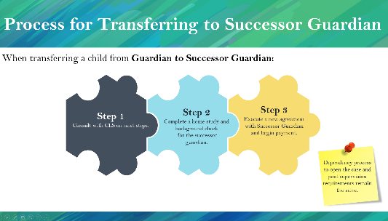  PG. 41 | STATE: When transferring a child from the original guardian to a Successor Guardian,  - Consult with CLS on next steps to reopen the case immediately.  - Complete a home study and background check for the Successor Guardian.  - Execute a new agreement with Successor Guardian and begin payment.  HIGHLIGHT: The dependency process to open the case and post-supervision requirements remain the same.  STATE: The Successor Guardian does not need to get licensed or be eligible for 6 consecutive months of foster care board payments. However, when placing the child with the Successor Guardian, a Unified Home Study must be completed.  The Successor Guardian will receive GAP benefits once the court approves the child’s placement with the Successor Guardian. If the court order for discharging to Permanent Guardianship takes longer than expected, the payment effective date will be retroactive to the date that the GAA was signed.
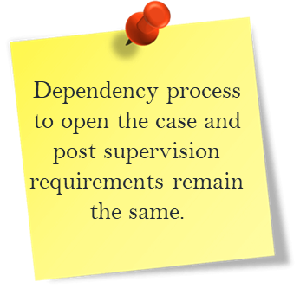
Process for Transferring to Successor Guardian
When transferring a child from guardian to Successor Guardian,
- Consult with CLS on next steps.
- Complete a Unified Home Study and background check for the Successor Guardian.
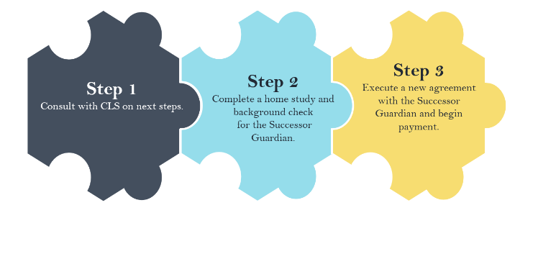
- Execute a new agreement with Successor Guardian and begin payment.

Redetermination
Instructor Information
Presentation – Redetermination  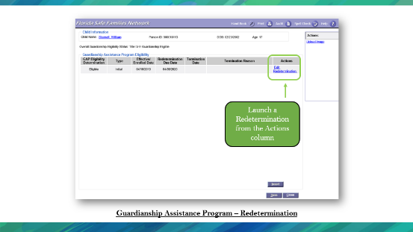  PG. 41  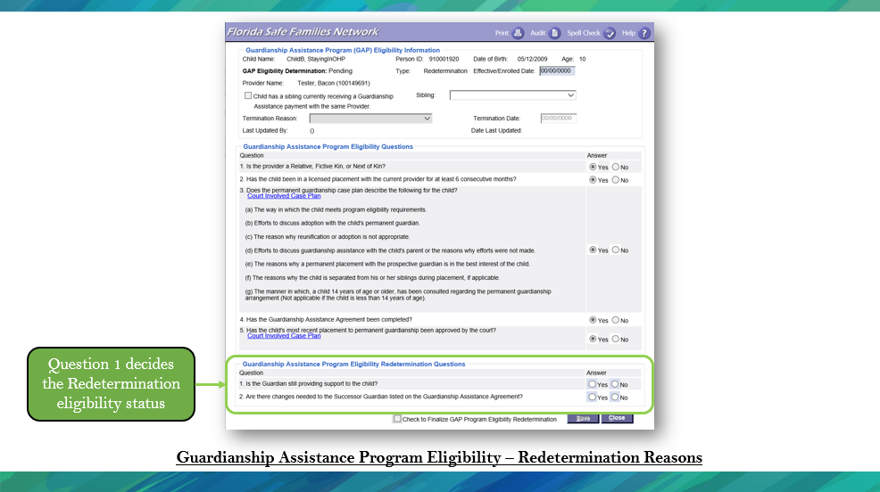 | STATE: Let’s look at how the annual redetermination will be completed.  Once the Initial GAP Eligibility page is completed and frozen, if the Eligibility Determination is Eligible, a Redetermination hyperlink displays in the Action column below the Edit hyperlink.  By selecting the Redetermination Hyperlink, a new GAP Page will launch with the redetermination information at the bottom of the page.  STATE: Question 1 determines the Redetermination eligibility status. If yes is selected, the child and guardian continue to be eligible for GAP payments. If no is selected, the payments are held, and the appeal process begins.  Upload the returned form into the File Cabinet on the FSFN GAP page.
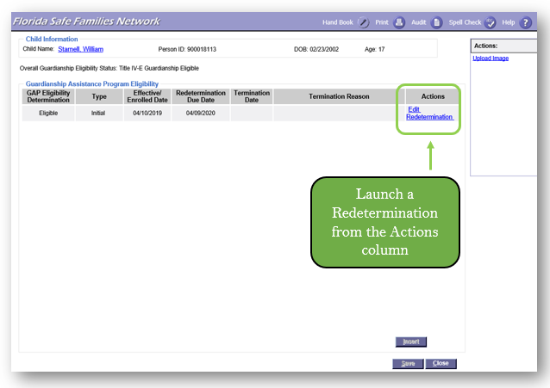
Guardianship Assistance Program – Redetermination
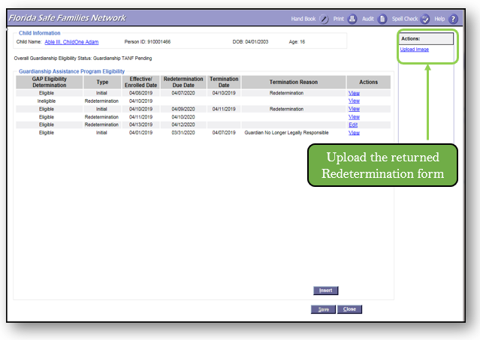
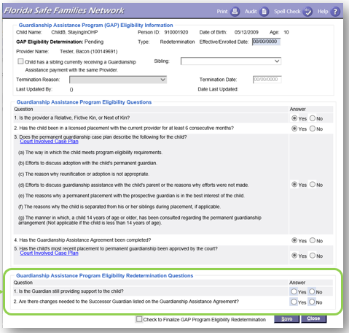
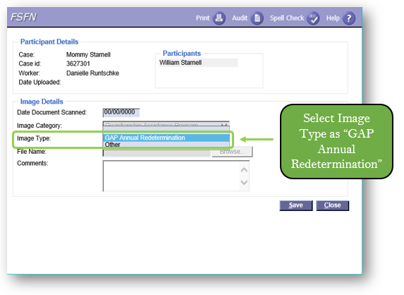

GAP Termination
Instructor Information
Presentation – GAP Termination  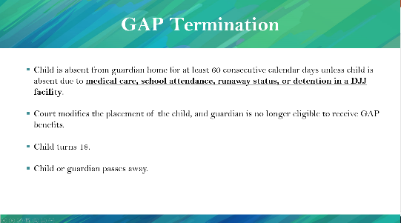  PG. 44  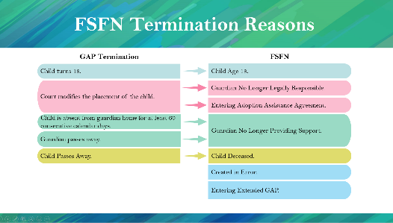 | STATE: The following are reasons GAP can be terminated:  - The child is absent from the relative home for at least 60 consecutive calendar days unless the child is absent due to medical care, school attendance, runaway status, or detention in a DJJ facility.  - The Court modifies the placement of the child, and the relative is no longer eligible for GAP benefits.  - The child turns 18.  - The child or relative passes away.  HIGHLIGHT: If the guardian passes away, the GAA needs to be terminated, but the program benefits remain.  STATE: As you can see in the chart, the Termination Reasons are matched up with the options provided in FSFN for documentation purposes.  READ the slide.
Presentation – GAA Termination  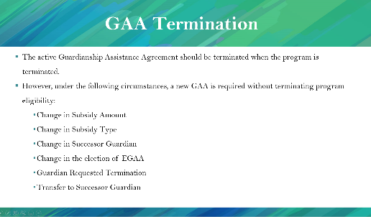  PG. 44  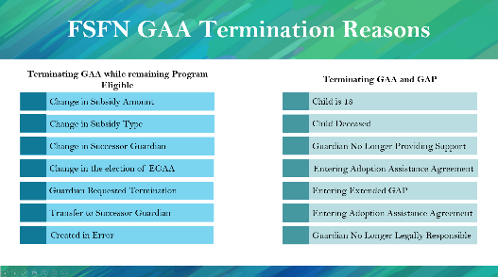  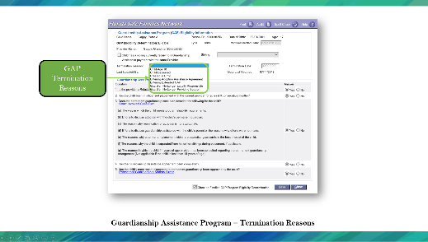  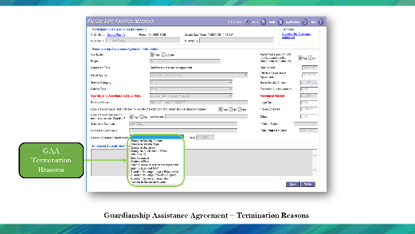 | STATE: The active Guardianship Assistance Agreement should be terminated when the program is terminated. However, under the following circumstances, a new GAA is required without terminating program eligibility:  - Change in Subsidy Amount  - Change in Subsidy Type  - Change in Successor Guardian  - Change in the election of EGAA  - Guardian Requested Termination  - Transfer to Successor Guardian  Under these circumstances, terminate the active GAA and create a new agreement. Do not terminate program eligibility.
GAP Termination
Program eligibility for GAP terminates when one of the following occurs:
- Child is absent from relative home for at least 60 consecutive calendar days unless child is absent due to medical care, school attendance, runaway status, or detention in a DJJ facility.
- Court modifies the placement of the child, and the relative is no longer eligible for GAP benefits.
- Child turns 18.
- Child or relative passes away.

FSFN GAP Termination Reasons
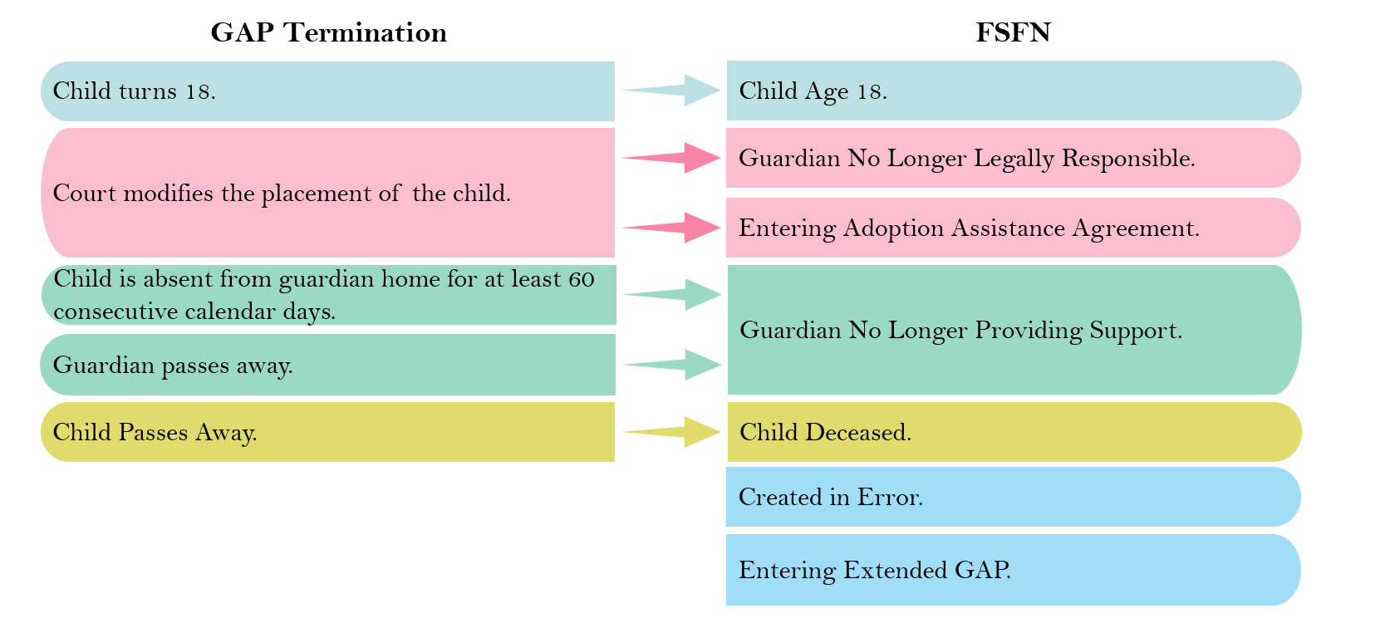

GAA Termination
Instructor Information
Presentation – GAA Termination  PG. 44 | STATE: The active Guardianship Assistance Agreement should be terminated when the program is terminated. However, under the following circumstances, a new GAA is required without terminating program eligibility:  - Change in Subsidy Amount  - Change in Subsidy Type  - Change in Successor Guardian  - Change in the election of EGAA  - Guardian Requested Termination  - Transfer to Successor Guardian  Under these circumstances, terminate the active GAA and create a new agreement. Do not terminate program eligibility.

- The active Guardianship Assistance Agreement should be terminated when the program is terminated.
- However, under the following circumstances, a new GAA is required without terminating program eligibility:
  - Change in Subsidy Amount
  - Change in Subsidy Type
  - Change in Successor Guardian
  - Change in the election of EGAA
  - Guardian Requested Termination
  - Transfer to Successor Guardian

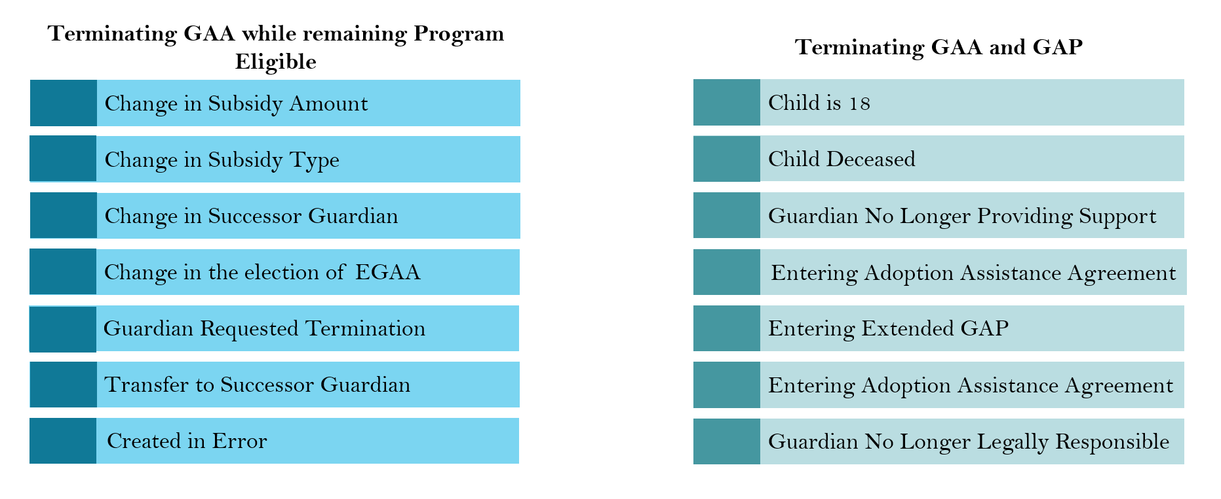
FSFN GAA Termination Reasons

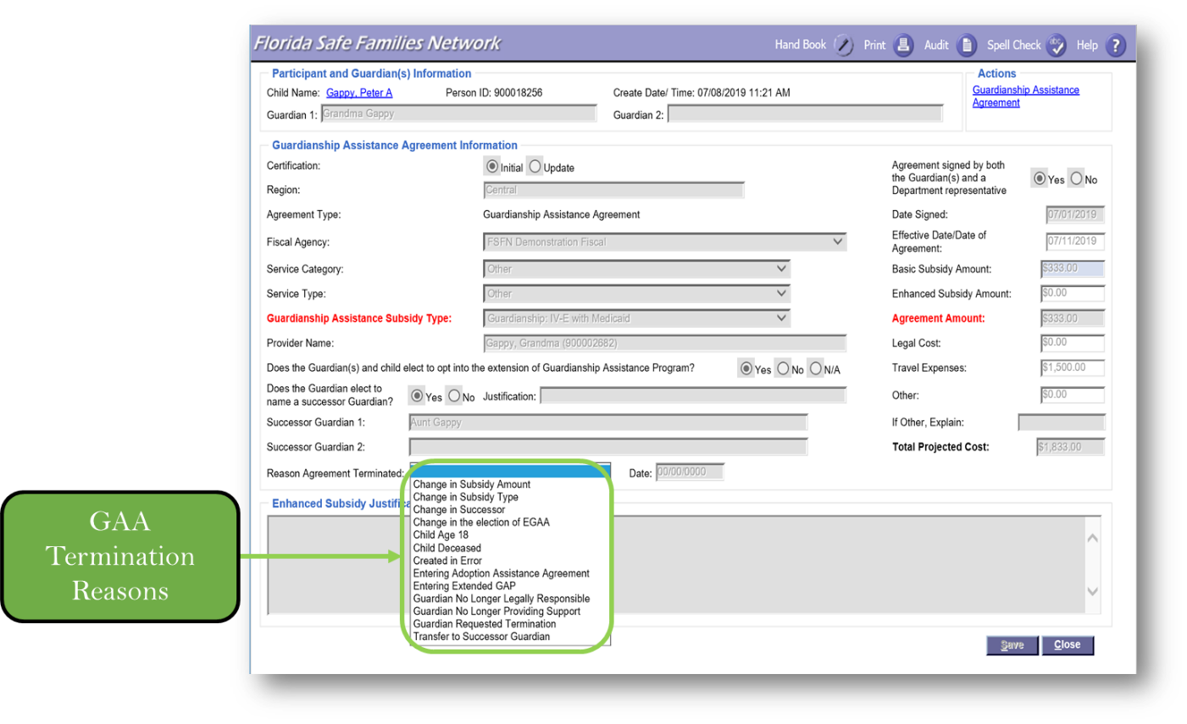
Guardianship Assistance Agreement – Termination Reasons

Guardianship Assistance Agreement – Termination Reasons
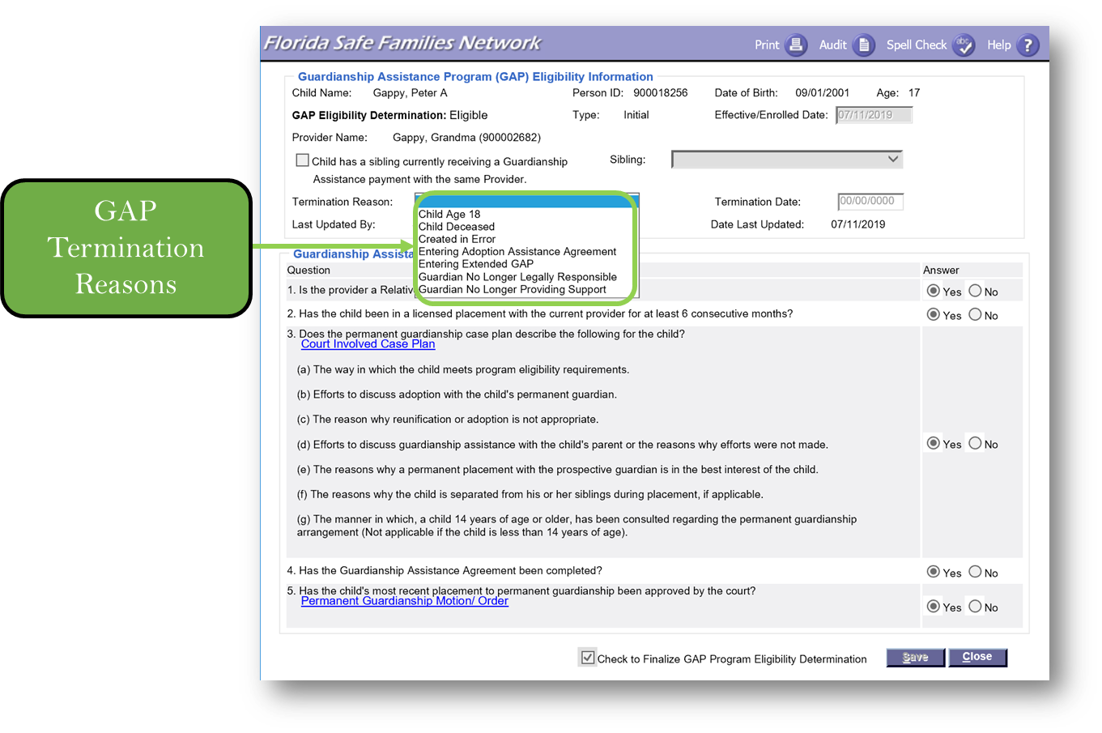

GAP Appeals
Instructor Information
Presentation – GAP Appeals  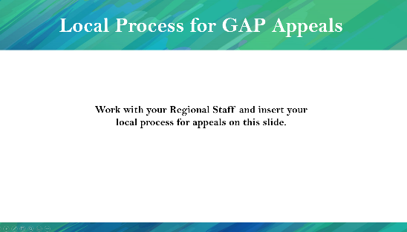  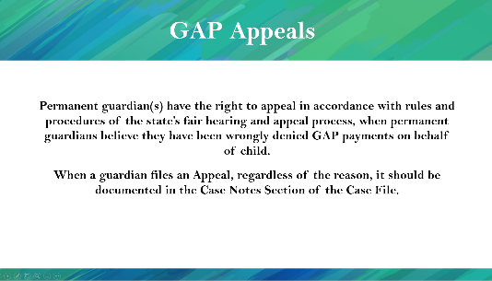  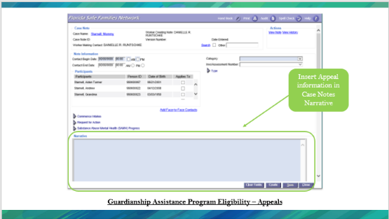  PG. 45 | STATE: Permanent guardian(s) have the right to appeal by rules and procedures of the state’s fair hearing and appeal process when permanent relatives believe they have been wrongly denied GAP payments on behalf of the child.  When a guardian files an Appeal, regardless of the reason, it should be documented in the Case Notes Section of the Case File.  NOTE: Work with your Regional Staff and insert your local process for appeals on this slide.
GAP Appeals
Permanent relative(s) have the right to appeal by rules and procedures of the state’s fair hearing and appeal process when permanent relatives believe they have been wrongly denied GAP payments on behalf of the child. When a guardian files an Appeal, regardless of the reason, it should be documented in the Case Notes Section of the Case File.

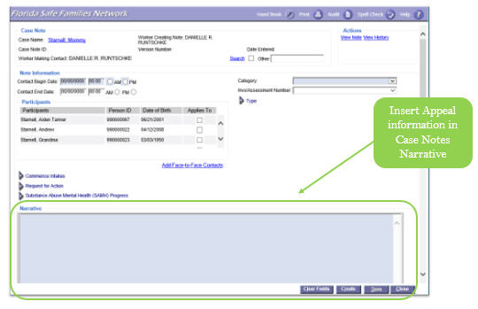
Guardianship Assistance Program Eligibility – Appeals

Conclusion of GAP
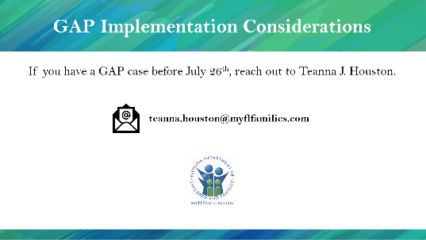  Presentation – GAP Implementation Considerations | This concludes our GAP session.  The GAP program begins July 1st, but the FSFN functionality will not be available until July 26th. If you have a GAP case before July 26th contact Teanna Houston at Teanna.Houston@myflfamilies.com to receive assistance.

Extended Guardianship Assistance Program (EGAP)
Instructor Information
Presentation – Extended Guardianship Assistance Program (EGAP)  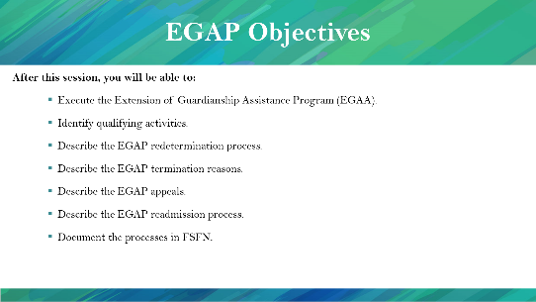  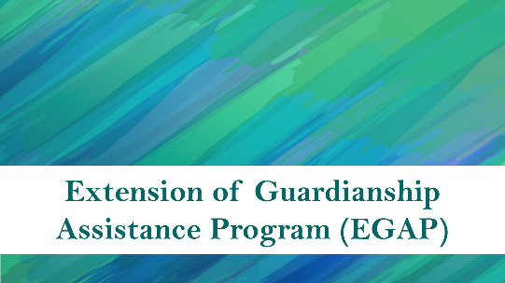 | STATE: We mentioned EGAP in Session A; this time we will cover EGAP in more detail.  After this session, you will be able to:  - Execute the Extension of Guardianship Assistance Program (EGAA).  - Identify qualifying activities.  - Describe the EGAP redetermination process.  - Describe the EGAP termination reasons.  - Describe the EGAP appeals.  - Describe the EGAP readmission process.  - Document the processes in FSFN.

Caregiver Benefits
Instructor Information
Presentation – Caregiver Benefits  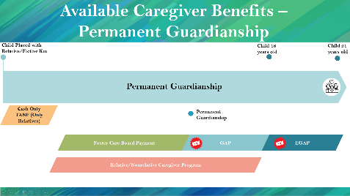  PG. 46 | STATE: If the child is 16 or 17 years old when the caregiver signs the initial Guardianship Assistance Agreement, the child may be eligible for the Extension of Guardianship Assistance Program benefits until 21 years old, as long as the child is participating in at least one of the qualifying activities.

Caregiver Benefits
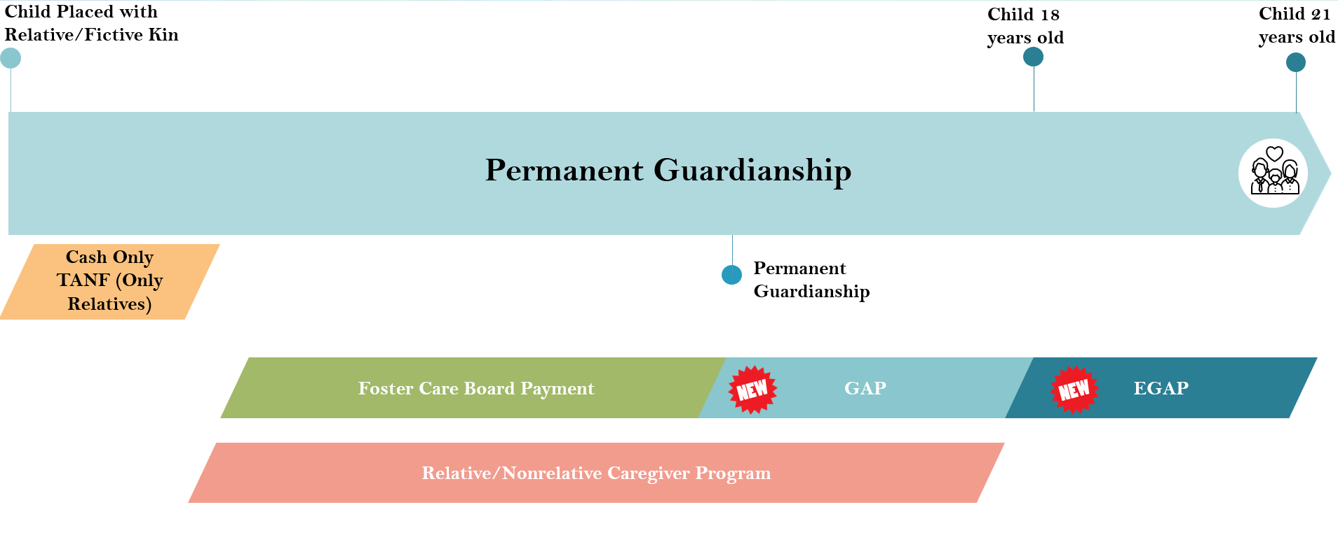

Extended Guardianship Assistance Program (EGAP) Overview
Instructor Information
Presentation – Extended Guardianship Assistance Program (EGAP) Overview  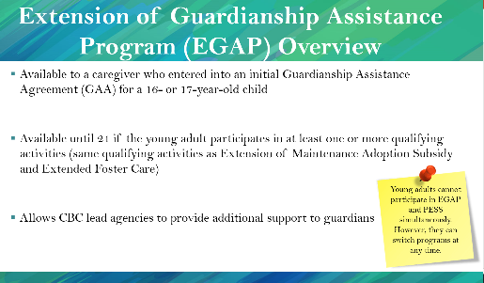  PG. 46 | STATE: Extended Guardianship Assistance Program (EGAP)  - Is available to guardians who entered into an initial Guardianship Assistance Agreement (GAA) for a 16 or 17-year-old child.  - Is available until 21 if the young adult participates in at least one or more qualifying activities (same qualifying activities as Extension of Maintenance Adoption Subsidy and Extended Foster Care)  - Allows CBC lead agencies to provide additional support to relatives.
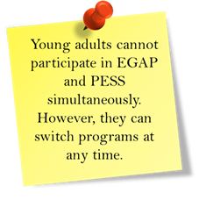
Extended Guardianship Assistance Program (EGAP)
- Is available to guardians who entered into an initial Guardianship Assistance Agreement (GAA) for a 16 or 17-year-old child.
- Available until 21 if the young adult participates in at least one or more qualifying activities (same qualifying activities as Extension of Maintenance Adoption Subsidy and Extended Foster Care)
- Allows CBC lead agencies to provide additional support to relatives.

Extended Guardianship Assistance Program (EGAP) Timeline Overview
Instructor Information
Presentation – Extended Guardianship Assistance Program Timeline Overview  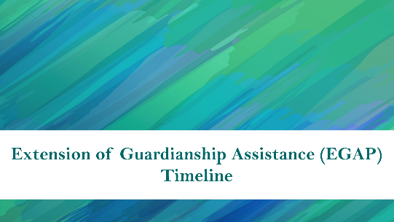  PG. 47  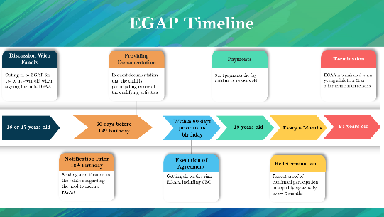 | STATE: The EGAP timeline starts with the caregiver signing the initial Guardianship Assistance Agreement when the child is 16 or 17 years old.  60 days before the child’s 18th birthday, the child welfare professional will send a written notification to the guardian and request documentation that the child is participating in one of the qualifying activities and arrange for the signing of the Extension of Guardianship Assistance Agreement (EGAA).  On the child’s18th birthday EGAP payments may begin.  Redeterminations occur every 6 months. The caregiver must provide documentation that the young adult is participating in at least one of the qualifying activities every 6 months.  The EGAP benefits are terminated when the child turns 21 years old or if another termination reason has occurred.
Extended Guardianship Assistance Program (EGAP) Timeline
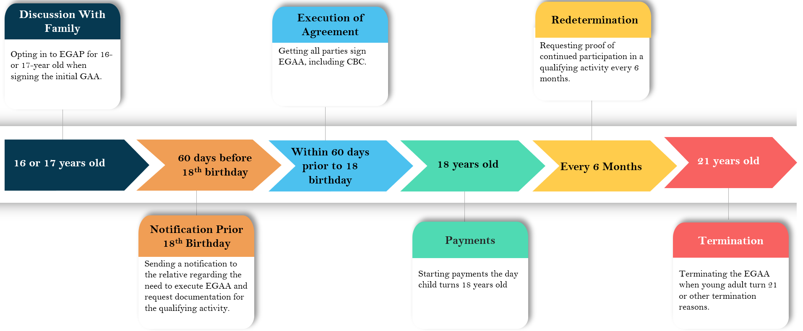

Guardianship Assistance Agreement Established at the Age of 16 or 17
Instructor Information
Presentation – GAP Established - Guardianship Assistance Agreement Established at the Age of 16 or 17  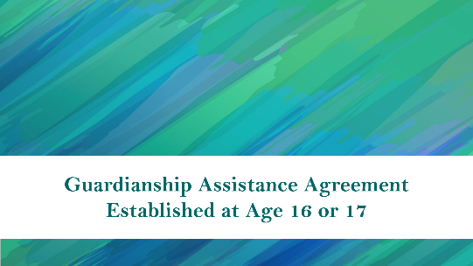  PG. 48  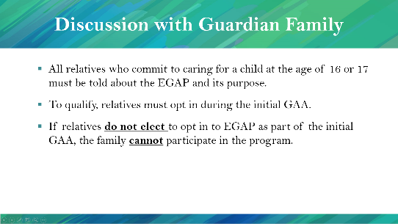 | STATE: To be eligible for EGAP, the child must be 16 or 17 when the initial GAA is signed.  STATE: To qualify, relatives must opt-in on the initial GAA.  HIGHLIGHT: If relatives do not elect to opt into EGAP as part of the initial GAA, the family cannot participate in the program.
Guardianship Assistance Agreement Established at the Age of 16 or 17
Discussion with Relative Family
- All relatives or fictive kin who commit to caring for a child at the age of 16 or 17 must be told about the EGAP and its purpose.
- To qualify, relatives and fictive kin must opt-in on the initial GAA.
- If relatives do not elect to opt into EGAP as part of the initial GAA, the family cannot participate in the program.

FSFN Extended Guardianship Assistance Agreement Election Question
Instructor Information
Presentation – Extended Guardianship Assistance Agreement Election Question  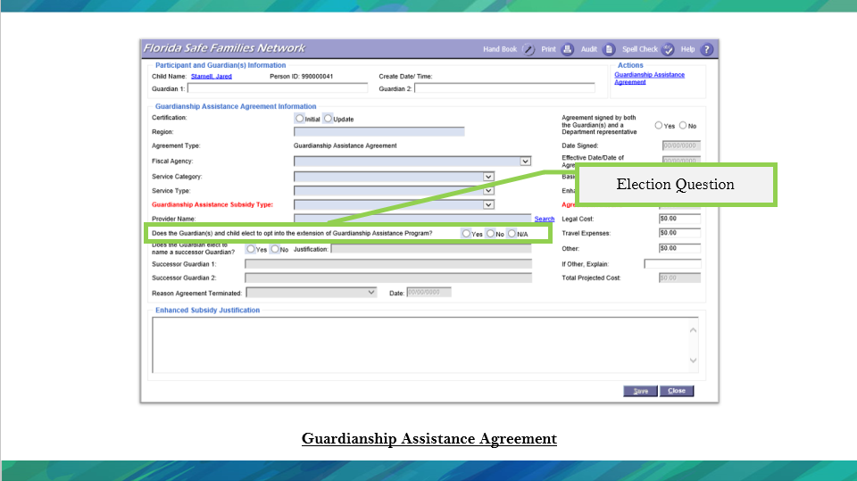 PG. 43 | STATE: If the relative or fictive kin chooses to opt-in on Extension of Guardianship Assistance Program, select the Opt-In button on the GAA page in FSFN.

Guardianship Assistance Agreement
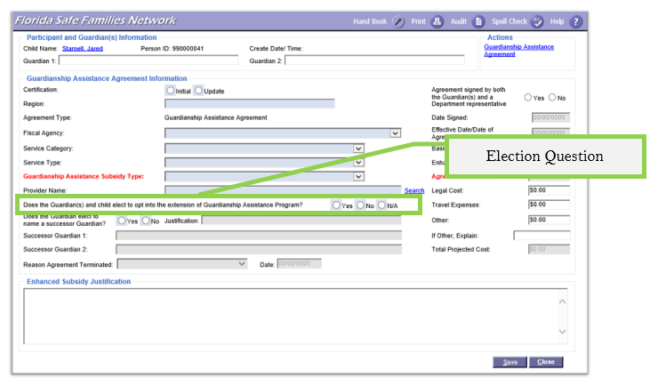

Youth Transitioning to Young Adult (60-day Period)

EGAP Eligibility Requirements
Instructor Information
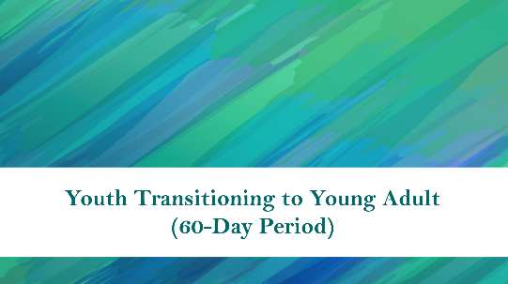  Presentation – EGAP Eligibility Requirements PG. 49  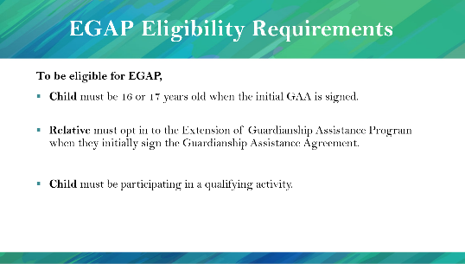 | STATE: To be eligible for EGAP,  - The child must be 16 or 17 years old when the initial GAA is signed.  - Relative must opt into the Extension of Guardianship Assistance Program when they initially sign the Guardianship Assistance Agreement.  - The child must be participating in a qualifying activity.
EGAP Eligibility Requirements
To be eligible for EGAP,
- Child must be 16 or 17 years old when the initial GAA is signed.
- Relative must opt into the Extension of Guardianship Assistance Program when they initially sign the Guardianship Assistance Agreement.
- Child must be participating in a qualifying activity.

Notification Prior to 18th Birthday
Instructor Information
Presentation – Notification Prior to 18th Birthday  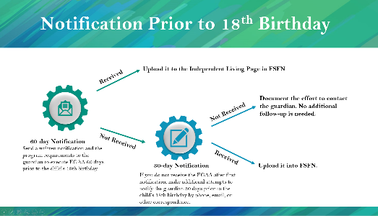  PG. 49 | STATE: 60 days before the child turns 18, the child welfare professional responsible for GAP needs to send written notification and the program requirements to the guardian to execute Extension of Guardianship Assistance Agreement (EGAA).  If you do not hear back from the guardian, make additional attempts (email, mail, phone, etc.) to notify the guardian 30 days before the child’s 18th birthday.  If you still do not receive a response, document the effort to contact the guardian. You do not need additional follow up.  If you receive the required documentation (signed EGAA and documentation of a qualifying activity), upload it into FSFN.  NOTE: The agreement execution day is important for the payment.
Notification Prior to 18th Birthday
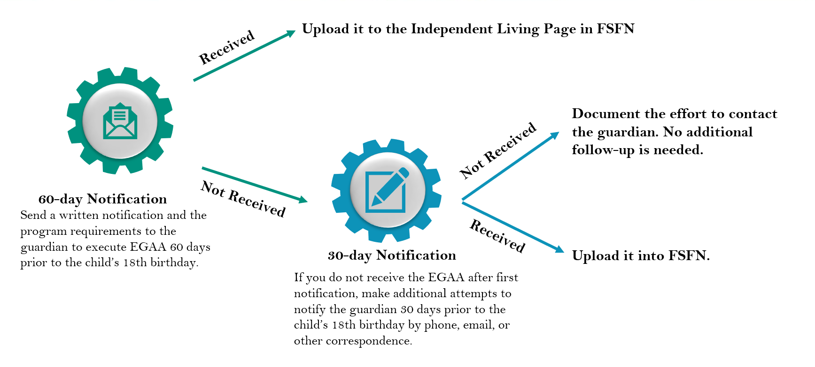

EGAP Qualifying Activities
Instructor Information
Presentation – Extended Guardianship Assistance Program (EGAP)  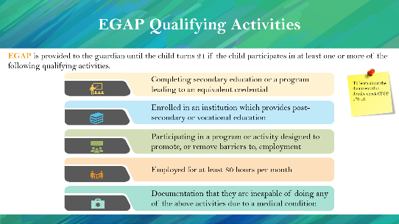  PG. 50 | STATE: EGAP is provided to the guardian on behalf of the young adult until the young adult turns 21 if the young adult participates in at least one of the following qualifying activities.  The qualifying activities are that:  - The young adult is completing secondary education or a program leading to an equivalent credential.  - The young adult is enrolled in an institution which provides post-secondary or vocational education.  - The young adult is participating in a program or activity designed to promote, or remove barriers to, employment.  - The young adult is employed for at least 80 hours per month.  - Guardian provides documentation that the child is incapable of doing any of the above activities due to a medical condition.
EGAP Qualifying Activities
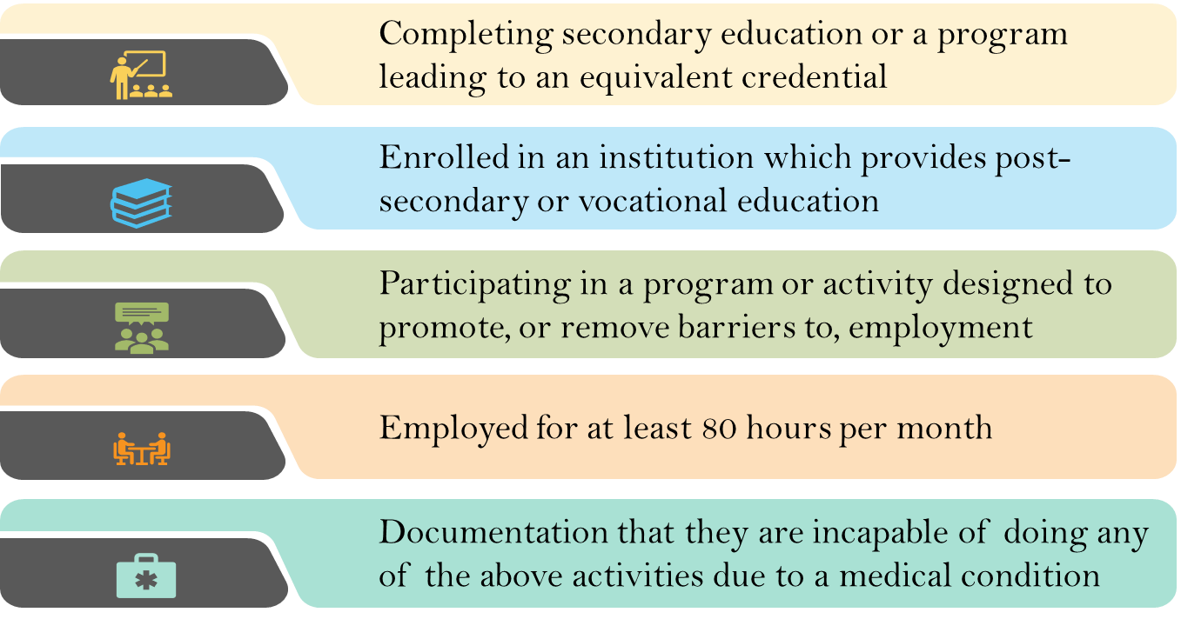
EGAP is provided to the relative on behalf of the young adult until the young adult turns 21 if the young adult participates in at least one or more of the following qualifying activities.

Extension of Guardianship Assistance Agreement (EGAA)
Instructor Information
Presentation – Extension of Guardianship Assistance Agreement (EGAA)  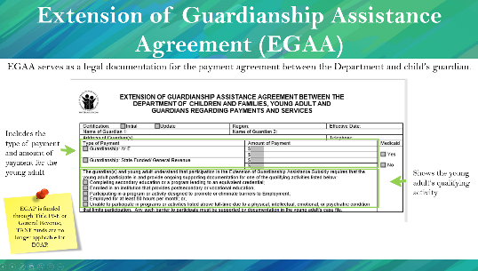  PG. 50 | STATE: Extension of Guardianship Assistance Agreement (EGAA) serves as legal documentation for the payment agreement between the Department and child’s guardian.  EGAA includes the type and amount of payment for the young adult.  EGAA shows the young adult’s qualifying activity.  STATE: EGAP is funded through Title IV-E or General Revenue; TANF funds are no longer applicable for EGAP.
Extension of Guardianship Assistance Agreement (EGAA)
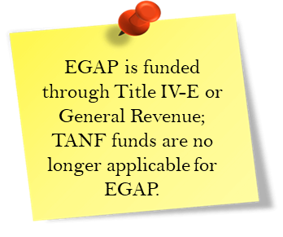
Extension of Guardianship Assistance Agreement (EGAA) serves as legal documentation for the payment agreement between the Department and the child’s guardian. EGAA:
- Includes the type of payment and amount of payment for the young adult.
- Shows the young adult’s qualifying activity.

Initiating EGAP
Instructor Information
Presentation – Extension of Guardianship Assistance Agreement (EGAA)  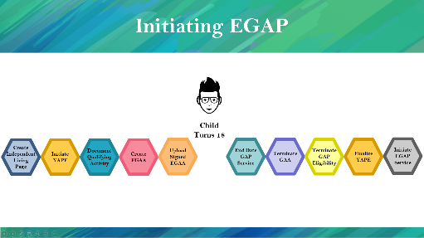  PG. 51 | STATE: Once the qualifying activity document are received, complete the following:  - Create an Independent Living Page  - Initiate the Young Adult Program Eligibility Page  - Document a Qualifying Activity  - Create the EGAA  - Upload the Signed EGAA  Then, complete the following when the child turns 18:  - End Date the GAP Service  - Terminate the GAA  - Terminate GAP Eligibility  - Finalize the Young Adult Program Eligibility Page  - Initiate an EGAP Service
Initiating EGAP
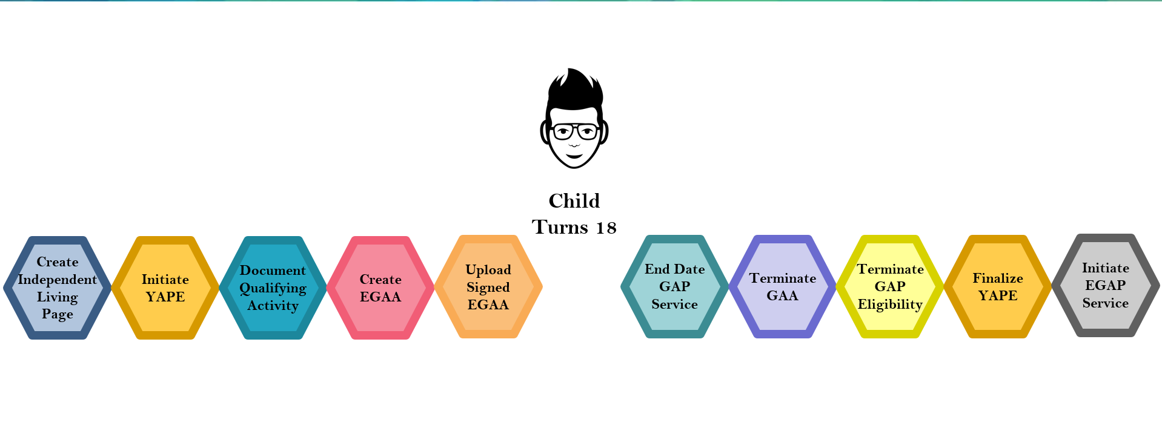

FSFN Extension of Guardianship Assistance Program
Instructor Information
Presentation – EGAP FSFN  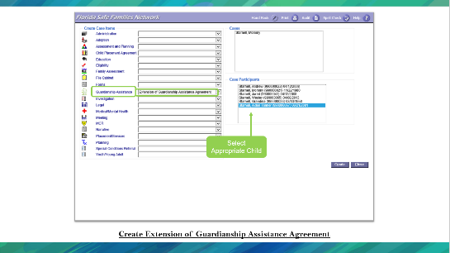  PG. 52  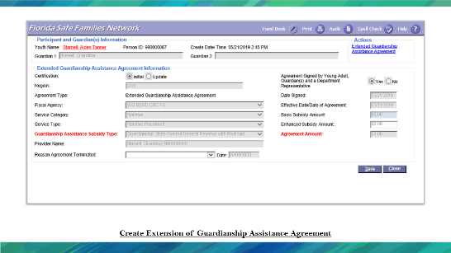 | STATE: From the FSFN Desktop select the Case Work Button. From Create Case Work page, select the Case name then select the participant (child), which will receive the payments. On the left side of the page, under the Create Case Items, look for the label Guardianship assistance. In the drop down select Extension of Guardian Assistance Program. Double check all selections and select “create” at the bottom right side of the page.  Via Case Book  Collapse all Expandos on the left side of the FSFN Desktop. Open the Expando labeled Cases. Select the Case Book hyperlink next to the appropriate Case. On the right side of Case Book, select Extended Guardianship Assistance Program under the Participant Actions. Select participant (child), which will receive the payments. Double check all selections and select “create” at the bottom right side of the page.  Enter information into the pop-up page regarding the Guardian, Fiscal Agency, Service Category, Service Type, Guardianship Assistance Subsidy type, Provider Name, and Agreement Signature date.
Presentation – EGAP FSFN  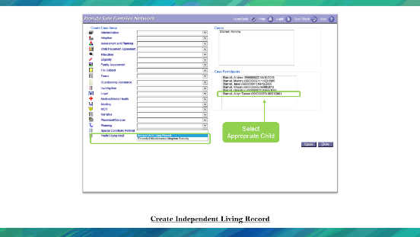  PG. 54  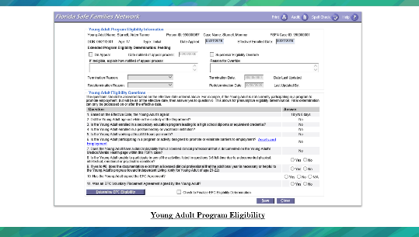  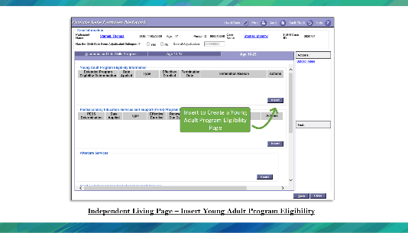  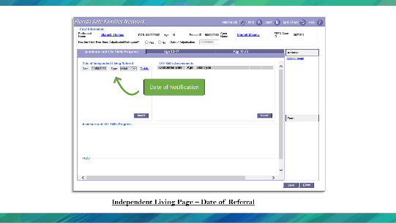 | STATE: From the Create Case Items section in FSFN, select “Independent Living Record” next to Youth/Young Adult. Make sure to select the Case Participants and then create the record.  Enter in the date that begins the Independent Living Record and select Initial for Type.  On the Age 18-23 tab, select insert to create a Young Adult Program Eligibility Page. This page must be created and completed when the child starts the EGAP.

FSFN Extension of Guardianship Assistance Program
Create Extension of Guardianship Assistance Agreement
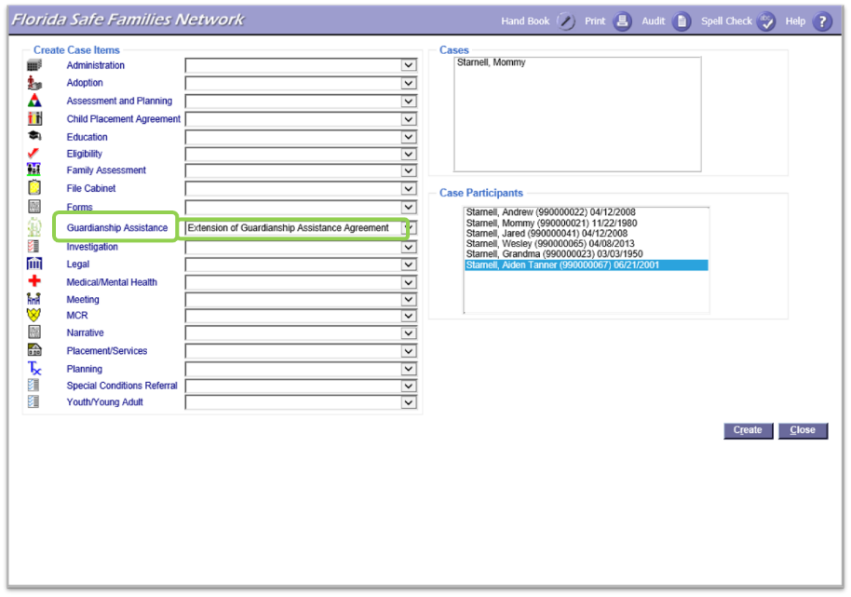
Via Case Work Tab
From the FSFN Desktop select the Case Work Button. From Create Case Work tab, select the Case name then select the participant (child), which will receive the payments. On the left side of the page, under the Create Case Items, look for the label Guardianship assistance. In the drop down select Extension of Guardian Assistance Program. Double check all selections and select “create” at the bottom right side of the page.
Via Case Book
Collapse all Expandos on the left side of the FSFN Desktop. Open the Expando labeled Cases. Select the Case Book hyperlink next to the appropriate Case. On the right side of Case Book, select Extended Guardianship Assistance Program under the Participant Actions. Select participant (child), which will receive the payments. Double check all selections and select “create” at the bottom right side of the page.

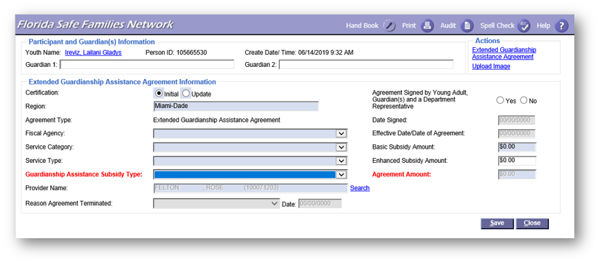
Participant and Guardian(s) Information
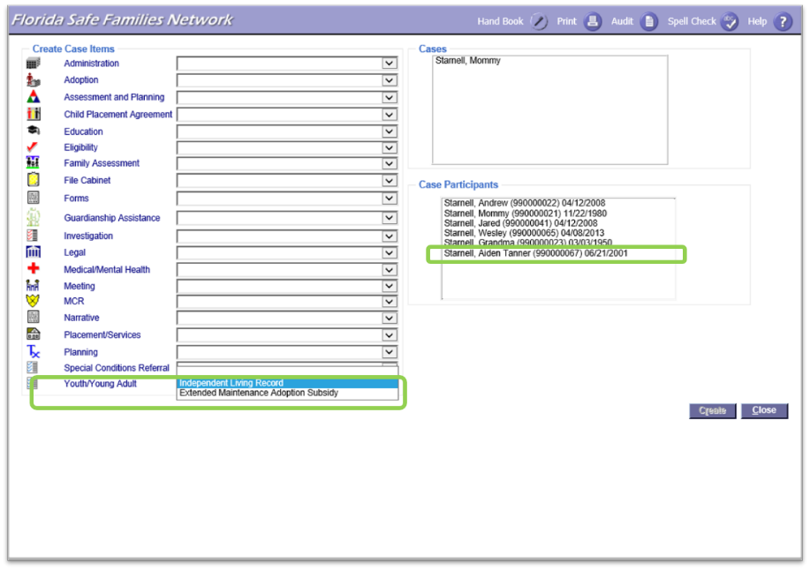
Enter information into the pop-up regarding the Guardian, Fiscal Agency, Service Category, Service Type, Guardianship Assistance Subsidy type, Provider Name, and Agreement Signature date.
Create Independent Living Record

From the Create Case Items section in FSFN, select “Independent Living Record” next to Youth/Young Adult. Make sure to select the Case Participants and then create the record.
Independent Living Page – Date of Referral
Enter in the date that begins the Independent Living Record and select Initial for Type.
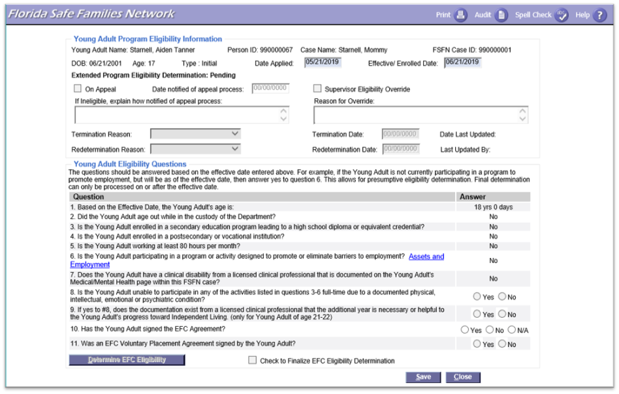
Independent Living Page – Insert Young Adult Program Eligibility
This page must be created and completed when the child starts the EGAP Program

EGAP Education
Instructor Information
Presentation – EGAP Education  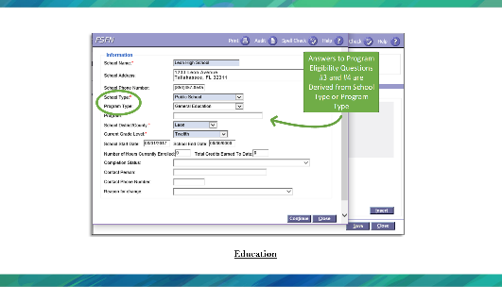  PG. 57 | STATE: When indicating Education as a qualifying activity, enter the information into the required fields.
EGAP Education Documentation
Education

When indicating Education as a qualifying activity, enter the information into the required fields indicated above.
Valid Educational Values
Instructor Information
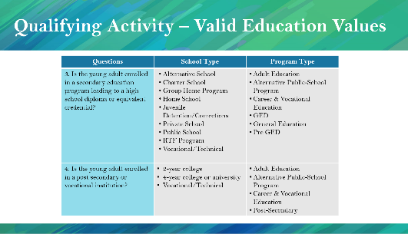  Presentation – Qualifying Activities – Valid Educational Values PG. 58 | STATE: This table shows the questions in FSFN with school type and program type.  READ the school and program types.
Valid Educational Values
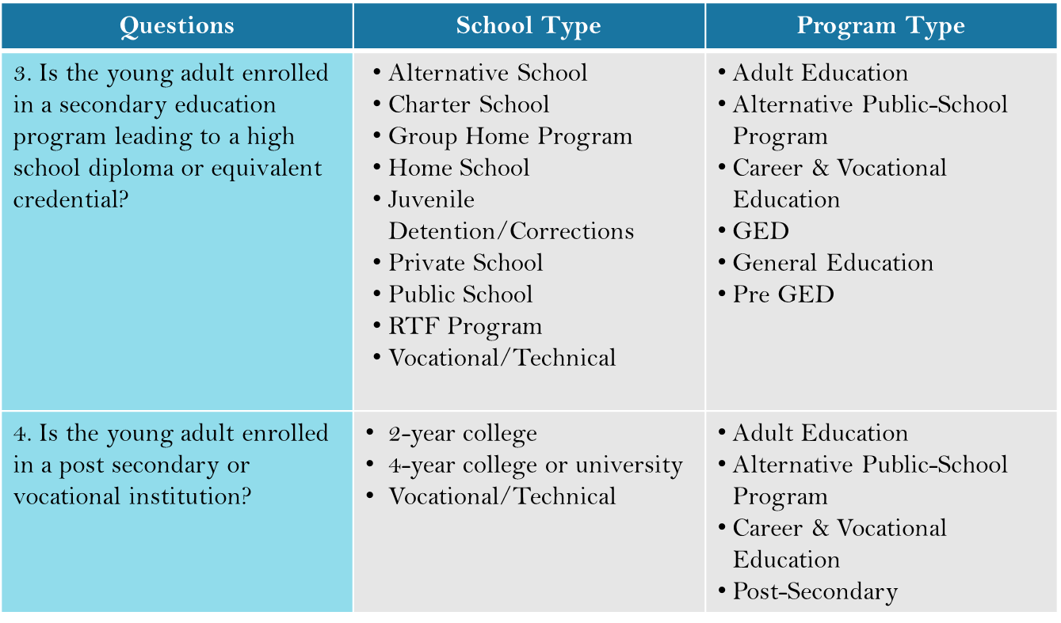
EGAP is provided to the relative until the child turns 21 if the child participates in at least one or more of the following qualifying activities.

Employment
Instructor Information
Presentation –Employment Page  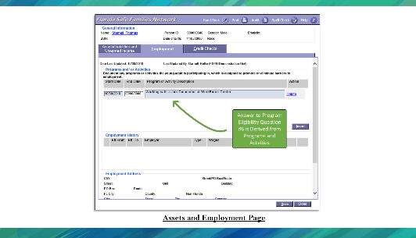  PG. 59 | STATE: Employment should be documented on the Employment tab of the Assets and Employment page, if this is the young adults qualifying activity.  Select insert at the bottom of the page to enter a new line within this page.
Employment
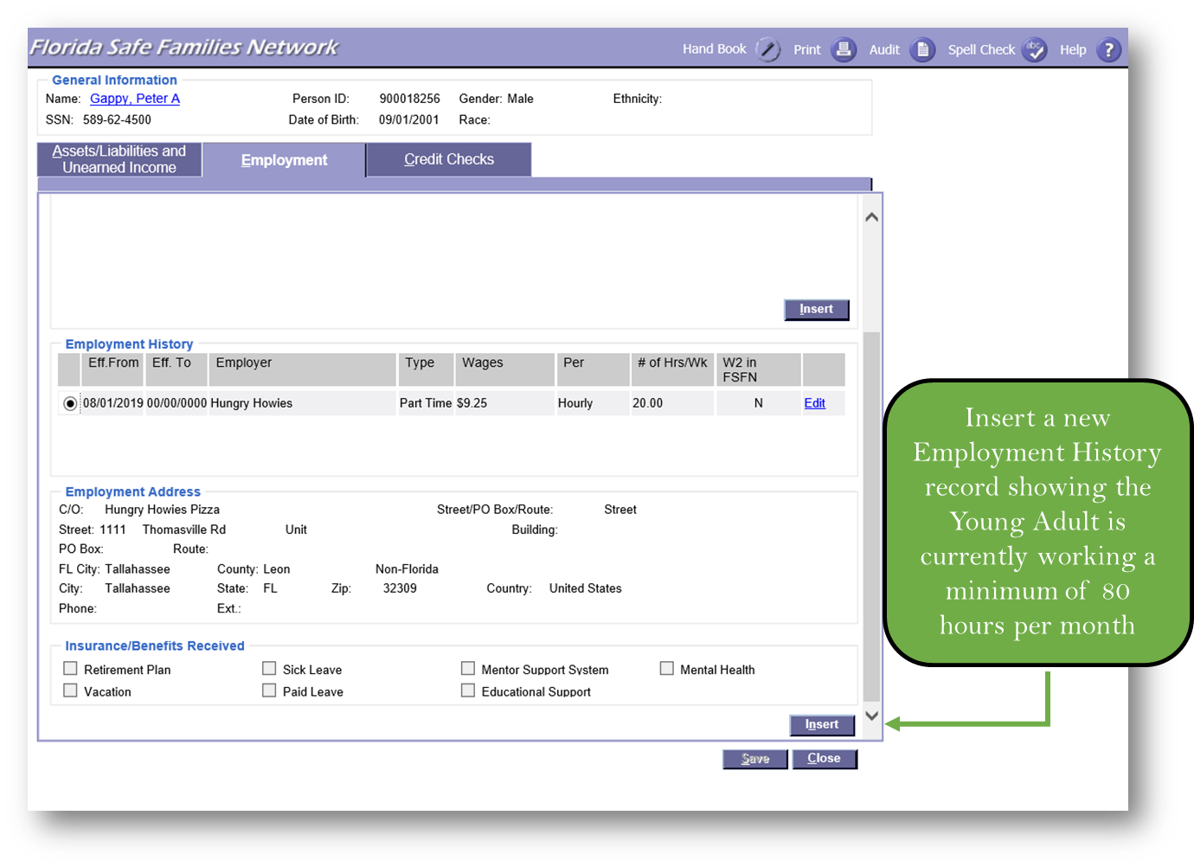

Assets and Employment Program
Instructor Information
Presentation – Assets and Employment Page  PG. 59 | STATE: Description of the Employment or Program must be included when documenting it as a qualifying activity in FSFN.
Assets and Employment Page
Description of the Employment or Program must be included when documenting it as a qualifying activity in FSFN.

Medical/Mental Health
Presentation – Medical/Mental Health Page  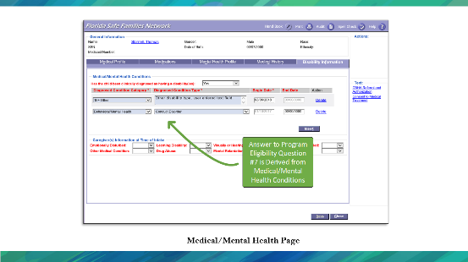  PG. 60 | STATE: When documenting the Medical/Mental Health in FSFN, ensure to select from the list of available drop-down options.

Medical/Mental Health Page
When documenting on Medical/Mental Health in FSFN, ensure to select from the list of available drop-down options.

Negotiating EGAP Payments
Instructor Information
Presentation – Negotiating EGAP Payments  PG. 61  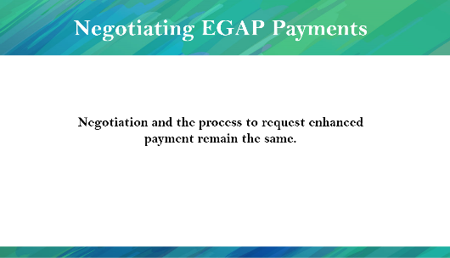 | STATE: EGAP payment negotiating and request enhancement process is the same as the GAP negotiating and enhancement process. Please refer to the instructions outlined in this guide starting at page 25.  NOTE: Participants of this training are required to receive additional training on how to negotiate a subsidy from your local Adoption Specialists.
Negotiating EGAP Payments
Negotiation and the process to request enhanced payment remain the same. Refer back to Page 25.

Finalizing the Agreement
Instructor Information
Presentation – Finalizing the Agreement  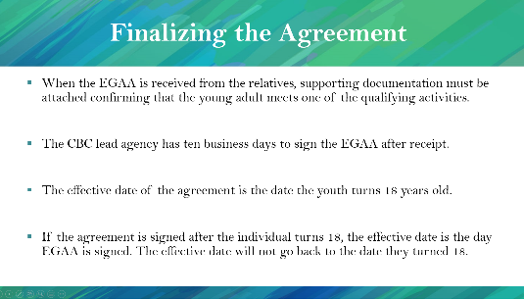  PG. 61 | STATE: When you receive the EGAA from the relatives, supporting documentation must be attached, confirming that the young adult meets one of the qualifying activities.  The CBC lead agency has ten business days to sign the EGAA after receipt.  The effective date of the agreement is the date the youth turns 18 years old.  If the agreement is signed after the individual turns 18, the effective date is the day EGAA is signed. The effective date will not go back to the date they turned 18.  NOTE: A copy of the EGAA is included in the appendix of the participant’s guide.
Finalizing the Agreement
- When the EGAA is received from the relatives, supporting documentation must be attached, confirming that the young adult meets one of the qualifying activities.
- The CBC lead agency has ten business days to sign the EGAA after receipt.
- The effective date of the agreement is the date the youth turns 18 years old.
- If the agreement is signed after the individual turns 18, the effective date is the day EGAA is signed. The effective date will not go back to the date they became 18.

Extended Guardianship Assistance Payment Agreement
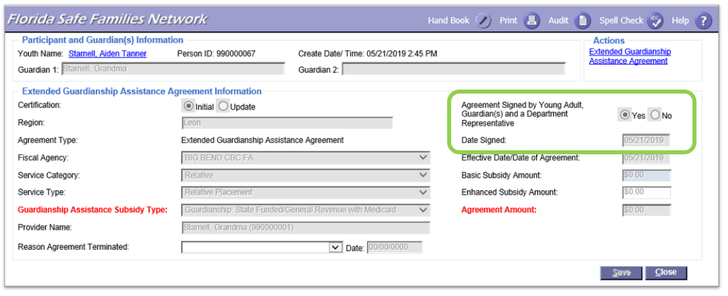

EGAP Payments
Instructor Information
Presentation – Extended Guardianship Assistance Program (EGAP)  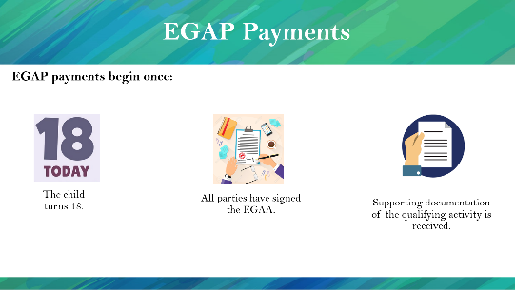  PG. 62  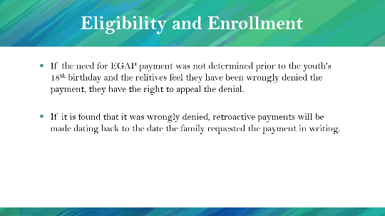 | STATE: The EGAP payments start once  - The child turns 18.  - All parties have signed the EGAA.  - Supporting documentation of the qualifying activity is received.  STATE: If the need for EGAP payment was not determined prior to the youth’s 18th birthday, and the relatives feel they have been wrongly denied the payment; they have the right to appeal the denial.  If it is found that it was wrongly denied, retroactive payments will be made dating back to the date the family requested the payment in writing.
EGAP Payments
EGAP payments begin once
- The child turns 18.
- All parties have signed the EGAA.
- Supporting documentation of the qualifying activity is received.
Eligibility and Enrollment
- If the need for EGAP payment was not determined prior to the youth’s 18th birthday, and the relatives feel they have been wrongly denied the payment, they have the right to appeal the denial.
- If it is found that it was wrongly denied, retroactive payments will be made dating back to the date the family requested the payment in writing.

EGAP Ongoing Program Eligibility
Instructor Information
Presentation – EGAP Ongoing Program Eligibility  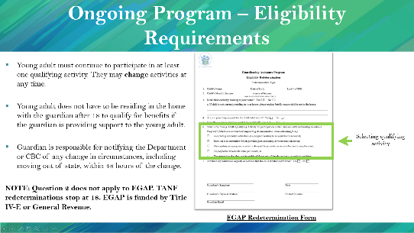  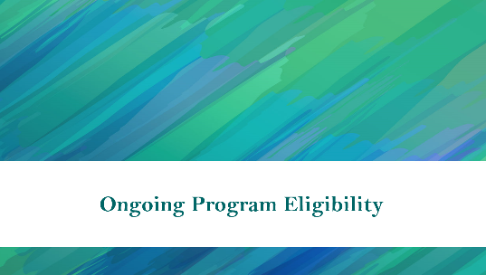  PG. 63 | STATE: The young adult must continue to participate in at least one qualifying activity. They may change the qualifying activity at any time.  The young adult does not have to be residing in the home with the relative after 18 to qualify for benefits if the relative is providing support to the young adult.  The relative is responsible for notifying the Department or CBC of any change in circumstances, including moving out of state, within 48 hours of the change.  NOTE: Question 2 does not apply to EGAP. TANF redeterminations stop at 18. EGAP is funded by Title IV-E or General Revenue.
Ongoing Program – Eligibility Requirements
- Young adult must continue to participate in at least one qualifying activity. They may change the qualifying activity at any time.
- Young adult does not have to be residing in the home with the relative after 18 to qualify for benefits if the relative is providing support to the young adult.
- Relative is responsible for notifying the Department or CBC of any change in circumstances, including moving out of state, within 48 hours of the change.
NOTE: TANF redeterminations stop at 18. EGAP is funded by Title IV-E or General Revenue.

EGAP Redetermination Process
Instructor Information
Presentation – EGAP Redetermination Process  PG. 63  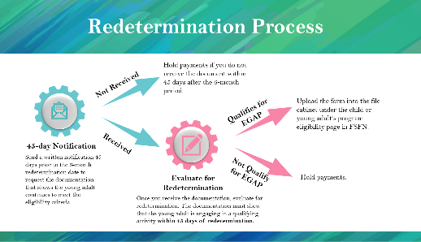 | STATE: EGAP redetermination process is similar to the GAP redetermination process.  Send a written notification 45 days prior to the 6-month redetermination date to request the documentation of the eligibility criteria for the young adult.  If the document, hold the EGAP payments until the form is received.  Once received, evaluate the proof of activity to redetermine the eligibility. The document must show that the young adult is engaging in a qualifying activity within 45 days of redetermination.  If the young adult does not qualify for EGAP, hold the payments.  If the young adult qualifies for EGAP, upload the form into the file cabinet under the child or young adult’s program eligibility page in FSFN.

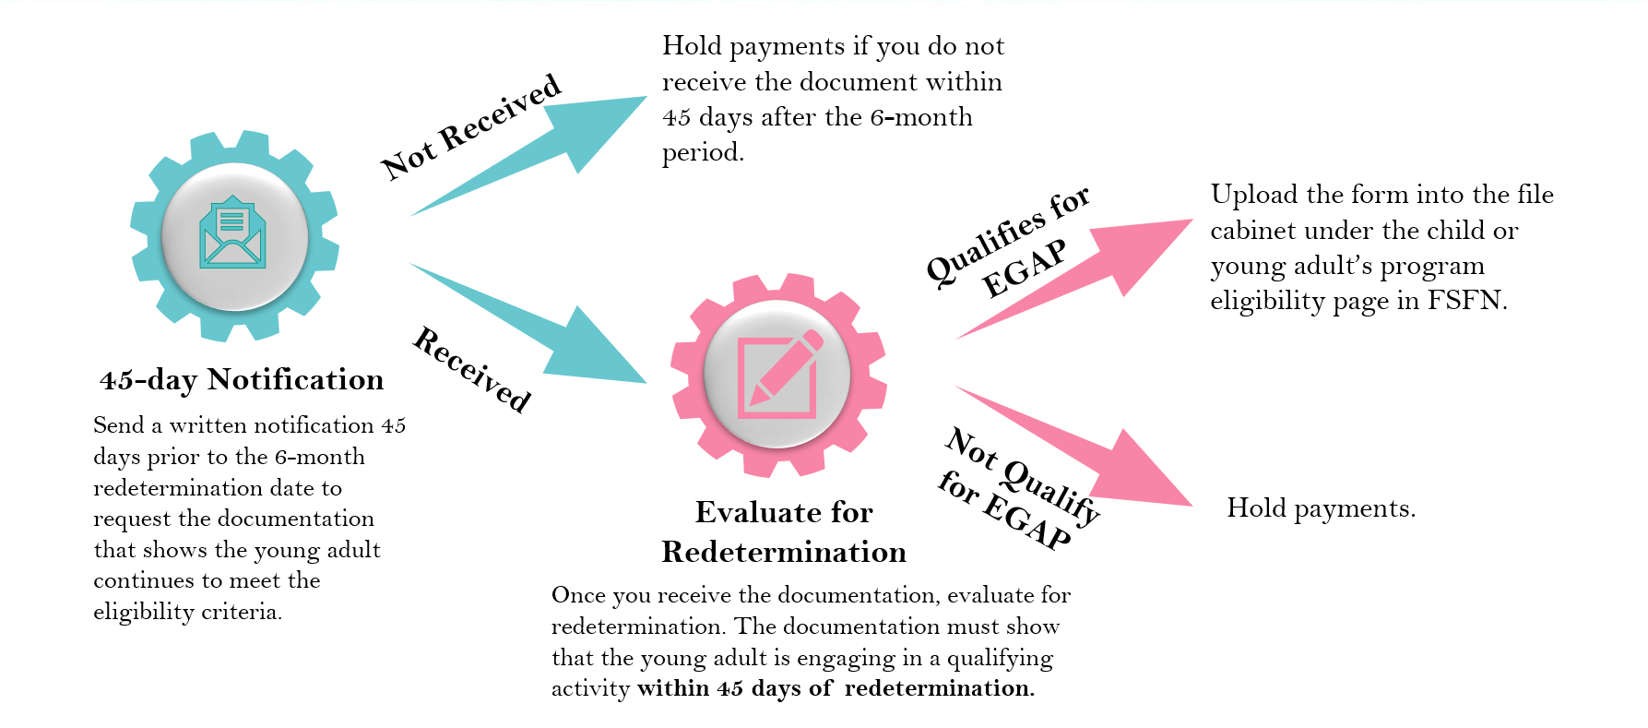
EGAP Redetermination Process

FSFN EGAP Redetermination
Instructor Information
Presentation – EGAP Redetermination  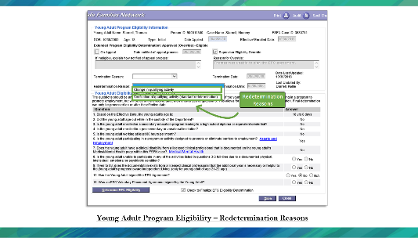  PG. 58 | STATE: When entering redetermination information into FSFN, indicate any changes to the Qualifying Activities. Please be sure to update the information in the YAPE page as well.
EGAP Redetermination
Young Adult Program Eligibility – Redetermination Reasons

When entering redetermination information into FSFN, indicate any changes to the Qualifying Activities. Please be sure to update the information in the YAPE page as well.

EGAP Termination

EGAP Termination Reasons
Instructor Information
Presentation – EGAP Termination Reasons  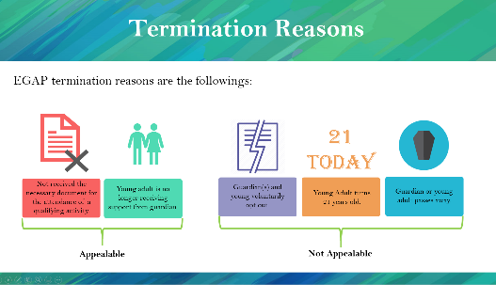  PG. 59 | STATE: Let’s look at the possible termination reasons. The EGAP benefits must be terminated when:  - Young adult turns 21 years old.  - Guardian or young adult or both voluntarily opt out (e.g., marriage, military).  - Young adult is no longer receiving support from the guardian.  - Guardian or young adult passes away.  - Young Adult is no longer participating in a qualifying activity.
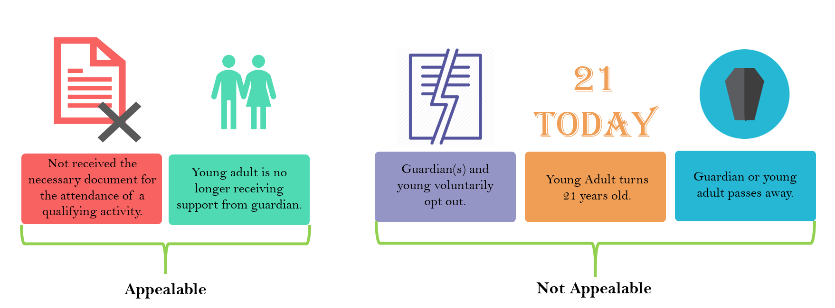
Termination Reasons

EGAP Termination for Appealable Reasons
Instructor Information
Presentation – EGAP Termination for Appealable Reasons  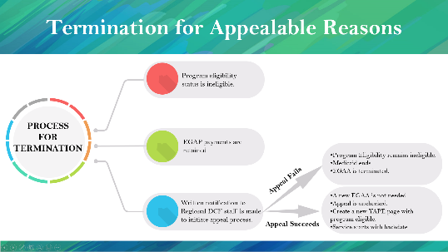  PG. 66 | STATE: During termination, the child welfare professional must  - Change the program eligibility status to ineligible.  - Hold the EGAP payments.  - Send a written notification to the Region in case the guardian appeals the termination reasons.  If the guardian appeals and the appeal fails,  - Program Eligibility remains ineligible.  - Medicaid ends.  - EGAA is terminated.  If the guardian appeals and the appeal succeeds,  - A new EGAA is not needed.  - Appeal is unchecked.  - A new row should be inserted to create YAPE page.  - Service starts with backdating.  HIGHLIGHT: If the termination reason is listed as “Not and Appealable Reason” simply terminate the GAA. The Appeal process does not apply.
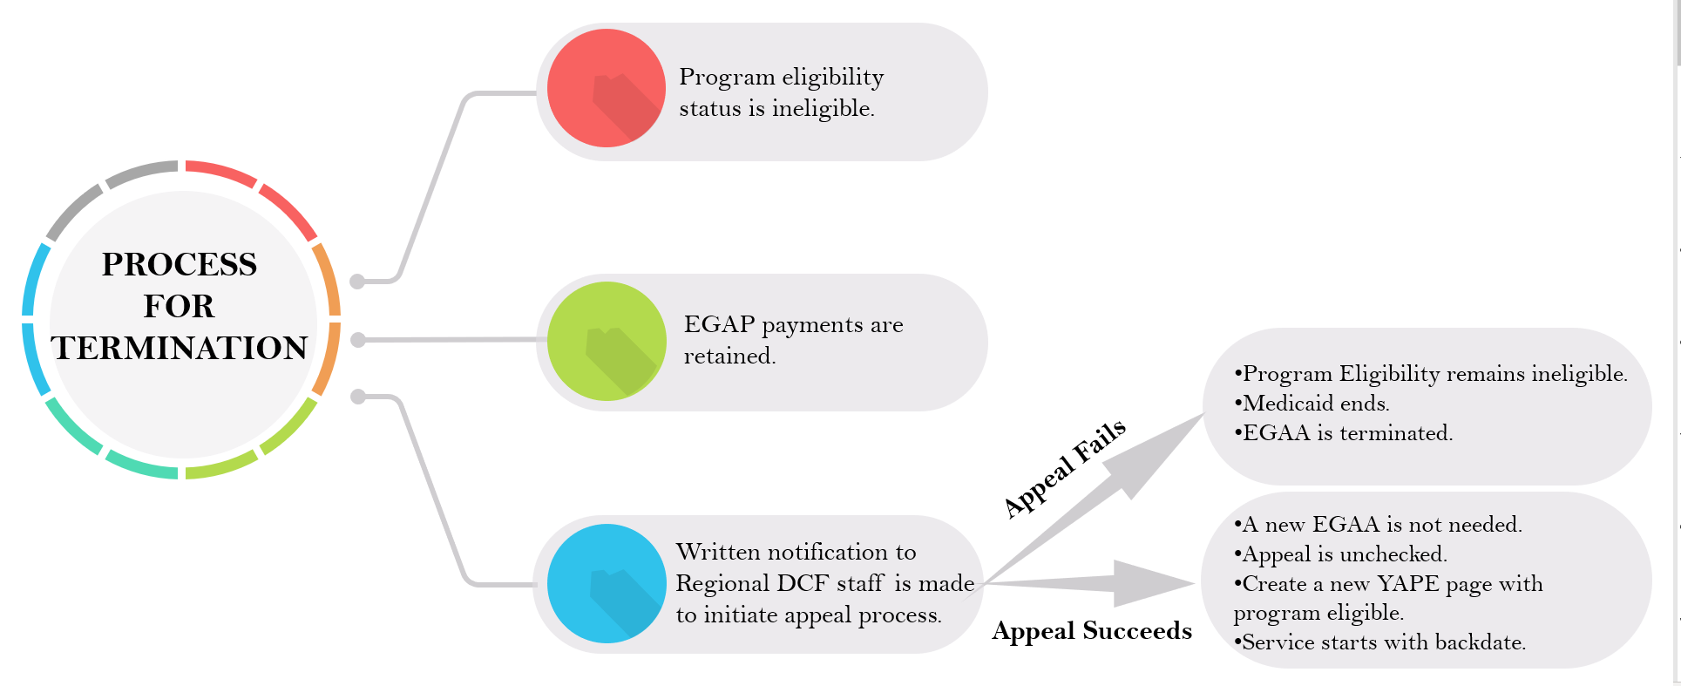
EGAP Termination for Appealable Reasons

FSFN EGAP Termination Reasons and Process
Instructor Information
Presentation – EGAP Termination Reasons and Process  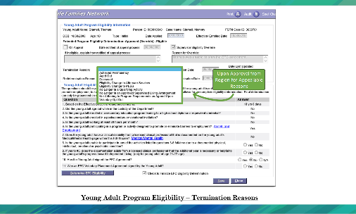  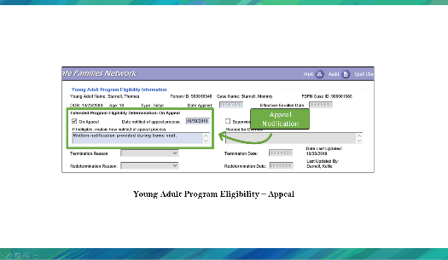  PG. 66 | STATE: If the program is being terminated, regardless of reason, indicate the Termination reason in the box provided.  STATE: Appeals are documented in the Young Adult Program Eligibility page for all children in EGAP.
EGAP Termination Reasons and Process
Young Adult Program Eligibility – Termination Reasons
If the program is being terminated, regardless of reason, indicate the Termination reason in the box provided.

Young Adult Program Eligibility – Redetermination Reasons

Appeals are documented in the Young Adult Program Eligibility page for all children in EGAP

EGAP Readmission
Instructor Information
Presentation – EGAP Readmission  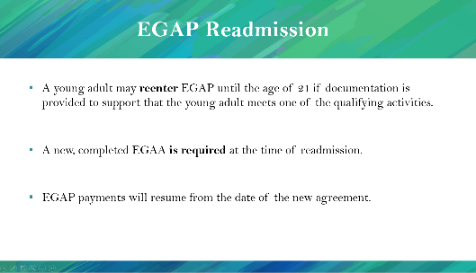  PG. 69  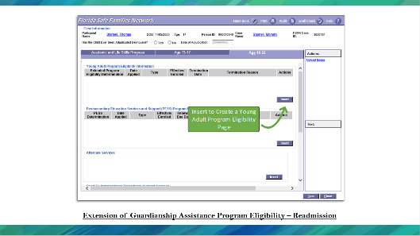 | STATE: A young adult may requalify for the EGAP benefits until the young adult reaches 21 if they provide documentation to support that the young adult meets one of the qualifying activities.  A new, completed EGAA is required at the time of readmission.  EGAP payments will resume from the date of new agreement.
EGAP Readmission
- A young adult may requalify for the EGAP benefits until the young adult reaches 21 if they provide documentation to support that the young adult meets one of the qualifying activities.
- A new, completed EGAA is required at the time of readmission.
- EGAP payment will resume from the date of the new agreement.

Extension of Guardianship Assistance Program Eligibility – Readmission
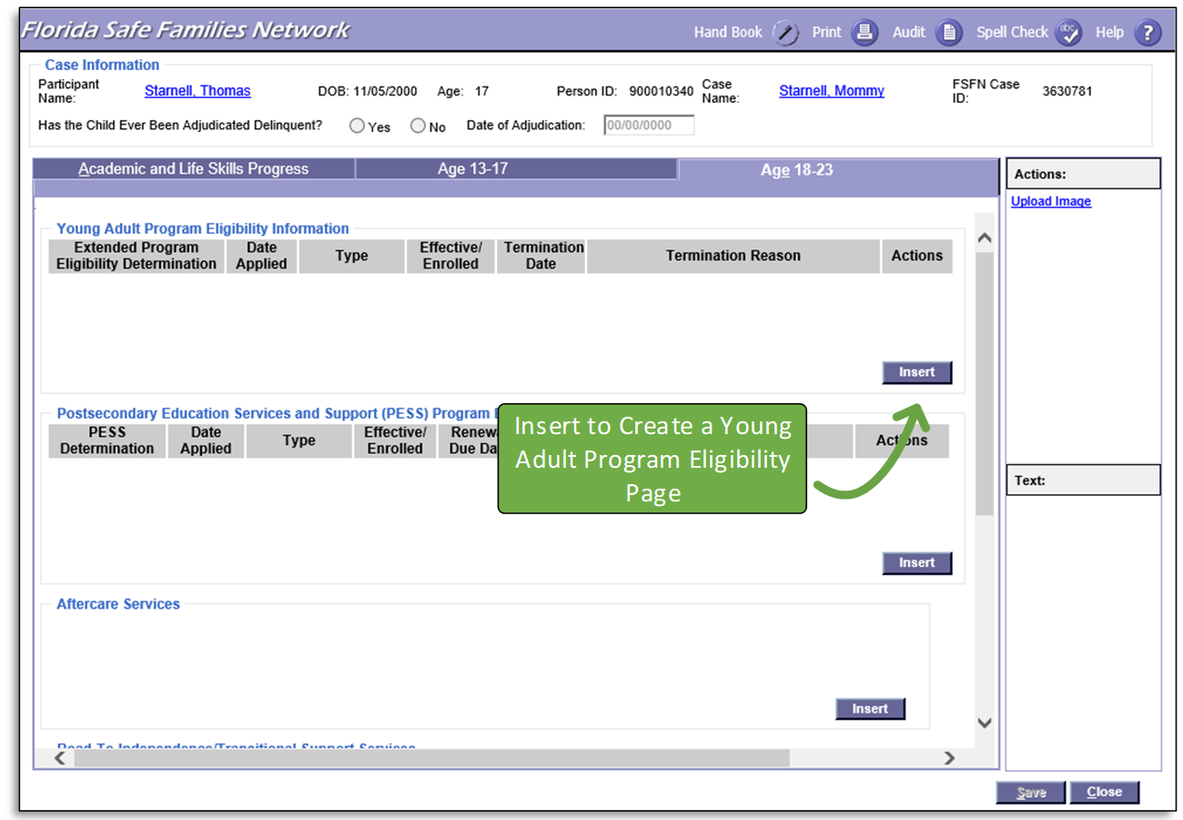
Readmission into EGAP simply requires a new Independent Living Record (YAPE) to be documented in FSFN.

FSFN Practice
Instructor Information
Presentation – FSFN Practice  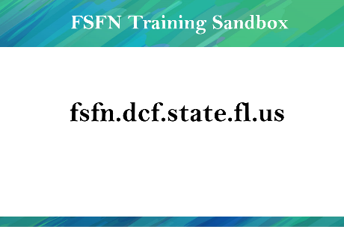 | STATE: Now, we will practice these processes in FSFN.  Have participants log into the FSFN Training Sandbox and follow along with their case while you demonstrate the following:  - GAP Page  - Open Case Book for the example case and launch the GAP Page for a child.  - Insert a new GAP Eligibility Row and launch the GAP Eligibility Page.  - GAP Presumptive Eligibility – GAP Eligibility Page - Initial  - Note the Initial Type.  - Insert a past date (greater than six months after the Out of Home Placement Begin Date) as the Effective/Enrolled Date and save the page.  - Review Question 1 as system derived from the Provider tab of the current Out of Home Placement.  - Review Question 2 as system derived from a comparison between the Out of Home Placement begin date and the Effective/Enrolled Date.  - Guardianship Assistance Agreement Page  - Create a Guardianship Assistance Agreement from the Participant Actions group box in Case Book.  - Complete the page and generate the Guardianship Assistance Agreement Word Document.  - Finalizing GAP Eligibility – GAP Eligibility Page – Initial  - Insert today’s date as the Effective/Enrolled Date and save the page.  - Answer Questions 3 – 5 and link a Court Involved Case Plan and Court Order.  - Finalize the eligibility determination.  - GAP Eligibility Page – Redetermination  - From the GAP Page, launch a Redetermination GAP Eligibility Page from the Initial created above.  - Answer Question 1 to continue eligibility.  - Answer Question 2 with no change to the Successor Guardian.  - Finalize the eligibility redetermination.  - GAP Eligibility Page – Termination  - From the GAP Page, edit the most recent GAP Eligibility Page.  - Select a Termination Reason, enter a termination date, and save the page.  - Guardianship Assistance Agreement Page - Termination  - From the Actions group box on the GAP Page, select Guardianship Assistance Agreement.  - On the Guardianship Assistance Agreement Page, select a termination reason, enter a termination date, and save the page.  - Launch the EGAA page and complete  - Create an Extended Guardianship Assistance Agreement by selecting Guardianship Assistance Agreement from the Participant Actions group box in Case Book.  - Complete the page and generate the Extended Guardianship Assistance Agreement Word Document.  - Launch the Independent Living page and save  - Launch the Young Adult Program Eligibility page and complete  - Complete the Educational, Assets and Employment, and Medical/Mental Health Pages  - Finalize the EGAA  - Create the Redetermination Reason  - Terminate EGAP
Recommended Seed Data Preparation
For each workshop, create the following:
- Case
- Parent
- Child – 17 Years Old (with no middle initial)
- Family Functioning Assessment – Ongoing (with Child above)
  - Case Plan Worksheet (with Parent’s tasks)
  - Court Involved Case Plan (with Parent’s tasks)
- Progress Update (with Child above)
  - Case Plan Worksheet (with Guardian information)
  - Court Involved Case Plan (with Guardian information)
- Provider
  - With approved “Initial License for Foster Home” Unified Home Study
  - Level 2 License backdated to before the Out of Home Placement date
  - With Traditional Foster Home Service Type
- Court Order
For each participant in the workshop, create the following:
- Child – 17 Years Old (Use the same first and last name as above, with different middle initials)
- Child in Out of Home Placement for at least six months with the Provider
- Completed IV-E Eligibility determined as eligible
Dates for Seed Data
Event | Notes | Example
Child’s Birthday | Choose a date where the child will turn 18 sixty days after the workshop. This sets up a scenario for a child preparing to enter EGAP. | 9/1/2001
Out of Home Placement Date | Allow for a placement longer than six months. | 6/1/2018
IV-E Eligibility Determination |  | 6/1/2018
Presumptive GAP Eligibility |  | 3/1/2019
GAA Initial Signed |  | 4/1/2019
Court Involved Case Plan |  | 5/1/2019
Discharge to PG |  | 5/1/2019
GAP Eligibility Effective Date |  | 5/1/2019
EGAP Eligibility Initial |  | July 2019
Child’s 18th Birthday |  | 9/1/2019

Instructor Information
Presentation – End of Session B  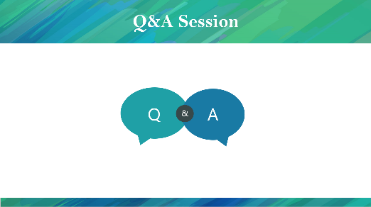 | STATE This concludes Session B.  Does anybody have any questions or is there anything that confuses you?

Appendix

