Guardianship Assistance Program (GAP)

Session A
July 2019
Trainer’s Guide

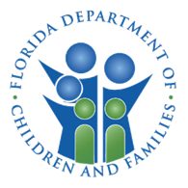
Contents
How to Use This Guide 3
Layout of Information 3
Trainer Guide Icons 4
Course Summary 5
Session A Objectives 6
Guardianship Assistance Program (GAP) 7
Title IV-E Waiver Expiration – E Waiver 9
Title IV-E Waiver 9
Title IV-E Waiver Expiration 10
Path Forward 10
Caregiver Benefits 11
Available Caregiver Benefits – Reunification 14
Available Caregiver Benefits – Adoption 14
Available Caregiver Benefits – Permanent Guardianship 15
Levels of Licensure 15
Guardianship Assistance Program (GAP) Overview 16
Guardianship Assistance Program (GAP) Benefits 17
Guardianship Assistance Program (GAP) Eligibility 18
Guardianship Assistance Program (GAP) Eligibility Stages Overview 19
Guardianship Assistance Program (GAP) Eligibility Initiation 21
GAP Presumptive Eligibility 22
Federal Funding for Guardianship Assistance Program 23
What is Important and New for Case Managers? 24
What is Important for Case Managers? 25
What is New for Case Managers? 26
Required Language Placement 27
FSFN Creating GAP Page 28
Siblings 36
Documenting Siblings Under GAP Page 37
Local Referral Process 38
Extended Guardianship Assistance Program (EGAP) Overview 39

How to Use This Guide

Layout of Information
This guide is designed to assist the trainer in delivering this module using color, layout, and graphics.
Shaded text indicates material that only the instructor sees. It contains your script, in black text, and background information, or directions in red text. This example shows your script.
Icons show the type of instructional strategy (i.e., presentation)

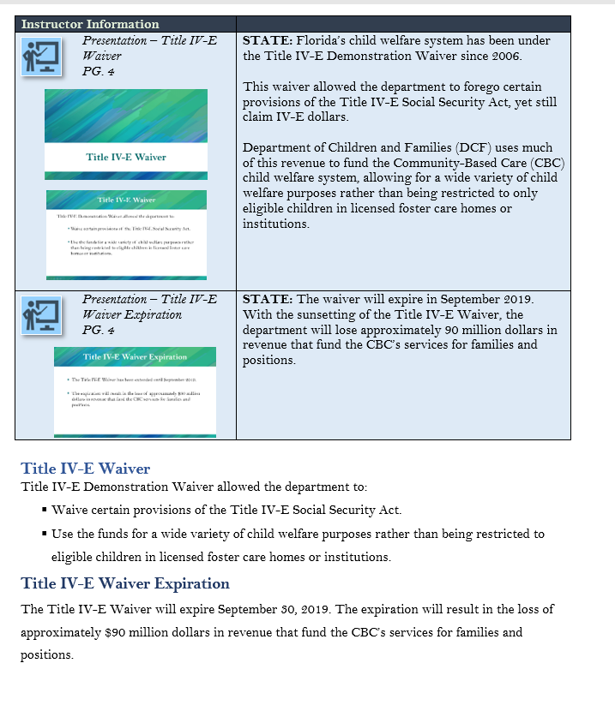
Participant Guide page number for your reference.

Copies of the PowerPoint™ slides that correspond to the Participant Guide pages.

Text and graphics on a white background is a replica of the Participant Guide page. You can refer to it to make your point and see exactly what the participants are seeing.

Trainer Guide Icons
 | Presentation

Course Summary
Course Goal: To enable trainees to practice GAP eligibility requirements.
Structure of Course
- Title IV-E Waiver Expiration
- Guardianship Assistance Program (GAP)
- What is Important and New for Case Managers?
Length of Course: 3 hours
Materials and Supplies Required:
- Participants Guide
- PowerPoint Presentation
Equipment
- Computer
- LCD Projector
Instructional Methods
- Lecture
- Question – Answer

Session A Objectives
When you complete this session, you will be able to:
- Identify the post Title IV-E Waiver initiatives.
- Differentiate benefits programs from permanency options.
- Explain the Guardianship Assistance Program (GAP), including eligibility and benefits.
- Document eligibility requirements.
- Apply the sibling placement process.
- Explain the Extension of Guardianship Assistance Program (EGAP).

Guardianship Assistance Program (GAP)
Instructor Information
Presentation – Session A Agenda  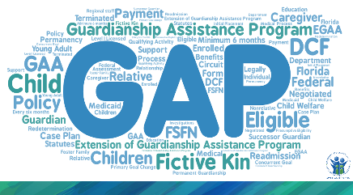  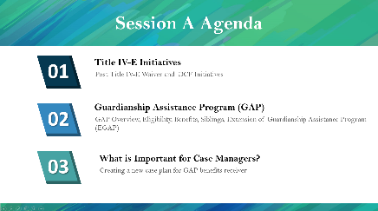 | STATE: Welcome to the train-the-trainer Guardianship Assistance Program (GAP) workshops.  STATE: This workshop is to teach you about the new benefits program for children who are discharged to permanent guardianship and their guardian.  Specifically, we will cover the following topics;  - The Changes in Title IV-E Waiver  STATE: We will look at the Title IV-E waiver and DCF initiatives to be prepared for a post waiver environment.  - Guardianship Assistance Program (GAP)  STATE: As part of the Path Forward initiative, the Guardianship Assistance Program (GAP) is a new benefits program. In this session, we will provide you an overview of the program, its benefits for children and guardians, the program eligibility requirements, the process for siblings when a sibling is eligible for GAP benefits, and the Extension of Guardianship Assistance Program, which we will refer to as EGAP.  - What is important and new for Case Managers?  STATE: Lastly, we will look at changes for case managers regarding required language in the Permanent Guardianship Case Plan and informing a child welfare professional responsible for GAP that the primary or concurrent permanency goal has changed to permanent guardianship.  STATE: The sessions are organized in a way that Session A will cover the high-level big picture of the Guardianship Assistance Program while Session B will focus on the Guardianship Assistance Program processes and procedures.
Presentation – Session A Objectives  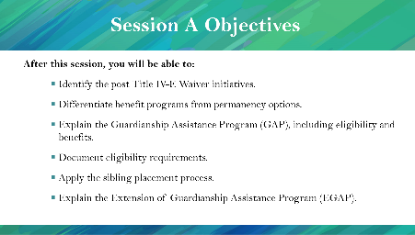  PG. 3 | STATE: Once you complete this session, you will be able to:  - Identify the post Title IV-E Waiver initiatives.  - Differentiate benefits programs from permanency options.  - Explain the Guardianship Assistance Program (GAP), including eligibility and benefits.  - Document eligibility requirements.  - Apply the sibling placement process.  - Explain the Extension of Guardianship Assistance Program (EGAP).
Objectives
When you complete this session, you will be able to:
- Identify the post Title IV-E Waiver initiatives.
- Differentiate benefits program from permanency options.
- Explain the Guardianship Assistance Program (GAP), including eligibility and benefits.
- Document eligibility requirements.
- Apply the sibling placement process.
- Explain the Extension of Guardianship Assistance Program (EGAP).

Title IV-E Waiver Expiration – E Waiver
Instructor Information
Presentation – Title IV-E Waiver  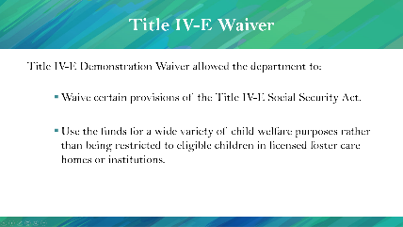  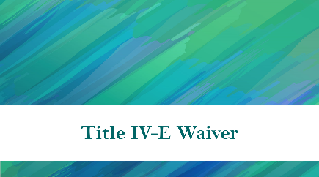  PG. 4 | STATE: Florida’s child welfare system has been under the Title IV-E Demonstration Waiver since 2006.  This waiver allowed the department to forego certain provisions of the Title IV-E Social Security Act, yet still, claim IV-E dollars.  Department of Children and Families (DCF) uses much of this revenue to fund the Community-Based Care (CBC) child welfare system, allowing for a wide variety of child welfare purposes rather than being restricted to only eligible children in licensed foster care homes or institutions.
Presentation – Title IV-E Waiver Expiration  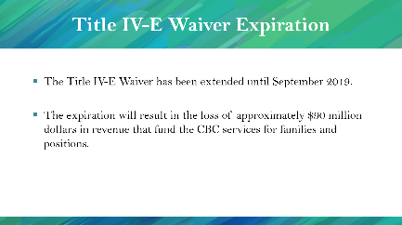  PG. 4 | STATE: The waiver will expire on September 30, 2019. With the sunsetting of the Title IV-E Waiver, the department will lose approximately 90 million dollars in revenue that fund the CBC’s services for families and positions.

Title IV-E Waiver
Title IV-E Demonstration Waiver allowed the department to:
  - Waive certain provisions of the Title IV-E Social Security Act.
  - Use the funds for a wide variety of child welfare purposes rather than being restricted to eligible children in licensed foster care homes or institutions.

Title IV-E Waiver Expiration
The Title IV-E Waiver will expire September 30, 2019. The expiration will result in the loss of approximately $90 million dollars in revenue that fund the CBC’s services for families and positions.

Path Forward
Instructor Information
Presentation – Path Forward  PG. 4  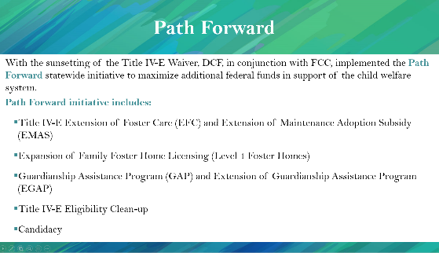 | STATE: To replace the lost funds, DCF, in conjunction with the Florida Coalition for Children (FCC), implemented the PATH FORWARD statewide initiative.  PATH FORWARD includes the following statewide programs to expand the department’s Title IV-E footprint and draw down additional federal funding.  - Title IV-E Extended Foster Care (EFC) and Extended Maintenance Adoption Subsidy (EMAS)  - Expansion of Family Foster Home Licensing (Level 1 Foster Homes)  - Guardianship Assistance Program (GAP) and Extended Guardianship Assistance Program (EGAP)  - Title IV-E eligibility clean-up  - Candidacy
Path Forward
With the sunsetting of the Title IV-E Waiver, DCF, in conjunction with FCC, implemented the Path Forward statewide initiative to maximize additional federal funds in support of the child welfare system.
Path Forward initiative includes:
    - Title IV-E Extended Foster Care (EFC) and Extended Maintenance Adoption Subsidy (EMAS)
    - Expansion of Family Foster Home Licensing (Level 1 Foster Homes)
    - Guardianship Assistance Program (GAP) and Extended Guardianship Assistance Program (EGAP)
    - Title IV-E Eligibility Clean-up
    - Candidacy
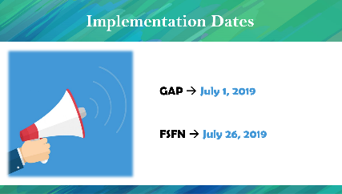  Presentation – Implementation Dates | STATE: GAP will be effective starting July 1st, 2019 while FSFN functionality will be available on July 26th, 2019.

Caregiver Benefits
Instructor Information
Presentation – Caregiver Benefits  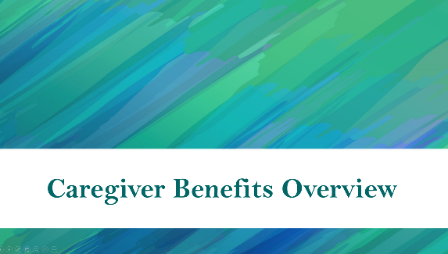  PG. 5 | STATE: Since GAP is a benefit program, we will start by reviewing the available benefits for each permanency option.  HIGHLIGHT: Before we start talking about the benefits, remember that how we think permanency as DCF has not changed.
Presentation – Reunification Caregiver Benefits  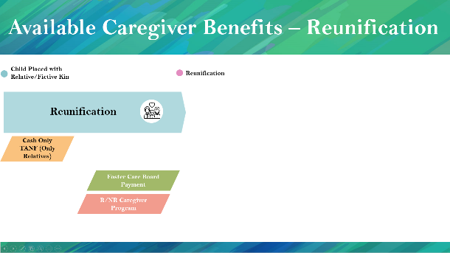  PG. 7 | STATE: When a child is removed from his or her home due to unsafe circumstances, the first goal is to provide help for the family and to reunify the child.  HIGHLIGHT: While case managers are focusing on reunification, if the child is placed with a relative, the relative can receive Cash Only TANF during the placement. After the child has been adjudicated dependent, relatives and nonrelatives can apply for the Relative or Nonrelative caregiver program to receive benefits.  If the caregiver chooses to become a Level I licensed foster parent, he or she is eligible to receive foster care board payments for the child.
Presentation – Adoption Caregiver Benefits  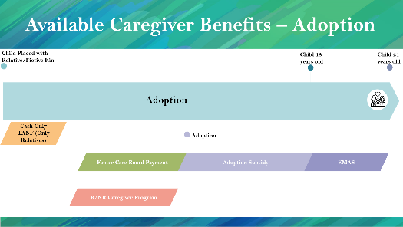  PG. 5 | STATE: If reunification is not an option and parental rights are terminated, the child is eligible for adoption. When the child is adopted, the adoptive family is eligible for Maintenance Adoption Subsidy (MAS).  STATE: If the adoptive family signs the Adoption Assistance Agreement when the child is 16 or 17 years old, the child is eligible to receive Extension of Maintenance Adoption Subsidy (EMAS) until the child turns 21 – if the child participates in a qualifying activity.
Presentation – Permanent Guardianship Benefits  PG. 6  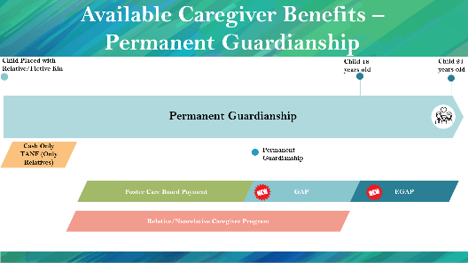 | STATE: If reunification and adoption are not the most appropriate options for the child and the case is discharged to permanent guardianship with relatives or fictive kin, relatives and fictive kin may be eligible for the relative/nonrelative caregiver program.  HIGHLIGHT: If the case is discharged to permanent guardianship with relatives or fictive kin, the Guardian may be eligible for GAP benefits until the child is 18 years old. If the child is 16 or 17 years old when the initial Guardianship Assistance Agreement is signed, the Guardian may receive Extension of Guardianship Assistance Program benefits until 21 years old, if the child is participating in at least one of the qualifying activities.  STATE: Nonrelatives are not eligible for GAP or EGAP benefits. A nonrelative must be deemed fictive kin to qualify.  STATE: It is important to know that the child must be 16 or 17 years old when the agreement is signed. If the agreement is signed when the child is 15 years old, and the case is closed when the child is 16 years old, the child is not eligible for EGAP.

Presentation – Licensure Level Comparison  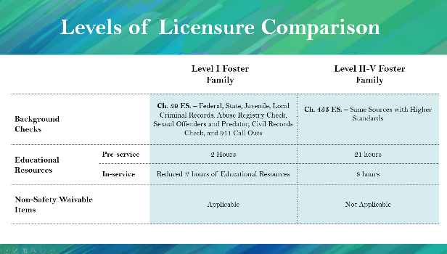  PG. 6 | NOTE: This slide is an overview of the differences between Level I and Level II-V licensures.  STATE: Since being at least a Level I licensed foster home is vital for GAP eligibility, we will remind you the differences between Level I foster families and Level II-V foster families.  Level I and Level II through IV foster care differ in three major ways: background screening, educational resources, and non-safety waivable items.  Level I foster families go through Federal, State, Juvenile, Local Criminal Records, Abuse Registry Check, sexual offenders and predator, civil records check and 911 callouts in accordance with Ch. 39. However, Level II-V licensed foster parents go through the same background checks, in accordance with Ch. 435 F.S. standards, which are higher than Ch. 39. F.S.  Second is educational resources; while the Level I foster families are required to take 2 hours for pre-service and less than 8 hours for in-service, the Level II-V foster families are required to take 21 hours for pre-service and 8 hours for in-service educational resources.  Third is non-safety waivable items. For Level I licensed foster families, certain non-safety related items can be waived if the items (or lack-of) are not putting the child in danger or can be substituted. For Level II-V licensed foster families, no items can be waived whether they are related to safety of the child or not.

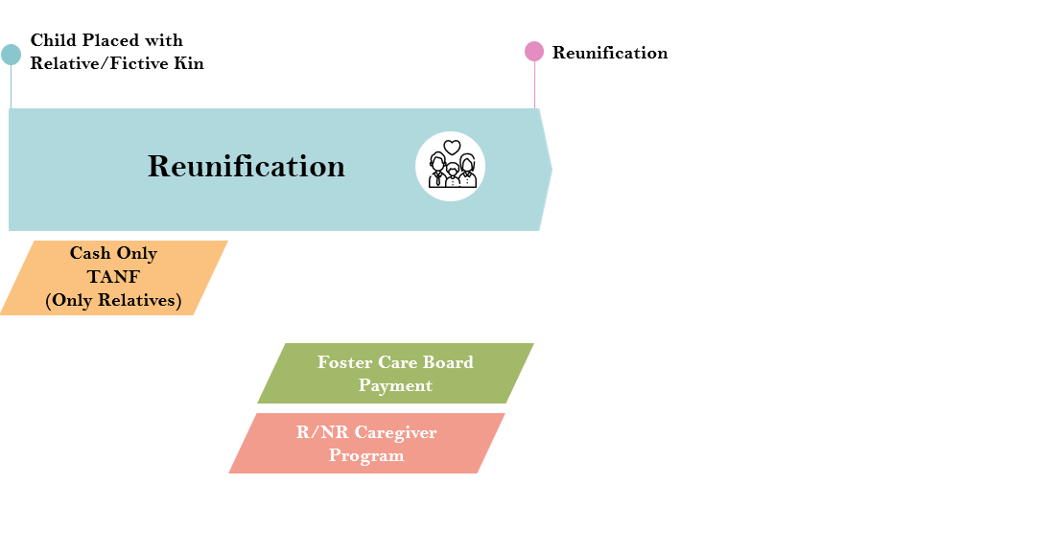
Available Caregiver Benefits – Reunification

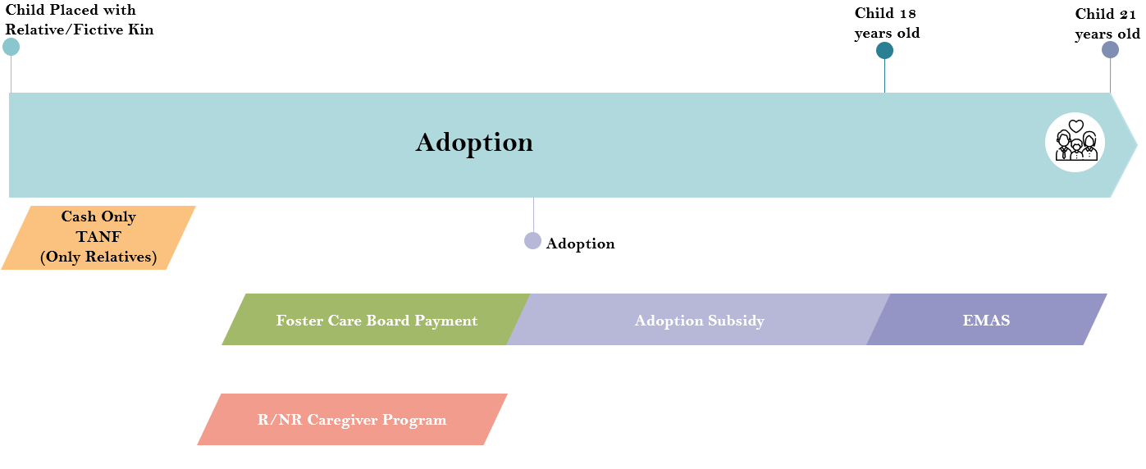
Available Caregiver Benefits – Adoption

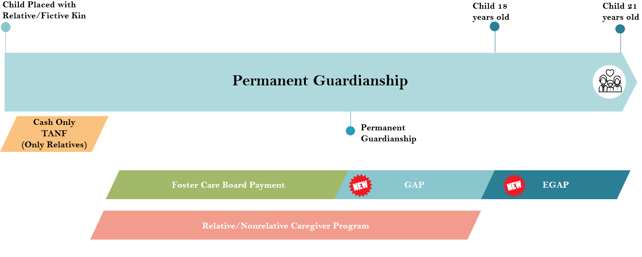
Available Caregiver Benefits – Permanent Guardianship

Levels of Licensure
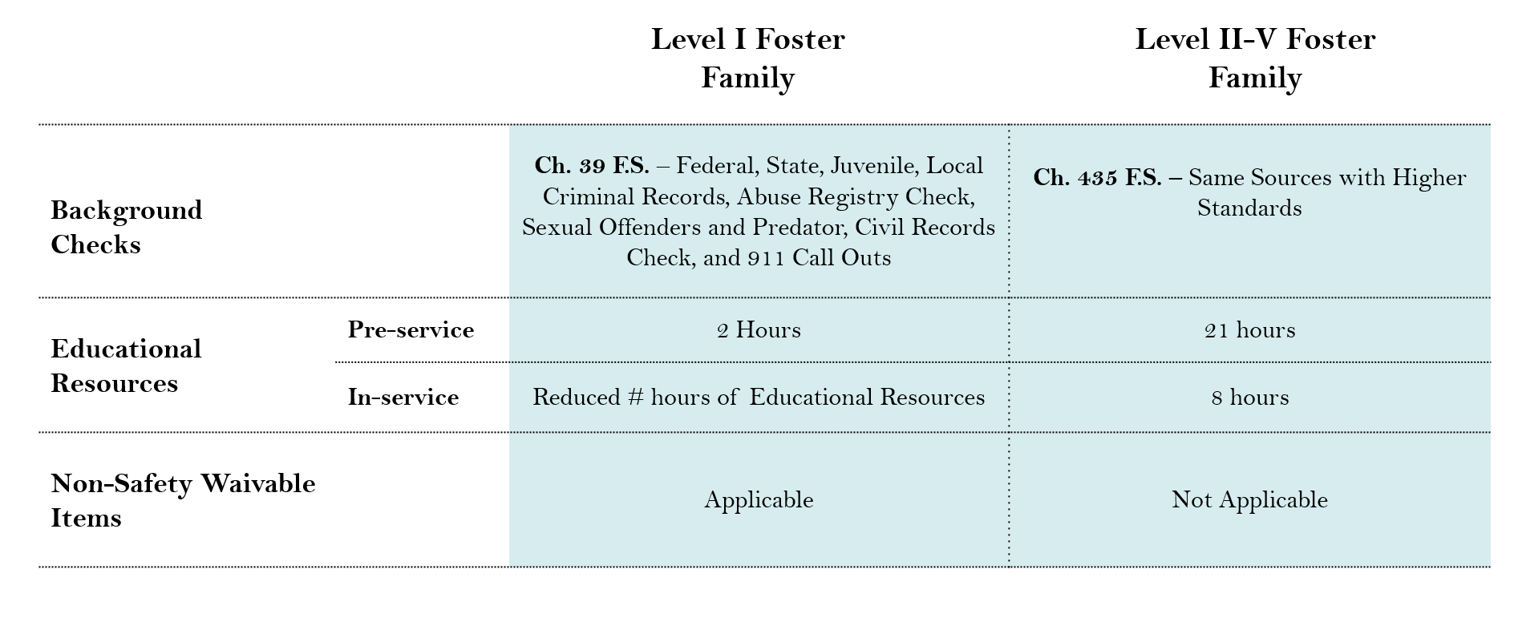

Guardianship Assistance Program (GAP) Overview
Instructor Information
Presentation – GAP Overview  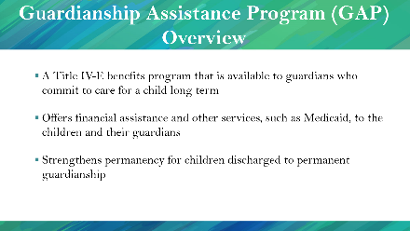  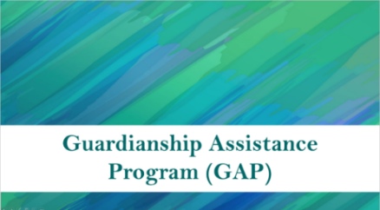  PG. 7 | STATE: Before we dive into the details of the Guardianship Assistance Program (GAP), we will overview the program, eligibility requirements, and benefits.  - GAP is a Title IV-E benefits program that is available to relatives and fictive kin who commit to caring for a child long term.  - GAP offers financial assistance and other services, such as Medicaid, to the children and their relatives.  - GAP strengthens permanency for children discharged to permanent guardianship.
Guardianship Assistance Program (GAP) Overview:
- A Title IV-E benefits program that is available to relatives and fictive kin who commit to caring for a child long term
- Offers financial assistance and other services, such as Medicaid, to the children and their relatives
- Strengthens permanency for children discharged to permanent guardianship

Guardianship Assistance Program (GAP) Benefits
Instructor Information
Presentation – Guardianship Assistance Program (GAP) – Benefits  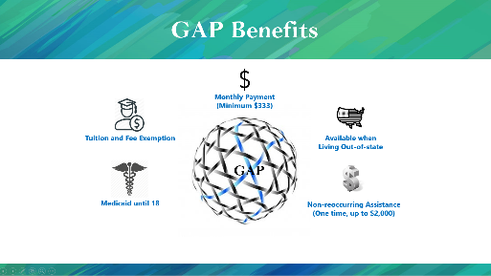  PG. 7 | STATE: Children who are closing out in permanent guardianship and are eligible for the GAP benefits will receive the following:  - Monthly payments of $333 for support of the child.  - Medicaid benefits until the child is 18 years of age (or 21 if the child is eligible for Extension of Guardianship Assistance Program).  - Tuition and fee exemptions.  - One-time payment to assist with the costs of establishing permanent guardianship ($2000 nonrecurring).  STATE: Also, the child and guardian may be eligible for these benefits even if they live out-of-state. This is different from the relative/nonrelative caregiver program which requires families to reside in the state of Florida to receive benefits.
Guardianship Assistance Program (GAP) Benefits
GAP benefits are:
  - Monthly payment of $333 for support of the child.
  - Medicaid benefits until 18 years of age (or 21 if eligible for Extension of Guardianship Assistance Program).
  - Tuition and fee exemption.
  - Available for children living out-of-state.
- One-time payment to assist with the costs of establishing permanent guardianship ($2000 nonrecurring)

Guardianship Assistance Program (GAP) Eligibility
Instructor Information
Presentation – Guardianship Assistance Program (GAP) – Eligibility Overview  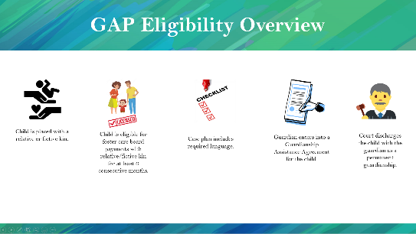  PG. 8 | STATE: Please keep in mind that this is an overview slide and not necessarily the order in which these tasks are completed.  To be eligible for GAP, a child must be placed with a relative or fictive kin, and the child must be eligible to receive foster care board payments for at least 6 consecutive months with the current caregiver.  HIGHLIGHT: Florida Statutes requires that Child Welfare Professionals must include the required language (Ch. 39.6225 – 10(a-g)) in the Permanent Guardianship Case Plan for a family to be eligible for the GAP benefits. The language is required for the GAP eligibility.  STATE: The caregiver must also enter into a Guardianship Assistance Agreement for the child prior to the case closing and the court discharging the child to permanent guardianship.
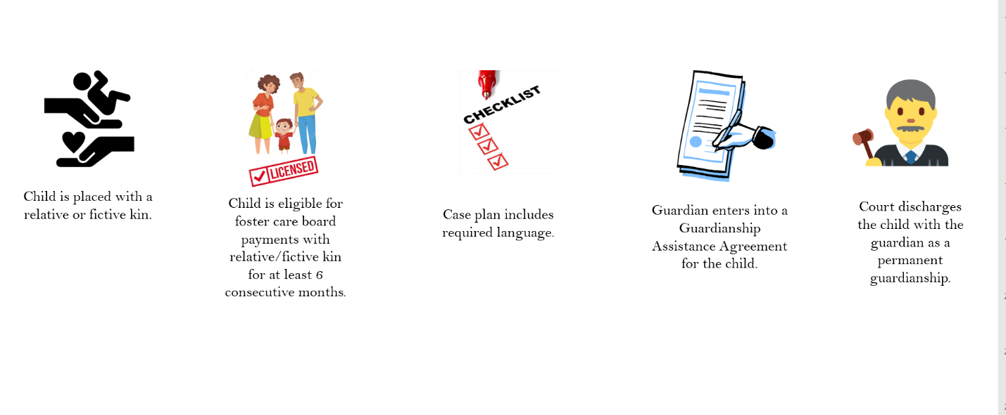
Guardianship Assistance Program (GAP) Eligibility Overview

Guardianship Assistance Program (GAP) Eligibility Stages Overview
Instructor Information
Presentation – Guardianship Assistance Program (GAP) Eligibility Stages  PG. 9  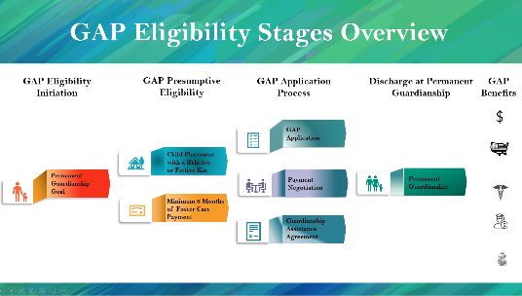 | STATE: We will start off with an overview of the GAP stages.  GAP has four stages with different tasks associated to each stage. The first stage is the GAP eligibility initiation. Here, either the primary goal has changed to permanent guardianship, or a concurrent goal of permanent guardianship has been added.  Second is the GAP presumptive eligibility stage. In this stage, the child must be placed with a relative or fictive kin, and the caregiver is eligible for at least 6 months of foster care board payment. During the presumptive eligibility stage, no legal document is required.  Once stage 1 and 2 requirements are met, stage 3 begins. Under stage 3, the relative or fictive kin completes the GAP application. Then, the relative and the child welfare professional negotiate the payment. The child welfare professional then finalizes the Guardianship Assistance Agreement.  During the last stage, the court discharges the child to permanent guardianship and the relative or fictive kin will be eligible for GAP benefits on behalf of the child.  STATE: We will look at each stage more closely. But this is the overall picture.
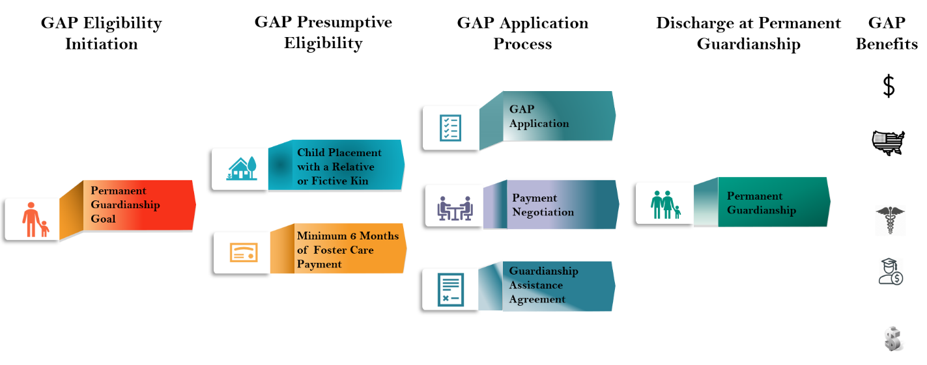
Guardianship Assistance Program (GAP) Eligibility Stages Overview

Guardianship Assistance Program (GAP) Eligibility Initiation
Instructor Information
Presentation – GAP Eligibility Initiation: Permanent Guardianship Goal  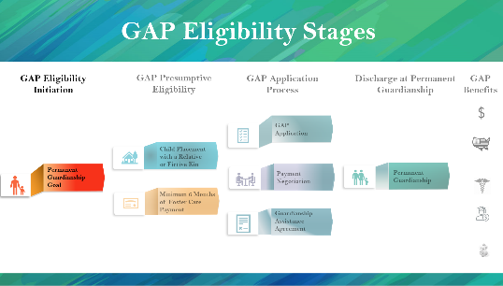  PG. 10  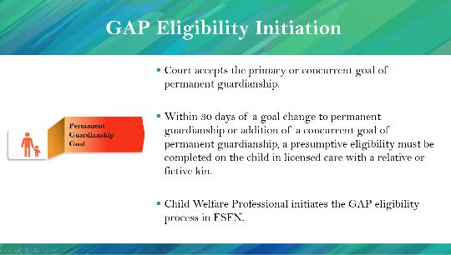 | STATE: To be presumptively eligible for the Guardianship Assistance Program, either the primary or concurrent goal must be permanent guardianship. Then, the court must accept the permanent guardianship goal.  Within 30 days of a goal change to permanent guardianship or addition of a concurrent goal of permanent guardianship, presumptive eligibility must be completed on the child in licensed care with a relative or fictive kin.  STATE: Once the GAP presumptive eligibility is initiated, the Child Welfare Professional who is responsible for GAP will create the GAP page in FSFN.
GAP Eligibility Initiation: Permanent Guardianship Goal
- Court accepts the primary or concurrent goal of permanent guardianship.
- Within 30 days of a goal change to permanent guardianship or addition of a concurrent goal of permanent guardianship, presumptive eligibility must be completed on the child in licensed care with relative or fictive kin.
- Child Welfare Professional initiates the GAP eligibility process in FSFN.

GAP Presumptive Eligibility
Instructor Information
Presentation –GAP Presumptive Eligibility  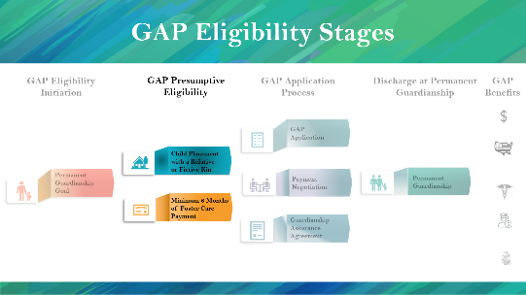  PG. 10  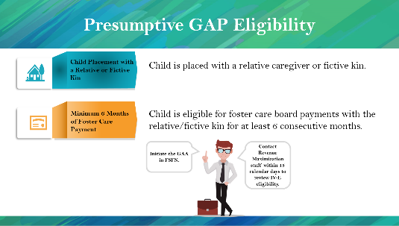 | STATE: Once permanent guardianship becomes the primary or concurrent goal, the Child Welfare Professional responsible for GAP* will need to confirm and document in FSFN that;  - The child is placed with a relative or fictive kin.  - The relative or fictive kin is eligible for foster care board payments for the child for at least 6 consecutive months.  * Update the presentation and participant guide to state who will confirm and document in FSFN in accordance with your local processes.  STATE: Once the child welfare professional responsible for GAP confirms the permanent guardianship goal, placement with relative or fictive kin, and that they were eligible for a minimum of 6 months of foster care payments, he or she will need to create a Guardianship Assistance Agreement (GAA) page in FSFN.  The child welfare professional should then contact the revenue maximization staff at the CBC within 15 calendar days to review the Title IV-E eligibility status.
GAP Presumptive Eligibility: Child is Placed with a Relative or Fictive Kin
The child is placed with relative caregiver or fictive kin.
GAP Presumptive Eligibility: Minimum 6 Months of Foster Care Payment
Relative or Fictive Kin is eligible for foster care board payments for the child for at least 6 consecutive months.
GAP Presumptive Eligibility
- GAA may be initiated once a child has been deemed presumptively eligible, the GAA must be completed in FSFN.
- Once presumptive eligibility has been determined, the child welfare professional shall contact the revenue maximization staff at the CBC within 15 calendar days to review the Title IV-E eligibility status.

Federal Funding for Guardianship Assistance Program
Instructor Information
Presentation – Federal Funding for GAP  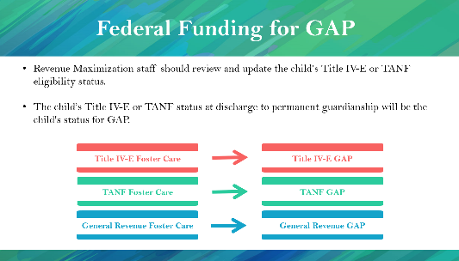  PG. 11 | STATE: As we mentioned in the previous slide, you need to contact your Revenue Maximization staff to determine which funding source will be used for GAP benefits.  Revenue Maximization staff should review and update the child’s Title IV-E or TANF eligibility status.  The child’s Title IV-E or TANF status at discharge to permanent guardianship will be the child's status for GAP. In other words,  Title IV-E Foster Care status will become Title IV-E GAP status.  TANF Foster Care status will become TANF GAP status.  General Revenue Foster Care will become General Revenue GAP status.
Federal Funding for Guardianship Assistance Program
- Revenue Maximization staff should review and update the child’s Title IV-E or TANF eligibility status.
- The child’s Title IV-E or TANF status at discharge to permanent guardianship will be the child's status for GAP.
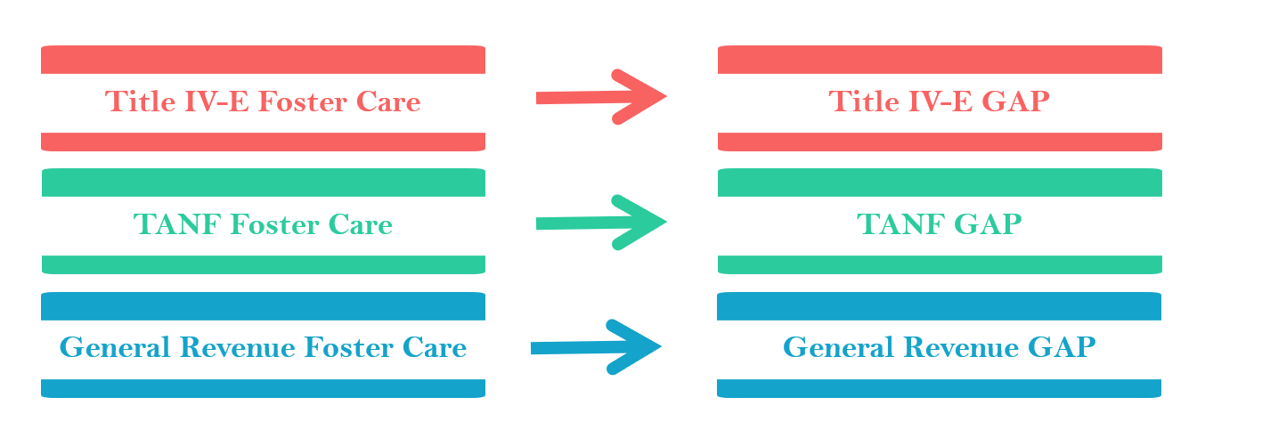

What is Important and New for Case Managers?
Instructor Information
Presentation – What is Important for Case Managers?  PG. 11  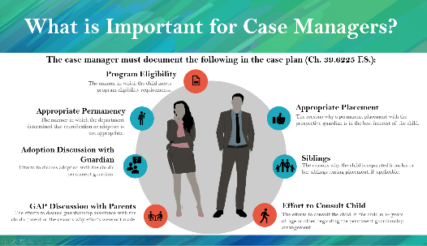 | STATE: So, what does this mean for case managers?  As of July 1st, Ch. 39.6225 F.S., requires that a permanent guardianship case plan is completed with the documented statutory required language.  STATE: Case managers are already including some of the information in their permanent guardianship case plans. The information already included can be seen in the blue circles. These items are statutorily required per Ch. 39.6221 F.S. to be included to achieve permanency with Permanent Guardianship. There are three additional items needed for the child to qualify for GAP, which are can be seen in the red circles.  Program Eligibility: The manner in which the child meets program eligibility requirements.  Appropriate Permanency: The manner in which the department determined that reunification or adoption is not appropriate.  Adoption Discussion with Guardian: Efforts to discuss adoption with the child’s permanent guardian.  GAP Discussion with Parents: The efforts to discuss guardianship assistance with the child’s parent or the reasons why efforts were not made.  Appropriate Placement: The reasons why a permanent placement with the prospective relative is in the best interest of the child.  Siblings: The reasons why the child is separated from his or her siblings during placement, if applicable.  The Effort to Consult the Child: The efforts to consult the child, if the child is 14 years of age or older, regarding the permanent guardianship arrangement.

Presentation – What is New for Case Managers?  PG. 12  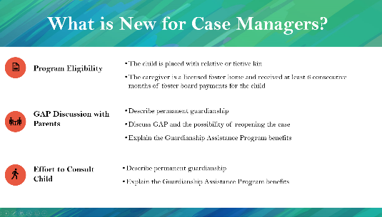 | STATE: The following new items must be included in the Permanent Guardianship Case Plan.  Program Eligibility is about documenting how the child will meet the following presumptive GAP eligibility requirements:  - The child is placed with relative or fictive kin.  - The caregiver is a licensed foster home and is eligible for at least 6 consecutive months of foster board payment.  GAP Discussion with Parents is about documenting the efforts to discuss guardianship assistance with the child’s parent or the reasons why efforts were not made to have this discussion.  - Describe permanent guardianship  - Discuss GAP and the possibility of reopening the case  - Explain the Guardianship Assistance Program benefits  Effort to Consult the Child is about documenting the efforts to consult the child about the permanent guardianship arrangement if the child is 14 years of age or older.  - Describe permanent guardianship to the child  - Explain the Guardianship Assistance Program benefits

What is Important for Case Managers?
Case managers must document the following in the case plan (Ch. 39.6225 F.S.):
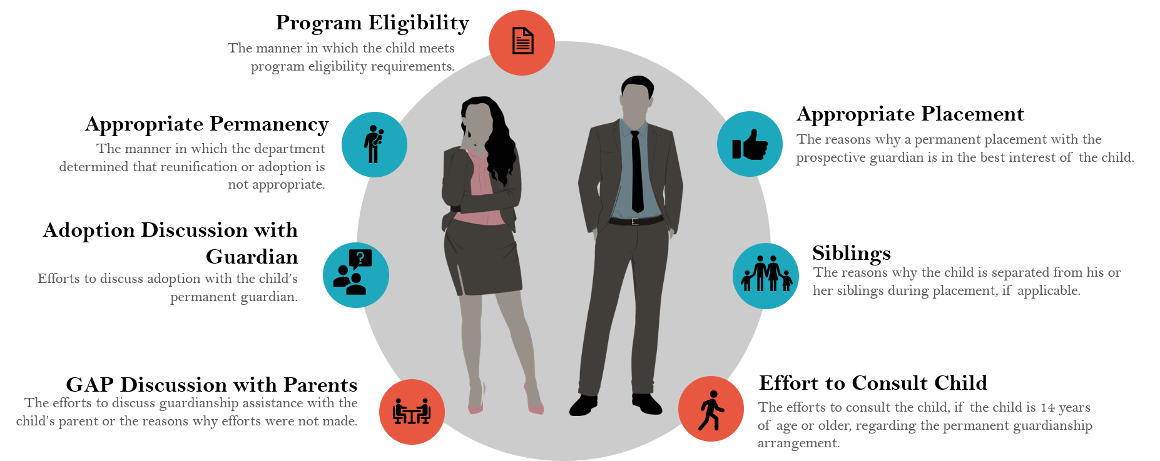

Program Eligibility: The manner in which the child meets the GAP eligibility requirements.
Appropriate Permanency: The manner in which the department determined that reunification or adoption is not appropriate.
Adoption Discussion with Guardian: Efforts to discuss adoption with the child’s permanent guardian.
GAP Discussion with Parents: The efforts to discuss guardianship assistance with the child’s parent or the reasons why efforts were not made.
Appropriate Placement: The reasons why a permanent placement with the prospective relative is in the best interest of the child.
Siblings: The reasons why the child is separated from his or her siblings during placement, if applicable.
Effort to Consult the Child: The efforts to consult the child, if the child is 14 years of age or older, regarding the permanent guardianship arrangement.

What is New for Case Managers?
Program Eligibility: How the child will meet the presumptive GAP eligibility requirements.
- The child is placed with relative or fictive kin.
- The caregiver is a licensed foster home and is eligible for at least 6 consecutive months of foster board payment.
GAP Discussion with Parents: The efforts to discuss guardianship assistance with the child’s parent or the reasons why efforts were not made.
- Describe permanent guardianship
- Discuss GAP and the possibility of reopening the case
- Explain the Guardianship Assistance Program benefits
Effort to Consult the Child: The efforts to consult the child, if the child is 14 years of age or older, regarding the permanent guardianship arrangement.
- Describe permanent guardianship
- Explain the Guardianship Assistance Program benefits
NOTE: Appropriate Permanency, Relative Not Adopting, Appropriate Placement, and Sibling are required for all case files while Program Eligibility, GAP discussion with parents, and effort to consult child are only required for GAP cases.

Required Language Placement
Instructor Information
Presentation – Where to Include the Required Language in Case Plan  PG. 13  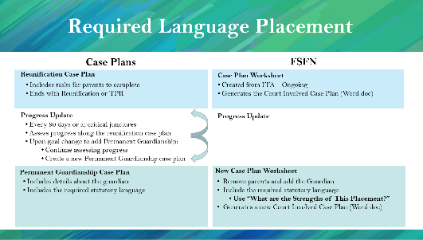 | NOTE: This slide is a high-level overview to show where the required statutory language will be placed in FSFN.  STATE: Once the permanency goal changes to include Permanent Guardianship, create a separate Permanent Guardianship Case Plan to document information regarding the Guardian and the required statutory language for GAP Eligibility.  To create the Permanent Guardianship Case Plan in FSFN, launch a new case plan worksheet, remove the parents, and add the Guardian (who must be a case participant). Within the Visitation/Family Time/Placement tab, insert the required statutory language under “What are the strengths of this placement?”. The 7 required questions should be answered for each child.  STATE: CLS will train attorneys on where to look in FSFN for the required language.  NOTE: To learn more about creating Case Plan Worksheets, click on the link to watch the short training video.
Required Language Placement
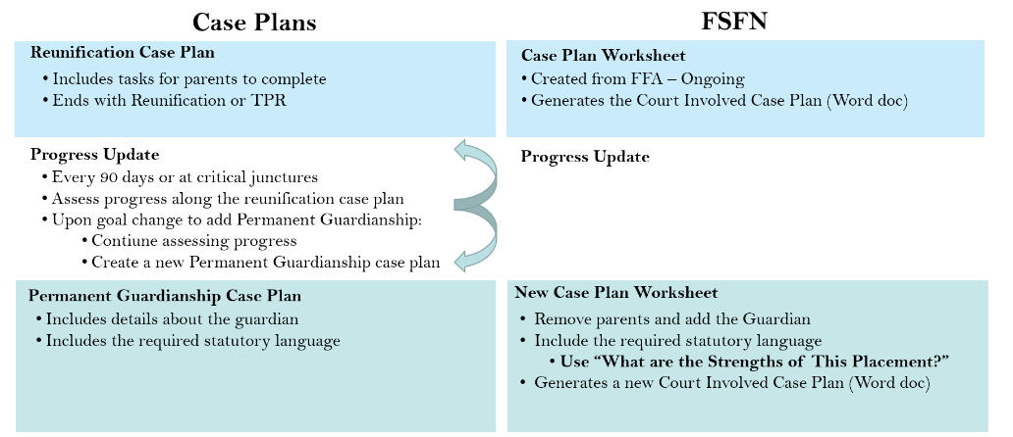

FSFN Creating GAP Page
Instructor Information
Presentation – GAP FSFN  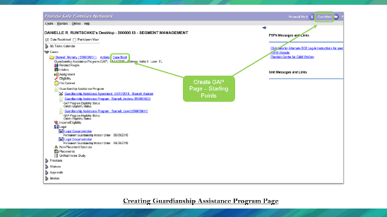  PG. 14-15  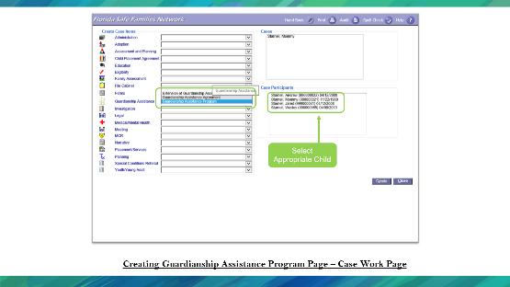  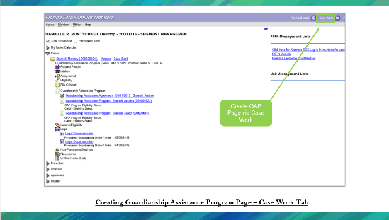 | STATE: The Guardianship Assistance Program Page can be accessed from two locations on the FSFN desktop, the Case Book hyperlink next to the Case Name, and the Case Work Button at the top of the screen.  STATE: To access from the Case Work Button: From the FSFN Desktop, select the Case Work Button. From Create Case Work, select the Case name then select the participant (child), which will receive the payments. On the left side of the page, under the Create Case Items find the label Guardianship assistance. In the drop-down, select Guardian Assistance Program. Double check all selections and select “create” at the bottom right side of the page.

Presentation – GAP FSFN  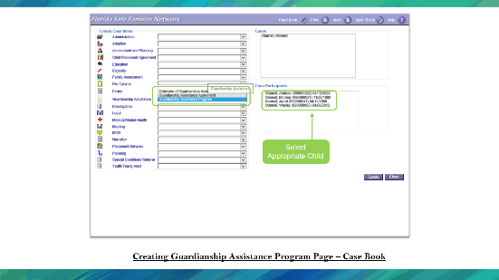  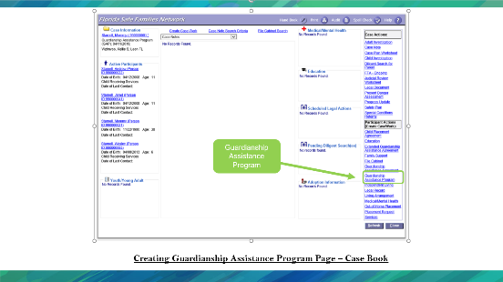  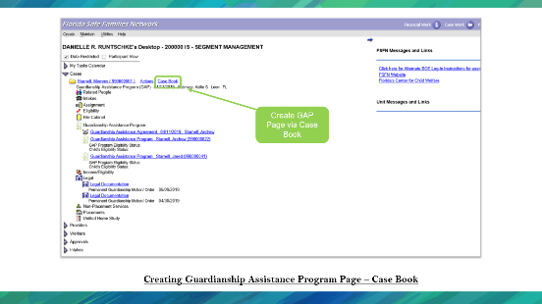  PG. 16 | STATE: To access from the Case Book Hyperlink, Collapse all Expandos on the left side of the FSFN Desktop. Open the Expando labeled Cases. Select the Case Book hyperlink next to the appropriate Case. On the right side of Case Book, choose Guardianship Assistance Program under the Participant Actions. Select participant (child), which will receive the payments. Double check all selections and select “create” at the bottom right side of the page.
Presentation – GAP FSFN  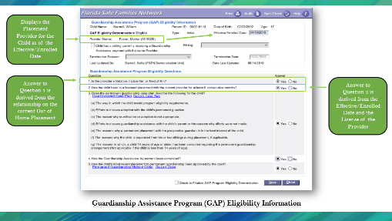  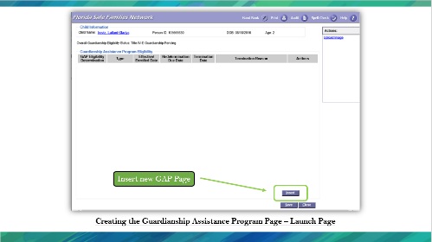  PG. 19  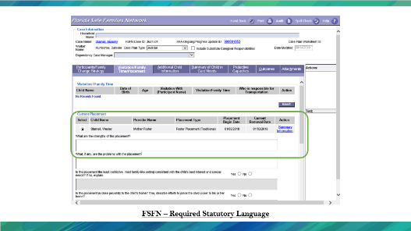  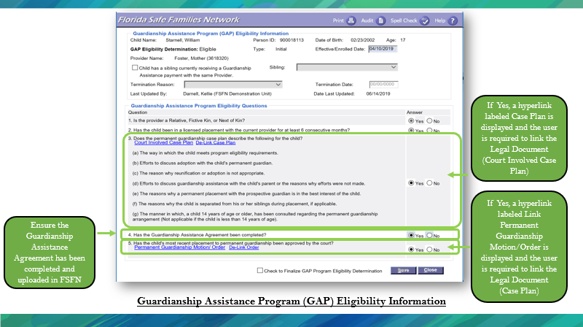 | STATE: On the Guardianship Assistance (GAP) Eligibility Information Page, select the Insert Button. On the GAP page document, the Effective/Enrolled Date as the date of the presumptive eligibility for this child. Questions 1 and 2 will automatically populate based on the information within FSFN. Review question 3(a-g), 4 and 5, and select the appropriate answer, linking the appropriate documents and court orders. Save the page. For the child to be eligible all answers should be ‘yes.’  Once all answers are yes, ensure the date reflects a 6-month enrollment time frame. Finally, select “Check to Finalize GAP Program Eligibility Determination” and save the page.

Creating Guardianship Assistance Program Page
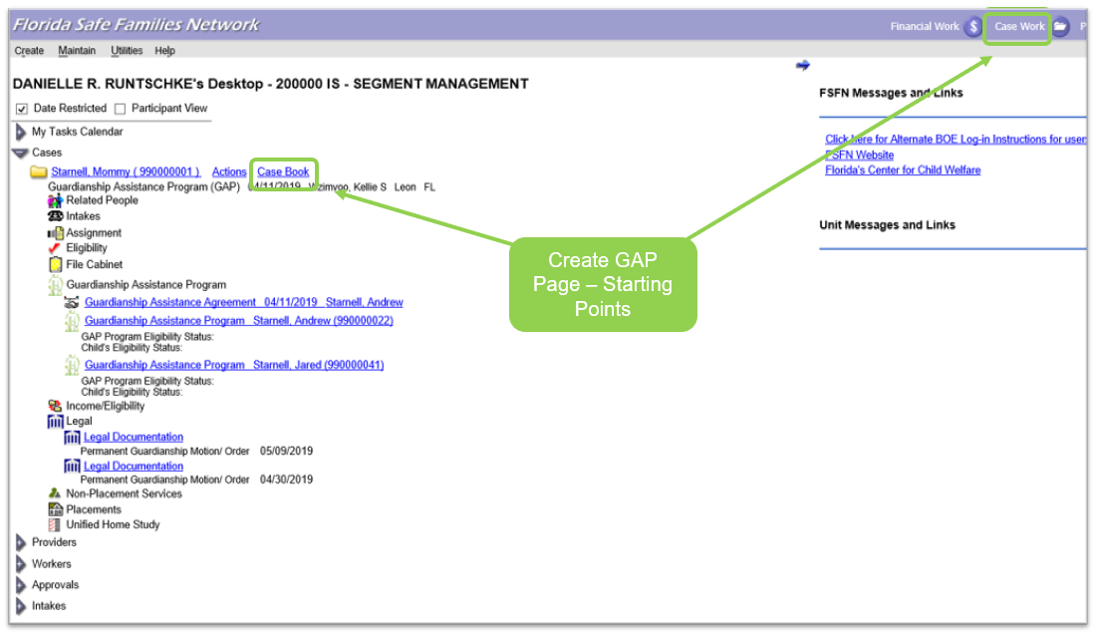
The Guardianship Assistance Program Page can be accessed from two locations, the Case Book hyperlink next to the Case Name, and the Case Work Button at the top of the FSFN Desktop.

Creating Guardianship Assistance Program Page – Case Work Button
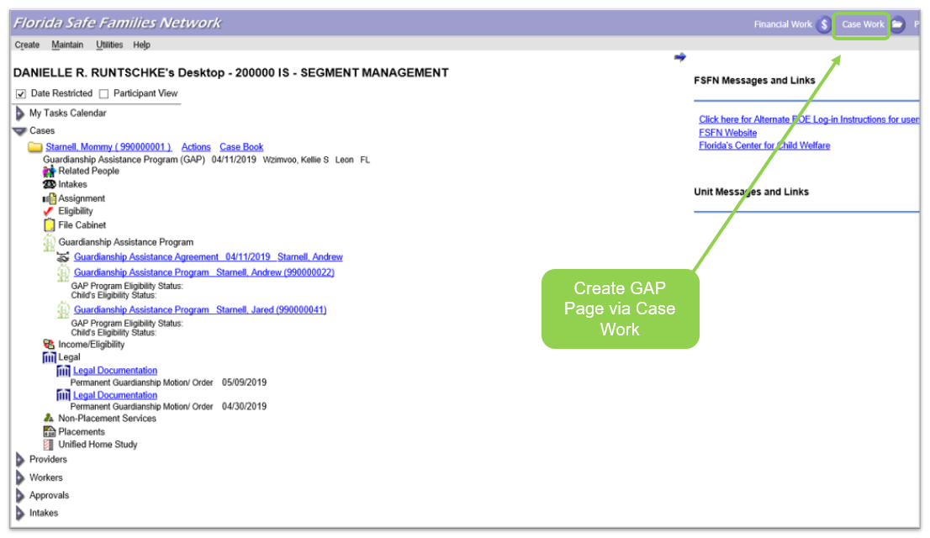
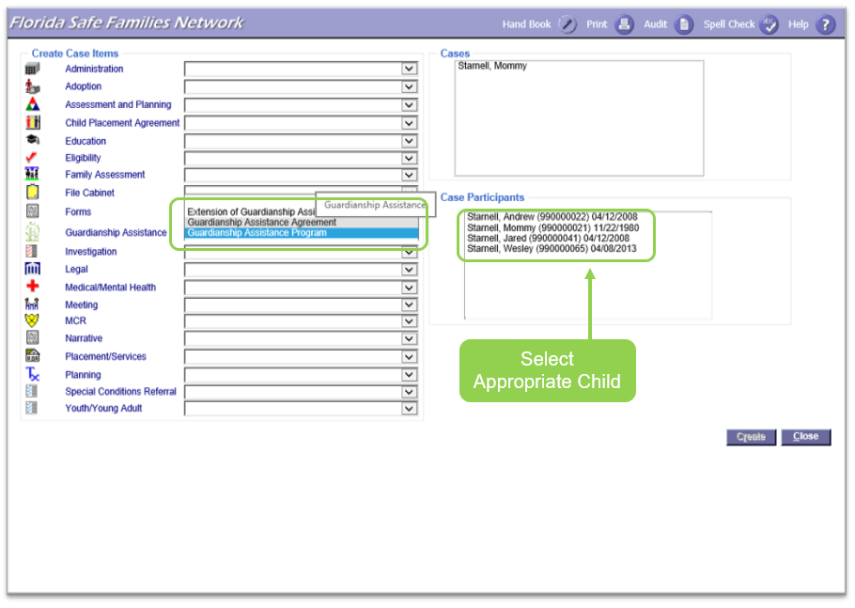
From the FSFN Desktop select the Case Work Button. From Create Case Work select the Case name then select the participant (child), which will receive the payments. On the left side of the page, under the Create Case Items, find the label Guardianship assistance. In the drop-down select Guardian Assistance Program. Double check all selections and select “create” at the bottom right side of the page.
Creating Guardianship Assistance Program Page – Case Book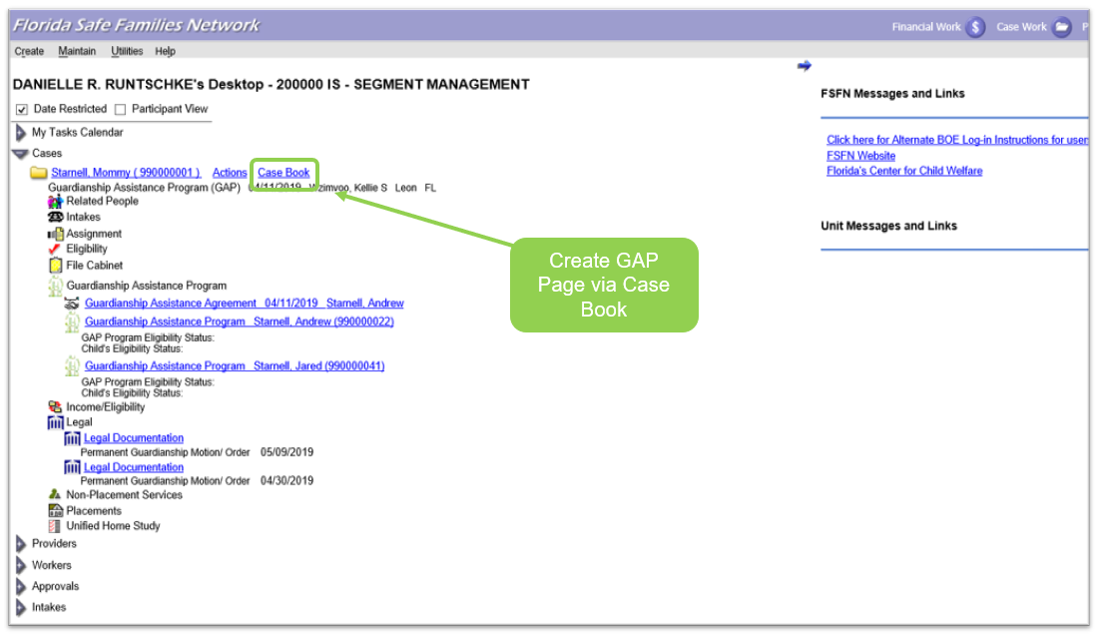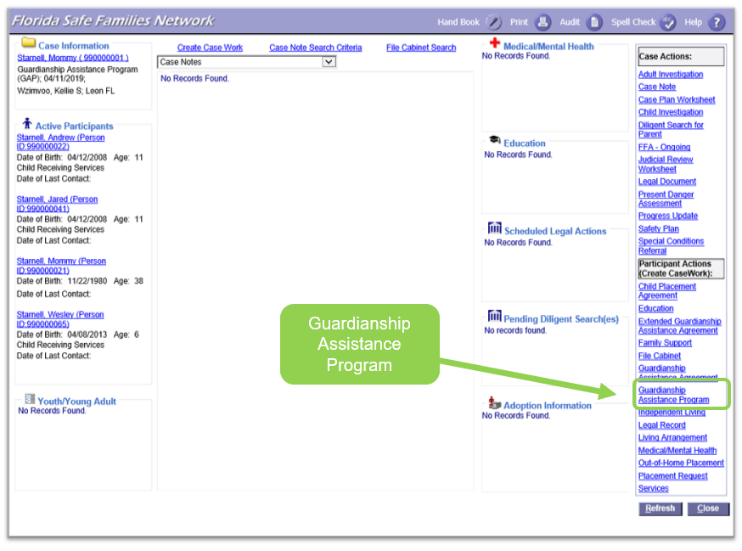
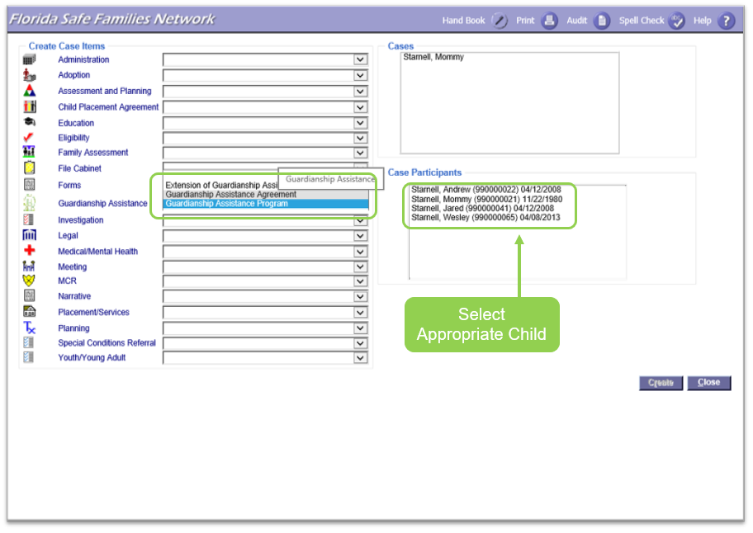
Collapse all Expandos on the left side of the FSFN Desktop. Open the Expando labeled Cases. Select the Case Book hyperlink next to the appropriate Case. On the right side of Case Book, select Guardianship Assistance Program under the Participant Actions. Choose participant (child), which will receive the payments. Double check all selections and select “create” at the bottom right side of the page.

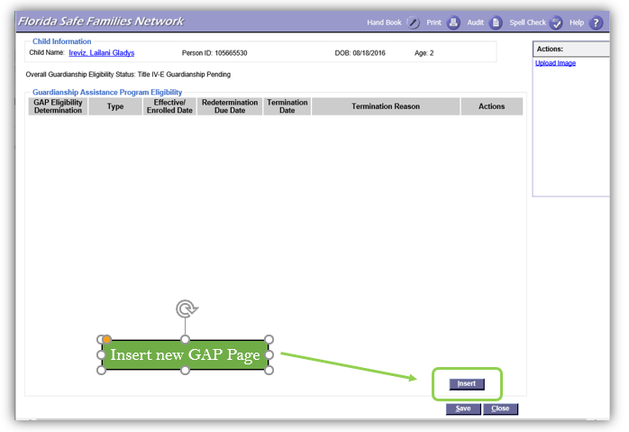
On the Guardianship Assistance (GAP) Eligibility Information Page, select the Insert Button.

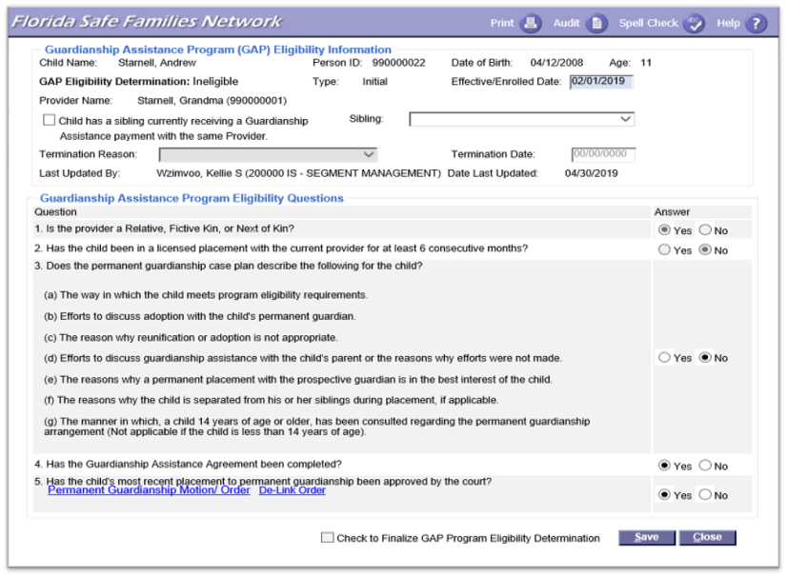
Guardianship Assistance Program (GAP) Eligibility Information
On the GAP Page document the Effective/Enrolled Date as the date of the presumptive eligibility for this child. Questions 1 and 2 will automatically populate based on the information within FSFN. Review question 3(a-g), 4 and 5, and select the appropriate answer, linking the appropriate documents and court orders. For the child to be eligible all answers should be ‘yes.’ Once all answers are yes, ensure the date reflects a 6-month enrollment time frame. Finally, select “Check to Finalize GAP Program Eligibility Determination” and save the page.

Siblings
Instructor Information
Presentation – Siblings  PG. 20  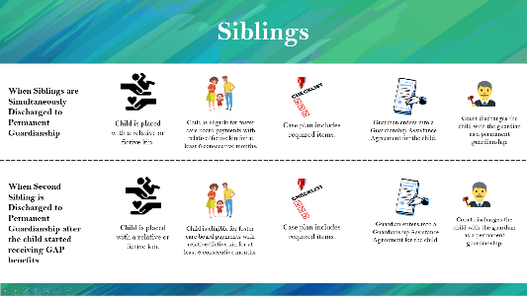 | STATE: There are two possible scenarios to place siblings together based on the second sibling’s placement timing.  If two siblings, let’s call them John and Mike, are placed with a relative at the same time, they both go through the same GAP process, which includes: placing the child with a relative or fictive kin, being eligible for 6 months of foster care payment, including required language in case plan, signing guardianship assistance agreement, and discharging the child with the guardian as a permanent guardianship. Nothing changes.  However, if John is placed with the relative first, his case is discharged at permanent guardianship, and the guardian starts receiving the GAP benefits, and Mike is placed with the same relative sometime later, 6-months foster care payment and case plan items are no longer required. In this case, the system already greys out question 1 and 2 on the GAP page in FSFN.
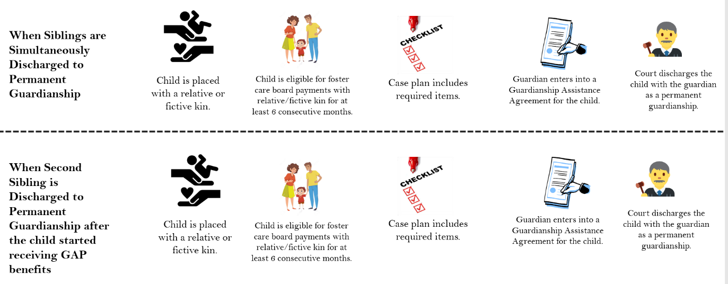
Siblings

Documenting Siblings Under GAP Page
Instructor Information
Presentation – Documenting Siblings under GAP page  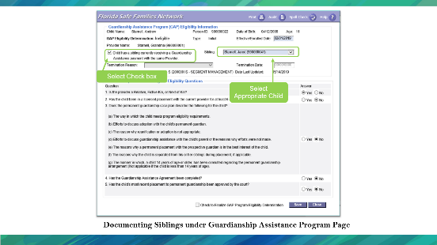  PG. 21 | STATE: Select the box indicating “Child has a sibling currently receiving a Guardianship Assistance payment with the same provider.”  Indicate which sibling in the corresponding box.  By checking this box, question 1 and 2 become grayed out and disabled.
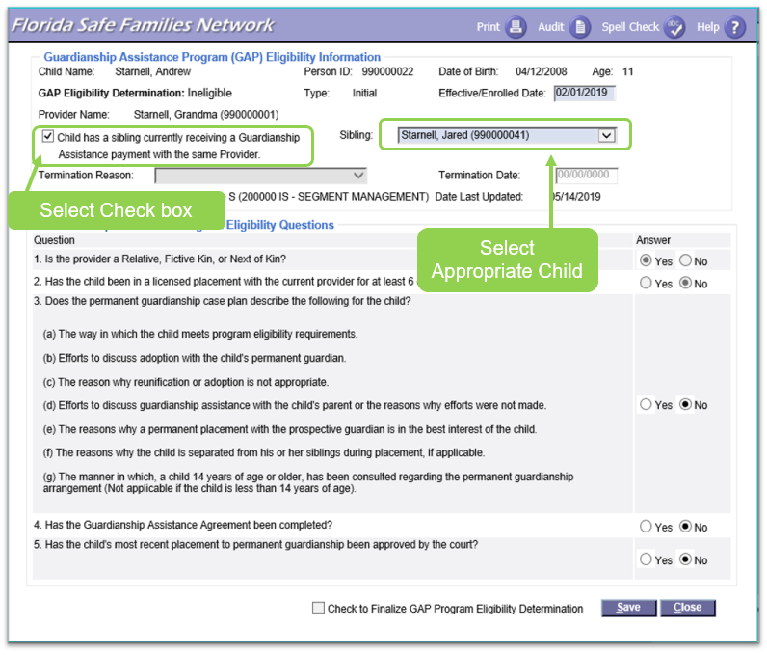
Documenting Siblings under Guardianship Assistance Program Page
Select the box indicating “child has a sibling currently receiving a Guardianship Assistance payment with the same provider.” Indicate which sibling in the corresponding box. This allows the first two questions in the eligibility section to be grayed out and not needed for eligibility.

Local Referral Process
Instructor Information
Presentation – Local Referral Process  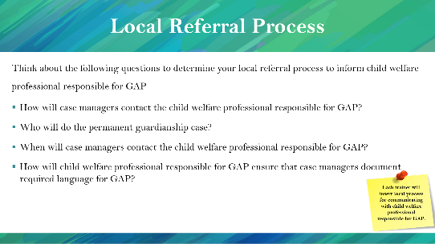  PG. 22 | STATE: Think about the following questions to determine your local referral process to inform child welfare professional responsible for GAP  - How will case managers contact the child welfare professional responsible for GAP?  - Who will do the permanent guardianship case plan?  - When will case managers contact the child welfare professional responsible for GAP?  - How will child welfare professional responsible for GAP ensure that case managers document required language for GAP?
Local Referral Process
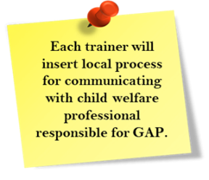
Think about the following questions to determine your local referral process to inform child welfare professional responsible for GAP
- How will case managers contact the child welfare professional responsible for GAP?
- Who will do the permanent guardianship case plan?
- When will case managers contact the child welfare professional responsible for GAP?
- How will child welfare professional responsible for GAP ensure that case managers document required language for GAP?

Extended Guardianship Assistance Program (EGAP) Overview
Instructor Information
Presentation – Extended Guardianship Assistance Program (EGAP)  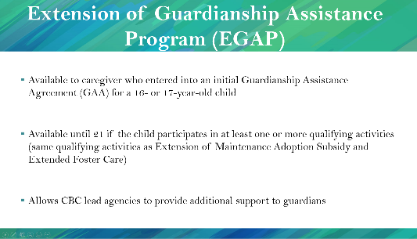  PG. 22 | NOTE: This slide is an overview of the Extension of Guardianship Assistance Program.  STATE: Similar to adoption, there is a possibility of extending GAP for children who are 18 years old or older.  Extended Guardianship Assistance Program (EGAP)  - Is available to relatives or fictive kin who entered into an initial Guardianship Assistance Agreement (GAA) for a 16 or 17-year-old child.  - Is available until 21 if the child participates in at least one or more qualifying activities (same qualifying activities as Extension of Maintenance Adoption Subsidy and Extended Foster Care)  - Allows CBC lead agencies to provide additional support to guardians.  HIGHLIGHT: Young adults cannot enroll in EGAP and PESS simultaneously. However, they can switch programs at any time.
Extended Guardianship Assistance Program (EGAP)
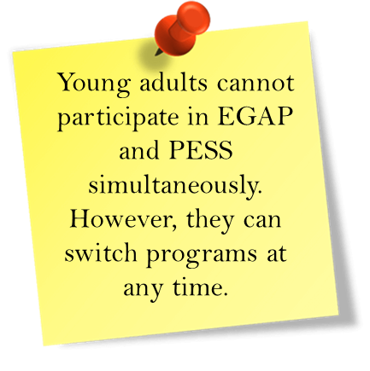
Extended Guardianship Assistance Program (EGAP)
- Available to caregiver who entered into an initial Guardianship Assistance Agreement (GAA) for a 16- or 17-year-old child
- Available until 21 if the child participates in at least one or more qualifying activities (same qualifying activities as Extension of Maintenance Adoption Subsidy and Extended Foster Care)
- Allows CBC lead agencies to provide additional support to relatives

Instructor Information
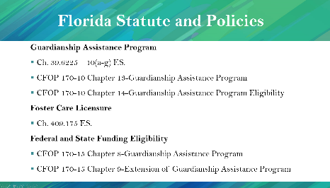  Presentation – Florida Statute and Policies | STATE: This slide shows the Florida Statute and DCF policies for Guardianship Assistance Program, Levels of Foster Home Licensure, and Federal and State Funding Eligibility.  READ the slide.
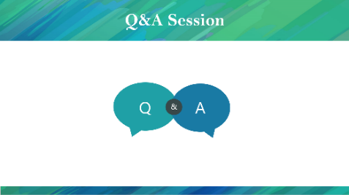  Presentation – End of Session A | STATE This concludes Session A. Does anyone have any questions?
Florida Statute and Policies
Guardianship Assistance Program
- Ch. 39.6225 – 10(a-g) F.S.
- CFOP 170-10 Chapter 13-Guardianship Assistance Program
- CFOP 170-10 Chapter 14-Guardianship Assistance Program Eligibility
Foster Home Licensure
- Ch. 409.175 F.S.
Federal and State Funding Eligibility
- CFOP 170-15 Chapter 8-Guardianship Assistance Program
- CFOP 170-15 Chapter 9-Extension of Guardianship Assistance Program


