Guardianship Assistance Program
(GAP)

Session B
June 2019

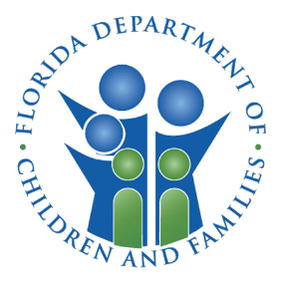

Contents
Session B 25
Objectives 25
Guardianship Assistance Program (GAP) Eligibility Stages 26
Guardianship Assistance Program (GAP) 27
GAP Application Process: GAP Application Form 27
GAP Eligibility Initiation: Negotiating Payments 27
GAP Negotiations: What to Consider 28
GAP vs. SSI and SSA 28
Enhanced Payments 29
Foster Care Board Rates 29
Local Process for Payments 30
Determination of GAP Payments 30
GAP Application Process: Guardianship Assistance Agreement 31
Successor Guardian 31
Background Screenings for Successor Guardian 32
FSFN Guardianship Assistance Agreement 33
Creating a Guardianship Assistance Agreement 33
Successor Guardian 34
FSFN Guardianship Assistance Agreement 35
Guardianship Assistance Program Agreement 35
Finalize the Guardianship Assistance Agreement 36
GAP Application Process: Discharge to Permanent Guardianship 38
Continued Program Eligibility 39
GAP Annual Redetermination 39
Redetermination Process 40
Transferring to Successor Guardian 41
FSFN Guardianship Assistance Program Redetermination 42
Guardianship Assistance Program – Redetermination 42
GAP Termination 44
FSFN GAP Termination Reasons 44
GAA Termination Reasons 45
FSFN GAA Termination Reasons 45
GAP Appeals 47
Guardianship Assistance Program Eligibility – Appeals 47
Extension of Guardianship Assistance Program 48
Caregiver Benefits – Permanent Guardianship 48
Extension of Guardianship Assistance Program (EGAP) Overview 48
Extension of Guardianship Assistance Program (EGAP) Timeline 49
Guardianship Assistance Agreement Established at the Age of 16 or 17 50
Discussion with Relative Family 50
Youth Transitioning to Young Adult (60-day Period) 51
EGAP Eligibility Requirements 51
Notification Prior to 18th Birthday 51
EGAP Qualifying Activities 52
Extension of Guardianship Assistance Agreement (EGAA) 52
Initiating EGAP 53
FSFN Extension of Guardianship Assistance Agreement 54
Qualifying Activities – Valid Educational Values 60
Negotiating EGAP Payments 64
Finalizing the Agreement 64
Extended Guardianship Assistance Payment Agreement 64
EGAP Payments 65
Eligibility and Enrollment 65
Ongoing Program Eligibility 66
Ongoing Program Eligibility Requirements 66
EGAP Redetermination Process 66
Young Adult Program Eligibility – Redetermination Reasons 67
Termination Reasons 68
EGAP Termination for Appealable Reasons 68
Young Adult Program Eligibility – Termination Reasons 69
EGAP Readmission 71
FSFN Practice 72
Appendix 75

Session B

Objectives
When you complete this session, you will be able to:
- Process the Guardianship Assistance Program Eligibility application.
- Negotiate the payment amount.
- Explain the Guardianship Assistance Agreement (GAA).
- Describe Successor Guardian.
- Describe the process for adding and changing the Successor Guardian processes.
- Describe the redetermination process.
- Identify the termination reasons.
- Describe the appeal process.
- Describe the readmission process.
- Document the processes in FSFN.
- Execute the Extension of Guardianship Assistance Program (EGAA).
- Identify qualifying activities.
- Describe the EGAP redetermination process.
- Describe the EGAP termination reasons.
- Describe the EGAP appeals.
- Describe the EGAP readmission process.
- Document the processes in FSFN.

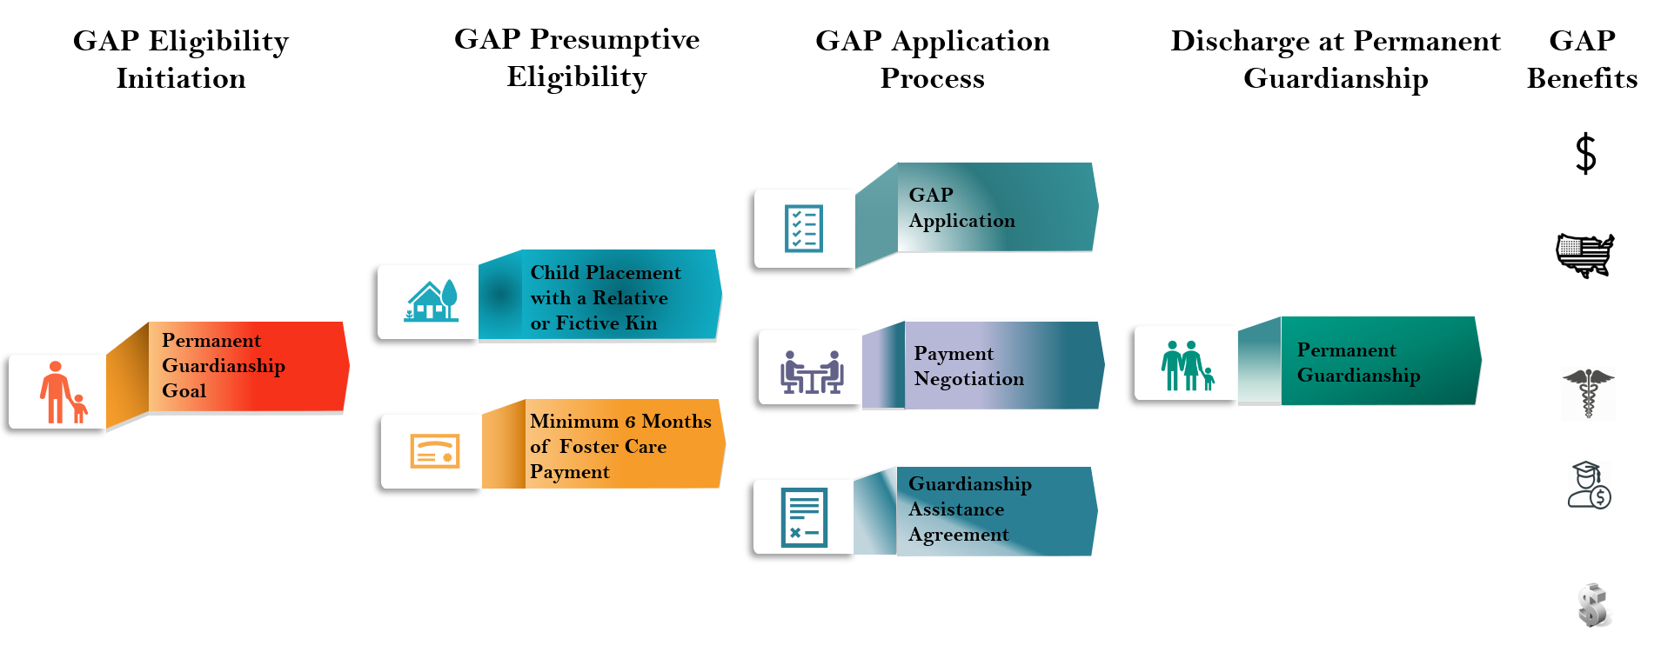

Guardianship Assistance Program (GAP) Eligibility Stages

Guardianship Assistance Program (GAP)

GAP Application Process: GAP Application Form
- Once the child is presumptively eligible, the caregiver must complete and submit a GAP application form.
- All applicants living in the home must sign the application.
- The applicant can withdraw their application at any time.
- Right to Appeal begins once the application is signed.
- Once signed, scan and upload the document to the FSFN GAP Page.
_______________________________________________________________________________________________________________________________________________________________________________________________________________________________________________________________
_____________________________________________________________________________________

GAP Eligibility Initiation: Negotiating Payments
- Initial GAP payments start at $333 per child monthly.
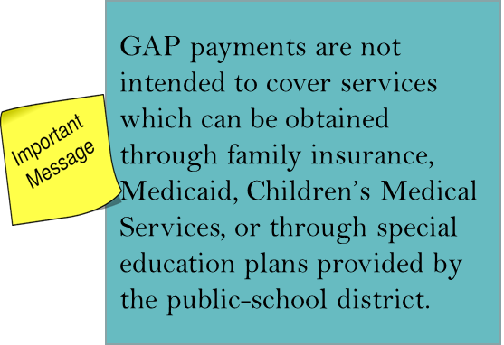
- A payment may be negotiated beyond the family’s level of licensure with RMD or designee’s approval.
- GAP payments should never exceed the foster care board level payment the family would receive based on the level of licensure.
_______________________________________________________________________________________________________________________________________________________________________________________________________________________________________________________________
_____________________________________________________________________________________

GAP Negotiations: What to Consider
- Initial determination of monthly GAP payments should be based on the child’s need and at the time of negotiation and projected future needs.
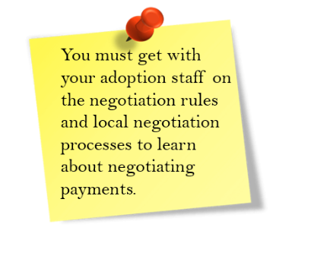
- In conjunction with the prospective relative(s) factors to identify are:
    - The immediate and long-term needs of the child
    - The services required to meet the child’s needs
    - Service costs
    - Family’s ability to provide the services
    - Other community resources and supports
_______________________________________________________________________________________________________________________________________________________________________________________________________________________________________________________________

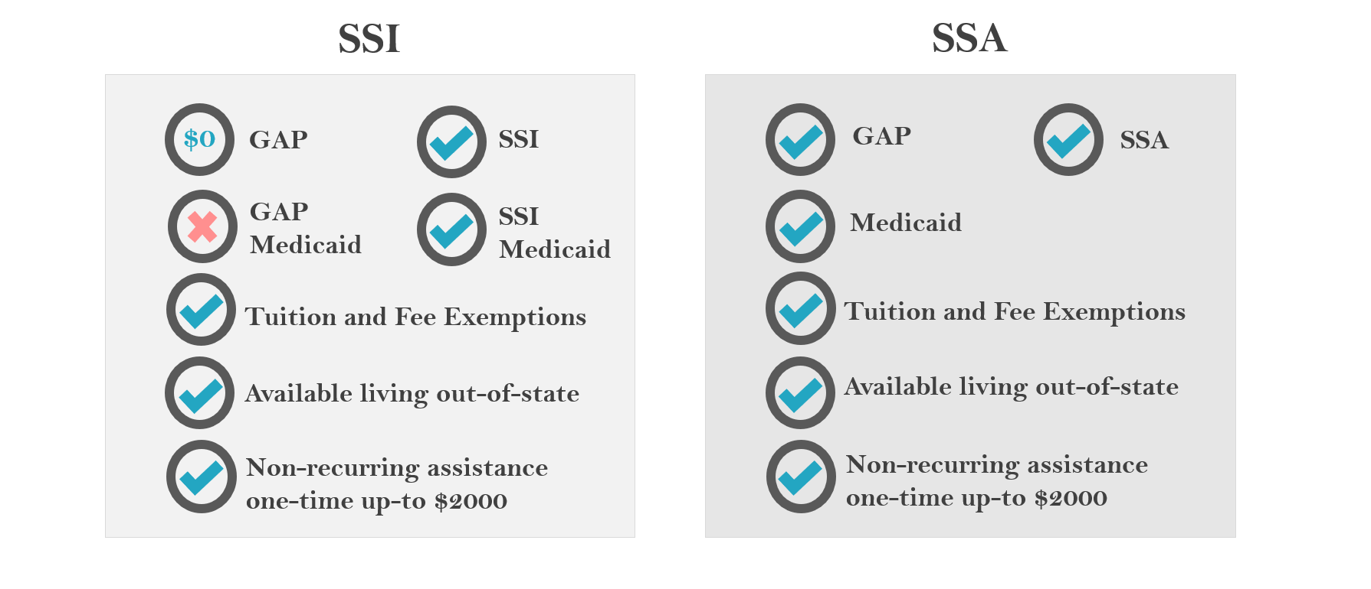
GAP vs. SSI and SSA
________________________________________________________________________________________________________________________________________________________________________________________________________________________________________________________________________________________________________________________________________________________________________________________________________________________________________

Enhanced Payments
- A CBC can negotiate a payment up to 100% of the statewide foster care board rate based on the level of licensure (CFOP 170-10 Chapter 14, section 14-5i).
- Based on the 2019 foster parent cost of living allowance increase, a CBC will be able to approve GAP amounts up to the statewide foster care board rates for families licensed as Level II-V identified in the Department’s annual “Foster Parent Cost of Living Allowance Increase” memo.
- Any rate over the statewide foster care board rates must be approved by the Department Regional Family Safety Program Office.
- All GAP enhanced payments must have the “Guardianship Assistance Payment Approval” form signed and attached to the Guardianship Assistance Agreement and uploaded into the FSFN filing cabinet.
_____________________________________________________________________________________
_______________________________________________________________________________________________________________________________________________________________________________________________________________________________________________________________

Foster Care Board Rates
Effective January 1 the room and board rates to level II-V foster parents was adjusted as follows:
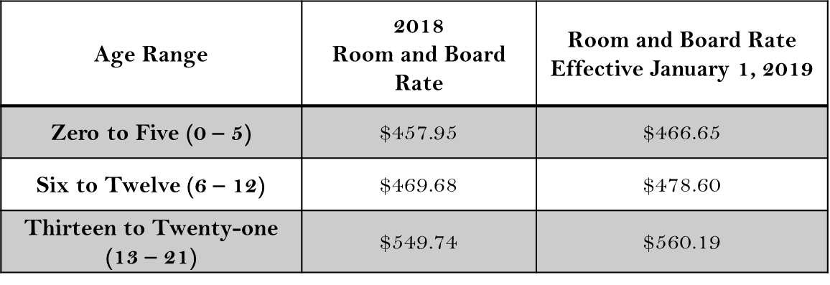

Level I Foster Care Board Rates will always remain $333. _______________________________________________________________________________________________________________________________________________________________________________________________________________________________________________________________

Local Process for Payments
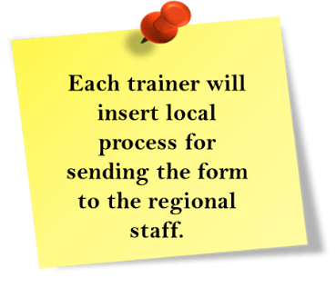

Determination of GAP Payments
- Relatives(s) have the right to appeal by the rules and procedures of the state’s fair hearing and appeal process when:
- The need for guardianship assistance payments is not determined prior to case closure.
- Relative(s) believe they have been wrongly denied guardianship assistance payments on behalf of a child.
- If it is found that the guardianship assistance payment was wrongly denied, retroactive payment will be made dating back to the date the relative(s) requested GAP payments in writing. Retroactive payment dating back to the date of placement will not be approved.
_______________________________________________________________________________________________________________________________________________________________________________________________________________________________________________________________
_____________________________________________________________________________________

GAP Application Process: Guardianship Assistance Agreement
- Serves as a legal documentation for payment between the Department and child’s relative.
- Is completed in FSFN by child welfare professional responsible for GAP.
- Includes the agreed upon benefits for the child.
- Identifies the Successor Guardian.
_______________________________________________________________________________________________________________________________________________________________________________________________________________________________________________________________
_____________________________________________________________________________________

Successor Guardian
- The Successor Guardian is an alternative should the Relative become unable to continue serving as the Relative.
- The Successor Guardian is not required to be a relative, fictive kin, or licensed caregiver.
- The guardian can change the Successor Guardian at any time.
- The guardian will be asked if they would like to change/update the Successor Guardian during the annual redetermination.
- The guardian can identify only one household as the Successor Guardian.
- The Successor Guardian must meet all background screening requirements when identified.
- When the guardian changes the Successor Guardian, a new GAA is required.
_______________________________________________________________________________________________________________________________________________________________________________________________________________________________________________________________
_____________________________________________________________________________________
_______________________________________________________________________________________________________________________________________________________________________________________________________________________________________________________________
_____________________________________________________________________________________

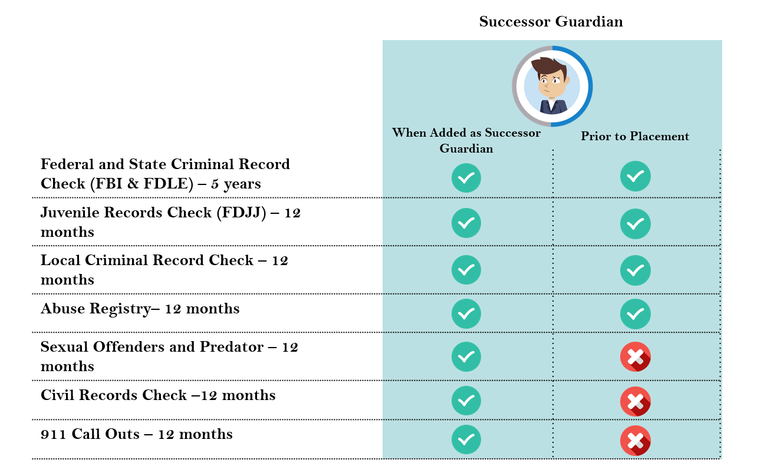
Background Screenings for Successor Guardian
_______________________________________________________________________________________________________________________________________________________________________________________________________________________________________________________________
_____________________________________________________________________________________
_______________________________________________________________________________________________________________________________________________________________________________________________________________________________________________________________
_____________________________________________________________________________________

FSFN Guardianship Assistance Agreement

Creating a Guardianship Assistance Agreement
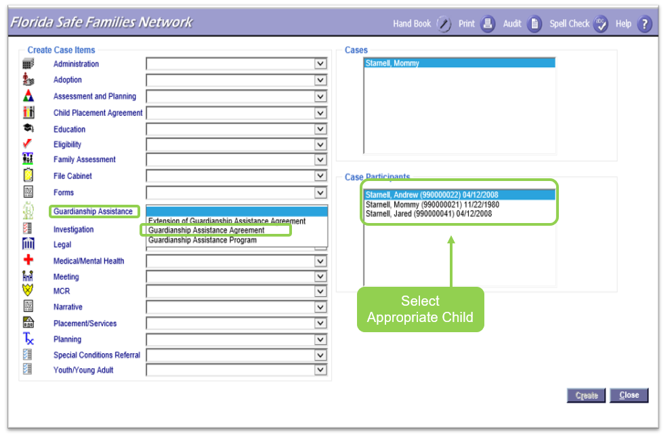
Via Case Work Button
From the FSFN Desktop select the Case Work Button. From Create Case Work select the Case name then select the participant (child), which will receive the payments. On the left side of the page, under the Create Case Items, look for the label Guardianship assistance. In the drop down select Guardian Assistance Agreement. Double check all selections and select “create” at the bottom right side of the page.
Via Case Book
Collapse all Expandos on the left side of the FSFN Desktop. Open the Expando labeled Cases. Select the Case Book hyperlink next to the appropriate Case. On the right side of Case Book, select Guardianship Assistance Agreement under the Participant Actions. Select participant (child), which will receive the payments. Double check all selections and select “create” at the bottom right side of the page.
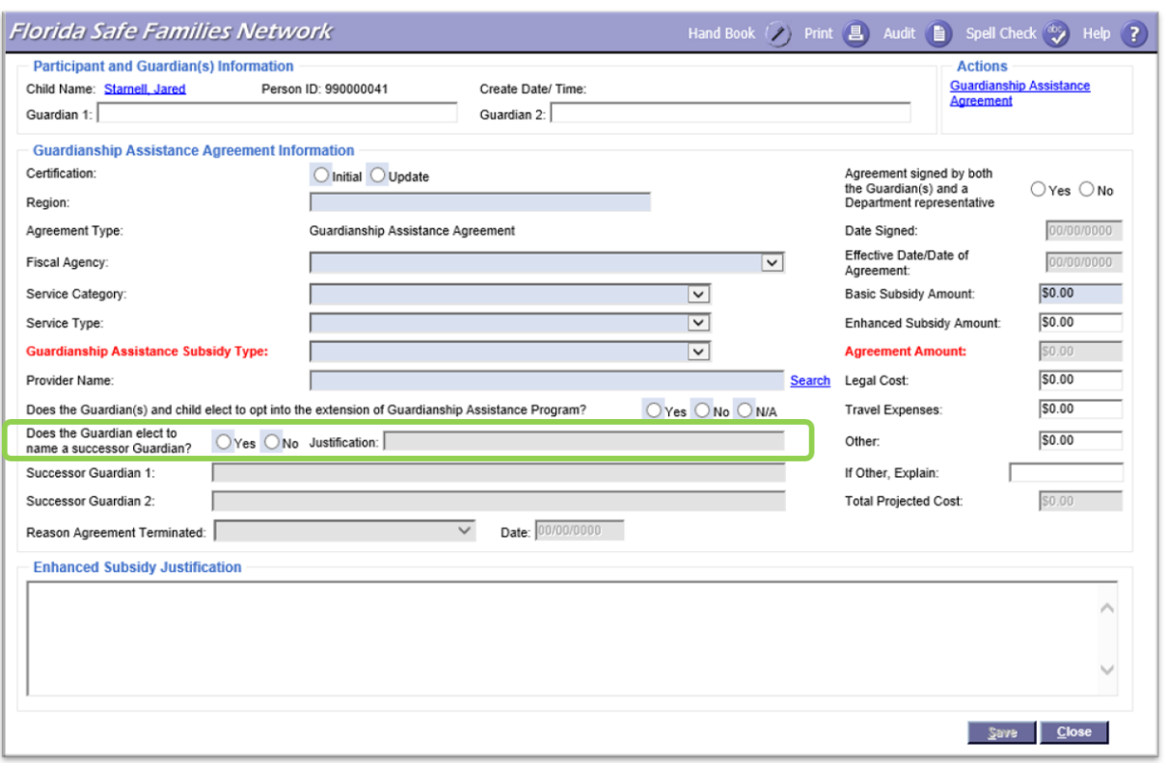
__________________________________________________________________________________________________________________________________________________________________________

Successor Guardian
When completing the Guardianship Assistance Agreement, if the Relative has selected a Successor Guardian, that information can be placed here. If they have not selected a Successor Guardian, the Justification section must be filled out. Background Checks must be completed when the Successor Guardian has been identified. _______________________________________________________________________________________________________________________________________________________________________________________________________________________________________________________________

FSFN Guardianship Assistance Agreement

Guardianship Assistance Program Agreement
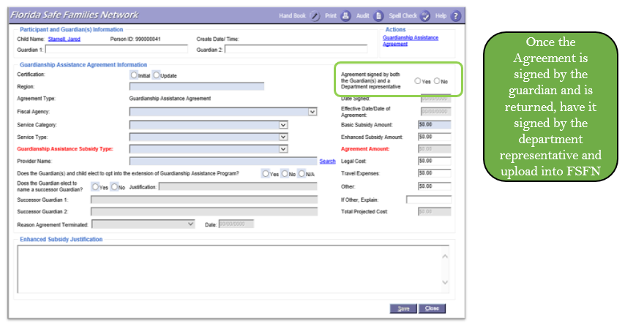
Once the Guardianship Assistance Agreement has been signed, indicate that the signed agreement needs to be uploaded in FSFN along with the signature date. File the agreement into the File Cabinet.
_______________________________________________________________________________________________________________________________________________________________________________________________________________________________________________________________

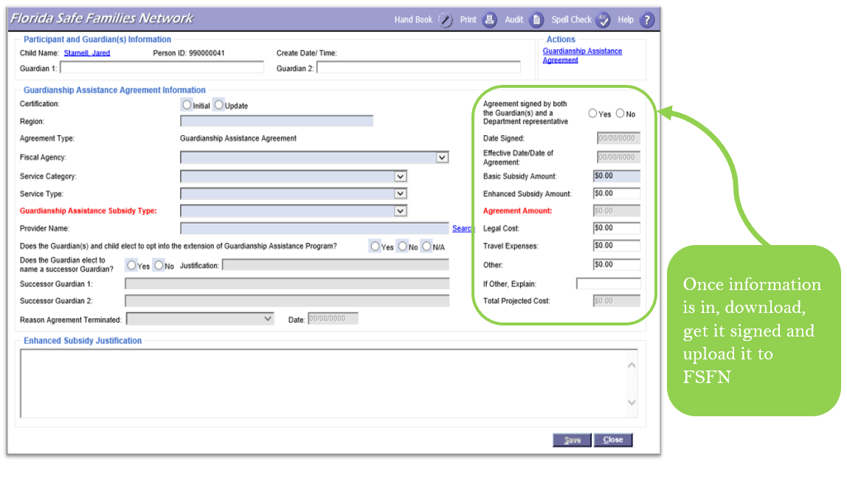
Finalize the Guardianship Assistance Agreement
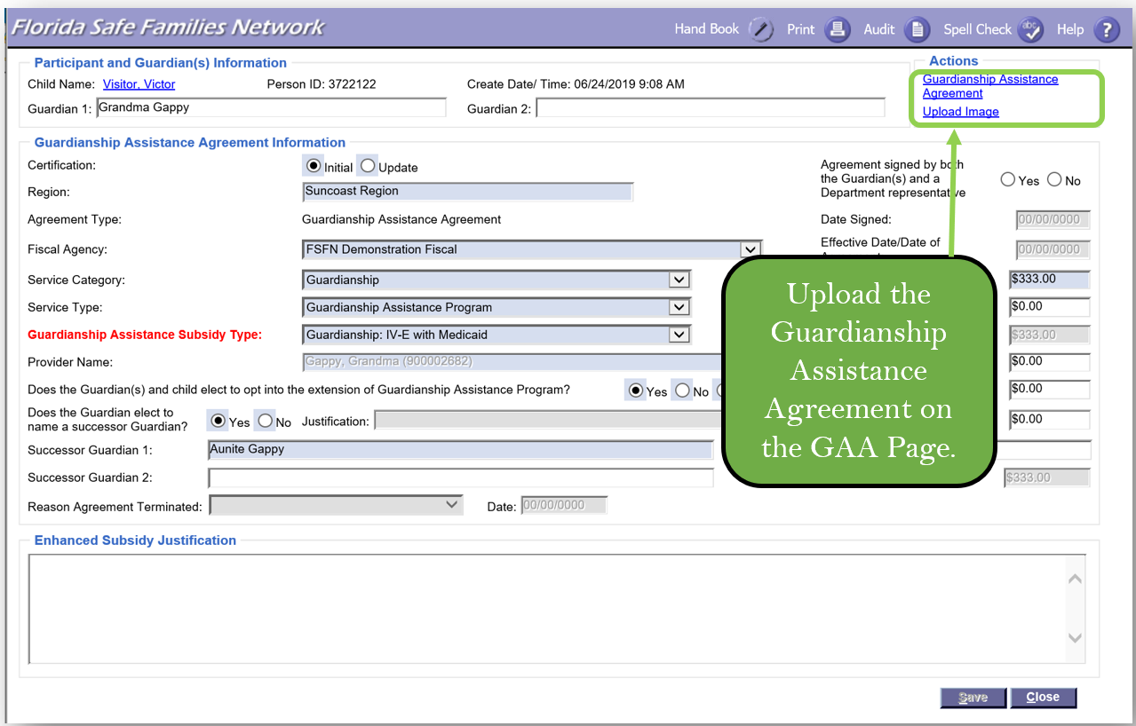
_______________________________________________________________________________________________________________________________________________________________________________________________________________________________________________________________
Upload the Guardianship Assistance Agreement
Once the Guardianship Assistance Agreement has been signed, upload an image of the document to FSFN on the Guardianship Assistance Agreement Page.
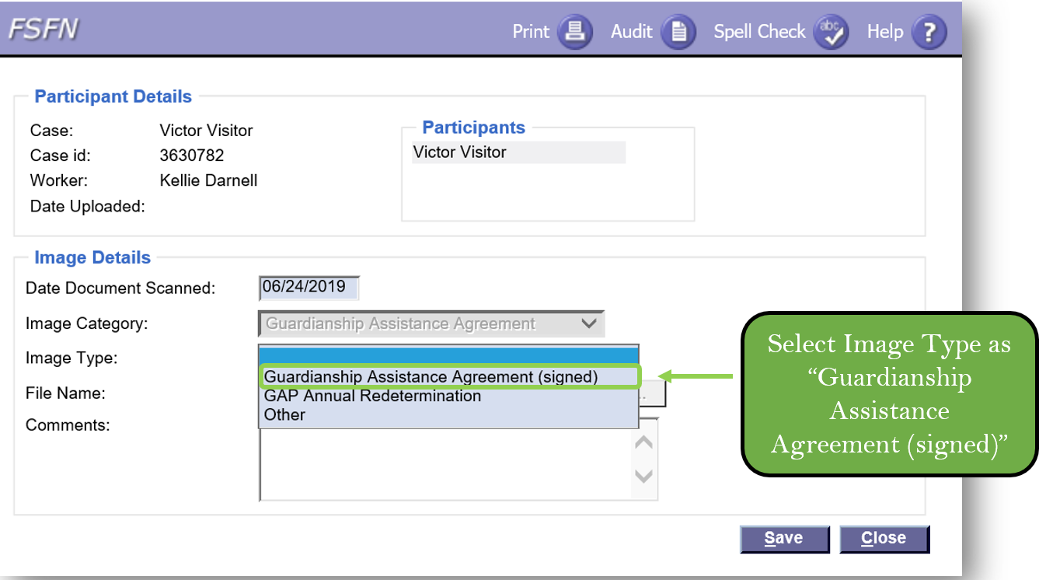

GAP Application Process: Discharge to Permanent Guardianship
- Guardian starts receiving GAP benefits.
- Medicaid continues.
- FSFN updates:
  - Link court order and finalize GAP Eligibility.
  - Finalize the GAA.
  - Discharge the Out of Home Placement with the reason of Permanent Guardianship.
  - Start a service for ALL children in GAP
  - Even if a child does not receive a GAP payment because of SSI, the service will open as a $0 service.
  - End Case Management assignment.
  - Local process for Primary assignment as the case remains open.
  - Submit a Medicaid change row to update the payee to the Guardian.
_______________________________________________________________________________________________________________________________________________________________________________________________________________________________________________________________
_____________________________________________________________________________________
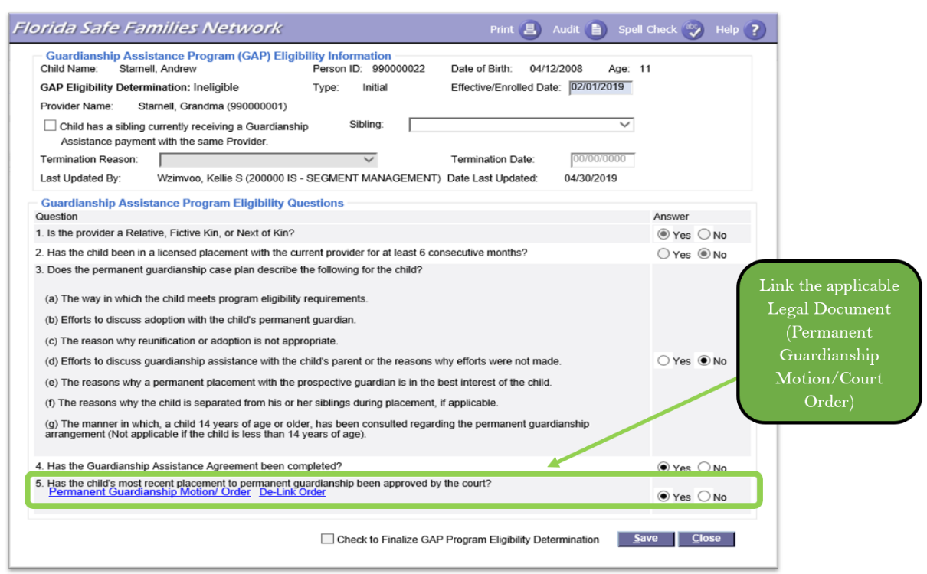
Guardianship Assistance Program – Link Court Order

__________________________________________________________________________________________________________________________________________________________________________

Continued Program Eligibility

GAP Annual Redetermination
- GAP eligibility is redetermined annually until the child is 18 years old.
- Relative must fill out the redetermination form and send it back to CBC lead agency within 30 days of written notification.
- Relative must attest they continue to provide support to the eligible child.
- Relative can make changes to Successor Guardian.
- Relative may request any additional supports and services the child may need.
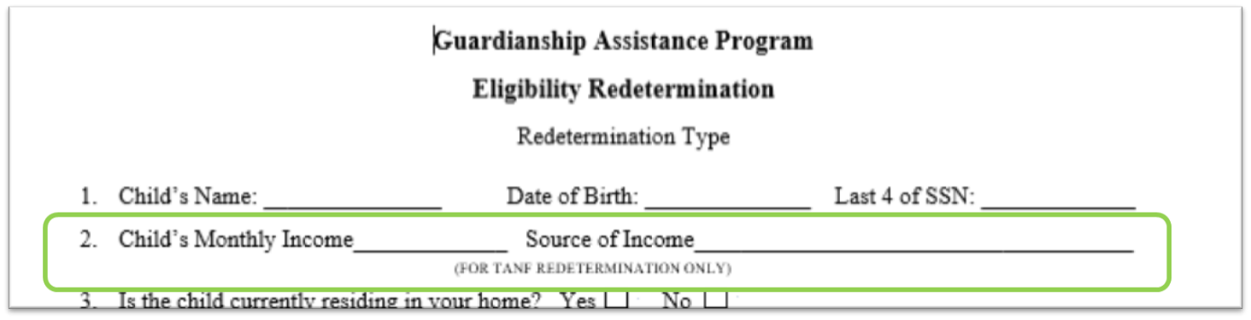
_______________________________________________________________________________________________________________________________________________________________________________________________________________________________________________________________

If the child’s source of income was deemed to be TANF GAP, the GAP annual redetermination would also be used as the TANF annual redetermination.
__________________________________________________________________________________________________________________________________________________________________________
__________________________________________________________________________________________________________________________________________________________________________

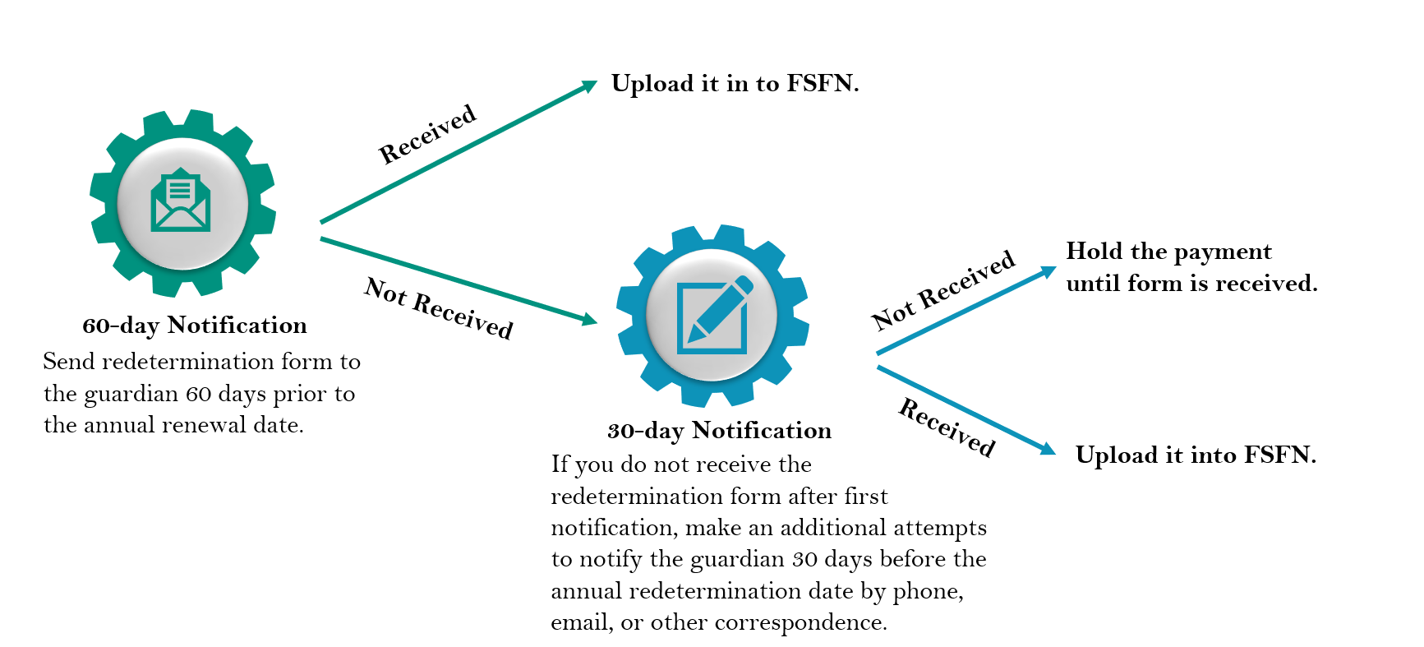
Redetermination Process
_______________________________________________________________________________________________________________________________________________________________________________________________________________________________________________________________
__________________________________________________________________________________________________________________________________________________________________________

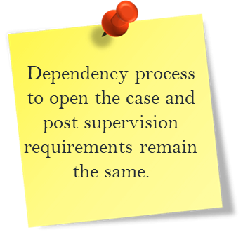
Transferring to Successor Guardian
When transferring a child from guardian to the Successor Guardian,
- Consult with CLS on next steps.
- Complete a home study and background check for the Successor Guardian.
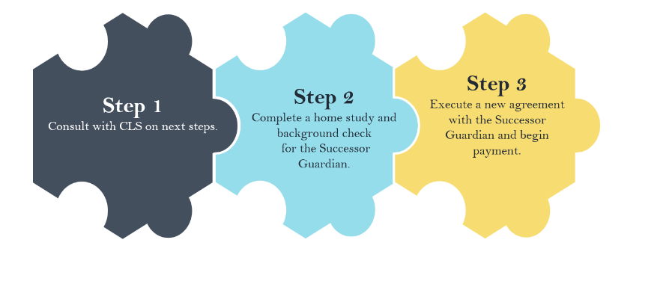
- Execute a new agreement with the Successor Guardian and begin payment.
_______________________________________________________________________________________________________________________________________________________________________________________________________________________________________________________________

FSFN Guardianship Assistance Program Redetermination

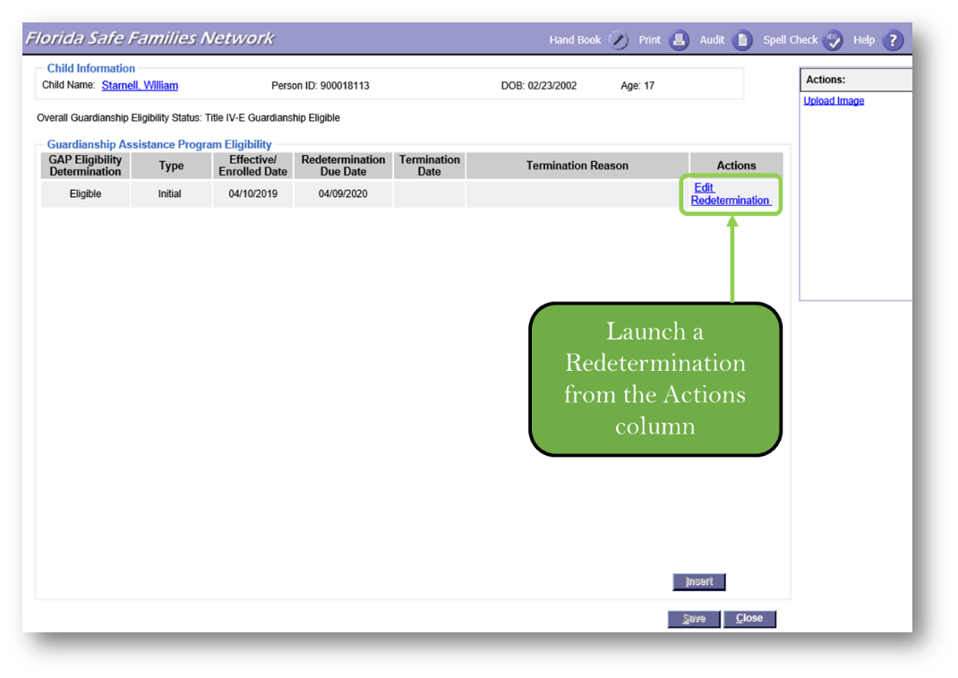
Guardianship Assistance Program – Redetermination

Once the Initial GAP Eligibility page is completed and frozen, if the Eligibility Determination is Eligible, a redetermination hyperlink displays in the Action column below the Edit hyperlink.
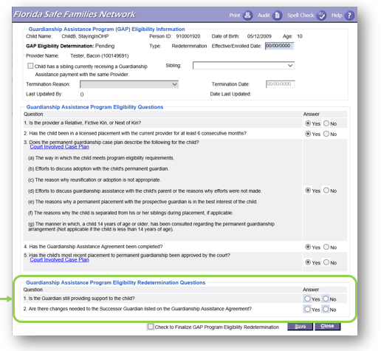
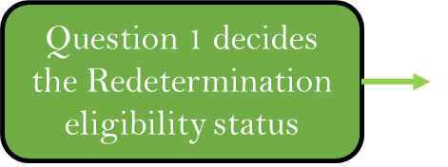

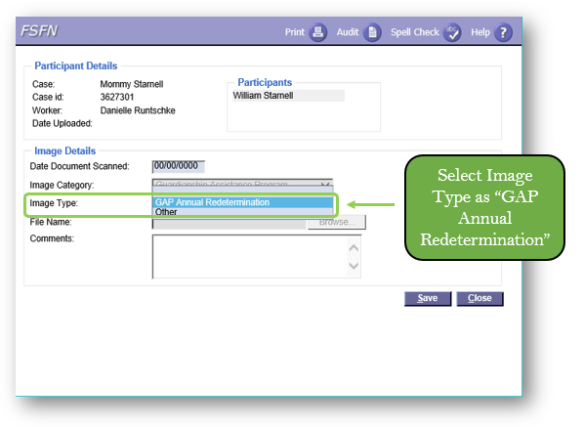
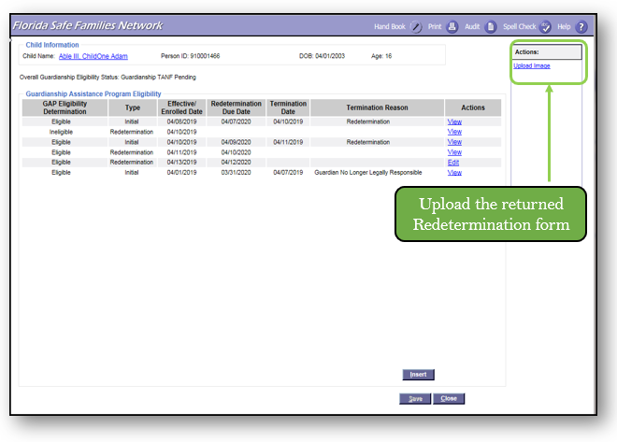

GAP Termination
Program eligibility for GAP terminates when one of the followings occur:
- The child is absent from the relative home for at least 60 consecutive calendar days unless the child is absent due to medical care, school attendance, runaway status, or detention in a DJJ facility.
- The court modifies the placement of the child, and the relative is no longer eligible for GAP benefits.
- The child turns 18.
- The child or relative passes away.
_______________________________________________________________________________________________________________________________________________________________________________________________________________________________________________________________
_______________________________________________________________________________________________________________________________________________________________________________________________________________________________________________________________

FSFN GAP Termination Reasons
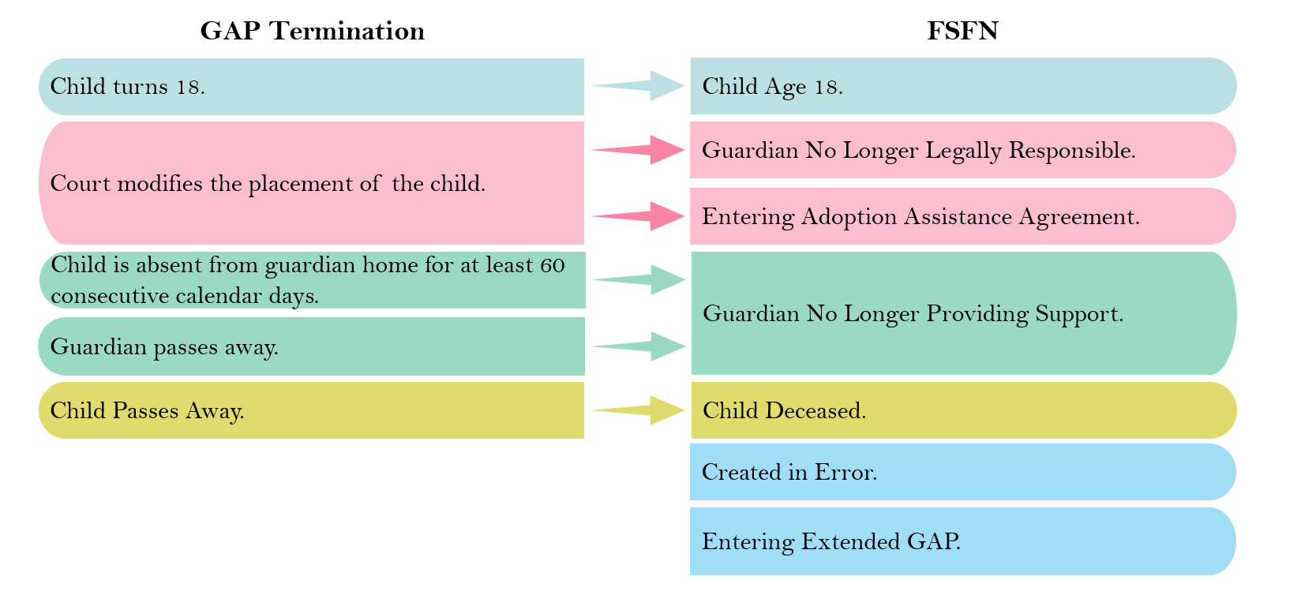
_________________________________________________________________________________________________________________________________________________________________________________________________________________________________________________________________________________________________________________________________________________________________________________________________________________________________________

GAA Termination Reasons
- The active Guardianship Assistance Agreement should be terminated when the program is terminated.
- However, under the following circumstances, a new GAA is required without terminating program eligibility:
  - Change in Subsidy Amount
  - Change in Subsidy Type
  - Change in Successor Guardian
  - Change in the election of EGAA
  - Guardian Requested Termination
  - Transfer to Successor Guardian
_______________________________________________________________________________________________________________________________________________________________________________________________________________________________________________________________

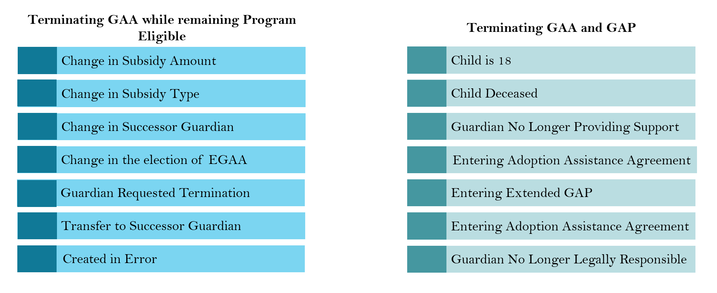
FSFN GAA Termination Reasons
______________________________________________________________________________________________________________________________________________________________________________________________________________________________________________________________

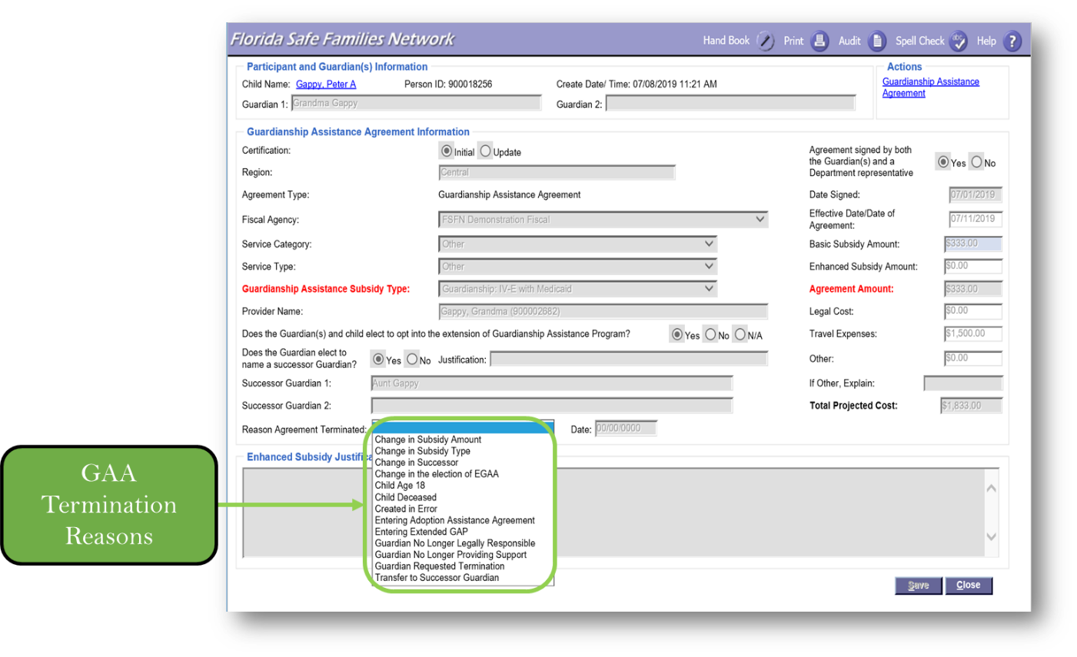
Guardianship Assistance Agreement – Termination Reasons
Guardianship Assistance Agreement – Termination Reasons
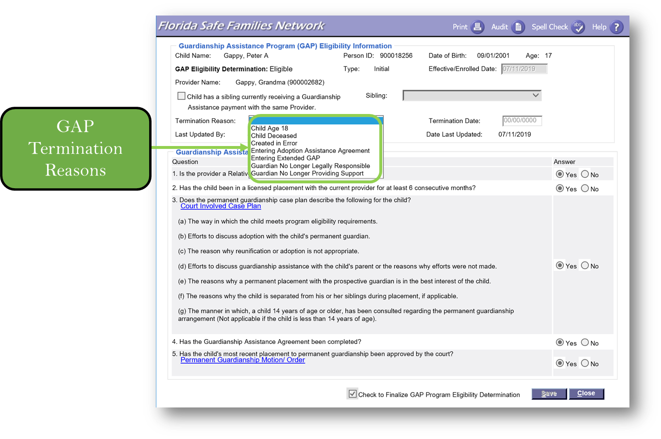

GAP Appeals
Permanent guardians(s) have the right to appeal in accordance with rules and procedures of the state’s fair hearing and appeal process, when permanent guardians believe they have been wrongly denied GAP payments on behalf of child. When a guardian files an Appeal, regardless of the reason, it should be documented in the Case Notes Section of the Case File.
_______________________________________________________________________________________________________________________________________________________________________________________________________________________________________________________________

Guardianship Assistance Program Eligibility – Appeals
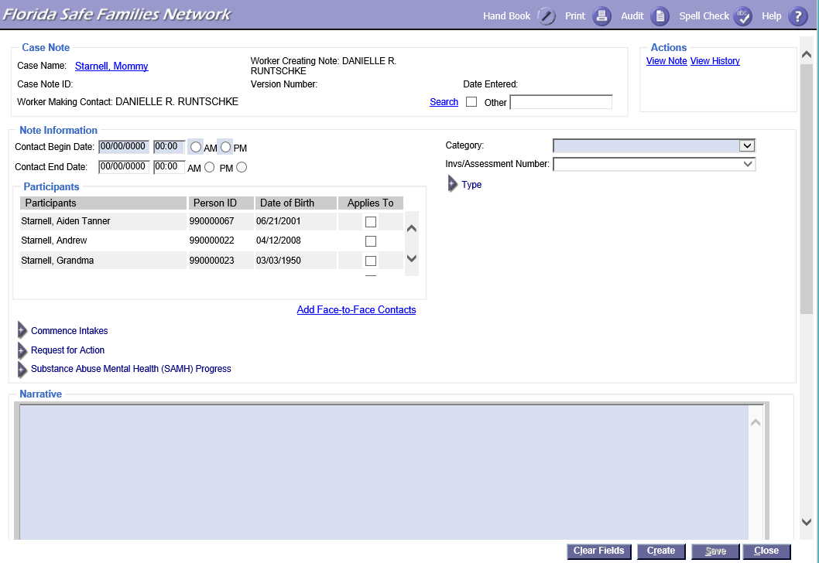
_______________________________________________________________________________________________________________________________________________________________________________________________________________________________________________________________

Extension of Guardianship Assistance Program

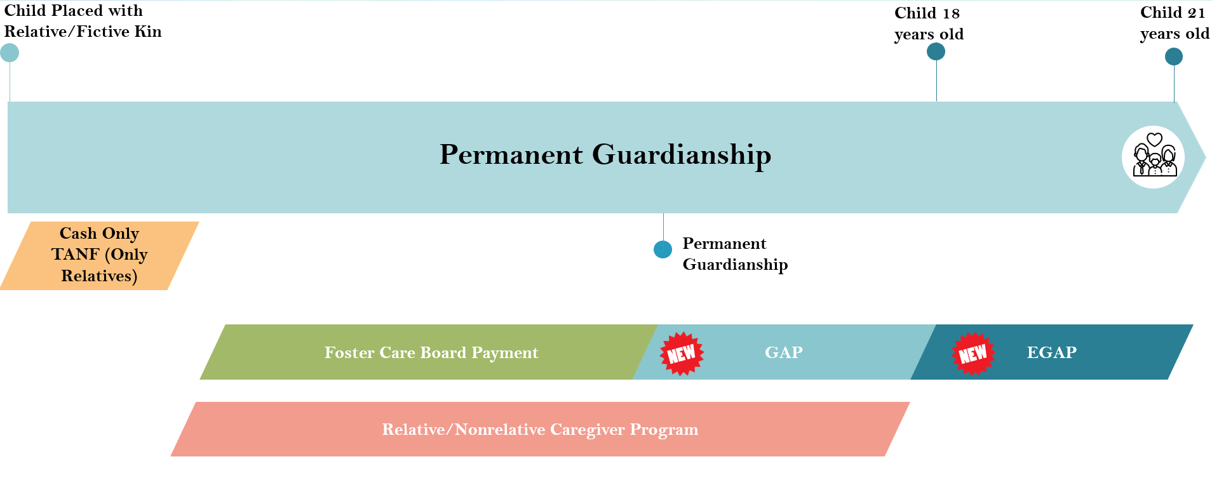
Caregiver Benefits – Permanent Guardianship
_________________________________________________________________________________________________________________________________________________________________________________________________________________________________________________________________________________________________________________________________________________________________________________________________________________________________________

Extension of Guardianship Assistance Program (EGAP) Overview
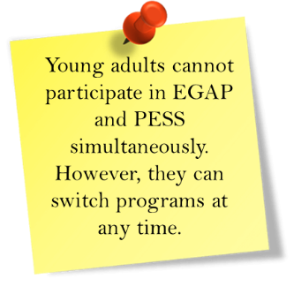
- Available to caregiver who entered into an initial Guardianship Assistance Agreement (GAA) for a 16- or 17-year-old child
- Available until 21 if the young adult participates in at least one or more qualifying activities (same qualifying activities as Extension of Maintenance Adoption Subsidy and Extended Foster Care)
- Allows CBC lead agencies to provide additional support to relatives
______________________________________________________________________________________________________________________________________________________________________________________________________________________________________________________________________________________________________________________________________________________________________________________________________________________________________________________________________________________________________________________________

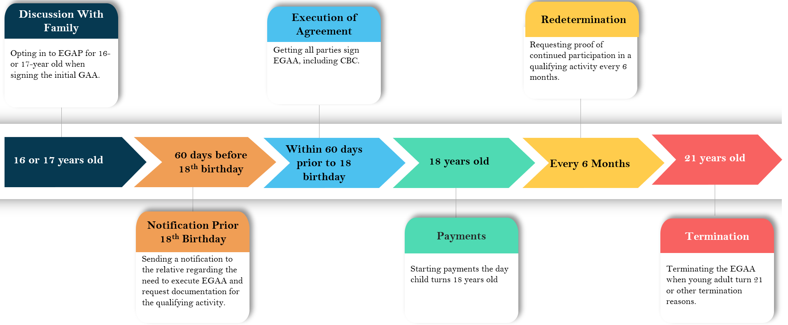

Extension of Guardianship Assistance Program (EGAP) Timeline

Guardianship Assistance Agreement Established at the Age of 16 or 17

Discussion with Relative Family
- All relatives who commit to caring for a child at the age of 16 or 17 must be told about the EGAP and its purpose.
- To qualify, relatives must opt in during the initial GAA.
- If relatives do not elect to opt in to EGAP as part of the initial GAA, the family cannot participate in the program.
_______________________________________________________________________________________________________________________________________________________________________________________________________________________________________________________________
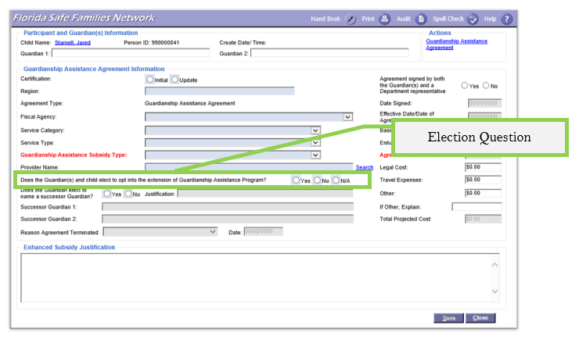
Guardianship Assistance Agreement Election Question
______________________________________________________________________________________________________________________________________________________________________________________________________________________________________________________________

Youth Transitioning to Young Adult (60-day Period)

EGAP Eligibility Requirements
To be eligible for EGAP,
- Child must be 16 or 17 years old when the initial GAA is signed.
- Relative/Fictive Kin must opt in to the Extension of Guardianship Assistance Program when they initially sign the Guardianship Assistance Agreement.
- Child must be participating in a qualifying activity.
______________________________________________________________________________________________________________________________________________________________________________________________________________________________________________________________________________________________________________________________________________________________________________________________________________________________________________________________________________________________________________________________

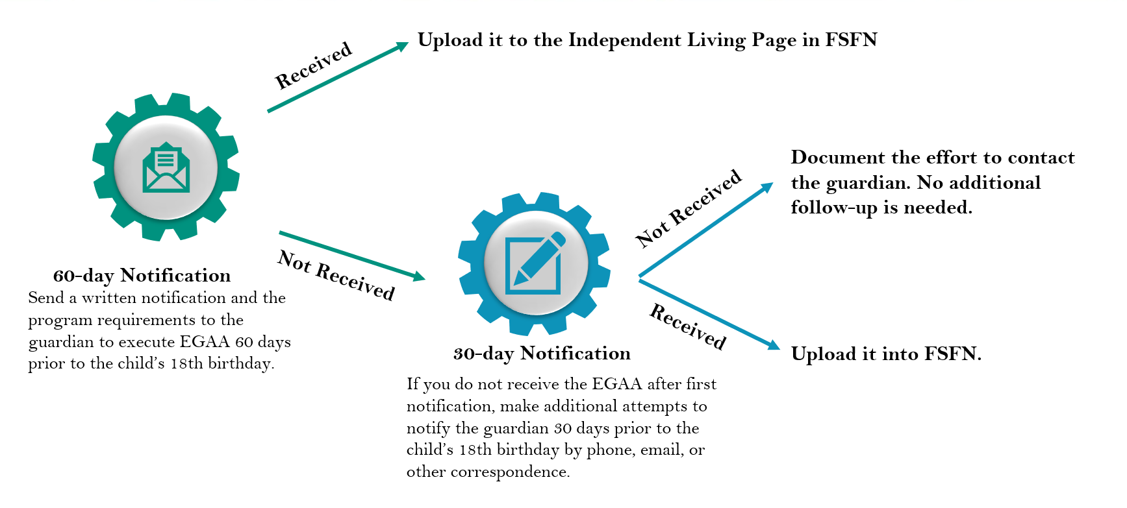
Notification Prior to 18th Birthday
_________________________________________________________________________________________________________________________________________________________________________________________________________________________________________________________________________________________________________________________________________________________________________________________________________________________________________

EGAP Qualifying Activities
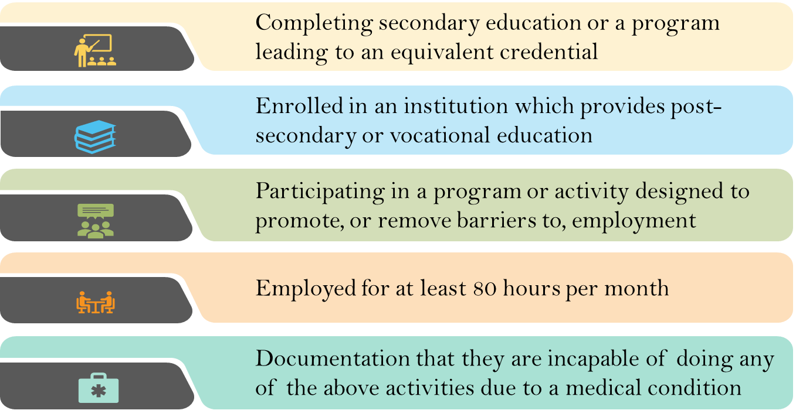
EGAP is provided to the relative on behalf of the young adult until the young adult turns 21 if the young adult participates in at least one of the following qualifying activities.

_______________________________________________________________________________________________________________________________________________________________________________________________________________________________________________________________

Extension of Guardianship Assistance Agreement (EGAA)
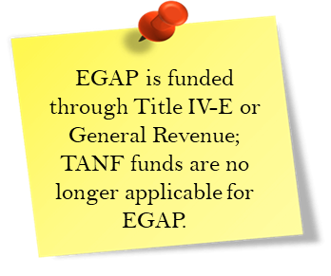
Extension of Guardianship Assistance Agreement serves as legal documentation for the payment agreement between the Department and child’s guardian. EGAA:
- Includes the type of payment and amount of payment for the young adult.
- Shows the young adult’s qualifying activity.
_______________________________________________________________________________________________________________________________________________________________________________________________________________________________________________________________

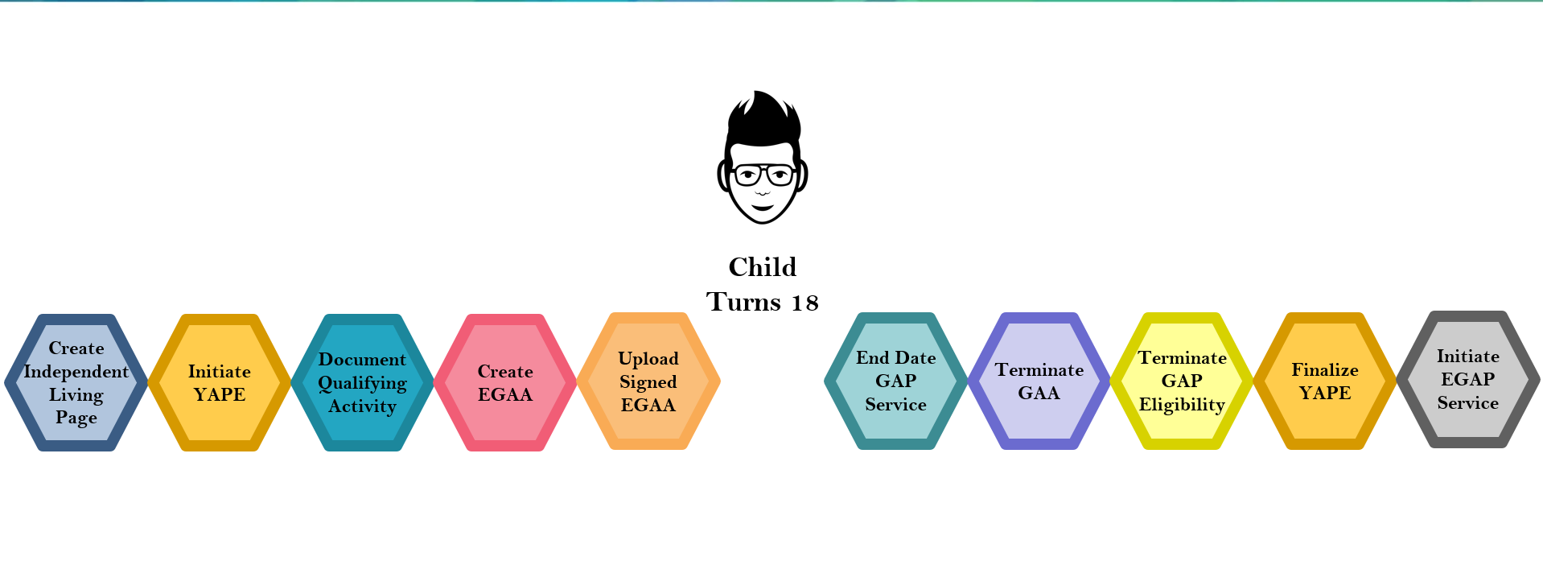
Initiating EGAP
_____________________________________________________________________________________________________________________________________________________________________________________________________________________________________________________________

FSFN Extension of Guardianship Assistance Agreement
Create Extension of Guardianship Assistance Agreement
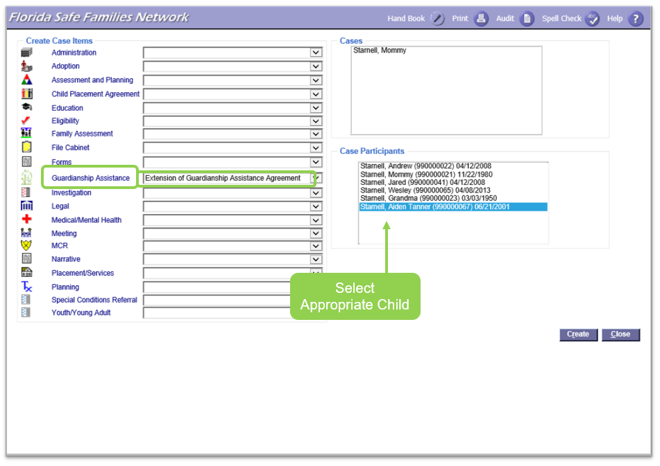Via Case Work Tab
From the FSFN Desktop select the Case Work Button. From Create Case Work page, select the Case name then select the participant (child), which will receive the payments. On the left side of the page, under the Create Case Items, look for the label Guardianship assistance. In the drop down select Extension of Guardian Assistance Program. Double check all selections and select “create” at the bottom right side of the page.
Via Case Book
Collapse all Expandos on the left side of the FSFN Desktop. Open the Expando labeled Cases. Select the Case Book hyperlink next to the appropriate Case. On the right side of Case Book, select Extended Guardianship Assistance Program under the Participant Actions. Select participant (child), which will receive the payments. Double check all selections and select “create” at the bottom right side of the page.
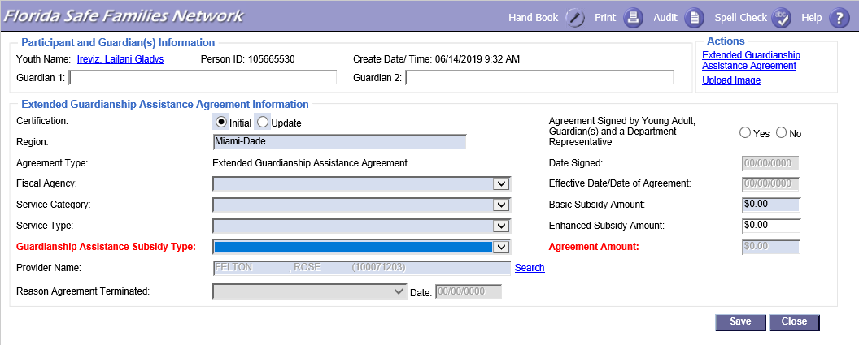
Participant and Guardian(s) Information
Enter information into the pop-up page regarding the Guardian, Fiscal Agency, Service Category, Service Type, Guardianship Assistance Subsidy type, Provider Name, and Agreement Signature date.
_______________________________________________________________________________________________________________________________________________________________________________________________________________________________________________________________

Create Independent Living Record
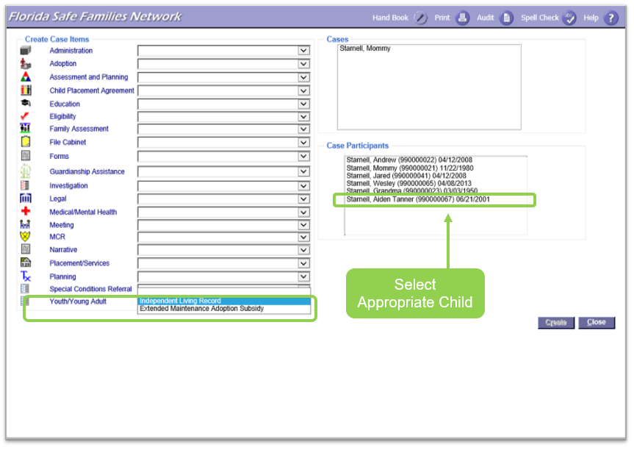
From the Create Case Items section in FSFN, select “Independent Living Record” next to Youth/Young Adult. Make sure to select the Case Participants and then create the record. _______________________________________________________________________________________________________________________________________________________________________________________________________________________________________________________________

Independent Living Page – Date of Referral
Enter in the date that begins the Independent Living Record and select Initial for Type.
_______________________________________________________________________________________________________________________________________________________________________________________________________________________________________________________________

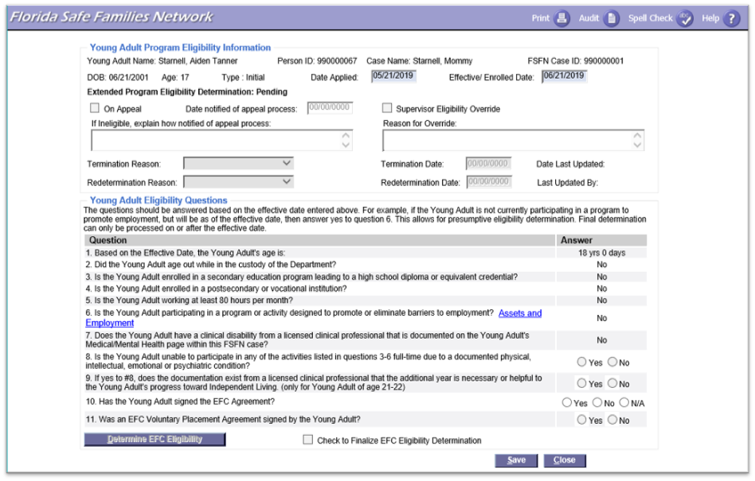
Independent Living Page – Insert Young Adult Program Eligibility
This page must be created and completed when the child starts the EGAP Program.
_______________________________________________________________________________________________________________________________________________________________________________________________________________________________________________________________

Education

When indicating Education as a qualifying activity, enter the information into the required fields. _______________________________________________________________________________________________________________________________________________________________________________________________________________________________________________________________

Qualifying Activities – Valid Educational Values
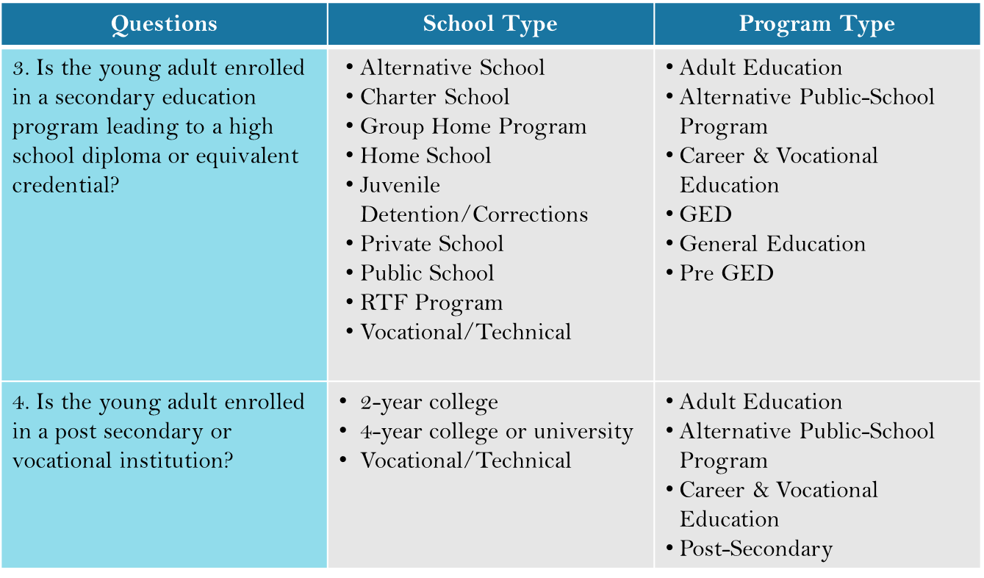
EGAP is provided to the relative until the child turns 21 if the child participates in at least one or more of the following qualifying activities.
_______________________________________________________________________________________________________________________________________________________________________________________________________________________________________________________________

Employment
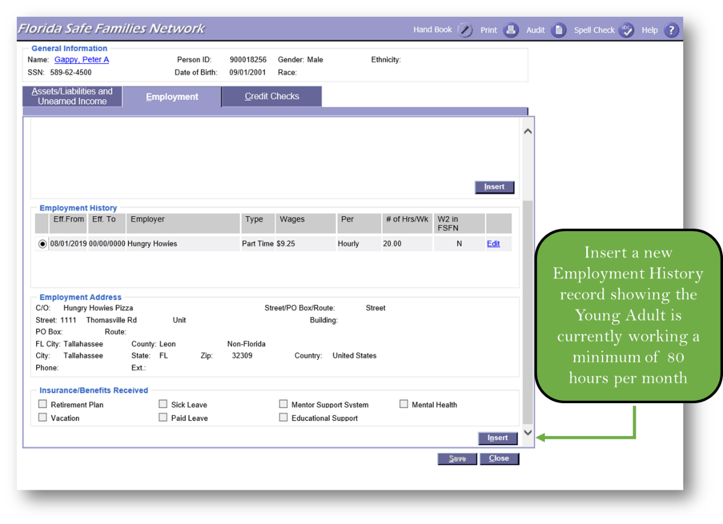
_______________________________________________________________________________________________________________________________________________________________________________________________________________________________________________________________

Assets and Employment Page
Description of the Employment or Program must be included when documenting it as a qualifying activity in FSFN. _______________________________________________________________________________________________________________________________________________________________________________________________________________________________________________________________

Medical/Mental Health Page

When documenting the Medical/Mental Health in FSFN, ensure to select from the list of available drop-down options. _______________________________________________________________________________________________________________________________________________________________________________________________________________________________________________________________

Negotiating EGAP Payments
Negotiation and the process to request enhanced payment remain the same. Refer back to Page 25.

Finalizing the Agreement
- When the EGAA is received from the relatives, supporting documentation must be attached confirming that the young adult meets one of the qualifying activities.
- The CBC lead agency has ten business days to sign the EGAA after receipt.
- The effective date of the agreement is the date the youth turns 18 years old.
- If the agreement is signed after the individual turns 18, the effective date is the day EGAA is signed. The effective date will not go back to the date they turned 18.
_______________________________________________________________________________________________________________________________________________________________________________________________________________________________________________________________
_____________________________________________________________________________________

Extended Guardianship Assistance Payment Agreement
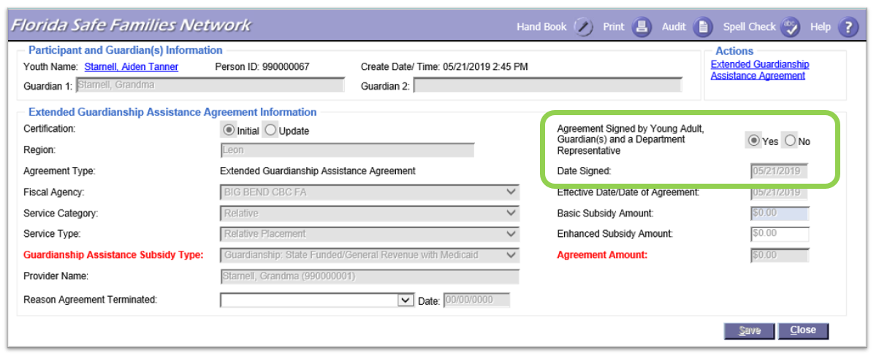
_______________________________________________________________________________________________________________________________________________________________________________________________________________________________________________________________

EGAP Payments
EGAP payments begin once
- The child turns 18.
- All parties have signed the EGAA.
- Supporting documentation of the qualifying activity is received.
_______________________________________________________________________________________________________________________________________________________________________________________________________________________________________________________________

Eligibility and Enrollment
- If the need for EGAP payment was not determined prior to the youth’s 18th birthday and the relatives feel they have been wrongly denied the payment; they have the right to appeal the denial.
- If it is found that it was wrongly denied, retroactive payments will be made dating back to the date the family requested the payment in writing.
_______________________________________________________________________________________________________________________________________________________________________________________________________________________________________________________________

Ongoing Program Eligibility

Ongoing Program Eligibility Requirements
- Young adult must continue to participate in at least one qualifying activity. They may change activities at any time.
- Young adult does not have to be residing in the home with the relative after 18 to qualify for benefits if the relative is providing support to the young adult.
- Relative is responsible for notifying the Department or CBC of any change in circumstances, including moving out of state, within 48 hours of the change.
NOTE: TANF redeterminations stop at 18. EGAP is funded by Title IV-E or General Revenue.
_______________________________________________________________________________________________________________________________________________________________________________________________________________________________________________________________

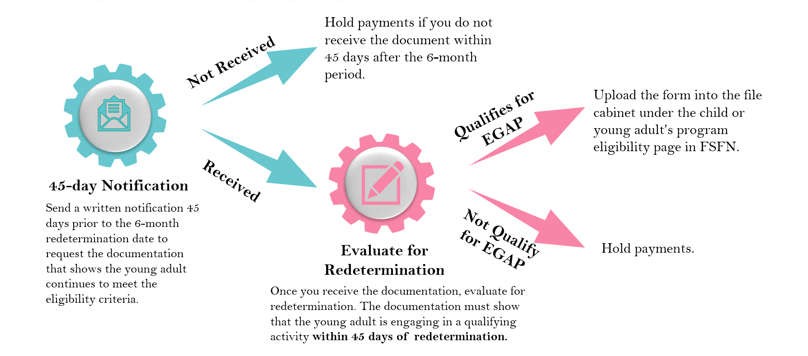
EGAP Redetermination Process
_______________________________________________________________________________________________________________________________________________________________________________________________________________________________________________________________
__________________________________________________________________________________________________________________________________________________________________________

Young Adult Program Eligibility – Redetermination Reasons
When entering redetermination information into FSFN, indicate any changes to the Qualifying Activities. Please be sure to update the information in the YAPE page as well. _______________________________________________________________________________________________________________________________________________________________________________________________________________________________________________________________

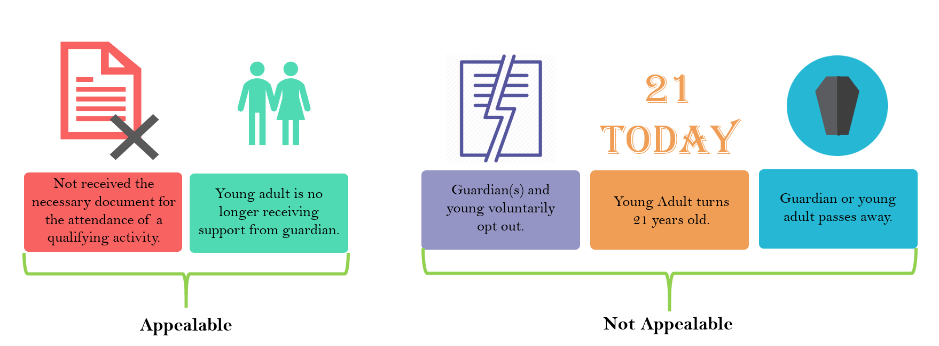
Termination Reasons
_______________________________________________________________________________________________________________________________________________________________________________________________________________________________________________________________

EGAP Termination for Appealable Reasons
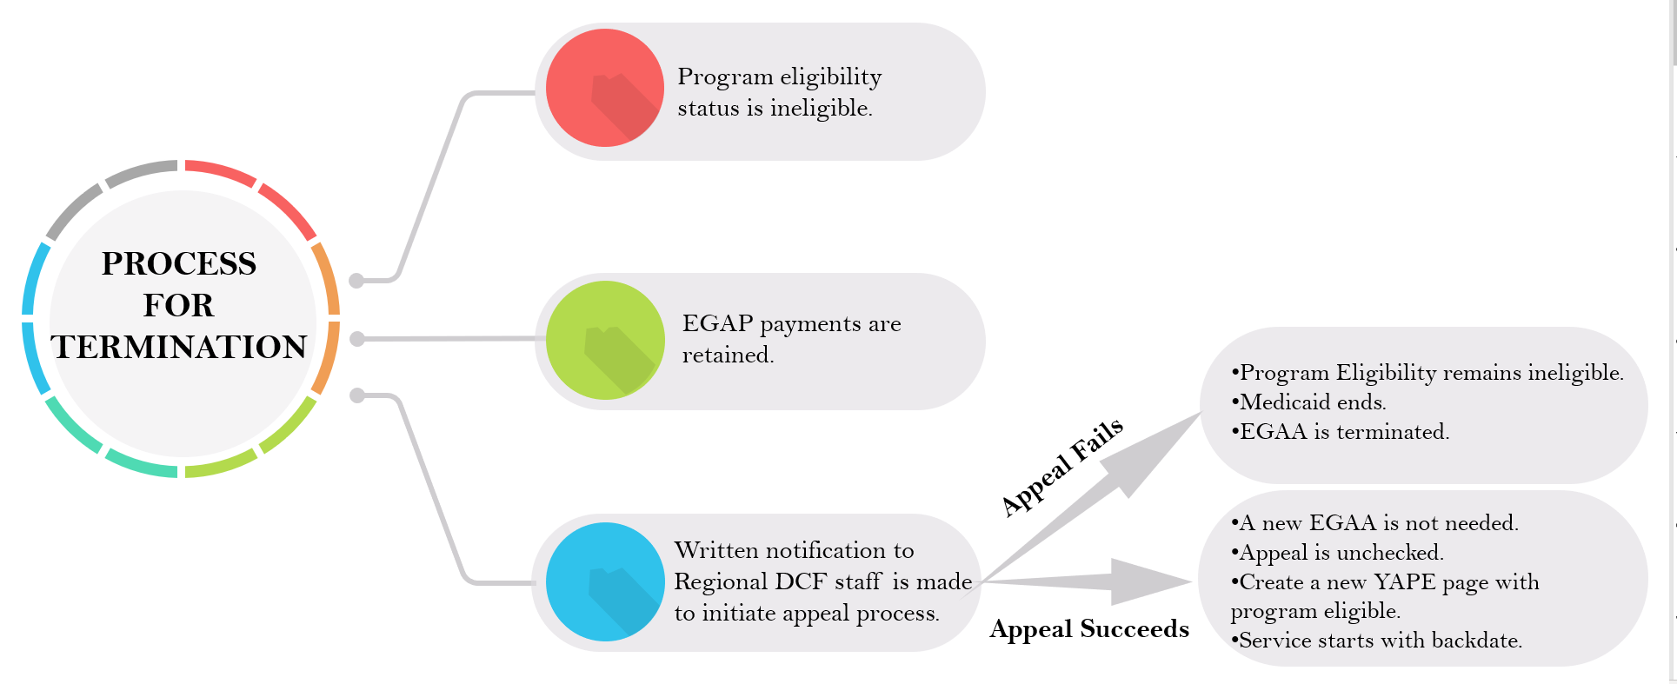
_______________________________________________________________________________________________________________________________________________________________________________________________________________________________________________________________
__________________________________________________________________________________________________________________________________________________________________________

Young Adult Program Eligibility – Termination Reasons
If the program is being terminated, regardless of reason, indicate the Termination reason in the box provided. _______________________________________________________________________________________________________________________________________________________________________________________________________________________________________________________________

Young Adult Program Eligibility – Redetermination Reasons

Appeals are documented in the Young Adult Program Eligibility page for all children in EGAP. _______________________________________________________________________________________________________________________________________________________________________________________________________________________________________________________________

EGAP Readmission
- A young adult may requalify for the EGAP benefits until the young adult reaches 21 if they provide documentation to support that the young adult meets one of the qualifying activities.
- A new, completed EGAA is required at the time of readmission.
- EGAP payments will resume from the date of the new agreement.
_______________________________________________________________________________________________________________________________________________________________________________________________________________________________________________________________
Extension of Guardianship Assistance Program Eligibility – Readmission
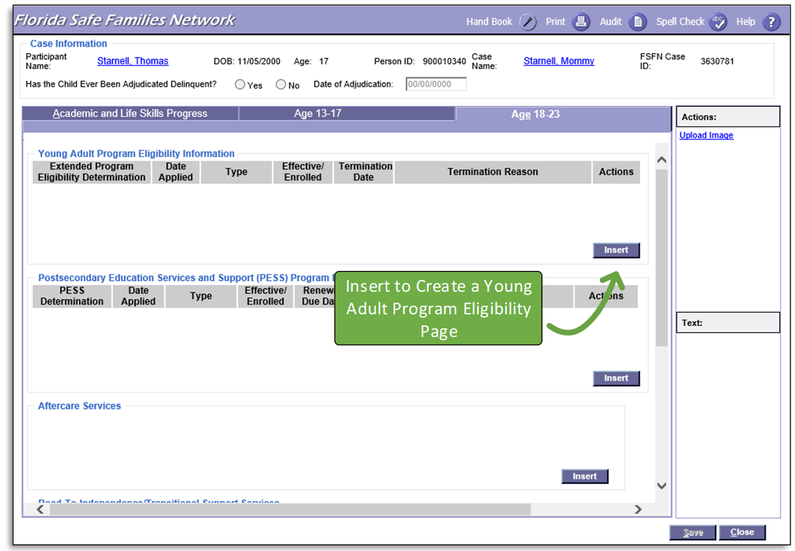
Readmission into EGAP simply requires a new Independent Living Record (YAPE) to be documented in FSFN. _______________________________________________________________________________________________________________________________________________________________________________________________________________________________________________________________

FSFN Practice
You will practice the following activities in FSFN.
- GAP Page
  - Open Case Book for the example case and launch the GAP Page for a child.
  - Insert a new GAP Eligibility Row and launch the GAP Eligibility Page.
_______________________________________________________________________________________________________________________________________________________________________________________________________________________________________________________________
_______________________________________________________________________________________________________________________________________________________________________________________________________________________________________________________________
- GAP Presumptive Eligibility – GAP Eligibility Page - Initial
  - Note the Initial Type.
  - Insert a past date (greater than six months after the Out of Home Placement Begin Date) as the Effective/Enrolled Date and save the page.
  - Review Question 1 as system derived from the Provider tab of the current Out of Home Placement.
  - Review Question 2 as system derived from a comparison between the Out of Home Placement begin date and the Effective/Enrolled Date.
_______________________________________________________________________________________________________________________________________________________________________________________________________________________________________________________________
__________________________________________________________________________________________________________________________________________________________________________
- Guardianship Assistance Agreement Page
  - Create a Guardianship Assistance Agreement from the Participant Actions group box in Case Book.
  - Complete the page and generate the Guardianship Assistance Agreement Word Document.
_______________________________________________________________________________________________________________________________________________________________________________________________________________________________________________________________
_____________________________________________________________________________________
- Finalizing GAP Eligibility – GAP Eligibility Page – Initial
  - Insert today’s date as the Effective/Enrolled Date and save the page.
  - Answer Questions 3 – 5 and link a Court Involved Case Plan and Court Order.
  - Finalize the eligibility determination.
_______________________________________________________________________________________________________________________________________________________________________________________________________________________________________________________________
_______________________________________________________________________________________________________________________________________________________________________________________________________________________________________________________________
- GAP Eligibility Page – Redetermination
  - From the GAP Page, launch a Redetermination GAP Eligibility Page from the Initial created above.
  - Answer Question 1 to continue eligibility.
  - Answer Question 2 with no change to the Successor Guardian.
  - Finalize the eligibility redetermination.
______________________________________________________________________________________________________________________________________________________________________________________________________________________________________________________________________________________________________________________________________________________________________________________________________________________________________________________________________________________________________________________________
- GAP Eligibility Page – Termination
  - From the GAP Page, edit the most recent GAP Eligibility Page.
  - Select a Termination Reason and save the page.
______________________________________________________________________________________________________________________________________________________________________________________________________________________________________________________________________________________________________________________________________________________________________________________________________________________________________________________________________________________________________________________________

- Guardianship Assistance Agreement Page – Termination
  - From the Actions group box on the GAP Page, select Guardianship Assistance Agreement.
  - On the Guardianship Assistance Agreement Page, select a termination reason, enter a termination date, and save the page.
- Launch the EGAA page and complete
  - Create an Extended Guardianship Assistance Agreement by selecting Guardianship Assistance Agreement from the Participant Actions group box in Case Book.
  - Complete the page and generate the Extended Guardianship Assistance Agreement Word Document.
_______________________________________________________________________________________________________________________________________________________________________________________________________________________________________________________________
_______________________________________________________________________________________________________________________________________________________________________________________________________________________________________________________________
- Launch the Independent Living page and save
- Launch the Young Adult Program Eligibility page and complete
- Complete the Educational, Assets and Employment, and Medical/Mental Health Pages
- Finalize the EGAA
- Create the Redetermination Reason
- Terminate EGAP
_______________________________________________________________________________________________________________________________________________________________________________________________________________________________________________________________
_______________________________________________________________________________________________________________________________________________________________________________________________________________________________________________________________
_______________________________________________________________________________________________________________________________________________________________________________________________________________________________________________________________
_______________________________________________________________________________________________________________________________________________________________________________________________________________________________________________________________

Appendix
GAP Application Form

Guardianship Assistance Agreement
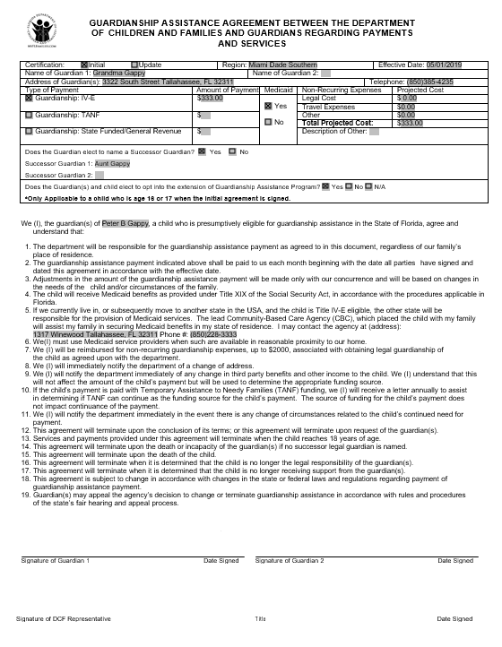

Negotiation Approval Form

Redetermination Form

Extension of Guardianship Assistance Agreement

