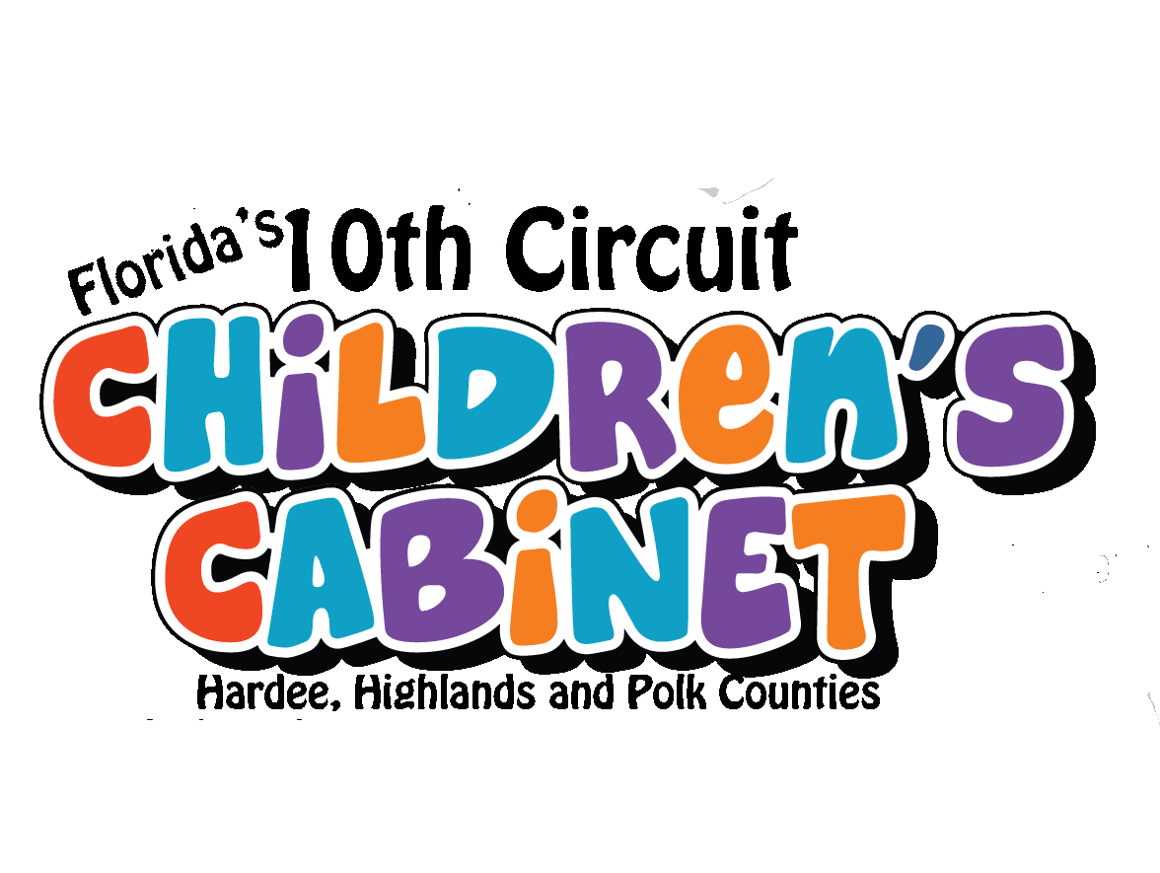

Quick Guide - Resources for the Uninsured and Underinsured

Medicaid: http://www.myflorida.com/accessflorida/
To locate Medicaid service centers visit http://www.dcf.state.fl.us/ess/index.shtml#svcctrs

Additional Medicaid programs include:
Coverage for prenatal care for pregnant women: call 1-866-796-0871 or visit
http://www.healthystarthhp.org/momcare.htm
Social Security: http://www.ssa.gov/applyfordisability/
For Children with Special Medical Needs: visit:
http://www.cms-kids/families/families.html

Health Insurance for Children 0-18 years:
Florida KidCare: www.floridakidcare.org or call 1-888-540-5437
Children already enrolled in FloridaKidCare and who have special medical or behavioral/emotional needs, may be eligible for Children Medical Services Network or Behavioral Health Specialty Care Network. Contact Children Medical Services for Polk, Hardee and Highlands counties for more information regarding these programs at (863) 413-3580

Health Insurance for Adults ages 19-64:
Cover Florida: www.coverfloridahealthcare.com or contact Blue Cross Blue Shield of Florida at 1-877-872-6580 or United Healthcare 1-800-809-9831

For Residents of Polk County only: Polk County Health Plan, call 863-534-5387
Or visit http://apps.polk-county.net/php/site/

Benefits for Adults and Children who were the Victim of a Crime:
Victim’s Crime Compensation: http://myfloridalegal.com/victims

Mental Health Providers who are Sliding Scale Fee:
Peace River Center: Providing services in Western Polk and Hardee County
http://www.peace-river.com/ or call Lakeland: (863) 248-3311
Bartow: (863) 519-0575 Wauchula: (863) 773-3228
Winter Haven Hospital, Center for Behavioral Health: Providing services in Eastern Polk and Highlands http://www.winterhavenhospital.org/facilities/cbh/
Or call Winter Haven: (863) 294-7062 or Sebring: (863) 385-5179

Health Providers who may offer services at reduced fees:

Polk County Health Department: (863) 519-7900 or www.mypolkchd.org
Highlands County Health Department: (863) 366-6040 Ext 215
http://www.doh.state.fl.us/chdHighlands/index.html
Hardee County Health Department: (863) 773-4161
http://www.floridashealth.com/chdHardee/index.html

Compiled by the Children’s Cabinet of the 10th Circuit. Subject to change. For informational purposes only. Inclusion does not imply endorsement by The Children’s Cabinet. For more information on The Children’s Cabinet, visit
http://childrenscabinet.wikidot.com

Health Providers who may offer services at reduced fees, continued:

Central Florida Health Care: http://www.cfhconline.org/
Avon Park: (863) 452-3000 Wauchula: (863) 773-2111
Dundee: (863) 419-3330 Frostproof: (863) 635-4891 Lakeland (863) 413-8600

Polk County only:
Lakeland: Volunteers in Medicine: (863) 688-5846
Winter Haven: The Haley Center: (863) 299-6562 http://www.fbcwinterhaven.com/templates/System/details.asp?id=30505&PID=30
Lake Wales: Lake Wales Care Center: (863) 676-6678
http://www.lakewalescarecenter.org/
Haines City: Parkview Outreach Community Center Medical Center:
(863) 353-6853 http://www.parkviewchristiancenter.org/

Specialty Care Clinics:
We Care of Polk County: 701-8070 (Doctor Referral is needed)

Health Care for the Homeless
Good Samaritan Clinic: (863) 687-8475, Lakeland

Discounted Prescription Medicine Programs:
Florida Discount Drug Card Program: www.floridadiscountdrugcard.com
1-866-341-8894 or (tty users) 1-866-763-9360
NACO: Prescription Discount Card: (863) 534-5387 or pick up at participating pharmacies

Various local pharmacies offer a wide variety of discount prescription drug services: Here are some examples in our area.
Kmart Target
Publix Walgreens
Sweetbay Wal-Mart

Developed March 2010

Compiled by the Children’s Cabinet of the 10th Circuit. Subject to change. For informational purposes only. Inclusion does not imply endorsement by The Children’s Cabinet. For more information on The Children’s Cabinet, visit
http://childrenscabinet.wikidot.com

