WRITTEN NOTICE OF EXEMPTION PER FLORIDA STATUTE

I am a Child Protective Investigator for the state of Florida Department of Children and Families, and am here for the purposes of an official investigation. My duties include the investigation of child abuse, neglect, exploitation, fraud, theft, or other criminal activities. Pursuant to Florida Statute Section 119.071(4)(d)1.a., I am exempt from providing you with any of the following records for myself, my spouse, or my children:

** Home Address(es) ** Telephone Number
** Social Security Number ** Photograph(s)
My Spouse or Children’s places of employment and the names and locations of the schools or daycare facilities attended by my children.

I do carry a DCF Child Protective Investigator ID (example below) that contains my name and title. If you wish, you may call the phone number contained below to check and verify that I am an official Child Protective Investigator of the state of Florida, Department of Children and Families.
DCF Child Protective Investigator

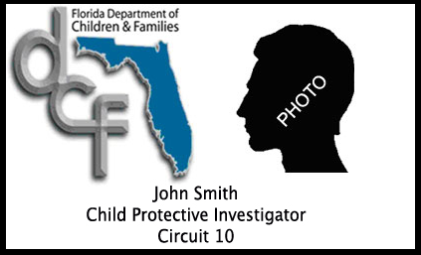

Lakeland Office: 863-413-3564 Bartow Office: 863-519-8262 or 863-534-7100
200 N. Kentucky Ave, 3rd Floor 1055 Highway 17 North, Bartow, FL 33830
Lakeland, FL 33801

Lake Wales Office: 863-678-4770 Sebring Office: 863-402-7716
730 SR 60 West, Lake Wales, FL 33853 1968 Sebring Parkway, Sebring, FL 33870

HOTLINE: 1-800-96-ABUSE

