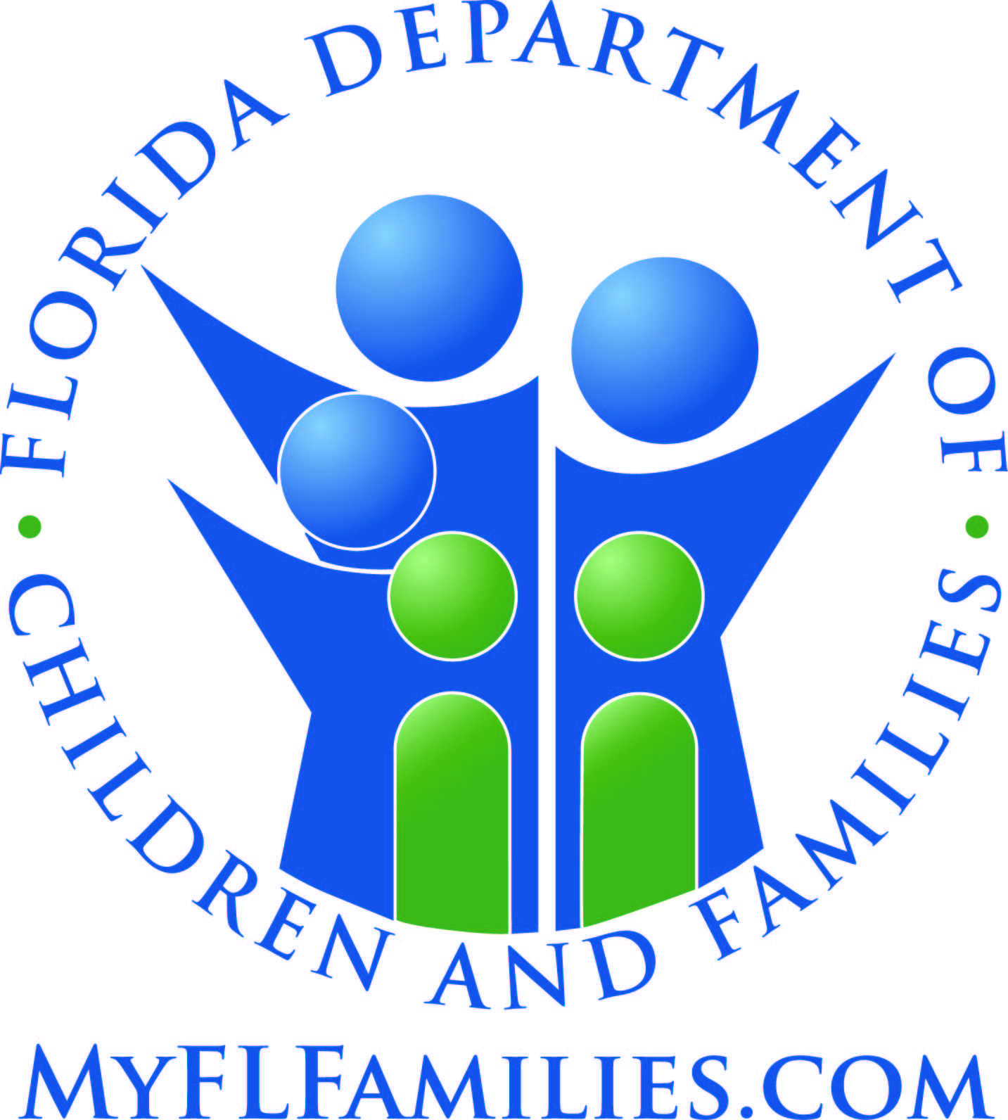
State of Florida
Department of Children and Families

Confidentiality: This letter is intended for the Persons listed below. If received in error, please contact my office immediately.

Date

Dear Mr. and Mrs. ??
Address
City, State, Zip

Reference: CSA Report Number

This letter serves as notice to you that the investigation, received on (insert date report was received), involving your family is being closed. My investigation revealed the following findings:

(List allegation code and findings, For example:)
Inadequate Supervision: No Indicators
Physical Injury: Not Substantiated

These findings are based upon the evidence gathered during the course of the investigation. The findings have been made in accordance with DCF Operating Procedures and Chapter 39 of the Florida Statutes. DCF Operating Procedures are available for your review at http://www.state.fl.us/cf_web/. The Florida Statutes are available for your review at http://www.flsenate.gov.

You are permitted to obtain a copy of the summary report of the investigation. This report can be obtained at my office, in person, with a valid photo ID, but please call first to make an appt to pick up the investigation summary. This report is only available for the person(s) allegedly responsible for the abuse or neglect and/or the parents of the children listed on the report.

Thank you for your patience and cooperation. If you have any questions, please call CPI (insert CPI’s name) or their supervisor (insert CPIS name).

Sincerely,

Child Protective Investigations
Department of Children and Families
(Insert the CPI’s office address and phone #)

